Finding Justice in Cyberspace: The Wickedness of Online Gender-Based Violence (GBV)
Nusaibah Edi Nugraha*¹ and Sekarayu Tunggadewi Anugraputri²
¹Faculty of Social and Political Sciences, Universitas Gadjah Mada
²Faculty of Psychology, Universitas Gadjah Mada
*Penulis Koresponden: nusaibahedi00@mail.ugm.ac.id

Abstrak
Secara umum, kekerasan berbasis gender di Indonesia terbagi ke dalam dua kategori; kekerasan berdasarkan ranah personal (privat) dan kekerasan berdasarkan komunitas dan negara (publik). Kasus kekerasan yang terjadi selama masa pandemi COVID-19 memberikan peringatan kepada masyarakat dan pemerintah bahwa kasus ini perlu menjadi perhatian. KBGO dalam bentuk luring maupun daring memiliki kompleksitas masing-masing, namun terlihat kesenjangan dalam penanganannya. Penelitian ini memiliki 2 tujuan, yakni sebagai berikut: (1) untuk melihat KBGO dalam di Indonesia; (2) untuk mengeksplorasi hubungan antara teori dan praktik KBGO. Kami menemukan bahwa walaupun kedua bentuk KBG diselimuti oleh hegemoni maskulinitas, namun ruang dalam internet membuat KBGO menjadi lebih kompleks. Saran yang dapat kami berikan adalah percepatan pengawalan implementasi UU TPKS dengan memperkuat organisasi lokal yang pro-gender dapat memperluas kesadaran kasus ini pada masyarakat awam.
Kata kunci: kekerasan berbasis gender online, wicked problem, respon kebijakan

AbstraCT
Gender-Based Violence in Indonesia is generally divided into two categories; kekerasan berdasarkan ranah personal (GBV that takes place in a private setting) and kekerasan berdasarkan komunitas dan negara (GBV that takes place in a public setting). Aside from this, the COVID-19 pandemic has brought to light an equally concerning form of GBV, online GBV. While both have their complexities, there seems to be a jarring gap in how current policy handles offline and online. The objectives of this research are two-fold: (1) to examine online GBV within the context of Indonesia; (2) to explore the nexus between theory and practice regarding online GBV. We found that although both types of GBV are shrouded in hegemonic masculinity, the added layer of the online space makes online GBV more complex, making it a Wicked Problem. The concept of a Wicked Problem is often used to descibe issues with high complexity making it difficult to solve Though at the time of write UU TPKS had not been legalized, the 10 year strugle behind it shows the wickedness behind this issue. As UU TPKS has yet to be implemented, we suggest upscaling grassroot feminist or pro-gender organizations in effort to spread awareness and further combat online GBV.
Keywords: online gender-based violence, wicked problem, policy response

INTRODUCTION
While the COVID-19 pandemic has undoublty disrupted national economies and public health systems, there is one issue in particular that has yet to gain the same global attention. This issue in question is the prevalence of gender-based violence (hereafter GBV), which has notably been dubbed by UN Women (2020) as “the shadow pandemic.” In the United Nations Chronicle, Vaeza (2020) mentions the adverse effects of lock-downs and stay-at-home regulations have had on women and girls in particular, despite having an argueably significant impact on preventing and limiting the spread of the pandemic. Staying at home, she argues, provides more oppurtunities for perpetrators to abuse mechanisms of power and control to further isolate survivors of GBV.
The existence of a shadow pandemic is quite evident in Indonesia. Data from The National Comission on Violence Against Women or Komnas Perempuan showed that in 2020 there was a downward trend of reported GBV cases (299.991 cases; 31% less than 2019) in their Catatan Tahunan (Catatahu) or their Yearly Report. Despite this, it should be noted that the amount of data they were able to attain was significantly less than previous years. This means that there is a high possibility that GBV cases were and are still being under-reported and thus current data does not nessecarily reflect the current state of GBV survivors. Although there is a lack of attainable data, Komnas Perempuan found that 34% of the organizations that they collaborated with in the data-collecting process stated that there was an increase in the frequency of reported cases during the ongoing pandemic, further highlighting prevelance of GBV. Komnas Perempuan themselves experienced a 60% increase in reporting going from 1.413 cases in 2019 to 2.389 cases in 2020 (Komnas Perempuan, 2020).
Among these reported cases, the increase of kekerasan berbasis gender online (KBGO) or online GBV is particularly noteworthy as a somewhat new pattern in the growing spectrum of GBV. We Are Social reported that in January of 2021 there are at least 170 million Indonesian citizens who are currently active on the internet with social media being the most popular activity (Hayati, 2021). Coupled with the necessity to constantly be online for everyday activities and the cultural construction of gender roles, this creates an environment rife with the possibility of falling pray to online GBV.
The likelihood of survivors of online GBV recieving protection is often times very slim as protection for survivors of offline GBV has always been limited. Although there is a fair amount of laws pertaining to women’s issues, at the time of writing this article there were no specific policy responses, particularly those pertaining to to online GBV that can be used as protection for survivors. This was one of the many reasons why many were highly anticipating the passing of the Bill on Sexual Violence Crimes (RUU TPKS) as official law. After ten years of a contentious and exhausting legal battle, finally the People’s Representative Council (Dewan Perwakilan Rakyat) enacted RUU TPKS as an official law in April 12, 2022. This paper was researched and written during 2021, before the passing of RUU TPKS. During the absence of what is considered a comprehensive law on gender-based violence, women were often forced to rely on gaps within the existing law to build their case. However, this runs the risk of criminalizing the survivor as many of these laws have been found to not be survivor-oriented and are still quite discriminatory towards women (Kania, 2015; Eddyono, 2018). This is further manifested in the institutions and systems that women must go through in order to report their GBV case. Women tend to forgo going through this process due to them often being dehumanized, with many people in positions of power, such as police officers and judges, normalizing acts of GBV (Nugraha, 2022).
In the case of online GBV, one could argue that the burden of providing evidence and building a case would be less as the nature of this particular form of GBV leaves behind evidence in the form of a digital footprint. This means that victims would be able to collect evidence and form a timeline via the history of their internet and/or social media application use, such as in the form of screenshots. However, survivors of online GBV are often even more so discriminated against, with many survivors being charged under Law No.211 of 2008 on Electronic Information and Transactions (UU ITE), most notably under Article 27 that prohibits the distribution of digital content “against propriety” and of “affronts and/or defamation..” These conditions demonstrate the complexity behind the issue of online GBV and also display the characteristics of what policymakers often reffer to as a Wicked Problem (hereafter WP). WPs are generally characterized that are complex, numerous and difficult to define making them difficult to solve (Peters, 2017).
So far, scholarship into online GBV is still fairly new and has been limited to studies that analyze the drivers behind this phenomenon. Scholarship adressing the policy response for online GBV or lack ther of is still rare. Due to this, the authors aim to enrich the discussion surrounding online GBV by taking a closer look at the complexity of this issue by looking at how the context of Indonesia influences the existence of violence and seeing what other factors further complicate online GBV. Further the objectives of this research are:
- To examine online gender-based violence within the context of Indonesia.
- To explore the nexus between theory and practice regarding online gender- based violence.

LITERATURE REVIEW

The Internet as a Gendered Space
The idea of internet as a gendered space is not a new concept in itself. Although initially thought to be gender-neutral, it has been discovered that individuals continue to make and respond to gender judgments of others in cyberspace based on assumptions regarding gender (Megarry, 2014). Marginalized voices are excluded, outsider histories are forgotten, and those with access to the means of cultural production define culture (Shaw, 2014). Due to this, it can be assumed that patriarchal thoughts and tendencies continue to be prevelant in digital spaces, further contextualizing the internet as a gendered space. This can be seen through how women have never been treated equally only and Internet appears to be firmly rooted in the practical reality of women’s everyday sexism in patriarchal societies (Daniels, 2009; Megarry, 2014; Shaw, 2014.).

This gender segregation of the internet is highlighted in existing discussions of online GBV, which is embedded in women’s offline experiences. Women, according to Megarry (2014), tend to experience a specific form of abuse in relation to their gender. Lewis (2017) and Jatmiko et al. (2020) both support this view. Despite their similarities, online abuse appears to be more complex, as violence can perpetuate and emerge permanently through the use of abusive texts and images. Furthermore, the persistence of violence has blurred the distinction between online and offline settings, allowing online violence to have offline consequences and vice-versa (Iyer et al., 2020).

Online Gender-Based Violence in Indonesia
Discussions of GBV and the Indonesian goverment’s lackluster responses are nothing new nor surprising. Cultural conceptions of online GBV often view violence as an inherent characteristic of men. Nilan et al. (2014) emphasizes this by categorizing responses towards three main discourses; the discourse of denial, the discourse of blaming the woman, and the dicourse of the man as a victim. With GBV still being a very taboo topic, coupled with the fact that violence is very normalized, the discourse of denial is seen as a strategy for “maintaining local harmony” where some choose to turn a blind eye. In the discourse of blaming women, the woman is frequently portrayed as the one who “invites” acts of violence by failing to follow the standards of what is considered a “good wife.” Rominto (2008) writes “it is the abused woman who provokes the beating, she argues, disobeys, cooks badly, is untidy, and denies sex” (p.52). Even outside the context of marriage, woman who are viewed as “bad woman” (perempuan nakal) are often blamed for any form of violence directed at them (Solvang, 2002 in Nilan et al., 2014). Violence done by men is frequently justified by claims that they are unable to control their actions and are driven by external forces. Despite this, GBV always involves men making decisions (Nilan, 2014). This three discourses are present within the ways the government attempts to respond to GBV.

The way laws and policies have been established to respond to GBV reflects the collective consicousness sorrounding it. While laws that can protect women exist, these laws do not always address the needs of women or victims of GBV (Kania, 2015; Eddyono, 2018). These regulations reflect not just the lack of interest in cases of GBV, but also the previously mentioned prevalence of normalizing violence and the tendency to side with the perpetrator rather than the victim (Hayati et al., 2014; Eddyono, 2018).

In the case of online GBV, Jatmiko et al. (2020) aimed to deconstruct the rise of online GBV in Indonesia by analyzing the experiences of offline GBV survivors. Many women who have experienced offline sexual violence continue to be victims of online violence. Furthermore, the COVID-19 pandemic has highlighted the fact that cyberspace has become a stepping stone for the creation of what they call an “online sexual violence revolution,” which provides opportunity for men to conduct violence.

THEORITICAL FRAMEWORK
In literature regarding gender and policy-making, policy responses and the institutions that implement them have been noted to be androcentric. This refers to the idea that “assumptions, concepts, beliefs, arguments, theories, methods, laws, policies, and institutions may all be ‘gendered’ in the sense that they are based upon, and they reinforce, male power advantage” (Hawkesworth, 1994: 105). Here, policy-making is interpreted as an ongoing process of planning and executing through the intervention of states (Lombardo et al., 2012). These interventions throughout the policy-making process affect existing inequalities, meaning that this process could very much worsen the state of women due to being fueled by a preexisting patriarchal structure. This is evident in Indonesia, especially in the case of GBV as many policies have been observed to be unfavorable towards victims (Eddyono, 2018; Hayati et al., 2014; Kania, 2015).
In order to further contextualize the issue of online GBV, this study utilizes the social-ecological framework (Heise, 1998) that can be seen below. Here, GBV is analyzed based on different factors at different levels (individual, interpersonal, family, neighborhood, and, community, as well as policy, systems, and society). The individual-level highlights individual experiences of gender norms. The interpersonal and family level reveals interactions between family members and smaller groups in the presence of patriarchal culture and views on the role of women. The neighborhood and community level demonstrates interactions with the wider society, cultures surrounding violence, as well as facilities and services available for survivors of GBV. The policy, systems, and society level shows how factors such as policy and public affect the dynamics of GBV on the national, state, and local level.

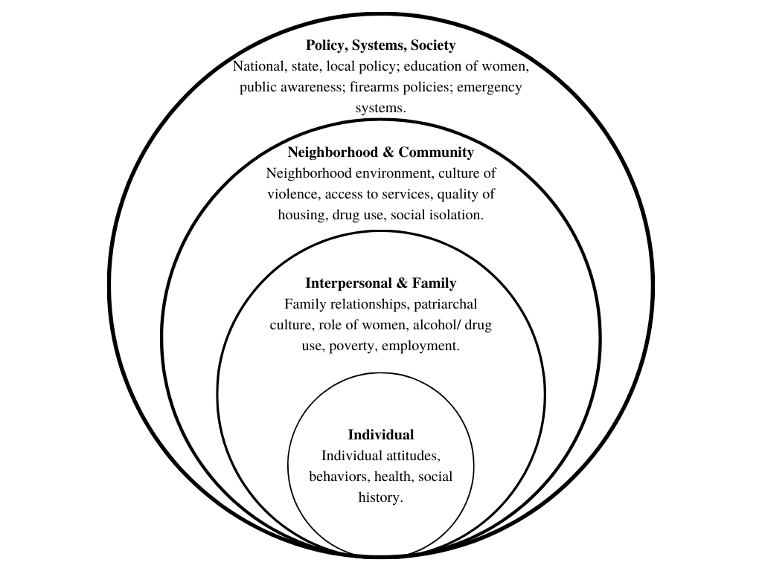
Figure 1 Social-Ecological Framework (adapted from Heise (1998)
Source: Iglesias et. al., 2019
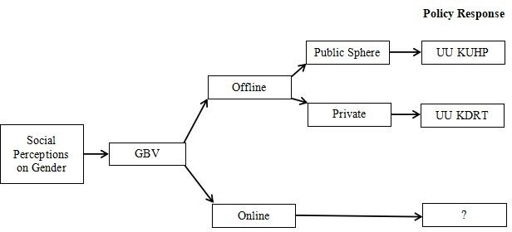
Aside from analyzing the various contexts of GBV, this study also attempts to address the complexities of online GBV through the concept of wicked problems (Figure 2). In the figure bellow, following the basic logic of Heise’s ecological framework, our model begins by showing how GBV is heavily influenced by social perceptions of gender that oftentimes “normalizes” violence (Nilan, 2014). The model then converges into the two general settings of GBV, public and private. These two spaces of GBV are then paired with laws that are often synonymous to them such as UU KUHP (The Criminal Code) that is usually used to dictate public cases of GBV and UU KDRT (Law on the Elimination of Domestic Violence) is used to dictate domestic violence or private cases of GBV. This model then further illuminates the dilemma of a clear policy response for online GBV as, unlike offline GBV, cases of online GBV cannot be approached the same way offline GBV is. Laws that could potentially dictate cases of online GBV such as UU ITE (Law on Electronic Information and Transactions) do not have statutes that address or protect victims of online GBV and as mentioned previously, tend to vilify victims. Thus, using this adapted ecological framework, the researchers hope to conduct further analysis on the lack of a clear policy

METHODS
Using the previously mentioned ecological framework as a guide, this research uses literary review or secondary research to integrate findings and perspectives from other scholars who have researched GBV, online GBV, as well as ideal policy responses towards online GBV. In addition to this, this research also draws upon supplementary data from briefs and reports.

FINDINGS AND DISSCUSSION

The Normalization of Violence and the Lack of Women’s Voices
In his exploration of the Indonesian male feminist, Adian (2001) points out the cultural understanding of gender being pre-determined (kodrati) as opposed to being socially constructed (konstruksi). This notions is echoed and further elaborated upon by Nilan et al. (2014) by pointing out many ways society tends to justify violence through three discourses; the discourse of denial, the discourse of blaming the woman, and the discourse of the man as a victim. Though contextually different, all three of these discourses show the reality that society tends to almost always points the proverbial finger at the women.
These beliefs are not limited to the general public, large institutions also seem to view GBV as an unimportant issue. This primarly due to the gender of the survivor (who are often women) and the notion that acts of harassment are “harmless” and “funny”. An explanation for this could be the lack of awareness regarding the severity of GBV and its impacts on survivors’ physical and mental well-being (Restikawasti, 2019 and Deitz et al., 2015). Women are also often seen as partly responsible for the violence they experience which is sometimes coupled with accusations that the woman supposedly engaged in a “consensual relationship” with the perpetrator (suka sama suka) (Lestari, 2018).
In the case of online GBV, these cases seem to be even more discredited, as they are seen as “just words” (Amnesty International, 2017) and something that “only happens virtually” (Juniarto, 2021). This way of thinking implies the belief that online GBV is not seen as legitimate or non-existent because it is not severe as offline GBV.
Although Indonesia does have several laws pertaining to women and women’s issues, it should be noted that at the time of writing there were no specific laws (payung hukum) that could address the issue of GBV. Coupled with fact that it has taken ten years to legalize UU TPKS, this shows that the Indonesian governemnet has had a lack of interest in women’s issues. This is further higlighted by the fact that existing laws at the time were unable to facilitate the diversity and complexity of GBV, particularly on issues regarding consent.
During this time, survivors were forced to cleverly interpret existings law to form a case against perpetrators (Veda, 2021), which is no easy feat. This can be seen in cases of online GBV, where relevant laws such as UU ITE could easily be used against them, providing another example of how Indonesian Law tends not to be oriented towards the protection of survivors. A legal guidebook for survivors that was put together by SAFEnet also echoes this point. Here they provide an extensive list of laws and regulations that can be used against perpetrators of online GBV while also providing a list of risks when using said laws and regulations (Veda, 2021). In her own experiences with Indonesian Law Eddyono (2020) observes that survivors are often ignored in favor of upholding public interest and protecting the perpetrator. Furthermore, the are usually vilified due to their efforts in seeking justice.

Online GBV: A Wicked Problem?
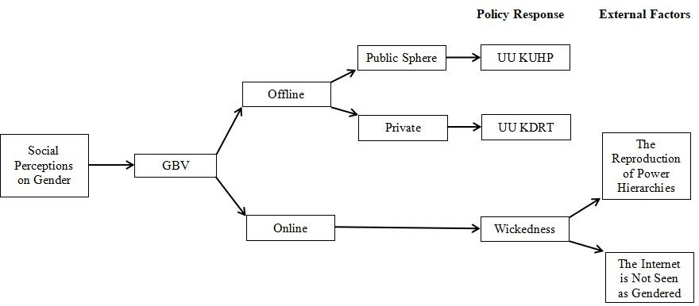
With the various contexts stated above, the authors suggest the notion that the lack of a policy response for online GBV is the result of GBV being a WP, and thus must be approached as such (see Figure 3). Ten key propositions form the basis of WP theory summarized by Eden and Wagstaff (2021) as the problem being (1) hard to define and have no definite formulation, (2) has no stopping rule, (3) unique, (4) has multiple explanations, and (5) may be symptomatic of another problem. The solutions are usually (1) not true or false but only good or bad, (2) has no immediate or ultimate test, (3) no clear solution or even set of possible solutions, (4) attempts at solutions have effects that may not be reversible or forgettable, and (5) policymakers bear the responsibility for wrong solutions. WP scholars find that most policy problems have wickedness to some degree, so they cannot be solved using rational-scientific methods (Eden & Wagstaff, 2021). This is not to say that offline GBV is not plagued with any sort of wickedness, however, we feel that the added dimension of the internet makes the matter of online GBV far more complex.
Figure 3 The Wickedness of Online GBV
In the figure above, we summarize the two main external factors of the wickedness of online GBV as the reproduction of power hierarchies and the internet being seen as gender-neutral. As noted in the findings of Megarry (2014) and Shaw (2014), online GBV often parallels that of offline GBV. Furthermore, the state of the internet is as such due to being heavily influenced by the dominant discourses of the offline world. Yet, due to the ambiguity of the space in which the violence takes place, online GBV is further denied recognition as a form of violence. This is in contrast to offline GBV, where the limited existing laws on women’s issues can still be used to protect women. Online GBV is thus faced with the undercurrent of disbelief or denial that the internet can be a gendered place, meaning that not only is there discourse of denial that GBV is a significant social issue that needs to be handled, but also a denial that the internet can facilitate GBV. While offline GBV is recognized as something that does indeed happen within society (albeit in a discourse that normalizes violence), the idea that women can also fall prey to violence online, a space that is seen by the general public as gender-neutral, seems preposterous. As WP cannot truly be solved, there is an urgent need to find strategies to cope with the wickedness of online GBV as COVID-19 has brought a rise in the use of the online space
Based on our findings, there is a cultural understanding of feminism and gender tends to normalize and encourage men to commit violence against women. It is further exacerbated by the ongoing COVID-19 pandemic where during PSBB, the use of the internet has increased. This new reality has caused a transference of offline violence to the online space, where the increased use of technology only further facilitates the hegemonic masculinity that is ever present within society. The internet is also generally seen as a gender-neutral place, causing for there to be an absence of a mechanism and procedures for reporting violence. This makes it easy for perpetrators of violence to remain unscathed while victims do not only feel the impacts online, but offline as well. This complexity in which the context of violence is still very much a grey area suggests that the issue is a WP with a high degree of wickedness. Generally speaking, GBV is often not recognized as a problem, but the added dimension of the internet only adds to the discourse of denial.
While WP can not necessarily be completely solved, there is still a possibility to develop strategies to cope with them. Although UU TPKS has already been passed as a law, the authors emphasize the need for further implementation. Clear regulations need to be put in place to ensnare perpetrators while providing legal protection for the victims against legal loopholes that could further victimize them, such as defamation articles. Furthermore, clear regulations and mechanisms should be in place, so that victims of GBV are not hesitant to report, as a legalized bill would mean that the state recognizes GBV, be it online or offline, as a problem. The authors also suggest the need for grassroot feminist or pro-gender equality organizations be upscaled in order to further their reach as these organizations have always played an active role in advocating and combating the prevalence of GBV. As the internet in Indonesia is still a very large gray area, we hope that with the help of these organizations we can shine light on the gendered implications of the Internet and raise public awareness. We also hope that this will reduce the discourse of denial and shift the narrative into a discourse that stands with victims of GBV both offline and online

REFERENCES
Journal Articles
Adian, Donny Gahral. 2001. “Feminis Laki-laki Sebagai Seni Pengambilan Jarak (Feminist Men and the Art of Keeping Distance). In G. Arivia & N.I. Subono (Eds.), Feminis Laki-laki: Solusi atau Persoalan (pp. 32–41). Jakarta, Indonesia: Penerbit Yayasan Jurnal Perempuan.
Deitz, Mandi F., Stacey L. Williams, Sean C. Rife, and Peggy Cantrell.2015. "Examining cultural, social, and self-related aspects of stigma in relation to sexual assault and trauma symptoms." Violence Against Women 21, no.5 : 598-615. https://doi.org/10.1177/1077801215573330
Daniels, Jessie. 2013. “Rethinking Cyberfeminism(s): Race, Gender, and Embodiment.” Women’s Studies Quarterly 37 (1): 353–69. https://doi.org/10.4324/9780203427415-33.
Eden, Lorraine, and M. Fernanda Wagstaff. 2021. “Evidence-Based Policymaking and the Wicked Problem of SDG 5 Gender Equality.” Journal of International Business Policy 4 (1): 28–57. https://doi.org/10.1057/s42214-020-00054-w.
Hawkesworth, Mary.1994. "Policy studies within a feminist frame." Policy Sciences 27, no. 2 : 97-118. -> kurang JSTORnya
Hayati, Elli Nur, Maria Emmelin, and Malin Eriksson. 2014. “Challenges for a Local Service Agency to Address Domestic Violence -a Case Study from Rural Indonesia.” Global Journal of Health Science 6 (6): 214–25. https://doi.org/10.5539/gjhs.v6n6p214.
Hayati, Nur.2021. “Media Sosial Dan Kekerasan Berbasis Gender Online Selama Pandemi Covid-19.” HUMAYA: Jurnal Hukum, Humaniora, Masyarakat, dan Budaya 1, no. 1: 43–52. https://doi.org/10.33830/humaya.v1i1.1858.2021
Heise, Lori L. 1998. “Violence against Women: An Integrated, Ecological Framework.” Violence Against Woman 4 (3): 262–90. https://doi.org/10.1177/1077801298004003002.
Iglesias, Camila, Carla Cardoso, and Pedro Sousa. 2019."Macrosystem and Women’s Fear of Crime in Intimate Relations: An Integrated Model." International Annals of Criminology 57, no. 1-2 : 172-197. https://doi.org/10.1017/cri.2020.10
Kania, Dede. 2015. “Hak Asasi Perempuan Dalam Peraturan Perundang-Undangan Di Indonesia (The Rights of Women in Indonesian Laws and Regulations).” Jurnal Konstitusi 12 (4): 716–34.
Lewis, Ruth, Michael Rowe, and Clare Wiper. 2017. “Online Abuse of Feminists as an Emerging Form of Violence against Women and Girls.” British Journal of Criminology 57 (6): 1462–81. https://doi.org/10.1093/bjc/azw073.
Lestari, Anna Puji.2019. "Blaming the Victim: Alienasi Gender dalam Media Online." Jurnal Ilmu Dakwah 39, no. 2 : 197-213. https://doi.org/10.21580/jid.v39.2.3999
Lombardo, Emanuela, Petra Meier, and Mieke Verloo.2012. "Policymaking and gender." J Women Poliy Policy 38, (1) : 1-9. https://doi.org/10.5278/freia.70824168
Megarry, Jessica. 2014. “Online Incivility or Sexual Harassment? Conceptualising Women’s Experiences in the Digital Age.” Women’s Studies International Forum 47 (PA): 46–55. https://doi.org/10.1016/j.wsif.2014.07.012.
Nilan, Pam, Argyo Demartoto, Alex Broom, and John Germov. 2014. “Indonesian Men’s Perceptions of Violence Against Women.” Violence Against Women 20 (7): 869–88. https://doi.org/10.1177/1077801214543383.
Peters, B Guy.2017. “What Is so Wicked about Wicked Problems? A Conceptual Analysis and a Research Program.” Policy and Society 36, no. 3: 385–96. https://doi.org/10.1080/14494035.2017.1361633
Restikawasti, Aulya Enggarining.2019. "Alasan perempuan melakukan victim blaming pada korban pelecehan seksual." Journal of Civics and Moral Studies 4, no. 1: 10-20. https://journal.unesa.ac.id/index.php/jcms/article/view/6465
Romito, Patrizia. 2008. “A Deafening Silence: Hidden Violence Against Women and Children”. Bristol, UK: Policy Press.
Shaw, Adrienne. 2014. “The Internet Is Full of Jerks, Because the World Is Full of Jerks: What Feminist Theory Teaches Us About the Internet.” Communication and Critical/ Cultural Studies 11 (3): 273–77. https://doi.org/10.1080/14791420.2014.926245
Thesis
Nugraha, Nusaibah.2022. “Dissecting Online Gender-Based Violence in 2021: In Search of a Policy Response” Undergraduate thesis (not published), Department of Public Policy and Management, Faculty of Social and Political Science, Gadjah Mada University
Online Sources
Amnesty International. 2017. Amnesty reveals the alarming impact of online abuse against women, Amnesty International, November 20 [online]. Available at: https://www.amnesty.org/en/latest/news/2017/11/amnesty-reveals-alarming- impact-of-online-abuse-against-women/ (accessed 8 May 2022)
Damar, Juniarto. 2021.Cedera Dunia Maya: Cerita Para Penyintas (Jakarta: LBH Apik. ix, https://pdf.usaid.gov/pdf_docs/PA00XTRT.pdf
Reports And Briefs
Iyer, Neema, Bonnita Nyamwire, and Sandra Nabulega. 2020. “Alternate Realities, Alternate Internet: African Feminist Research for a Feminist Internet,” no. August: 1– 50.
Komnas Perempuan. 2020. “Kekerasan Meningkat: Kebijakan Penghapusan Kekerasan Seksual Untuk Membangun Ruang Aman Bagi Perempuan Dan Anak Perempuan.” Catahu: Catatan Tahunan Tentang Kekerasan Terhadap Perempuan. https://www.komnasperempuan.go.id/file/pdf_file/2020/CatatanTahunanKekerasanTerhadapPerempuan2020.pdf.
Veda, J. A. (2021). Aspek Hukum untuk Jerat Pelaku: Panduan Seri Kedua Sigap Hadapi Penyebaran Konten Intim Non-Konsensual, SAFEnet, Februari 2021 [online]. Available at: https://awaskbgo.id/ncii2/ (accessed 31 January 2022)

