STRUT LINKER GEOMETRY IMPROVING MECHANICAL BEHAVIOR OF CORONARY STENT

Rachmat Sriwijaya^{1,2*}, Dita Ayu Mayasari³, and Siti Sunarintyas^{2,4}
¹Department of Mechanical and Industrial Engineering
Faculty of Engineering, Universitas Gadjah Mada
²Biomedical Engineering
Graduate School, Universitas Gadjah Mada
³Biomedical Engineering,
Faculty of Engineering, Dian Nuswantoro University
⁴Department of Biomaterials
Faculty of Dentistry, Universitas Gadjah Mada

*Corresponding author: sriwijaya@gadjahmada.edu

ABSTRAK
Stent adalah salah satu solusi umum yang ditawarkan kepada pasien dengan atherosclerosis. Stent yang ideal harus memiliki sifat mekanik dan biologis yang baik. Penelitian ini bertujuan untuk menganalisis pentingnya geometri strut linker mempengaruhi perilaku mekanik stent terutama pada persentase recoil, foreshortening, dan prediksi factor keamanan terhadap kelelahan stent dengan analisis menggunakan metode elemen hingga. Hasil penelitian menunjukkan bahwa geometri strut linker akan berpengaruh terhadap perilaku mekanik dari stent.
Kata kunci: Stent; Atherosclerosis; Strut linker; Recoil.

ABSTRACT
The stent is one of the standard solutions offer to the patient with atherosclerosis. An ideal stent should have excellent mechanical and biological properties. This research aims to analyze how vital strut linker geometry affects the mechanical behavior of stent, especially on recoil percentage, foreshortening percentage, and fatigue safety factor prediction using finite element analysis. The result showed that strut linker geometry would specify mechanical behavior.
Keywords: Stent;Atherosclerosis; Strut linker; Recoil.

INTRODUCTION
The atherosclerosis is one of the most morbidity and mortality causes in industrial country and development country (Dou et al., 2017). Atherosclerosis is a pathological condition in blood vessels that is marked by inflammation and plaque formation (Khyza et al., 2017). The atherosclerotic plaque formation consists of heterogeneous lipid-rich necrotic nuclei. A thin fibrous and a thin fibro-atheroma surround that necrotic. (van Soest et al., 2017). This plaque causes narrowing of the arteries and reduces the supply of blood and oxygen to the heart. This physical situation can cause myocardial infarction and death (Zilberman, 2011). One of the standard solutions for atherosclerosis is doing percutaneous transluminal coronary angioplasty procedure that can restore the vessel's obstruction. This procedure is using the stent that placed onto the catheter balloon and delivered to the target location (McGloughlin, 2011).
A stent is a coiled wire-mesh tube in small size for holding narrowed blood vessels (Hsiao et al., 2012). The stent consists of two main parts, the ring element, and the linker element. Linker element connect ring element that consists of several struts (Patel et al., 2016). Based on the forming material, there are two types of stents, namely drug-eluting stents (DES) and bare-metal stents (BMS) (Meraj et al., 2015). The drug-eluting stents, an advanced product, commonly are polymer-based material that contains a particular drug, on the other hand, the bare-metal stents, a conventional product, are made of the metal alloy without drug substitution. (Ho et al., 2016). Despite materials, stent geometry also contributes to the mechanical strength of the stent. A modification of the stent design and geometry is another way to improve the mechanical properties of the same materials. There is only two strut shape on the modern stent, crown- and wave-shape (Sommer et al., 2010). Both strut and linker geometry contributes to the mechanical strength of the stent. The mechanical properties such as flexibility, expansion ability, and radial strength so can be determined (Ho et al., 2016).
The endurance of the stent against its surrounding condition in blood vessels should have known to avoid stent failure. Analysis of the mechanical properties of a stent is necessary for improving stent design. This analysis approached by using finite element analysis (FEA). The Finite element analysis approach in engineering design is a powerful tool to determine and improve the mechanical behavior of stents (Debusschere et al., 2015). The mechanical properties of the stent on blood vessels investigated to find the von Mises stress distribution, flexibility, recoil, and foreshortening percentage also the fatigue safety factor of the stent by using the finite element analysis method (Xu et al., 2016).
Nowadays, there are so many strut linker geometries of the stent that the company offers on commercial products. However, the strut linker geometry of the stents available on the market today are I-, U-, V-, S- and N-shape (Patel et al., 2016). This research is for knowing the best geometry of strut linker on an open-cell coronary stent that made of cobalt-chromium alloy using finite element analysis. Co-Cr alloy is one of the common metals on medical devices due to its excellent mechanical properties and biocompatibility. Co-Cr also has better radio-opacity than stainless steel that makes track-able during the delivery process (Ho et al., 2016).

METHODOLOGY
Stent Modeling
The stent modeled using Autodesk Inventor Professional 2017. The design and dimension of the stent adapted from a commercial product. The inner diameter of the stent, the thickness, and the width were 2.09 mm, 0.08 mm, and 0.05 mm, respectively. There are four stents with different strut linker geometry, named I, U, V, and S (Figure 1). The location of the strut linker is peak-valley (out-of-phase) with open cell orientation. One stent consists of two sequential crown-ring that connected with four strut linkers.

Finite Element Model
The finite element analysis of the stent used the Abaqus software. The model of the finite element of the stent adapted from Hsiao et al. (2012) and Mayasari et al. (2018). The approach consisted of the five issues, i.e., crimping, expansion, recoil, and fatigue, refer to the systolic and the diastolic pressure record.
1. Stent crimping applied from 2.25 mm to 1.5 mm (outside diameter).
2. Apply crimp recoil.
3. Stent expansion applied to 4.15 mm (outside diameter).
4. Apply expansion recoil.
5. Apply stent fatigue under 120/80 mmHg systolic/diastolic pressure.

The percentage of recoil expansion determined from the stent diameter calculated between the latest balloon expansions after its deflation.
$$\% recoil expansion= \frac{D_{step 3}-D_{step 4}}{D_{step 3}}$$
Furthermore, the percentage of foreshortening was the length of the stent that calculated between after crimp recoil and after expansion recoil:
$$\% foreshortening= \frac{L_{step 2}-L_{step 4}}{L_{step 3}}$$
The crimper and the balloon catheter needed on the crimp and expansion process; therefore, all of the components assembled as seen in Figure 2.

Properties of Materials and Boundary Conditions
The material properties of the stent were using Co-Cr L605 features and treated by isotropic hardening. The Young’s modulus, Poisson ratio, and the yield stress are 243 GPa, 0.29 MPa, and 483 MPa, respectively. Moreover, the properties of the materials of the artery were using Mooney-Rivlin hyper-elastic model. This hyper-elastic model assumed that the artery is isotropic materials.

Mesh Geometry
The stent model in this work has meshed in the 8-node linear brick element with incompatible mode (C3D8I). Furthermore, the crimper and the catheter balloon meshed using the 4-node quadrilateral surface element. This choice reduces the integration step ((SFM3D4R). The meshing the vascular used an 8-node with linear brick, hybrid, and also constant pressure (C3D8H).

Fatigue Safety Factor
The fatigue safety factor (FSF) distribution calculated using the predicted stress amplitudes and mean stresses by applying the Modified-Goodman relationship. The FSF in the approaching model determined as:
$\frac{1}{FSF}$ = $\left(\frac{σ_{m}}{σ_{u}}\right)+\frac{\left({∆σ}/2\right)}{\left({{∆σ}_{e}}/2\right)}$
Whereas, $σ_{m}$, $σ_{u}$, ${∆σ}/2$, and ${{∆σ}_{e}}/2$ represent the zero mean stress, the actual stress associated with the ultimate tensile strength, the stress amplitude, and the endurance strength of Co-Cr materials, respectively (Marrey et al., 2006).

RESULT AND DISCUSSION
The stent simulation on the vascular in this research used the Abaqus software. This simulation was resulting in radial displacement, length displacement, contour plot that represents von Mises stress distribution, and maximum principal stress. Based on radial displacement, the diameter of the stent changed during the simulation (Figure 3). The diameter decreased along the crimping step and increased a little bit when crimping recoil. The stent diameter increase in lined the width of the catheter balloon when the balloon inflated then the diameter of the stent decrease slightly when the balloon deflated. The changes in recoil after crimping were lower than recoil after expansion. This condition could happen because of stent contact with hyper-elastic blood vessels after expansion. Therefore, the vessel tends to keep its shape due to its hyper-elastic properties and press the stent.
The final diameter of stent post balloon deflated was slightly different from each other correspond to the hyper-elastic properties of blood vessels. The changes of stent diameter used for the calculated recoil percentage for each strut linker. Based on Figure 4, the highest recoil percentage was on stent with a U-shape of the linker, 6.62%, while the lowest was on stent with V-shape of the linker, 3.49%. Radial displacement on stent with U-shape linker was not uniform. One of the end of the stent with a U-shape linker has the diameter decrease more than the other one (Figure 5). The mechanism of how to strut linker geometry affected recoil percentage has not known.
The length of the stent also changed during the simulation. These changes contrast with the stent diameter. The length of the stent became longer during crimping and shorter during expansion. The final measure of the stent after the expansion slightly increased. The expansion pressure on the inner surface of the stent made stent foreshortening since the stent geometry approach similar to double hex geometry, which has a positive Poisson ratio. Positive Poisson ratio geometry is geometry, which has an increase of diameter and a decrease of length while expansion pressure is given (Douglas, 2012).
The changes of stent length form the Abaqus simulation used for the calculated foreshortening percentage. As seen in Figure 6, the highest foreshortening percentage was on S-shape of the linker, 29.94%, while the lowest foreshortening was on the I-shape of the linker, 26.34%. Stent with S-shape linker has the highest foreshortening percentage because its geometry has more deflection points, so that it also has more open space. Therefore, when expansion pressure was applied, the strut was pulled to the expansion direction and made the strut linker compacted.
In this research, the additional systole-diastole pressure used for predicting the fatigue safety factor (FSF). The prediction of FSF calculated using maximum principal stress. The result for each strut linker geometry listed in Table 1. Moreover, the lowest FSF prediction was on the stent with the U-shape linker. The small value of FSF shows the endurance of stent against systole, and diastole is weak, so it would be easy to fracture on that element.

CONCLUSION
The finite element analysis of the different strut linker shapes of the stent has done in this research. It was showed that strut linker geometry has a pivotal role in getting an ideal stent with small recoil and foreshortening percentage due to its job to prevent the blood vessel narrowed. The further study still needed to evaluate the flexibility of each stent with its different strut linker geometry.

Acknowledgments
The authors thank those at the Universitas Gadjah Mada and the Dian Nuswantoro University who have contributed to this research.

BIBLIOGRAPHY
Debusschere, N., Segers, P., Dubruel, P., Verhegghe, B., and De Beule, M. (2015). A finite element strategy to investigate the free expansion behaviour of a biodegradable polymeric stent. Journal of biomechanics, 48(10), 2012-2018.
Douglas, G.R., 2012. Design of stent expansion mechanisms (Doctoral dissertation, University of British Columbia).
Dou, Y., Chen, Y., Zhang, X., Xu, X., Chen, Y., Guo, J., Zhang, D., Wang, R., Li, X., and Zhang, J., 2017. Non-proinflammatory and responsive nanoplatforms for targeted treatment of atherosclerosis. Biomaterials, 143, pp.93-108.
Ho, M.Y., Chen, C.C., Wang, C.Y., Chang, S.H., Hsieh, M.J., Lee, C.H., Wu, V.C.C., and Hsieh, I., 2016. The development of coronary artery stents: from bare-metal to bio-resorbable types. Metals, 6(7), p.168.
Hsiao, H.M., Chiu, Y.H., Lee, K.H., and Lin, C.H., 2012. Computational modeling of effects of intravascular stent design on key mechanical and hemodynamic behavior. Computer-aided design, 44(8), pp.757-765.
Khyzha, N., Alizada, A., Wilson, M.D., and Fish, J.E., 2017. Epigenetics of atherosclerosis: emerging mechanisms and methods. Trends in Molecular Medicine, 23(4), pp.332-347.
Mayasari, D.A., Sriwijaya, R., Siswomiharjo, W., and Sunarintyas, S., 2018, August. Free Expansion Behaviour of Coronary Stent Based on Strut Linker Geometry. In 2018 4th International Conference on Science and Technology (ICST) (pp. 1-4). IEEE.
Marrey, R.V., Burgermeister, R., Grishaber, R.B., and Ritchie, R.O., 2006. Fatigue and life prediction for cobalt-chromium stents: A fracture mechanics analysis. Biomaterials, 27(9), pp.1988-2000.
McGloughlin, T. (Ed.). (2011). Biomechanics and mechanobiology of aneurysms. Berlin, Germany: Springer.
Meraj, P.M., Jauhar, R., and Singh, A., 2015. Bare metal stents versus eluting drug stents: where do we stand in 2015?. Current treatment options in cardiovascular medicine, 17(8), p.39.
Patel, S.M., Li, J., and Parikh, S.A., 2016. Design and Comparison of Large Vessel Stents: Balloon Expandable and Self-Expanding Peripheral Arterial Stents. Interventional cardiology clinics, 5(3), pp.365-380.
Sommer, C.M., Grenacher, L., Stampfl, U., Arnegger, F.U., Rehnitz, C., Thierjung, H., Stampfl, S., Berger, I., Richter, G.M., Kauczor, H.U., and Radeleff, B.A., 2010. Impact of stent design on in-stent stenosis in a rabbit iliac artery model. Cardiovascular and interventional radiology, 33(3), pp.565-575.
van Soest, G., Marcu, L., Bouma, B.E., and Regar, E., 2017. Intravascular imaging for characterization of coronary atherosclerosis.Current Opinion in Biomedical Engineering, 3, pp.1-12.
Xu, J., Yang, J., Huang, N., Uhl, C., Zhou, Y., and Liu, Y., 2016. Mechanical response of cardiovascular stents under vascular dynamic bending.Biomedical engineering online, 15(1), p.21.
Zilberman, M. (Ed.). (2011). Active implants and scaffolds for tissue regeneration. Berlin, Germany: Springer.

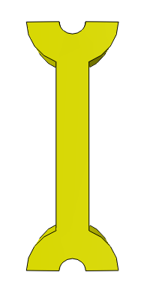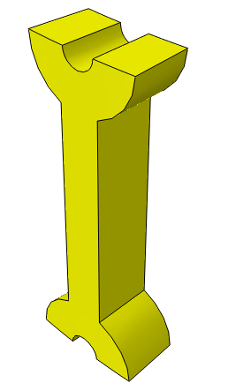
A | B
 | 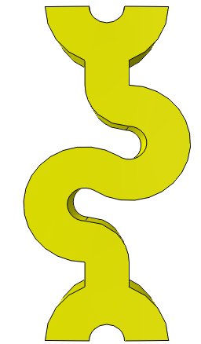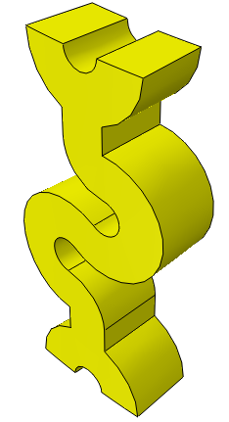
C | D
Figure 1.
Four stents with different strut linker geometry
Blood Vessels
Crimper
Stent
Catheter Balloon

Figure 2.
Crimper and balloon catheter

Figure 3.
Change in-stent diameter

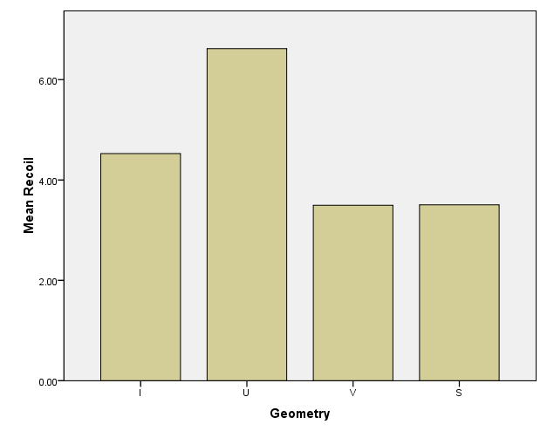
Figure 4.
The recoil of the stent structure

Table 1.
Fatigue safety factor for each strut linker geometry
Strut Linker Model | Max. Principal Stress at Systolic Pressure, 120 mmHg (Mpa) | Max. Principal Stress at Diastolic Pressure, 80 mmHg (Mpa) | Mean Stress, σm (Mpa) | Stress Amplitude, Δσ/2 (Mpa) | Inverse Fatigue Safety Factor (1/FSF) | Fatigue Safety Factor (FSF)
I | 636.2 | 617.0 | 626.6 | 9.6 | 0.48 | 2.09
U | 649.2 | 650.6 | 649.9 | 0.7 | 3.14 | 0.32
V | 639.1 | 640.5 | 639.8 | 0.7 | 0.44 | 2.25
S | 554.9 | 556.1 | 555.5 | 0.6 | 0.38 | 2.59

Figure 5.
Radial displacement of U-shape linker
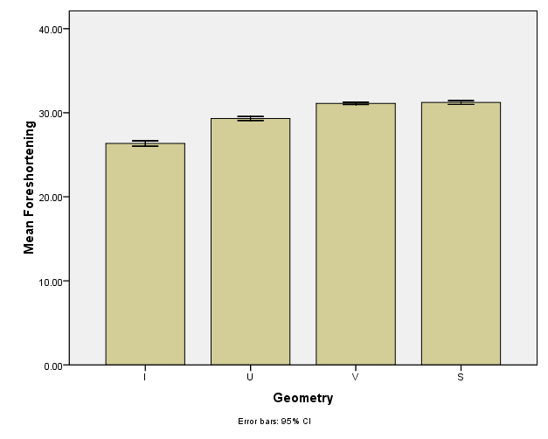

Figure 6.
Foreshortening for each strut linker geometry

