LAMPIRAN
Lampiran 1. Kondisi analisis GC-MS
Method
[Comment]
===== Analytical Line 1 =====
[AOC-20i+s]
# of Rinses with Presolvent :3
# of Rinses with Solvent(post) :5
# of Rinses with Sample :2
Plunger Speed(Suction) :High
Viscosity Comp. Time :0.2 sec
Plunger Speed(Injection) :High
Syringe Insertion Speed :High
Injection Mode :Normal
Pumping Times :5
Inj. Port Dwell Time :0.3 sec
Terminal Air Gap :No
Plunger Washing Speed :High
Washing Volume :8uL
Syringe Suction Position :0.0 mm
Syringe Injection Position :0.0 mm
Solvent Selection :only A
[GC-2010]
Column Oven Temp. :80.0 °C
Injection Temp. :280.00 °C
Injection Mode :Split
Flow Control Mode :Pressure
Pressure :80.0 kPa
Total Flow :300.5 mL/min
Column Flow :1.19 mL/min
Linear Velocity :40.1 cm/sec
Purge Flow :3.0 mL/min
Split Ratio :250.0
High Pressure Injection :OFF
Carrier Gas Saver :OFF
Splitter Hold :OFF
Oven Temp. Program
Rate Temperature(°C) Hold Time(min)
- 80.0 5.00
20.00 250.0 2.00
< Ready Check Heat Unit >
Column Oven : Yes
SPL1 : Yes
MS : Yes
< Ready Check Detector(FTD) >
< Ready Check Baseline Drift >
< Ready Check Injection Flow >
SPL1 Carrier : Yes
SPL1 Purge : Yes
< Ready Check APC Flow >
< Ready Check Detector APC Flow >
External Wait :No
Equilibrium Time :3.0 min
[GC Program]
[GCMS-QP2010 Ultra]
IonSourceTemp :200.00 °C
Interface Temp. :300.00 °C
Solvent Cut Time :1.00 min
Detector Gain Mode :Absolute
Detector Gain :0.80 kV
Threshold :0
[MS Table]
--Group 1 - Event 1--
Start Time :1.50min
End Time :15.00min
ACQ Mode :Scan
Event Time :0.30sec
Scan Speed : 625
Start m/z :70.00
End m/z :250.00
Sample Inlet

Lampiran 3. Perhitungan
- Susut pengeringan
Berat Basah = 200 gram
Berat Kering = 20,7873 gram
Fuli = $\frac{Berat Kering}{Berat Basah}$ x 100 %
= $\frac{20,7873}{200}$ x 100 %
= 10,03937 %

- Rendemen
Volume minyak atsiri = 6,6 mL
Berat = 7,1247 gram
Rendemen = $\frac{berat minyak}{berat fully basah}$ x 100 %
= $\frac{7.1247}{200}$ x 100 %
= 3.56 %

Lampiran 4.Hasil Uji Biokimia
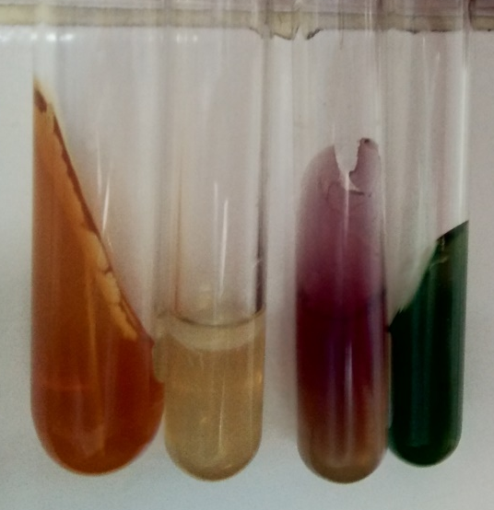
Ecschericia coli
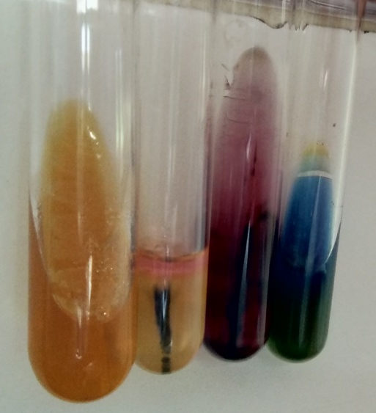
Stapylococus aureus

Lampiran 5. Hasil Uji Dilusi
Bakteri Ecschericia coli
Tabung
Konsentrasi (%) | Gambar
60 | 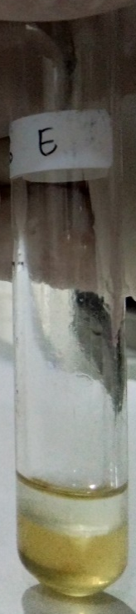
30 | 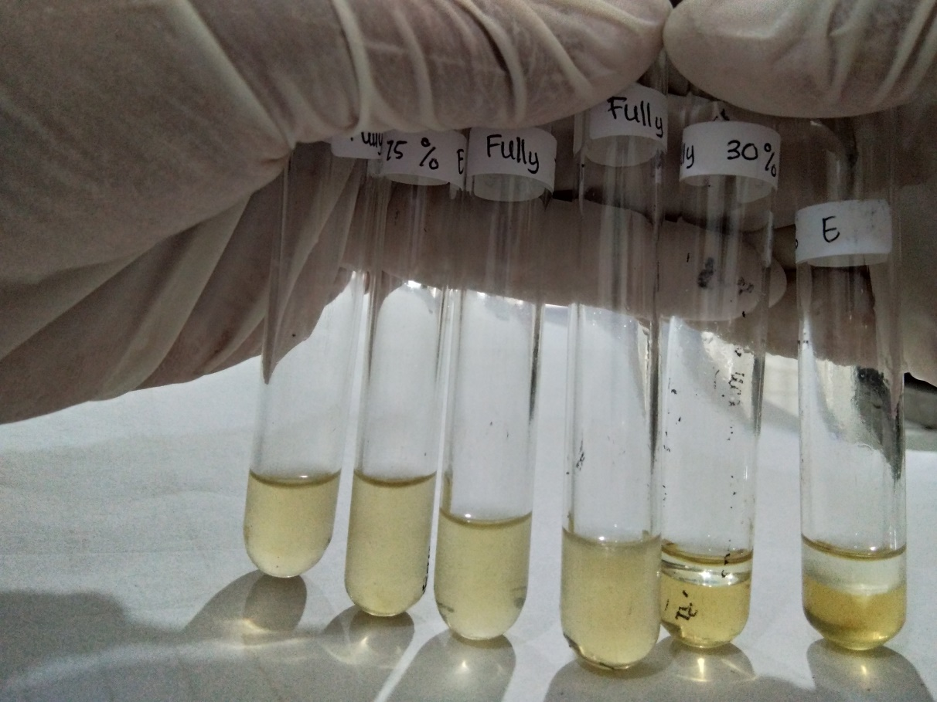
15
7,5 | 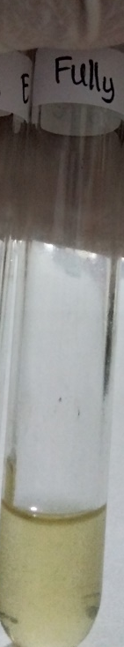
3,725
Kontrol (+) | 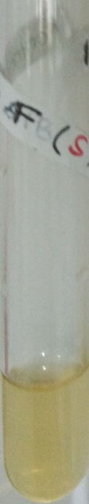
Kontrol (–) | 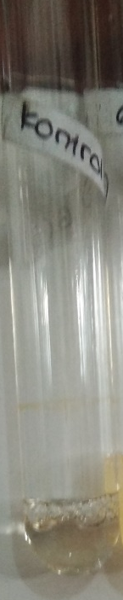

Petri disk
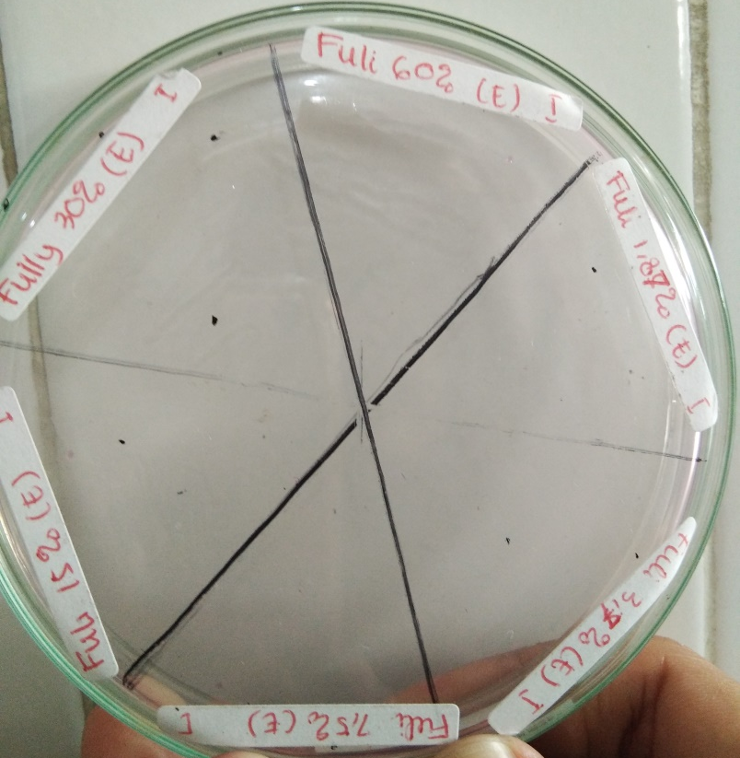
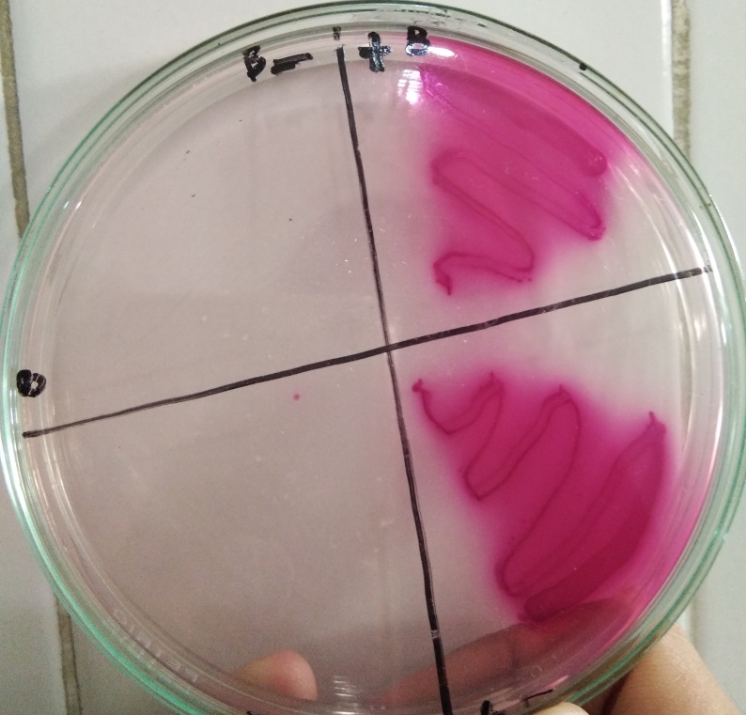

Bakteri Stapylococus aureus
Tabung
Konsentrasi (%) | Gambar
60 | 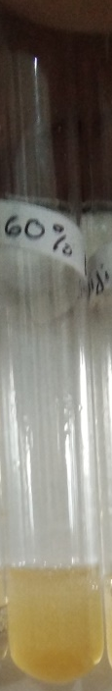
30 | 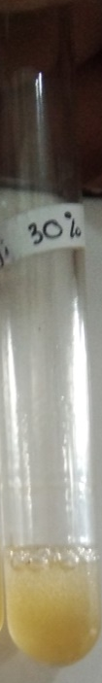
15 | 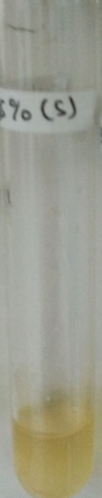
7,5 | 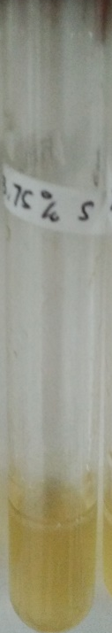
3,725 | 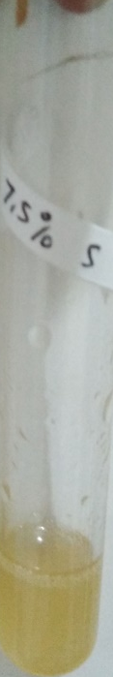
Kontrol (+)
Kontrol (–)

Petri disk
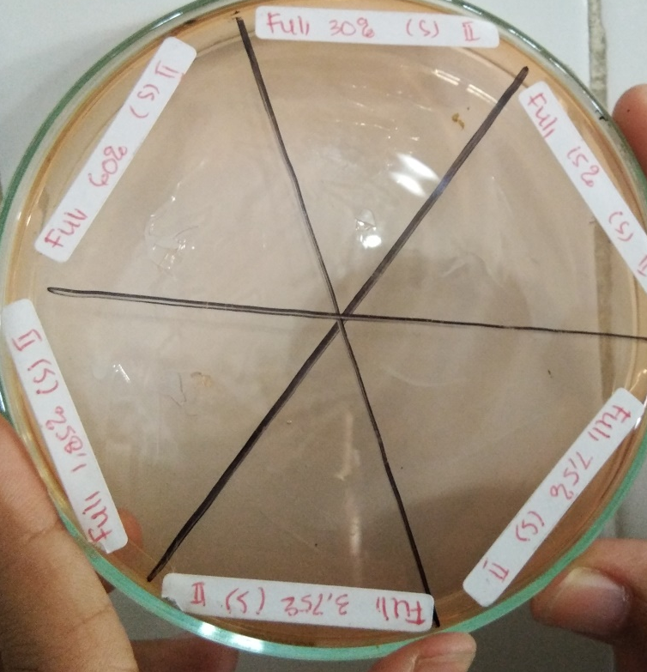
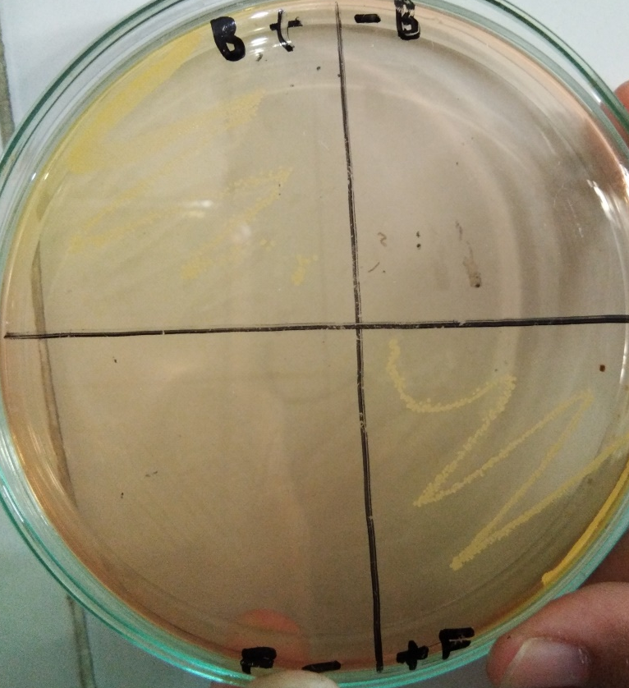

Lampiran 6. Hasil Uji Difusi
Bakteri Ecschericia coli
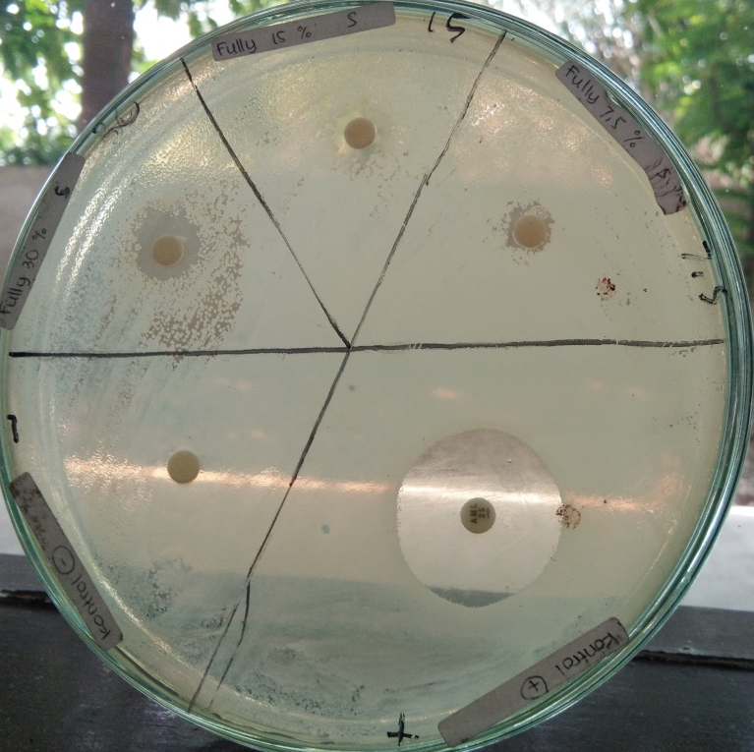
Bakteri Stapylococus aureus
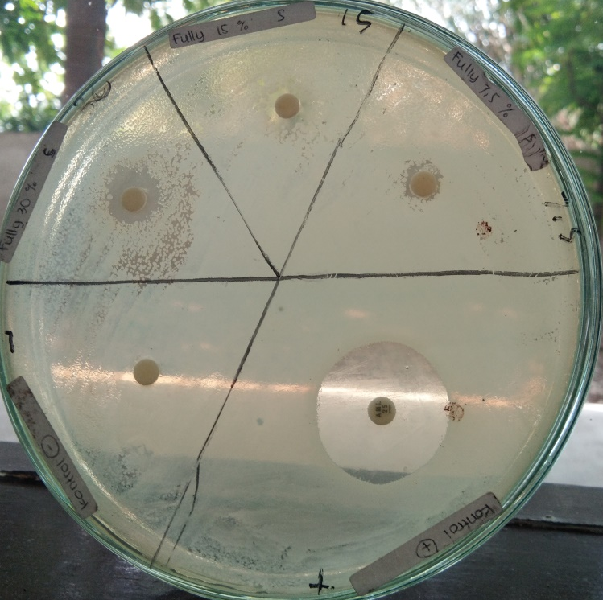

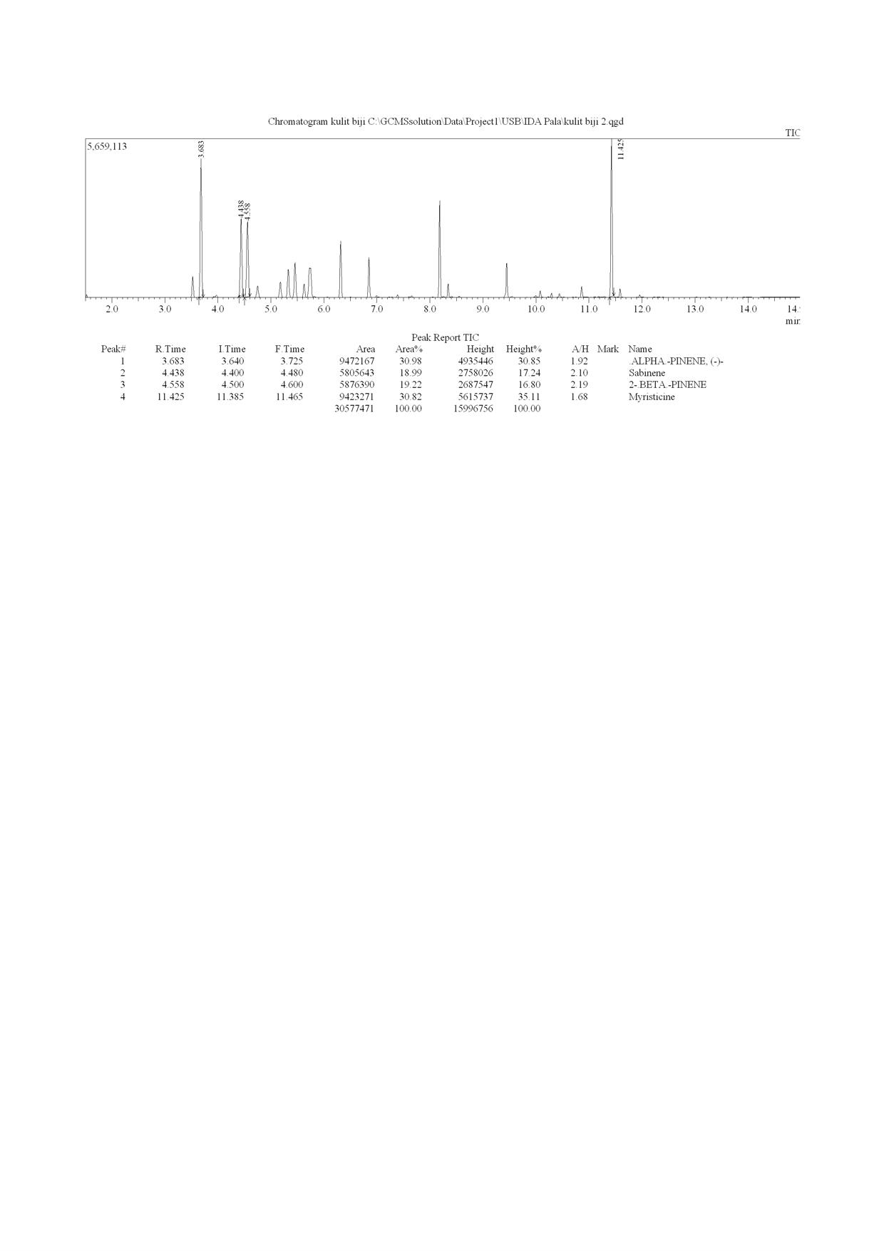
Lampiran 7. Hasil GC Minyak Atsiri Fuli Pala

Lampiran 8. Hasil MS Senyawa Minyak Atsiri Fuli Pala
α-pinen

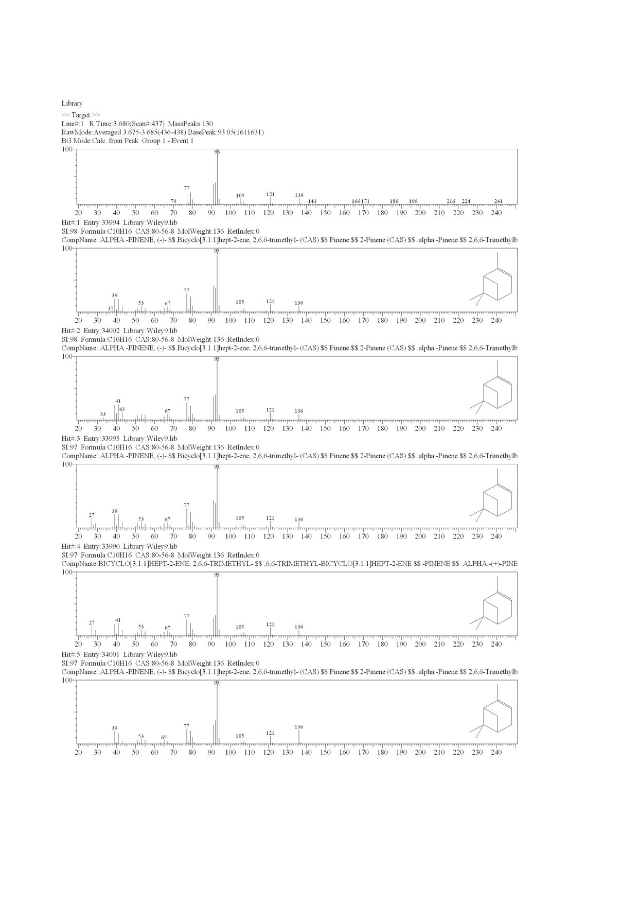
Sabinen
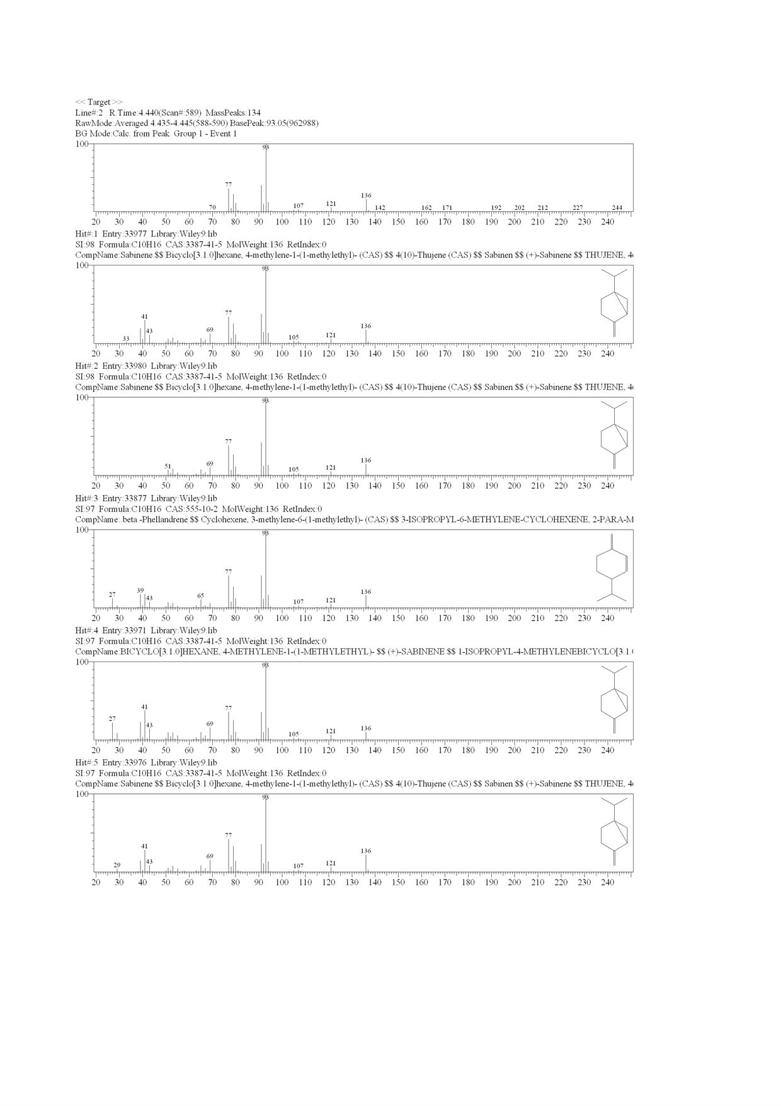
2-β-pinen
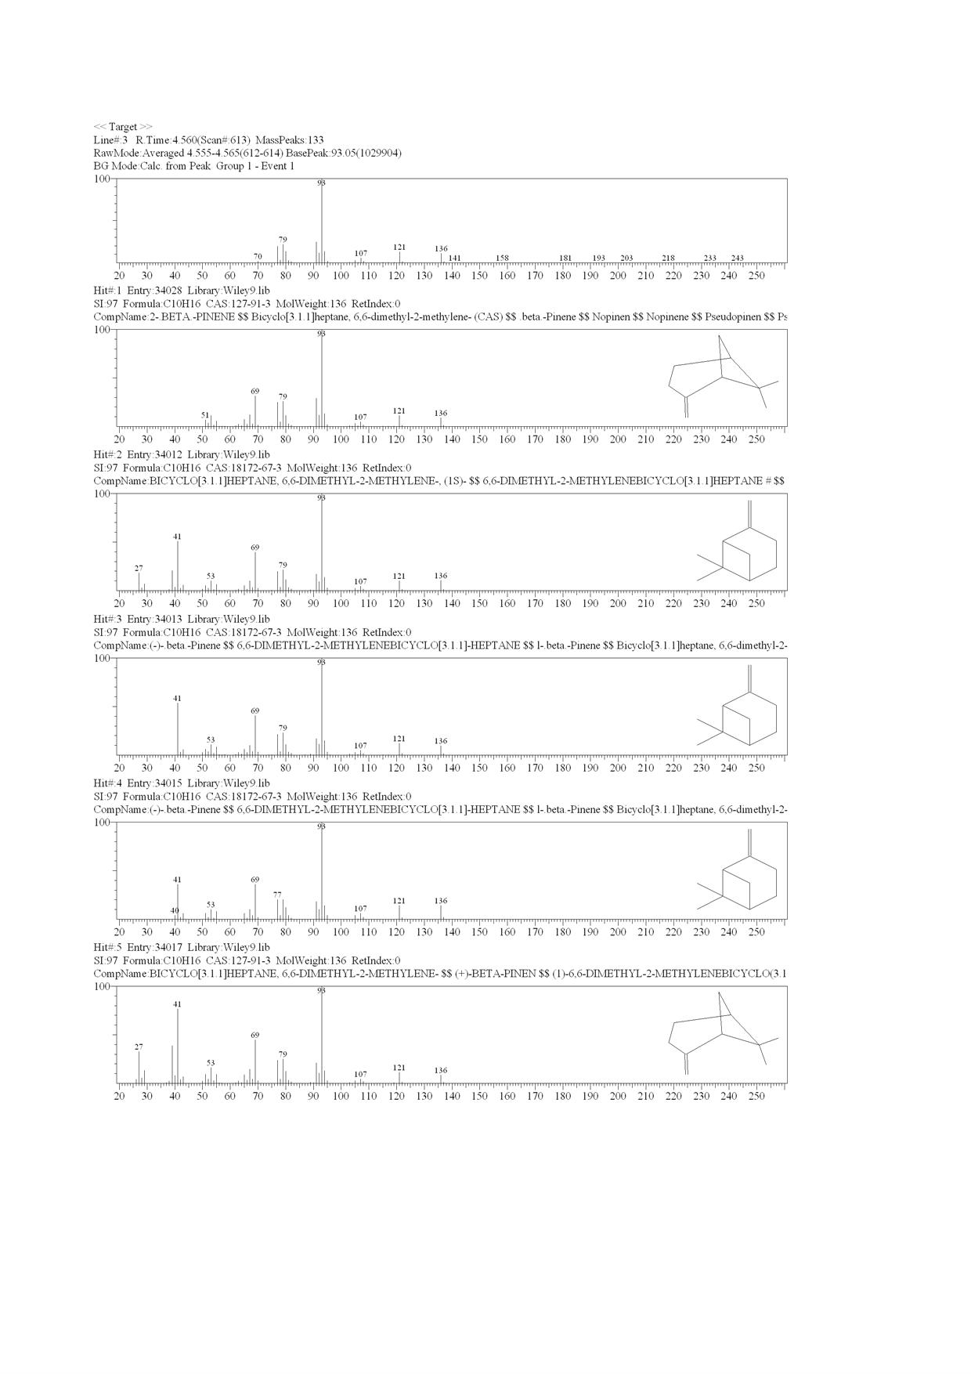

Miristisin
