Analysis of soil bacterial diversity from tropical rainforest and oil palm plantation in Jambi, Indonesia by 16S rRNA-DGGE profiles
Risky Hadi Wibowo^{1,5}, Nisa Rachmania Mubarik², Iman Rusmana³, Maggy Thenawidjaya Suhartono⁴

¹ Microbiology Study Program, Department of Biology, Bogor Agricultural University

^{2,3} Department of Biology, Faculty of Mathematic and Natural Sciences, Bogor Agricultural Univerisity, Dramaga- Bogor 16680, West java, Indonesia.

⁴ Department of Food Science and Technology, Faculty of Agricultural and Technology, Bogor Agricultural University, Kampus IPB Dramaga, Bogor 16680, West Java, Indonesia.

⁵ Department of Biology, Faculty of Mathematics and Natural Sciences, University of Bengkulu, Kampus UNIB Kandang Limun, Bengkulu 38112, Indonesia.

*Corresponding author. Tel.: +6281263886312. Email: nrachmania@ipb.ac.id

Abstract
Oil palm plantation deforestation are the most invasive land use changes in Southeast Asia. It has impacted its rich and unique biodiversity. This study aims to investigate the diversity of soil bacteria based on 16S rRNA gene profiles from tropical forest and oil palm plantation in Jambi Province, Indonesia. Soil sample was taken from tropical forest and oil palm plantation from Jambi province, Indonesia. The forest site is in Bukit Duabelas National Park, and the nearby oil palm plantation is in Sarolangun District, Jambi Province, Indonesia. The diversity of bacterial communities from top soil of tropical forest and oil palm plantation in Sumatra was studied using Denaturing gradient gel electhroforesis (DGGE) of 16S rRNA gene and common biodiversity indices. PCR amplification of 16S rRNA gene was successfully conducted primers-using 33F/ 518R primers. Phylogenetic approach was used for revealing the community shift of bacterial phyla and genera in both areas. Phylogenetic analysis showed there were 4 phyla of bacteria i.e Firmicutes, Alphaproteobacteria, Gammaproteobacteria, and Actinobacteria respectively. Actinobacteria was the most dominant group in both areas. Diversity analysis showed that Shannon-Wienner index (H’) of soil bacterial community in four locations ranged between 1.90 and 2.93, while the equitability index (e ') ranged between 0.914 and 0.934. it can be concluded that the composition of soil bacterial community in the oil palm plantations, based on total number of bands 16S rRNA generated from DGGE was richer than that in the Bukit Dua Belas National Park. It was probably caused by plantation year circle more than 10 years and routenely activities during the plantation management, such as agricultural lime, herbicide and fertilizer, and others handling oil palm plantation in this area.
Keywords: Soil bacterial community, Tropical forest, Oil palm plantation, Denaturing gradient gel electrophoresis (DGGE), 16 S rRNA.

1. Introduction
Forests in the tropical area are unusual ecosystems that are rich in endemic species of flora, fauna and microbes. Prokaryotes (bacteria) are the most abundant and diverse group of microorganisms in soil. These microorganisms are important for most nutrient transformations in soil and major drivers of biogeochemical cycles. In top soil, the bacteria are important in decomposition of organic matters in soils. Lowland forests are highly sensitive to the impacts of land use change (transformation) to agro-forest industry (such as oil palm plantation), due to the interdependence of the vegetation with the soil substrate, which relies on the maintenance of adequate water, canopy cover, organic litter inputs, and handling of land use (Ko et al. 2005; Yule 2010).
Indonesia forest had been damaged 3.5 million hectares per year since 1999 until 2006, 2 million hectares per year between 2006-2010, and 300,000 hectares per year between 2010-2012. Transformation from primary to secondary forest is caused largely by timber extraction. Migrants change and convert part of the forest to temporary cropland. Such land can evolve into permanent tree-based production systems (agro-forests), suggest that in Jambi (Sumatra) (Palm et al. 2005). There were 420 thousand hectares of production forest in Jambi heavily damaged by the high rate of conversion to industrial timber plantation, palm oil plantations, coal mines and the opening of other minerals, such as iron and gold. The extensive damage approximately 30% of the approximately 1.4 million hectare remaining forest areas. In Jambi Province, Sumatra, Indonesia, the loss of environmental services given by trees is a non-linear trend. A gradual simplification of complex agro-ecosystems of agro-forests with increasing profitability might be threatened by the palm oil plantation industry (Mudiyarso et al. 2002).
A change in the microbial biomass is not always accompanied by a change in the microbial community diversity and activity, and land-use change have more severe effects on the soil microbial community structure than agro-forest age. Several factors may be involved. The soil microbial community may have been impacted by land-use conversion that involved significant soil disruption, such as cultivation, compaction, and fertilizer application. Several studies have shown that plant species have a major selective influence on microbial communities in soil, included bacterial diversity (Xue et al. 2008).
Bacterial diversity can be quantified using two methods by cultivable and uncultivable approach. The majority of soil microorganisms are unable to be cultured, and only a small fraction of soil microbial diversity is cultivated. Problem solving of this limitation is using molecular biology and protein engineering strategies, such as meta-genomic (Glogauer et al. 2011). Metagenomic is a culture-independent genomic analysis of whole microbial communities inhabiting a exacting niche (Armougom and Raoult 2009). Recently use of the denaturing gradient gelelectrophoresis (DGGE) of the PCR amplified DNA fragments has become a new approach to study the structural diversity of microbial communities which overcomes the disadvantages in cloning and sequencing of the DNA fragments. DGGE was initially developed for use in the medical research for detection of point mutations (Fischer and Lerman 1983) but it was introduced in the microbial ecology by Muyzer et al. (1993).
Denaturing gradient gel electrophoresis (DGGE) allows one to directly determine the richness and evenness of the dominant microbial species using 16S rRNA gene amplicons and, thus, to profile the corresponding microbial populations in both a qualitative way and a semiquantitative way. The diversity can be estimated from the number of 16SrRNA gene sequence similarity groups (i.e. the number of DNA bands on the DGGE gel and the intensity of DGGE bands. For the sake of simplicity, each band is considered to represent an operational taxonomic unit known as a species. Therefore, the present study was conducted to analyze and compare the diversity of soil bacteria in tropical rain forest and oil palm plantation in Jambi Province based on 16S rRNA gene- DGGE profiles.
2. Materials and methods
2.1. Soil Sampling and Laboratory Analysis
This research was conducted in National Park of Bukit Dua Belas (NPBD) and Oil Palm Plantation of Humusindo, in Jambi Province, Indonesia in August 2016 (Figure 1). Sampling sites of NPBD (latitude 01º56’ 576” to 01º56’502”S; longitude 102º34’879” to 102º34’836”E, altitude 87m to 116m asl) and oil Palm Plantation (latitude 01º56’491” to 01º56’958”S; longitude 103º15’140” to 103º15’122”E, altitude 42m to 64m asl) were determined base on Purposive Random Sampling. Soil samples were collected from triplicate plots of 25 m² each from all the two sample sites. Soil samples were collected separately from two soil depths, i.e. surface 0-20 cm, using a soil sample corer with a diameter and height of 10 cm and 25 cm. A total of 12 soil core samples were collected from each triplicate plots of TB03 and TB04 (tropical forest), SW01 and SW02 (oil Palm plantation) sites and were mixed to obtain a composite sample for each site. The soil samples were transported to the laboratory at room temperature and then stored at -20⁰C until required for analysis. The physico-chemical characteristics of soil were determined on field fresh soil or after air drying of the soil samples (Okalebo et al. 1993).
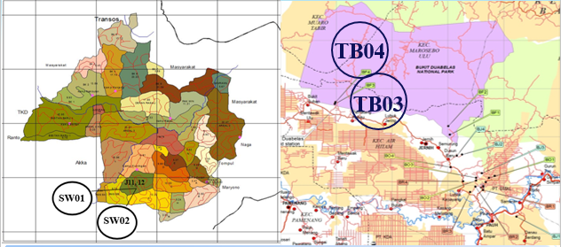
Figure 1. Map of Sampling location. Oil palm plantation of Humusindo (left) and National Park of Bukit Dua Belas (Right)

2.2. DNA Extraction and Quantification from Soil Ssmples
Extraction of community soil DNA was conducted using the Fast DNA® SPIN Kit for Soil (BIO 101 according to manufacturer’s instruction). Approx. 0.5 g of fresh soil (stored at -20°C) was taken in a 2 mL E-tube containing lysing mixture. 978 µL SPB (sodium phosphate buffer) and 122 µL MT buffer were added in the tube and homogenized at maximum speed for 1 min. The suspension was centrifuged for 1 min at 14000 x g and the supernatant was transferred into a clear 2 ml tube and 250µL PPS (protein precipitation solution) was added followed by mixing the tube for 2 min. Then the tube was centrifuged again for 5 min at 14000 x g and the supernatant was transferred into a 15 mL tube. 1 mL of binding matrix suspension was added and the tube was turned upside down for at least 5 times to allow binding of DNA to the matrix. About 500 µL of the supernatant at the surface layer of the tube was discarded and resuspended the remaining supernatant in the binding matrix. The slurry was transferred into a Spin Tube in two aliquots of 500 µL each and centrifuged to discard the waste liquids. Finally, the DNA in the Spin filter was washed with 500 µL of SEWS-M (salt/ethanol wash solution, DNase-free) at 14000 x g for 1 min and the filtrate was discarded. The Spin was removed from the tube and air dried for 5 min at room temperature. The Spin was replaced into a fresh catch tube and 75-100 µL of DNA eluting solution (DES, Dnase /TE Buffer) was added while gently stirring the filter membrane with the pipette tip. Then, the tube was centrifuged at 14000 x g for 1 min to elute the DNA into the catch tube. The DNA content of the extract was checked at 1% agarose gel and then quantified using Nanodrop 2000 spectrophotometer (Thermo Scientific, Wilmington, USA).
2.3. PCR Amplification using 16S rRNA
PCR amplification of 16S rRNA gene was performed using T1 Thermocycler (BIOMETRA-Analytic Jena, Goettingen, Germany). Amplification of 16S rRNA gene was performed using primer pair of P338F- GC (5’ GCCCGC CGCGCGC GGCGGG CGG GGCGGGGGCACGGGGGGACTCCTACGGGAGGCAGCAG-3’) and P518R (5’-ATTA CCGCG GCTGCTGG -3’) (Overeas et al. 1997) with PCR set up for initial denaturation at 94 ºC for 5 min, followed by 35 cycles of 92 ºC denaturation for 30 sec, 58 ºC annealing for 30 sec, 72 ºC extension for 25 sec, and the final extension at 72 ºC for 3 min (Masrukhin et al. 2017). The PCR product was determined by electrophoresis in agarose gel (1% w/v) and visualized in G:BOX gel documentation (Syngene, Frederick USA).

2.4. DGGE analysis of 16S rRNA gene
DGGE was performed by using D Code Universal Mutation Detection System (Bio-Rad, Hercules, CA, US). As much as 25 µL sample (20 µL DNA + 55 µL loading dye) was loaded into 8% (w/v) polyacrilamide gel with 30–70% gradient denaturant. For 100% denaturant was 7M urea and 40% formamide. The electrophoresis process was performed at 150 V, 60 ºC for 5.5 h in 1 × TAE buffer (Tris- acetate- EDTA). The gel was stained by 0.1% (w/v) Ethidium Bromide (EtBr) for 15 min. The gel image documentation was performed using G:BOX Gel Documentation (Syngene, Frederick, USA). DGGE bands were analyzed using CLIQS 1D software (Total Lab) to estimate the DNA band volume and total band appeared in the gel. Clustering analysis was conducted based on CLIQS 1D analysis results. Each DGGE band appeared on the gel was excised and stored in a microtube containing 100 µL nuclease- free water. The microtubes were stored in a refrigerator overnight. Two microliters of the excised bands were used as the template for re-PCR process. The re-PCR condition was the same as previous PCR condition.

2.5. Phylogenetic and Cluster Analysis
The PCR products were sequenced in a company laboratory providing sequencing services. The sequences of 16S rDNA gene was analyzed using ChromasPro (Technelysium, AU) for assembling and trimming process. The sequences were compared to the database in the GeneBank by using BLASTN (Basic Local Alignment Sequence Tools for nucleotide) (blast.ncbi.nlm.nih.gov). MEGA 6.0 software was used to do the phylogenetic analysis, and the phylogenetic tree was constructed using the neighbor-joining method according to the Bayesian information criterion (BIC) score. A hierarchical cluster analysis, based on UPGMA correlation, was conducted using MEGA 6.0 software (Tamura et al. 2013).

2.6. Analysis of Diversity and Evenness Index
Shannon diversity index (H’) and Pielou’s equitability index (E’) can be easily calculated to describe possible changes in the dominance among DGGE OTUs using the following equations:
Bacterial diversity in the samples was estimated using Shannon-Wienner index of bacterial diversity (H). The Shannon diversity index was calculated as
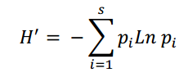

Based on Eichner's formula for relative band intensities (Eichner et al. 1999). Pi was defined as ni/N, where Ni is the area of a peak in intensity and N the sum of all peak areas in the lane profiles.
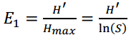

3. Results and Discussion
3.1. Environmental Variables
Using the DGGE method to analyze the sequencing of the 16S rRNA gene, the composition of soil bacterial communities observed in two separate soil systems of tropical forest (TB) and oil palm plantations (SW) were tested and compared. The sequence of 16S rRNA gene was influenced by the chemical composition of two soil types, such as total carbon (TC), total nitrogen (TN), soil pH, C/N ratio, and availability phosphate (AP) (Table 1). Organic matter content in the palm plantations tend to be higher, although not significant, compared that in the Bukit Dua Belas National Park. This is most likely influenced by anthropogenic factors such as fertilizer use and land processing management by humans.
Conversion of forestland into plantation can affect the soil chemical properties. This process changes the pH condition, carbon content, and modifies ratio of C/N and composition of phosphate in the soil. As a result of the conversion of forestland to plantation, one of the most important elements affecting the bacterial community is soil pH (Tripathi et al. 2012). Soil pH in two oil palm plantation regions was higher than in NPBD, although the differences were not significant. This may be due to the soil acidic alleviation process during the land clearing for plantation. The tendency of ultisol forestland that is acidic and poor of nutrients can be treated with ground limestone such as dolomite which contains Mg and Ca which are materials for soil acidic alleviation and have good effect toward soil properties such as increasing soil nutrients N and P, reducing the levels of Al and Mn, increasing soil pH and reducing the concentration of phytotoxins in highly acidic soil (Cristancho et al. 2014).
Ratio of C/N between oil palm plantation and tropical forests are not significantly different. Ratio of C/N ratio is an indicator that shows process of mineralization and immobilization of N from organic material by microbial decomposers. An arid region has lower C / N ratio than a wet area. The C/N ratio that less than 20 indicate the N mineralization, greater than 30 indicate the N immobilization, whereas between 20 and 30 indicate the balance of mineralization and immobilization (Hanafiah 2005). The low C/N ratio indicates the soil containing more nitrogen, while the high C/N ratio indicates the low nitrogen content. It will make the competition between soil microbes and plants to obtain available nitrogen. The soil of palm plantations contains lower contents of nitrogen and carbon than that of forest land, so its C/N ratio is also low. The soil with high C/N ratio needs the addition of nutrients to prevent it from nutrient deficiency, especially for nitrogen.
Table 1. Soil Variable Analysis
Sample | pH (H₂0) | pH (KCL) | Total Carbon  (%) | Total Nitrogen  (%) | Phosphate  Availability (mg/100mg) | Rasio of C/N
NPBD | 4.0 | 3.7 | 1.33 | 0.11 | 18 | 12.091
Oil palm plantation | 4.6 | 4.0 | 0.98 | 0.09 | 15 | 10.889

Generally, the change of forest land-use into plantations leads to decreasing level of organic C (Table 1). This condition was caused because some occurs because much of the carbon been swept by erotion, runoff, lost in the form of gas, and also because of the absence of organic fertilization to supply of carbon in the soil. Organic carbon levels in soil cultivated with plantation crops range from low to moderate. Carbon stock in forestland is generally higher than that of plantation land, either in the body of vegetation, in soil or in the form of litter. It means that forestland is much more effective in absorbing and storing carbon than plantation (Monde 2009). The assessment criteria of physical and chemical properties of soil based on Tropical Soil Quality Index (TSQI), total carbon (0.98%), total nitrogen (12:09%) in forestland of Bukit Dua Belas National Park were classified as very low level category, and available phosphate (18 mg/100g) was classified as low level category, while total carbon (1.33%), nitrogen content (0.11%) and available phosphate (15mg/100g) in ​​oil palm plantation land are classified as low level category. Phosphate (P) is an essential element for all living organisms that makes up cell membranes, nucleic acids, proteins, and as the energy source such as GTP, ATP, and NADPH. This compound is also biological and environmental limiting factor and limiting nutrient for plants (Azziz et al. 2012). After nitrogen, phosphorus is the second most important critical element required by living organisms. Despite their abundance in nature, its availability is limited in the form unsoluble phosphate. Some species of bacteria have the ability to dissolve the phosphate in nature. The high availability of phosphate in oil palm plantation increases the quantity of nutrients for soil bacteria. The availability of various nutrients can also increase the diversity and abundance of soil bacteria in palm oil plantations differs from that in the forest NPBD.

3.2 Soil DNA extraction and amplification of 4 Locations
The result of DNA extraction varies from 38-114.8 (ng/mL) (Table 2). The purity ratio of DNA obtained from four locations is low, around 1.35 to 1.50. Good-purity DNA, generally have an A260/280 ratio of 1.8- 2.0, and an A260/230 ratio above 2.0. The DNA extraction using FastDNA SPIN KIT for soil (MP Biomedicals, USA) resulted in total DNA with low purity, pure DNA and RNA with an A260/280 ratio from 1.8- 2.0 and an A260 / 230 ratio above than 2.0 (Yeates et al. 1998; Sambrook and Russell 2001). A280 is the wavelength for protein, A260 is for DNA and A230 is for phenol, and also humic acid. Humic acid contamination in the soil can interfere in the DNA quantification process because humic acid absorbed well A230 and A260 nm (Yeates et al. 1998). In addition the A260/A30 ratio is very low at 0.07- 0.28, this value indicates the presence of humic acid or humic acid-like molecules detected in the A230 wavelength absorption. The amplification of 16S rRNA gene of bacteria in the soil from tropical forest and palm oil plantation were analyzed using nested PCR and used primer p338F and p518R . This technique used two-time PCR, the first and second phase PCR produced 187 bp products.

Tabel 2. Quantity and Quality of DNA Extraction from 4 Soil Samples

No. | Sample | Nucleid acid Consentration (ng/µl) | 260/280 | 260/230
1. | SW01 | 85.0 | 1.37 | 0.14
2. | SW02 | 38.0 | 1.50 | 0.07
3. | TB03 | 236.3 | 1.35 | 0.28
4. | TB04 | 144.8 | 1.40 | 0.20

3.3 The diversity of bacterial 16S rRNA Based on Method Non-Culture DGGE
This study used a non-culture approach, which not only can obtain bacteria that has been known for dominant and easily cultured, but also uncultured bacteria by 16S rRNA genes obtained directly from environmental samples. The uncultured bacteria can be used to determine the breadth of bacterial distribution in an environment, as well as providing metabolic and biochemical information that has not before been discovered (Harris et al. 2004).
The bacterial diversity in soil samples from NPBD forest and oil palm plantation was analysed. Based on the results of the DGGE, namely DNA band profile, diversity index of quantification of the BNA band intensity, dendogram analysis, OTU identity of DNA, and phylogenetic relationships among OTU(s). The results of 16S rRNA gene PCR product separation showed that the pattern of the bacterial communities vary in each sample and result of DGGE interpretation (Figure 2A). Band distribution pattern on polyacrylamide gel showed that the bacterial community in the soil samples of oil palm plantation (16-24 bands) is more diverse than soil samples of NPBD (6-8 bands).
The results of cluster analysis that compares the similarities in all samples based on the results of DGGE band position (Figure 2B) put the samples into two main clusters. Analysis of soil bacterial communities patterns of similarity with binary data showing the soil bacterial community in the soil samples palm plantations SW01 and SW02 have similarities of ± 99%. Meanwhile, a community sample of soil patterns in tropical forests TB03 and TB04 also have similarities of ± 99% but it has its clusters differ with soil samples in oil palm plantations. This indicated the presence of different patterns of community with soil samples in oil palm plantations.

3.4. BLAST and Phylogenetic Analysis
The DGGE analysis of total bacterial community showed 9 different bands from 4 soil samples. Purified DNA of DGGE bands were amplified with the same primer without GC clamps with a size of ± 180 bp product (Figure 3). Sequence alignment were conducted using Mega 6 software. The alligned sequence is a 16S rRNA sequence with a base length of about 173bp using 338f and 518r primers which amplified the third region of 16S rRNA genes (Overeas et al. 1997). The nine bands that have been successfully sequenced are then compared among the OTU sequences to see the same sequence sequence and the different base pairs sequences of the nine DGGE OTU sequences (Figure 4). The results obtained are that the nine OTU sequences have sustainable areas in some sequences marked with black areas. The gray area shows sequences between OTUs that have the same region (semi conserved region) whereas the white area is a variable region showing the difference of the basic sequences of each OTU from DGGE.
Sequence analysis was conducted using Chromas Pro software. Sequences that have been analyzed and compared with a database in Genebank using BLAST-N (Basic Local Alignment Tools- nucleotide). The obtained results showed 6 bands of DGGE were identified as uncultured bacterium. However, there were 3 DGGE band identified as Enterococcus canis (band 1) with the similirity percentage of 94%, Pseudomonas aeruginosa (band 2) by 100% and the percentage of similarity Weisselia confusa (band 3) was about 93% (Table 3). Generally, the percentage of sequence similarity of DGGE results with Genebank database were about 89-100%.
Phylogenetic tree was constructed by neighbor joining tree with bootstrap 1000x. The sequence analysis of 16S rDNA DGGE bands showed 3 different phylla of bacteria which were found in both of location i.e Actinobacteria, Proteobacteria (Bethaproteobacteria, and Gammaproteobacteria), Firmicutes (Figure 5). Betaproteobacteria, gammaproteobacteria, and Firmicutes are 3 subphylum appearing on DGGE results from soil samples of oil palm plantations. While Actinobacteria are a group that always appear in both samples and the most dominating in both soil samples both TNBD forest and oil palm plantations.
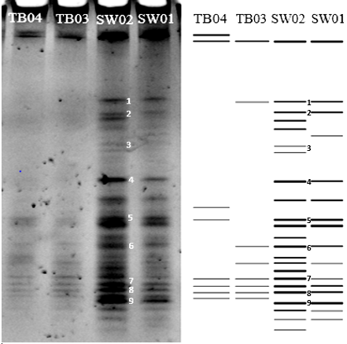
(A)
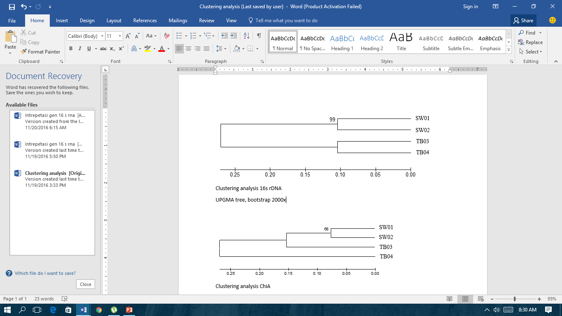
(B)
Figure 2. (A) DGGE profile of 16S rRNA from soil samples (left). DGGE illustration by CLIQS 1D software (right). Nine bands were excised for further analysis. (B) Clustering analysis of soil bacterial diversity, based on 16S rRNA gene showed different cluster between oil palm plantation of Humusindo (SW) and National Park of Bukit Dua Belas (TB) area.

Table 3. Blast N result of DGGE bands base on 16S rRNA gene

No. | Closely relative description | Quary Cover | E-Value | Identity | Accesion number | Family
Clone band 1 | Enterococcus canis strain NBRC 100695 | 99% | 3e-62 | 94% | NR_113931.1 | Bacili/  Firmicutes
Clone band 2 | Pseudomonas aeruginosa P-hrb07 | 99% | 2e-98 | 100% | GU214819.1 | Gamma-Proteobacteria
Clone band 3 | Weisselia confusa | 99% | 4e-76 | 93% | AM117158.1 | Bacili/  Firmicutes
Clone band 4 | Uncultured Bacteria  QM-73-158 | 92% | 6e-84 | 100% | Ku928795.1 | Beta-proteobacteria
Clone band 5 | Uncultured bacterium clone A15C08 | 95% | 6e-38 | 91% | JQ379115.2 | Actinobacteria
Clone band 6 | Uncultured bacterium clone VHA39_ | 99% | 2e-69 | 95% | KX753094.1 | Actinobateria
Clone band 7 | Uncultured bacteria clone BButL 8P5CO2 | 98% | 2e-83 | 99% | LK024724.2 | Actinobacteria
Clone band 8 | Uncultured bacteria clone MA-537 | 99% | 2e-83 | 99% | KM 207493.1 | Actinobacteria
Clone band 9 | Uncultured bacteria clone Out 26067 | 54% | 3e-16 | 89% | KX878538.1 | Actinobacteria

DGGE results showed that group of species that have been identified were almost belong to the uncultured species in abundance. The Actinobacteria group was the most dominant in oil palm plantations, with a higher relative abundance than forest soils. These results in agreement with Lee-Cruz et al. (2013) which concluded the group Actinobacteria was more abundant in palm oil than on forest land. Actinobacteria Anthropogenic activities have impacted the existence of forests and oil palm plantations through the fertilization process. Actinobacterial shift communities on oil palm plantations, as well as ectomycorrhizal fungal communities, have been characterized as a result of anthropogenic intervention and forest conversion (Kerfahi et al. 2014). The increasing the number of Actinobateria especially actinomycetales group on deforested land explain why the increased availability of nutrients in supporting the growth of the Actinobacteria as copiotropic bacteria (Wagner and Horn 2006).

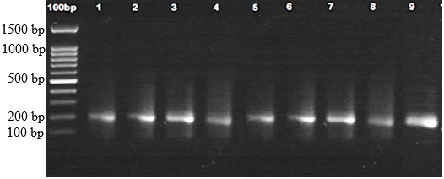
187bp

Figure 3. Amplification of 16S rRNA gene soil bacteria from four sample locations with product size ±180 bp using primer p338F (Non GC Clamps) and p518R. Lane 100 bp as a marker, lane 1 to line 9 : clone band of DGGE
Species were detected in DGGE results that belong to a group Firmicutes / bacilli were Enterococcus canis and Weisselia confuse. Most of the species that belong to Firmicutes phylum have a high and good resistance varied to dryness and extreme environmental factors. Because these microorganisms are known to thrive in carbon-rich environments and land surface temperatures vary throughout the day, a significant rise in the relative abundance of Firmicutes sequences observed following land conversion is detected.
Species detected in DGGE results were classified in Gammaproteobacteria ie Pseudomonas aeruginosa, from the group Betaproteobacteria included into uncultured bacteria. In this study found no species belonging to the group Alfaproteobacteria, Deltaproteobacteria and Epsilonproteobacteria. These results are consistent with studies Janssen et al, (2002) which states that the bacterial phylum Proteobacteria was the highest abundance. Alphaproteobacteria was the most abundant class followed by Gammaproteobacteria, Betaproteobacteria, Deltaproteobacteria, and Epsilonproteobabteria. The higher comparison of proteobateria in oil palm plantations compared to primary forest land because of the large influx of fertilization and organic matter which showed the soil fertility and could decrease of competition of the microbs. Betaproteobacteria were copiotrophic, and their relative abundances were highest in soils with high C availability, either as an essential ingredient of the soil or as a nutrient. The relative abundances of Acidobacteria decreased while the relative abundances of Betaproteobacteria and Bacteroidetes increased (Fierer et al. 2007). Total carbon in oil SW sites was found to be lower than in TB sites in this study, but on the contrary, carbon in SW sites was found to be higher than in TB sites.

3.5. Shannon-Wiener (H’) and Equitability (e’) Index
Shannon-wiener (H') diversity analysis were used to estimate the diversity of microbes in each sampling sites. The results showed that the bacterial soil community diversity index (H') based on 16S rRNA gene at four locations ranged at 1.90 – 2.93. Meanwhile the equitability index (E') at four locations ranged at 0.914 – 0.939 (Figure 6).
The composition of soil bacterial community revealed in the DGGE profile showed SW01 and SW02 have relatively high abundance of bacteria compared with TB03 and TB04. This result was also confirmed by diversity index of Shannon Wienner. The differences of the bacterial diversity among the samples can be influenced by some factors both abiotic and biotic (Hallman et al. 1997). Lee-Cruz et al. (2013) in agreement reported that soil results of cultivation produce a diversity of microbial higher than the forest soil, this can be happen due to the activity of cultivation that do like tilling the soil and run off from fertilizers produced will decrease competition nutrients that will produce more diverse of microbes.
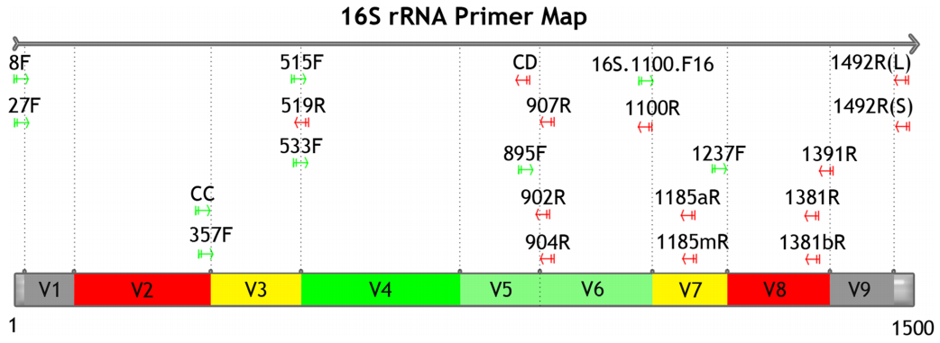
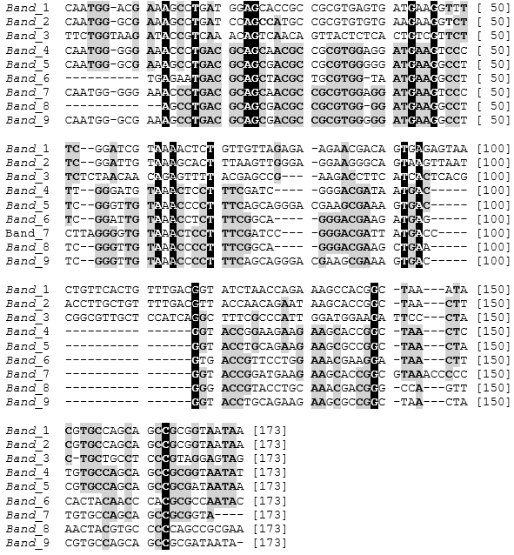

Figure 4. Sequence Alignment of 9 16S rRNA gene sequences in the third region of soil bacteria obtained from DGGE analysis

KM207493.1 Uncultured bacterium clone MA-537
LK024724.2 Uncultured bacterium clone BButL8P5C02
GQ203346.1 Uncultured actinobacterium clone OH16a/15
EU628805.1 Uncultured actinobacterium clone YYFS332
Band 8
band 7
LN715290.1 Uncultured bacterium clone A15C08
HM665231.1 Uncultured bacterium clone GB7N87003G3XMB
Band 5
band 9
KX877612.1 Uncultured bacterium clone Otu17530
KX878538.1 Uncultured bacterium clone Otu26067
KU928795.1 Uncultured bacterium clone QM-T3-158
LC017120.1 Uncultured beta proteobacterium clone EDay154M1-CL78
Band 4
Band 6
KX752899.1 Uncultured bacterium clone VLA 1
KX753094.1 Uncultured bacterium clone VHA 39
LN716046.1 Uncultured bacterium clone A26F03
Band 2
GU214819.1 Pseudomonas aeruginosa strain p-hrb07
KX682023.1 Pseudomonas nitroreducens strain TA-E11
AM117158.1 Weissella confusa clone 2BM9
KX131147.1 Weissella cibaria strain bcpca-qj-2
Band 3
Band 1
AB681226.1 Enterococcus canis strain NBRC 100695
LC096240.1 Lactobacillus capillatus strain JCM 15044
X99555.1 Pyrolobus fumarius
98
63
89
71
99
100
63
84
92
99
88
44
49
68
70
61
81
66
64
57
36
0,05

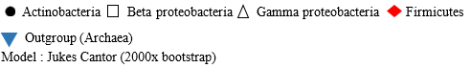

Figure 5. Phylogenetic tree of 9 DGGE bands of 16S rRNA. The tree was constructed using neighbour joining method through 2000x bootstrap.
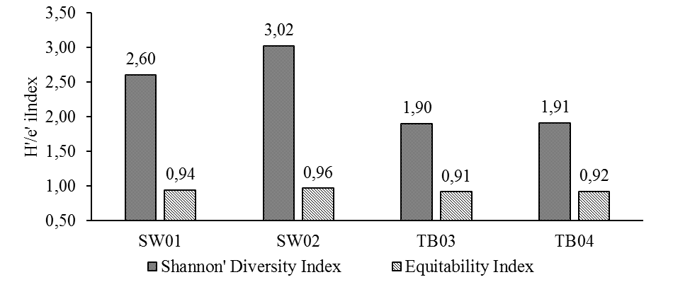
Figure 6. Diversity Index of Shannon-wienner and Equitability index of Bacterial community based on 16S rRNA gene

4. Conclusions
Conversion of forestland into plantation can affect the chemical properties of the soil so it changes pH conditions, carbon content, C/N ratio and composition of soil phosphate that may affect the diversity of soil bacteria in two locations of tropical forests and oil palm plantations. Based on the number of bands 16S rRNA obtained through DGGE, the soil bacterial population in oil palm farms seems to be more diverse than that in Bukit Dua Belas National Park. The identification of 16S rRNA and phylogenetic analysis of 16S rRNA found out four different phyla in the oil palm plantation, i.e. Proteobacteria (Betaproteobacteria and Gammaproteobacteria), Firmicutes, and Actinobacteria. Diversity analysis showed that Shannon-wiener index (H’) of soil bacterial community in four locations ranged between 1.90 and 2.93, while the equitability index (E') ranged between 0.914 and 0.934. Despite the fact that the oil palm plantation had some more phyla and genera of bacteria in soil than the lowland forest, the bacterial shift community occurred during forest change in sediment. It was caused by plantation management, such as agricultural lime, herbicide, and others handling oil palm plantation.
References
Armougom F, Henry M, Vialettes B, Raccah D, Raoult D. 2009. Monitoring bacterial community of human gut microbiota reveals an increase in Lactobacillus in obese patients and methanogens in anorexic patients. PLoS ONE 4 (9): e7125.
Azziz G, Bajsa N, Haghjou T, Taulé C, Valverde A, Igual JM, Arias A. 2012. Abundance, diversity and prospecting of culturable phosphate solubilizing bacteria on soils under crop-pasture rotations in a no-tillage regime in Uruguay. Apply of Soil Ecology 61: 320-326.
Cristancho RJA, Hanafi MM, Omar SRS, Rafii MY. 2014. Aluminum speciation of amended acid tropical soil and its effects on plant root growth. Journal Plant Nutrition 37(6): 811-827.
Eichner CA, Erb RW, Timmis KN, WagnerDÖbler I. 1999. Thermal gradient gel electrophoresis analysis of bioprotection from pollutant shocks in the activated sludge microbial community. Applied and Environmental Microbiology 65(1): 102-109.
Fierer N, Bradford MA, Jackson RB. 2007. Toward an ecological classification of soil bacteria. Ecology 88: 1354-1364.
Fischer SG, Lerman LS. 1983. DNA fragments differing by single base-pair substitutions separated in denaturing gradient gels: correspondence with melting theory. Proceedings of National Academic of Sciences, USA. 80(6): 1579-1583.
Glogauer A, Martini VP, Faoro H, Couto Gh, Muller-Santos M, Monteiro RA, Mitchell DA, de Souza EM, Pedrosa FO, Krieger N. 2011). Identification and charachterization of new true lipase isolated through metagenomic approach. Microbiollogy Cell factories 10: 10-54.
Hallman J, Quadt-Hallmann A, Mahaffee WF, Kloepper JW. 1997. Bacterial endophytes in agricultural crops. Canadian Jurnal Microbiology 43: 895-914.
Hanafiah KA. 2005. Basic of Soil Science. PT. Raja Grafindo Persada (In Bahasa Indonesia), Jakarta.

Harris JK, Kelley ST, Pace NR. 2004. New perspective on uncultured bacterial phylogenetic division OP11. Apply Environmental of Microbiology 70 (2): 845-849.
Janssen PH, Yates PS, Grinton BE, Taylor PM, Sait M. 2002. Improved culturabililty of soil bacteria and isolation in pure culture of novel members of the divisions acidobacteria, actonobacteria, proteobacteria, and verrucomicrobia. Applied and Environmental of Microbiology 68(5): 2391-2396.
Kerfahi D, Tripathi BM, Lee J, Edwards DP, Adams JM. 2014. The impact of selective-logging and forest clearance for oil palm on fungal communities in Borneo. PLoS ONE 9(11): e111525.
Ko WH, Wang IT, Ann PJ. 2005. A simple method for detection of lipolytic microorganisms in soils. Journal of soil biology and Biochemistry 37(3): 597-599.
Lee-Cruz L, Edwards DP, Tripathi BM, Adams JM. 2013. The impact of logging and forest conversion to oil palm on soil bacterial communities in Borneo. Appled and Environmental Microbiology 79(23): 7290-7297.
Masrukhin, Rusmana I, Mubarik NR. 2017. Effect of biofertilizer on the diversity of nitrogen - fixing bacteria and total bacterial community in lowland paddy fields in Sukabumi West Java, Indonesia. Malaysian Journal of Microbiology 13(2): 139-146.
Monde A. 2009. Degradation of Carbon Stock (C) Due to the Use of Forest Land to Become Cocoa Land in Nopu River Basin, Central Sulawesi. Agriculture faculty. University of Tadulako. Journal of Agroland 16(2): 110 – 117.
Murdiyarso D, Van-Noordwijk M, Wasrin UR, Tomich TP, Gillison AN. 2002. Environmental benefits and sustainable land-use options in the Jambi transect, Sumatra, Indonesia. Journal of Vegetation Science 13: 429–438.
Muyzer G, Waal EC, Uitierlinden AG. 1993. Profiling of complex microbial populations by denaturing gradient gel electrophoresis analysis of polymerase chain reaction amplified genes coding for 16s rRNA. Applied and Environmental Microbiology 59(3): 695-700.
Okalebo JR, Gathua KW, Woomer PL. 1993. Laboratory methods of soil and plant analysis: A working manual. UNESCO, Nairobi.
Overeas L, Fomey L, Daae FL. 1997. Distribution of bacterioplankton in meromictic lake saelevannet, as determined by denaturing gradient gel electrophoresis of PCR amplified gene fragments coding for 16S rRNA. Applied and Environmental Microbiology 63: 3367-3373.
Palm CA, Vosti SA, Shanchez PA, Ericksen PJ. 2005. Slash and Burn The Search for Alternative. Columbia University Press, New York.
Sambrook J, Russell. 2001. Molecular Cloning: A Laboratory Manual. Cold Spring Harbor Laboratory Pr,
Tamura K, Stecher G, Peterson D, Filipski A, Kumar S. 2013. Mega 6: Molecular evolutionary genetics analysis version 6.0. Molecular Biology and Evolution 30(12): 2725-2729.
Tripathi BM, Kim M, Singh D, Lee-Cruz L, Lai-Hoe A, Ainuddin AN. 2012. Tropical soil bacterial communities in malaysia: ph dominates in the equatorial tropics too. Microbial Ecology 64: 474-484.
Wagner M, Horn M. 2006. The Plantomycetes, Verrucomicrobia, Chlamydiae and sister phyla comprise a superphylum with biotechnological and medical relevance. Current Opinion in Biotechnology 17: 241–249.
Xue D, Yao HY, Ge DY, Huang CY. 2008. Soil microbial community structure in diverse land use systems : A comparative study using biolog, DGGE, and PFLA analyses. Pedosphere 18(5): 653-663.
Yeates C, Gillings MR, Davison AD, Altavilla N, Veal DA. 1998. Methods for microbial DNA extraction from soil for PCR amplification. Biological Procedures Online 1(1): 40-47.
Yule CM. 2010. Loss of biodiversity and ecosystem functioningin Indo-Malayan peat swamp forests. Biodiversity Conservation 19: 393–409.

