Journal of
Tropical Biodiversity and Biotechnology

Declaration of Originality

I hereby confirm that I am the author of the written manuscript here enclosed and that I have compiled it in my own words.

Title of manuscript (in block letters):
Intergeneric Hybridization between Phalaenopsis 2166 and Vanda ‘saint valentine’: Characterization of
Parents Using ndhE Partial Sequence

With my signature I confirm that:
• I have not committed any of the forms of plagiarism.
• I have documented all methods, data and processes truthfully.
• I have not manipulated any data.
• I have mentioned all persons who were significant facilitators of the work. I am aware that the work may be screened electronically for plagiarism.

Place, date

Purwokerto, April 25, 2021

Author name(s) (in block letters) Signature(s)
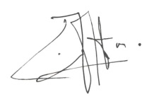

Murni Dwiati
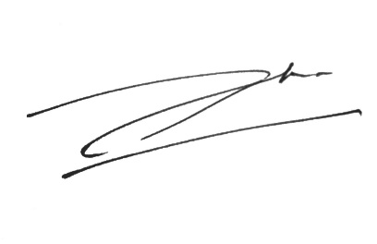

Agus Hery Susanto

Note: fill and scan this form and upload along with the manuscript file during submission.

Editorial address: Faculty of Biology, UGM, Jl. Teknika Selatan, Sekip Utara, Yogyakarta 55281
Email: jtbb.biologi@ugm.ac.id | Website: http://jtbb.or.id

