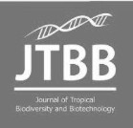Journal of

Tropical Biodiversity and Biotechnology

**Declaration of Originality**

I hereby confirm that I am the author of the written manuscript here enclosed and that I have compiled it in my own words.

Title of manuscript (in block letters):

EFFECT OF IRON TOXICITY ON THE GROWTH OF *Calliandra calothyrsus* AND *Lucaena*

*Leucocephala* SEEDLINGS

With my signature I confirm that:

* I have not committed any of the forms of plagiarism.
* I have documented all methods, data and processes truthfully.
* I have not manipulated any data.
* I have mentioned all persons who were significant facilitators of the work. I am aware that the work may be screened electronically for plagiarism.

Place, date

Bogor, May 10 2021

Author name(s) (in block letters) Signature(s)



MOHAMMAD AGUS SALIM

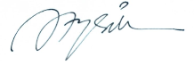

LULUK SETYANINGSIH



IMAM WAHYUDI

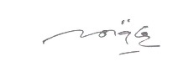

SRI WILARSO BUDI

Note: fill and scan this form and upload along with the manuscript file during submission.

Editorial address: Faculty of Biology, UGM, Jl. Teknika Selatan, Sekip Utara, Yogyakarta 55281 Email: [jtbb.biologi@ugm.ac.id](mailto:jtbb.biologi@ugm.ac.id) | Website: [http://jtbb.or.id](http://jtbb.or.id/)