Journal of

Tropical Biodiversity and Biotechnology

Declaration of Originality

I hereby confirm that I am the author of the written manuscript here enclosed and that I have compiled it in my own words.

Title of manuscript (in block letters):
Detection of knockdown-resistance mutations (V1016G and F1534C) in dengue vector from urban park, Surabaya, Indonesia
With my signature I confirm that:
- I have not committed any of the forms of plagiarism.
- I have documented all methods, data and processes truthfully.
- I have not manipulated any data.
- I have mentioned all persons who were significant facilitators of the work. I am aware that the work may be screened electronically for plagiarism.

Place, date
Surabaya, April 18th 2021

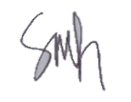
Author name(s) (in block letters) Signature(s)

Shifa Fauziyah
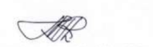
Sri Subekti
Budi Utomo
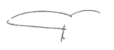
Teguh Hari Sucipto
Hebert Adrianto
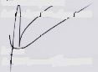
Aryati
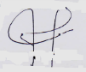
Puspa Wardhani
Soegeng Soegijanto
Note: fill and scan this form and upload along with the manuscript file during submission.

Editorial address: Faculty of Biology, UGM, Jl. Teknika Selatan, Sekip Utara, Yogyakarta 55281 Email: jtbb.biologi@ugm.ac.id | Website: http://jtbb.or.id

