February 2nd, 2021

Dear Dr. Miftahul Ilmi,

I am pleased to submit our manuscript entitled “Herpetofaunal assemblages in the lowland streams and adjacent plantations of Sumatera Barat” by Fitra Arya Dwi Nugraha, Fajar Kaprawi, Rijal Satria, Ahmad Muammar Kadafi, Ade Agung Prasetyo for consideration as a Journal of Tropical Biodiversity and Biotechnology research article.

In this manuscript, we show that the diversity level of herpetofauna in the lowland rocky medium size streams and adjacent rubber plantations is high which suggest us to not underestimate their community structures. We also show that the plantation that has a small river in it could be more approriate for habitat of herpetofauna.

We believe that our paper is appropriate for publication by Journal of Tropical Biodiversity and Biotechnology because it discussed the community diversity and ecology. Our manuscript creates a for future studies in the management of conservation in the lowland area.

This manuscript has not been published before and is not being considered for publication elsewhere. We have no conflicts of interest to disclose. If you feel that the manuscript is appropriate for your journal, we suggest the following reviewers:
Donan Satria (Universitas Gadjah Mada, donan.satria@ugm.ac.id), Nia Kurniawan (Universitas Brawijaya, wawan@ub.ac.id)

Thank you for your consideration. Sincerely,
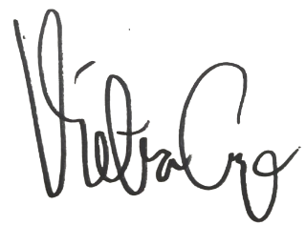
Fitra Arya Di Nugraha
Department of Biology, Faculty of Mathematics and Natural Sciences, Universitas Negeri Padang
fitraaryadn@fmipa.unp.ac.id
+6281275550439

