Detection of AtRKD4 Protein During Somatic Embryogenesis In Dendrobium lineale Rolfe Transgenic Orchids Carrying 35S::GR::AtRKD4
Gde Cahyadi Wirajagat¹, Ni Luh Putu Kayika Febryanti¹, Fitriana Puspitasari¹, Dika Sundari¹, Jose Gutierrez-Marcos², Endang Semiarti^{1, *)}

¹Faculty of Biology, Universitas Gadjah Mada, Yogyakarta, Indonesia, 55281
² School of Life Science, University of Warwick, England, CV4 7AL
^{*)}Corresponding author: endsemi@ugm.ac.id

Abstract
Dendrobium lineale Rolfe is a wild orchid from Papua (Indonesia), which is a risk of extinction due to over-exploitation of its natural habitat. Therefore, efforts for conservation of this endangered species are urgently needed. Mass propagation of wild D. lineale has been conducted by genetic engineering through the transgenic insertion of AtRKD4- a gene implicated in embryo development in Arabidopsis. In this study, molecular analyses have revealed that the AtRKD4 transgene is integrated in the genome of D. lineale and show a stable somatic transmission. We also show that AtRKD4 is strongly induced in leaves of transgenic D. lineale after chemical induction with Dexamethasone (DEX) or Thidiazuron (TDZ). Collectively, our data reveal a rapid and straitforward methodology that could aid the conservation of endangered orchid species.

Keywords: Dendrobium lineale, AtRKD4 gene, Dexamethasone-thidhiazuron, Somatic embryo, AtRKD4 protein

1. Introduction
Dendrobium lineale Rolfe is an endemic orchid of Papua that is threatened on its habitat due to over-exploitation. D.lineale is favored because it shows tall stems and produces many beautiful purplish-white flowers (Rolfe 1889; Pridgeon 1992). This orchid is named D. lineale because has lined sepals and petals (Pridgeon 1992). In addition, D. lineale can be used for medical purposes such as anti-cancer. It contains types of phytochemicals such as flavonoids, polysaccharides, bibenzyl, phenanthrene, alkaloids, sesquiterpenoids, and steroids. A common problem with D. lineale is that it is not easy to breed and grow naturally, so the population of this orchid is quite abundant (Semiarti et al 2020). Several types of orchids are increasingly rarely found in nature due to overexploitation, domestication and trade as parent orchids in cultivation (Ivakdalam & Pugesehan, 2016). In vitro propagation is expected to be the right solution for ex situ conservation because possible to produce mass number of plants with similar characteristic to its parental (Setiari et al. 2018). Propagation through in vitro culture can increase the quantity, the number of tillers obtained in a relatively short time (Hartati et al. 2016). Optimization of in vitro propagation can be done by using genetic engineering, by inserting foreign genes through Agrobacterium tumefaciens. An embryo gene of Arabidopsis thaliana, AtRKD4 gene in this study was inserted into the genome of D. lineale protocorms through A. tumefaciens strain EHA105 that harbor pTA7002 plasmid, therefore it can induce large numbers of somatic embryos in a relatively short time. The gene construction used an inducible promoter equipped with Glucocorticoid Response Element (GRE), requiring dexamethasone (DEX) which is a glucocorticoid compound as an inducer to induce transcription or activation of transgenes (Mursyanti et al. 2015). The insertion of the AtRKD4 gene into the genome of orchids has been carried out and has successfully demonstrated the formation of somatic embryos in transformant orchid leaves after being induced with DEX on leaves and protochorms of Phalaenopsis amabilis (Hsing et al. 2016)
The formation of somatic embryos in orchid plants can be inducted by the addition of growing regulatory substances in the medium of in vitro culture. Auxin and cytokinin are commonly used for induction of in vitro somatic embryo (Moradi et al. 2017). Thidiazuron (N-phenyl-N'-1,2,3-thiadiazol-5-ylurea) is a cytokinin class growth regulator known to have potential activity in shoot regeneration and proliferation, and is effective in inducing somatic embryo formation (Ghosh et al. 2018). TDZ with 3 mgL⁻¹ concentration is the best concentration used to induce the formation of somatic embryos in the roots, stems, leaves explants, and protocorm of P. amabilis orchids (Mose et al. 2017).
According to Semiarti et al. (2007 & 2011) plant genetic transformation is the right method to improve the quality of orchid plants because it can break barriers between species and insert beneficial traits from superior genes from other plant species. The success of genetic transformation is shown by detection and integration of AtRKD4 transgenes in the orchid genome, and also the activation of these genes in orchid transformants (Setiari et al. 2018). Somatic embryogenesis is a promising technique used in the proliferation of plants. It is also a way to support ex situ conservation (Maruyama & Hosoi 2019). Protein detection of AtRKD4 needs to be done because the function of genes is biochemically carried out by proteins which is the result by gene expression and it determine the character of plants at each stage of their development (Utami et al. 2007). RKD4 Protein (RWP-RK motif-containing 4 putative transcription factors domain) is one of two subfamily of RWP-RK protein motifs (amino acid sequences consist of arginine (R), Tryptophan (W), Polin (P), arginine (R) and lysine (K)) proteins located inside the nucleus which are transcription factors based on similarities of form with basic leucine zipper protein and basic helix-loop-helix. The function of the RKD4 protein is to trigger the expression of genes needed for the initiation of the process of forming a divisional pattern in the zygote and the process of early development of the embryo (Chardin et al. 2014)
The AtRKD4 gene has been successfully inserted into the D. lineale orchid genome, but the stability of the AtRKD4 gene integration and the expression of the gene in the orchid genome are not yet known. This research aims to analyze the stability level of AtRKD4 gene integration in the genome of D. lineale transformant and to analyze the expression of the gene which can produce AtRKD4 protein in D. lineale transformants.

2. Materials and Methods
2.1 Plant Materials and T-DNA Construct
The materials used in this study are candidate of D. lineale transformant plantlets aged 1 year 6 months planted New Phalaenopsis (NP) media, obtained from research which carrying the AtRKD4 gene with 35S::GR/UAS:AtRKD4 T-DNA construct and D. lineale non-transformant (wild type). The transformant candidates are the result of Agrobacterium-mediated genetic transformation. The D. lineale transformant plant used in this study carrying T-DNA which contains the inducible system of GVG, which contains a synthetic protein fusion for the GAL4 DNA binding domain, the transcriptional activator VP16 and a portion of the rat Glutacorticoid Receptor (GR). The expression of the GVG gene fusion is driven by strong promoter 35S promoter from the cauliflower mosaic virus (CAMV). T-DNA also carries Hygromycin phosphotransferase (HPT) gene, which confers resistance to hygromycin and was used as selectable marker on selection medium (Figure 1).
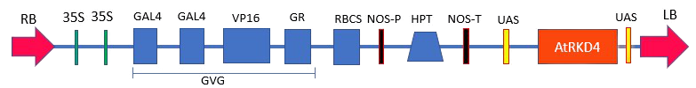
Figure 1. The structure of T-DNA harboring 35S::GR/UAS::AtRKD4 in plasmid pTA7002/EHA 105 (Mursyanti et al. 2015)

2.2 Detection of AtRKD4 integration in the genome of orchid transformant

2.2.1DNA isolation of transformant and non-transformant D. lineale candidates
Samples used for genome DNA isolation are 2 samples of non-transformant and 10 samples transformant plantlets. Leaves of non-transformant plants and candidates of transformant weighing 20 – 30 mg, were inserted into the mortar added 250 μl CTAB 3%, and crushed until smooth using mortar and then added 250 μl CTAB 3%. Homogenized and incubated with waterbath at 60°C for 30 minutes. After 30 minutes, added 500 μL of chloroform solution, inversion 6 times. Then incubated with a shaker for 30 minutes in temperature room. Sample centrifuged at 14.000 rpm for 10 minutes. Supernatan was moved into a new tube and recorded volume, added isopropanol according to the volume of the supernatant then incubated at a temperature of-20°C for 10 minutes. The mixture was subsequently centrifuged at 14.000 rpm for 10 minutes. Discarded the supernatant, pellets plus 500 μl EtOH 70%, and centrifuged 10.000 rpm for 5 minutes, the supernatant is discarded, the DNA pellets are hardened at a temperature 37 °C for 30 minutes. The dry pellet of DNA was diluted with 30 µl TE, incubated in the waterbath with a temperature of 60°C for 5 min. Isolated genome DNA was stored at a temperature of -20 °C for subsequent analyses.

2.2.2 Electrophoresis DNA genome of transformant and non-transformant candidate
The procedure for confirmation of AtRKD4 genome integration on transformant and non-transformant candidate plantlets analyzed by 1% agarose gel electrophoresis in 1X TAE solution. The 1% agarose gel is made with a weighed of agarose 0.30 g and dissolved in 30 ml TAE 1X solution using microwave. Then added 3 µl EtBr to dissolved agarose. The condensing agarose gel is inserted in an electrophoresis chamber. The chamber was filled with TAE-1X solution to the agarose gel. Three µl DNA samples mixed with 1 µl loading dye and inserted into the station. Electrodes connected to power supply with 100 volts voltages for 20 minutes. After the electrophoresis, the gel is observed with UV transilluminator.

2.2.3 Detection of the integration of T-DNA that carrying 35S::GR::AtRKD4 in transformed orchid plants
Detection of transgene AtRKD4 and HPT in the genome of D. lineale were performed by PCR (Polymerase Chain Reaction) method. DNA genome of non-transformant and transformant plant candidates carrying 35S:: GR:: AtRKD4 analyzed with PCR using a specific primer for AtRKD4 and HPT genes. Primer AtRKD4 contains 5'CTTCCATATCTAGGAGAGAATCAAG-3' (reverse) and 5-'GTTCATTTCATTTGGAGAGGACG-3' (forward) produced bands of DNA with the size of 382 bp.
Specific primer for HPT genes: HygF, 5-TCGGACGATTGCGTCGCATC-3; HygR, 5'AGGCTATGGATGCGATCGCTG-3', produced bands with a size of 545 bp. The PCR process is carried out under the conditions according to the protocols of the Bioline MyTaq™ HS Red Mix. The steps are pre-denaturation stage at 95ºC temperature for 1 minute, denaturation at 95ºC temperature for 15 seconds, the annealing stage at 58ºC for AtRKD4 and 61ºC for the HPT for 15 seconds, the extension stage at a temperature of 72ºC for 10 sec, the final stage was cooling at 4℃ temperature with 35 PCR cycles. The results of the PCR were run in electrophoresis gel using 1% agarose gel in TAE 1X buffer with 100 volt voltages for 20 minutes and observed with UV Transilluminator.

2.2.4 AtRKD4 protein analysis on D. lineale transformant plant
Protein analysis of transformant plant was carried out using the SDS-PAGE (Sodium Dodecyl Sulphate Poly Acrylamide Gel Electrophoresis) method. The protein analysis began with protein isolation, measurement of protein concentration and electrophoresis with SDS-PAGE. The total of protein isolation was carried out using transformant plant leaves which had been induced in DEX media 15 μM and TDZ 3 mgL⁻¹ for 5 days. The isolation was carried out by crushed 200mg leaves by mortar and pestle at 300 μl Phosphat Buffer Saline (PBS) with pH 7 as an extraction buffer until homogen. The sample was inserted in an 1.5 ml eppendorf tube. After that, the sample was centrifuged at a speed of 10,000 rpm for 10 minutes with a temperature of 4ºC. The acquired supernatant then transferred into a new tube. 200 μl supernatant was added with 50 μl 5X sample buffer (3.9 ml of aquabides; 1.0 ml 0.5 M Tris pH 6.8; 0.8 ml glycerol; 1.6 ml SDS 10%; 0.4 ml 2-mercaptoethanol; 0.4 ml 1% Bromophenol Blue). Heated mixture on water with a temperature of 90ºC for 5 minutes to degrade the protein. Samples was stored at -20ºC. Supernatant (8 µl) was used to measure total concentration of proteins by using spectrophotometry.
Determination of protein concentration was carried out with 8 μl supernatant added with 200 μl bradford solution. The protein concentration was measured by spectrophotometry at a wavelength of 595 nm. Bovine Serum Albumin (BSA) proteins was used as a standard to calculate the protein concentrations. The steps of electrophoresis with SDS-PAGE are put a plate glass arranged with a frame from Bio-Rad and printed 12% lower gel. Then the 12% running gel mixed homogeneous (30% acrylamide 4.0 ml; 4X LGB (Lower Gel Buffer) 2.50 ml; aquabides 3.45 ml; TEMED 5 μl, APS 10% 50 μl) the mixture then inserted into a plate glass through its chamber up to one cm from the upper limit of the plate. Upper gel made like a lower gel. The 5% upper gel mixed homogeneous (30% acrylamide 0.67 ml; 4X UGB (Upper Gel Buffer) 1.25 ml; aquabides 3.05 ml; TEMED 5 μl, APS 10% 50 μl) then the mixture inserted on top of the lower gel that has hardened to full. Comb inserted to create wells in the buffer. Samples and markers were ready to be inserted into the comb hole. Electrophoresis was run in 50 volts for 50 minutes and 100 Volts for 60 minutes. The staining process was carried out using 40% methanol, 10% glacial acetic acid, 50% aquabidest and 0.1% Coomasie Blue for 24 hours. The next process was destaining stage using 40% methanol, 10% glacial acetic acid and 50% aquabidest. The reaction were stopped after all the protein bands visible, observed and taken pictures of the gel to analysis.

3. Results and Discussion
3.1 Integration stability of putative transformants
The detection of 35S::GR/UAS:AtRKD4 integration stability in D. lineale was carried using ten transgenic plantlets and two wild type plantlets (Figure 2).
Figure 2. Transformant candidates and non-transformant of D.lineale. A-B: Non-transformant plants (NT#1, NT#2) and C-L: 10 putative transformant (T#1-T#10) is 1 year 6 months. Bar = 1 cm
Detection of the stability of T-DNA carrying the gene AtRKD4 in the transformant orchid D. lineale showed that AtRKD4 gene amplification resulted in a DNA fragment of 382 bp in length. AtRKD4 proteins were not amplified in NT plants, indicated that all non-transformant plants did not contain AtRKD4 gene in their genomes. The presence of these DNA fragments indicates the stabile integration of the 35S::GR/UAS:AtRKD4 transgene in the D. lineale genome and that during growth and development of transformant the transgene is somatically maintained.
Figure 3. Detection of AtRKD4 integration in the genome of D.lineale. M: DNA marker. Lines 1-10: Genomes of D. Lineale transformant. Lines 11-12: Genomes of D. lineale non-transformant (NT)
Detection of D. lineale transformant and non transformant genomes was carried out using HPT primers. Integration of HPT gene (545 bp) was detected in the orchid genome. HPT is an enzyme produced by the Streptomyces hygroscopicus bacteria that is resistant to hygromycin. HPT was used as a selection marker found in T-DNA of A. tumefaciens insinced into the genome of orchids that used to prove positive transformant plants. Detection of HPT gene in the plant genomes proved that transformant plants were resistant to hygromycin antibiotics even though plantlets grown on medium containing hygromycin (Setiari et al. 2018).
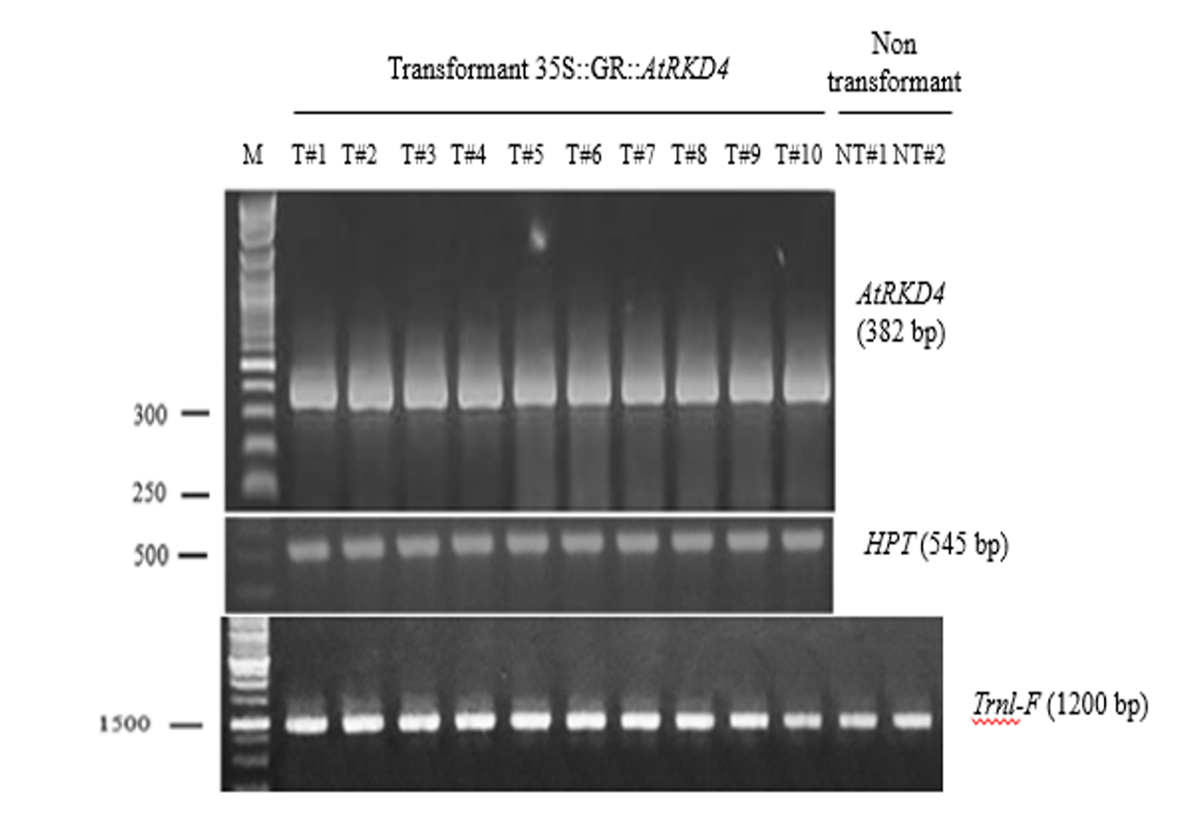
Figure 4. Detection integration of AtRKD4, HPT and trnL-F transgen in the transformant genome of D. lineale. a. Amplikon HPT gene (545 bp), b. Gen AtRKD4 (382 bp), c. trnL-F gene (1200 bp). Lines 1-10: transformant candidate plants. Lines 11-12: Non-transformant plants
Molecular markers roled as control is an important part in plant biotechnology development related to gene regions both in DNA and genomes (Yeşiltaş et al, 2019). The interspace fragment trnL-F of chloroplast genome was used as internal control of PCR analysis. Chloroplasts have their own genome which contains conserved genes and encodes many specific components. It is usually passed down maternally in most angiosperms (Filiz et al. 2018).

3.2 Induction of AtRKD4 protein in transformant plant
Detection of AtRKD4 gene expression carried out after leaves of transformant plant induced on NP media containing 15 μM DEX or 3 mgL⁻¹ TDZ for 1, 3, 5 and 7 days. T-DNA in the pTA7002 plasmid construct used to insert the AtRKD4 gene contain a glucocorticoid response element (GRE) activated by hormone steroids such as DEX. In this study, TDZ played a role as an alternative to activate somatic embryos. The most optimal expression of the AtRKD4 gene detected after 5 days with DEX or TDZ. One of the growth regulators widely used in in vitro propagation systems is TDZ (Mahendran & Bai 2016). TDZ 10 mg/L successfully induces the formation of somatic embryos in the Phalaenopsis 'Sogo Vivien' (Kasi & Semiarti 2016).
The activation of AtRKD4 transgenes induced by GVG proteins which responded to the presence of hormones synthetic glucocorticoids such as DEX. DEX works across plasma membranes diffusion and bonded with glucocorticoid receptors (GR), which are in the unprotected state, as a cytoplasmic complex with 90kDa Heat Shock Protein (HSP90). The separation of HSP90 was due to the absence of ligands localized the transcription factor into nucleus. Inside the nucleus, GR binded to specific DNA sequences and activated the expression of the AtRKD4 gene (Schena et al. 1991).

3.3 The detection of AtRKD4 Protein after induction by DEX and TDZ
AtRKD4 transgene expression at the translation level was known in the absence of protein formation in the D. lineale carried 35S::GR/UAS::AtRKD4 after given DEX or TDZ treatment. Analysis of protein molecules can be carried out using the Sodium Dodecyl Sulphate - Polyacrylamide Gel Electrophoresis (SDS-PAGE) method. This methode use to detect protein bands of the AtRKD4 gene formed with a molecular weight of 28.53 kDa electrophoresis separation. (Heda et al. 2016). The total of isolated protein from leaves of transformant plant carrier 35S::GR/UAS::AtRKD4 was suspected band of AtRKD4 protein with weight of molecule 28.53 kDa (Figure 5) after 5 days treatments.
The observations showed that a ~28kDa protein was present in 35S::GR/UAS:AtRKD4 transfomants treated with NP +15 μM DEX or NP + 3 mg.L⁻¹ TDZ . However, in transformant plants cultured in NP0 media, the predicted AtRKD4 protein was not detected. Collectively, our results show that AtRKD4 is strongly expressed in 35S::GR/UAS:AtRKD4 transformant upon induction with DEX and TDZ.
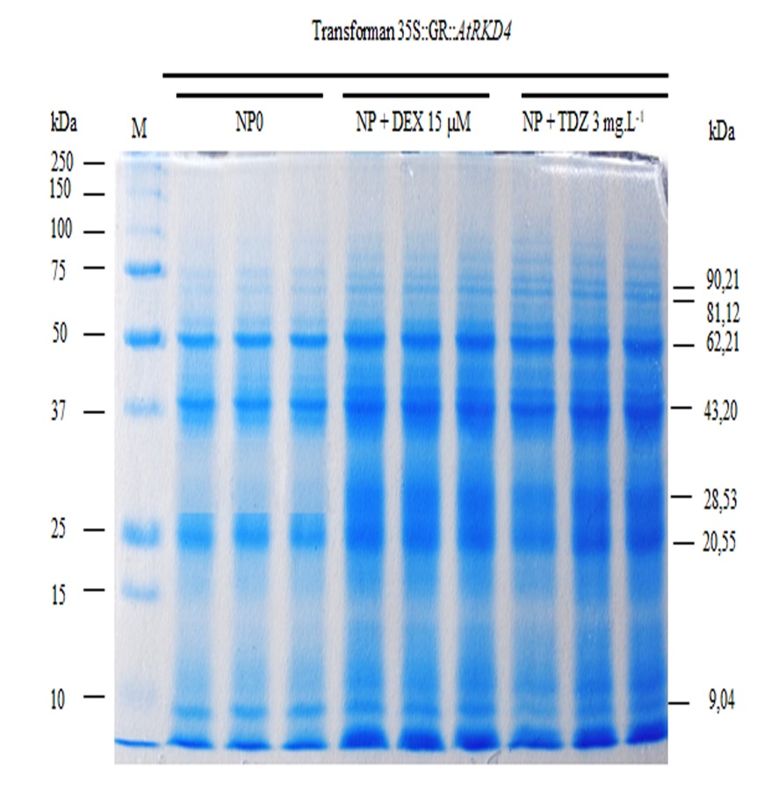
Figure 5. Protein profile of transformant plant D. lineale carrier 35S::GR/UAS::AtRKD4. Line 1: protein mark 250 kDa (Biorad); Line: 2-4 induction with medium NP0. Lines 5 -7: induction with medium NP + DEX 15 μM, Line: 8 -10 induction with medium NP + TDZ 3 mgL⁻¹
Based on the profile of the protein formed, a weight analysis of protein band molecules was performed using microsoft excel. Linear equations were obtained by molecular weight log measurements and migration band size of y = -0.1537X + 2.235 with R of 0.9581. The results of the analysis of protein molecule weight (Table 1).

Table 1. Protein band molecular weight on protein profile of transformant plants

Number of Bands | NP0 (kDa) | NP+DEX 15 µM (kDa) | NP+ TDZ 3mgL⁻¹ (kDa)
1 | 90.21 | 90.21 | 90.21
2 | 81.12 | 81.12 | 81.12
3 | 62.21 | 62.21 | 62.21
4 | 43.20 | 43.20 | 43.20
5 | - | 28.53 | 28.53
6 | 20.55 | 20.55 | 20.55
7 | 9.04 | 9.04 | 9.04

The molecular weight calculation of the sample is presented in Table 1 showed that protein was detected in all treatments except one protein in NP0 treatment. Protein with 90,21 kDA was the largest protein which detected in whole of induction treatments.
The protein profile shows that the translation process was running well as seen from the formation of AtRKD4 gene expression products in the form of proteins.
4. Conclusion
The AtRKD4 genes is stably integrated in the D. lineale transformant that showed in the genome of 10 plantlets of D. lineale transformant candidates. The AtRKD4 protein was also detected after induction of DEX 15 µM and TDZ 3 mgL⁻¹ for 5 days. The protein bands formed in transformant plants tend to be uniform.

Acknowledgement
This research was supported by grant from Ministry of Research and Technology Higher Education RI on the Scheme of Rekognisi Tugas Akhir (RTA) 2020. We thank to Steffanie Nurliana, M.S for providing transformant plants and non-transformant of D. lineale.

Author Contribution
G.C.W.: data collection, analysis and interpretation data, preparation and writing of the article. N.L.P.K.F.: idea of the experiment, data collection, preparation and writing of the article. F.P.: data collection, analysis and interpretation data, preparation and writing of the article. D.S.: data collection, analysis and interpretation data, preparation and writing of the article. J.G.M.: founder of T-DNA construct. E.S.: adviser of work, data collection and analysis, interpretation, critical review.

References
Chardin, C.,T.Girin, F. Roudier, Meyer, C., A. Krapp. 2014. The Plant RWP-RK Transcription Factors: Key Regulators of Nitrogen Responses of Gametophyte Development. Journal of Experimental Botany, 65(19): 5577–5587.
Filiz, E. Uras, M.E. Ozyigit, I.I. Sen, U. Gungor. H. 2018. Genetic Diversity and Phylogenetic Analyses of Turkish Rice Varieties Revealed by Issr Markers and Chloroplast Trnl-F Region. Fresenius Environ, 27(12): 8351–8358.
Ghosh, A., Igamberdiev, A.U., Debnath, S. C., 2018. Thidiazuron-Induced Somatic Embryogenesis And Changes Of Antioxidant Properties In Tissue Cultures of Half-High Blueberry Plants. Scientific Reports, 8(1): 69-78.
Heda,G. D., O.B. Omotola. R. P. Heda. J. Avery. 2016. Effects of Reusing Gel Electrophoresis and Electrotransfer Buffers on Western Blotting. Journal of Biomol Tech. 27(3):113–118.
Hsing, H. X., Lin, Y. J., Tong, C. G., Li, M. J. Chen, Y. J. Ko, S. S., 2016. Efficient and Heritable Transformation of Phalaenopsis Orchids. Botanical Studies, 57(1).
Ivakdalam, L.M., Pugesehan, D.J., 2016. Keragaman Jenis Tanaman Anggrek (Orchidaceae) Di Cagar Alam Angwarmase, Kabupaten Maluku Tenggara Barat. Jurnal Agroforestri. 11(3):161-168.
Kasi, P.D. and Semiarti, E. 2016. Pengaruh Thidiazuron Dan Naphthalene Acetic Acid Untuk Induksi Embryogenesis Somatik Dari Daun Anggrek Phalaenopsis “Sogo Vivien”. Jurnal Dinamika, 7:31-40.
Mahendran, G. And bai, V.N. 2016. Direct Somatic Embryogenesis of Malaxis Densiflora (A. Rich.) Kuntze. JGEB. 14:77-81.
Maruyama, T. E. Hosoi Y., 2019. Progress in Somatic Embryogenesis Of
Japanese Pines. Front Plant Sci., 10:31.
Moradi, S. Daylami, D.M. Arab, S. K. Vahdati. 2017. Direct Somatic Embryogenesis in Epipactis Veratrifolia, A Temperate Terrestrial Orchid. Journal of Horticultural Science and Biotechnology, 92(1): 88–97, doi:https://doi.org/10.1080/14620316.2016.1228434
Mose, W. Indrianto, A. Purwanto, A. Semiarti, E. 2017. The Influence Of Thidiazuron On Direct Somatic Embryo Formation From Various Types Of Explant In Phalaenopsis Amabilis (L.) Blume Orchid. Hayati Journal of Biosciences, 24(4): 201–205, doi: https://doi.org/10.1016/j.hjb.2017.11.005
Mursyanti, E. A. Purwanto. Moeljopawiro, Semiarti, E., 2015. Induction Of Somatic Embryogenesis Through Overexpression Of AtRKD4 Genes In Phalaenopsis “Sogo Vivien” Indonesian Journal of Biotechnology, 20(1):45– 53.
Pridgeon, A. 1992. The Illustrated Encyclopedia Of Orchids. Oregon: Timber
Press, Inc., pp.304
Rolfe, R. A. 1889. Dendrobium lineale Rolfe. Gardeners’ Chronicle. 2:381
Schena, M. Lloyd, A.M. Davis. R. W. A. 2018. Steroid-Inducible Gene Expression System For Plant Cells. Proc. Natl. Acad. Sci. 88:10421-10425.
Semiarti, E. Indrianto, A. Purwantoro, A. Isminingsih, S. Suseno, N. Ishikawa, T. Yoshioka, Y. Machida, Y. Machida, C., 2007. Agrobacterium Mediated Transformation of The Wild Orchid Species Phalaenopsis amabilis. Plant Biotechnology, 24:265-272.
Semiarti, E. Indrianto, A. Purwantoro, A. Machida, Y. Machida, C. 2011. Agrobacterium-Mediated Transformation Of Indonesian Orchids For Micropropagation. in: Alvarez, M., Genetic Transformation. Croatia: Intech, pp.215-240.
Setiari, N. Purwantoro, A. Moeljopawiro, S. Semiarti, E. 2018. Micropropagation Of Dendrobium Phalaenopsis Orchid Through Overexpression Of Embryo Gene AtRKD4. Agrivita. 40(2):284-294.
Utami, E. S. W. Soemardi, I. Taryono, T. Semiarti, E., 2007. Somatic Embryogenesis of The Phalaenopsis amabilis (L.) Bl: Structure and Developmental Pattern. Journal of Biological Researches, 13(1):33–38.
Yeşiltaş, B.N. Kolören, O., 2019. Molecular Characterization of Sicyos Species in Ordu And Giresun Provinces. Turk. J. Weed sci, 22(1):.37–44.

