Journal of

Tropical Biodiversity and Biotechnology

Declaration of Originality

I hereby confirm that I am the author of the written manuscript here enclosed and that I have compiled it in my own words.

Title of manuscript (in block letters):
DNA Barcoding and Phylogenetic Analysis in Kayu Angin (Usnea spp.) Based on ITS rDNA

With my signature I confirm that:
- I have not committed any of the forms of plagiarism.
- I have documented all methods, data and processes truthfully.
- I have not manipulated any data.
- I have mentioned all persons who were significant facilitators of the work. I am aware that the work may be screened electronically for plagiarism.

Place, date
Jakarta, 8 august 2020

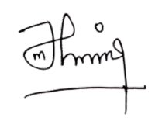
Author name(s) (in block letters) Signature(s)

Miftahul Jannah

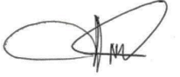
Muhammad Rifqi Hariri
Rina Sri Kasiamdari

Niken Satuti Nur Handayani

Note: fill and scan this form and upload along with the manuscript file during submission.

Editorial address: Faculty of Biology, UGM, Jl. Teknika Selatan, Sekip Utara, Yogyakarta 55281 Email: jtbb.biologi@ugm.ac.id | Website: http://jtbb.or.id

