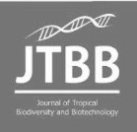
Journal of
Tropical Biodiversity and Biotechnology

Declaration of Originality

I hereby confirm that I am the author of the written manuscript here enclosed and that I have compiled it in my own words.

Title of manuscript (in block letters):
Ulva lactuca Linnaeus POTENTIALLY PROMOTES MALE REPRODUCTIVE INDICES AND DEPRESSIVE-LIKE BEHAVIOR OF HYPERTRIGLYCERIDEMIC WISTAR RATS (Rattus norvegicus Berkenhout, 1769)

With my signature I confirm that:
- I have not committed any of the forms of plagiarism.
- I have documented all methods, data and processes truthfully.
- I have not manipulated any data.
- I have mentioned all persons who were significant facilitators of the work. I am aware that the work may be screened electronically for plagiarism.

Place, date
Yogyakarta, October 9th 2020

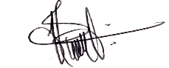
Author name(s) (in block letters) Signature(s)

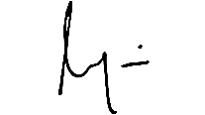
ANGGORO CHANDRA YULISTIYANTO

MAYUMI HERSASANTI
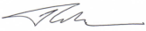
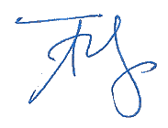
RAHADIAN YUDO HARTANTYO

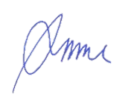
LAKSMINDRA FITRIA

ABDUL RAZAQ CHASANI

MULYATI

Note: fill and scan this form and upload along with the manuscript file during submission.

Editorial address: Faculty of Biology, UGM, Jl. Teknika Selatan, Sekip Utara, Yogyakarta 55281 Email: jtbb.biologi@ugm.ac.id | Website: http://jtbb.or.id

