Tabel 1. Data BB kambing dalam dua minggu
No. | BB awal (Kg) | BB akhir (Kg)
(P’)  1  2  3  4  (P-)  1  2  3  4  (P+)  1  2  3  4  (P1)  1  2  3  4  (P2)  1  2  3  4 | 16  16  16  16  16  16  16  16  16  16  16  16  16  16  16  16  16  16  16  16 | 18,8  18,5  18,5  19,2  19,5  19,2  18,8  18,8  19,9  19,5  19,5  19,2  20,5  19,8  20,2  20,2  20,2  20,2  19,8  20,3

Tabel 2. Kadar kolesterol kambing dalam dua minggu
No. | Kadar kolesterol awal (mg/dl) | Kadar kolesterol akhir (mg/dl)
(P’)  1  2  3  4  (P-)  1  2  3  4  (P+)  1  2  3  4  (P1)  1  2  3  4  (P2)  1  2  3  4 | 150  150  150  150  150  150  150  150  150  150  150  150  150  150  150  150  150  150  150  150 | 150  140  148  150  85  84  83  83  73  73  72  72  76  64  72  72  63  64  61  61

Grafik 1. Rata-rata peningkatan BB kambing harian
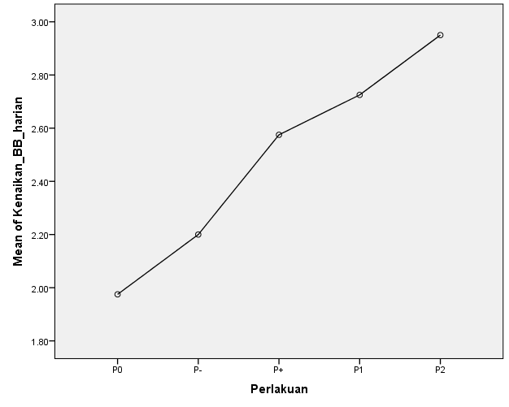
Grafik 2. Rata-rata penurunan kadar kolesterol kambing
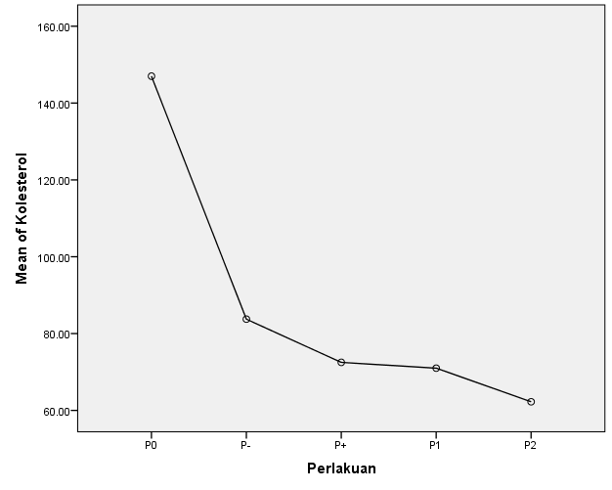

Tabel 3. Standar deviasi
Perlakuan | Mean ± Standart Deviation (SD)
 | Berat badan | Kenaikan harian | Kolesterol
P0 | 18,75^{c} ± 0,332 | 1,98^{c} ± 0,236 | 147,00^{d} ± 4,761
P- | 19,08^{c} ± 0,340 | 2,30^{bc} ± 0,245 | 83,75^{c} ± 0,957
P+ | 19,53^{b} ± 0,287 | 2,57^{ab} ± 0,150 | 72,50^{b} ± 0,577
P1 | 20,18ª ± 0,287 | 2,73ª ± 0,525 | 71,00^{b} ± 5,033
P2 | 20,13ª ± 0,222 | 2,95ª ± 0,173 | 62,25ª ± 1,500

