LIST OF FIGURE

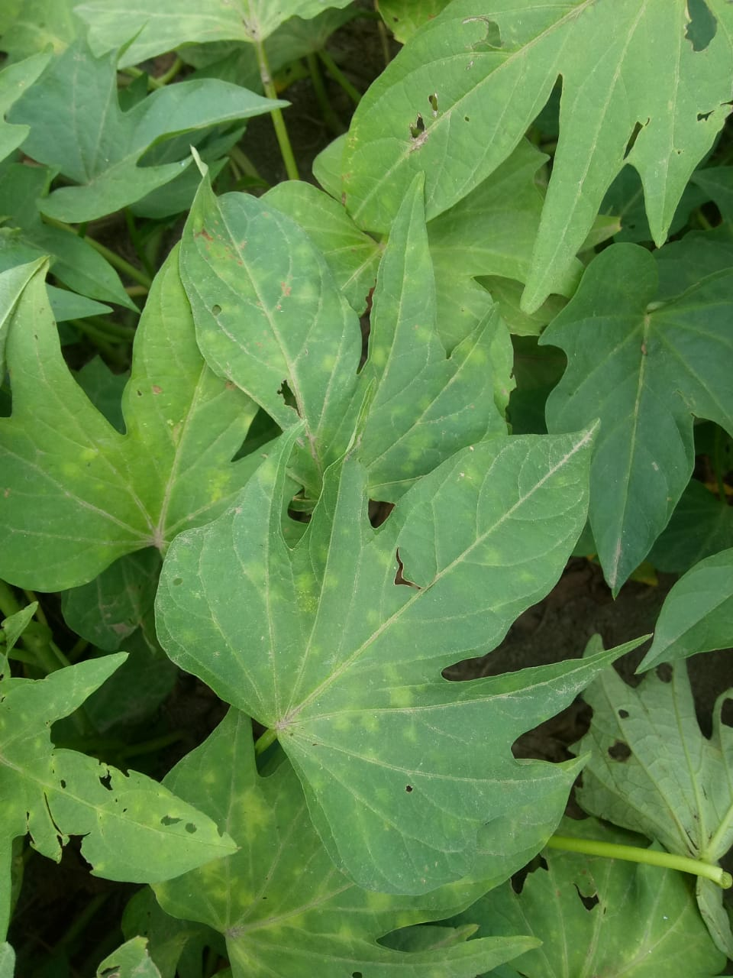
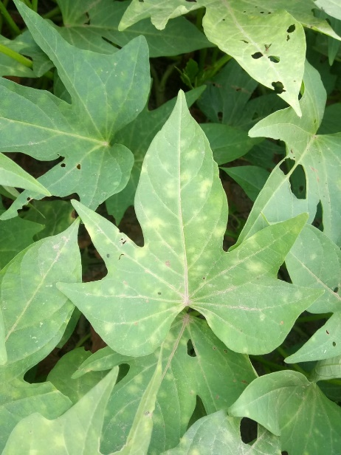
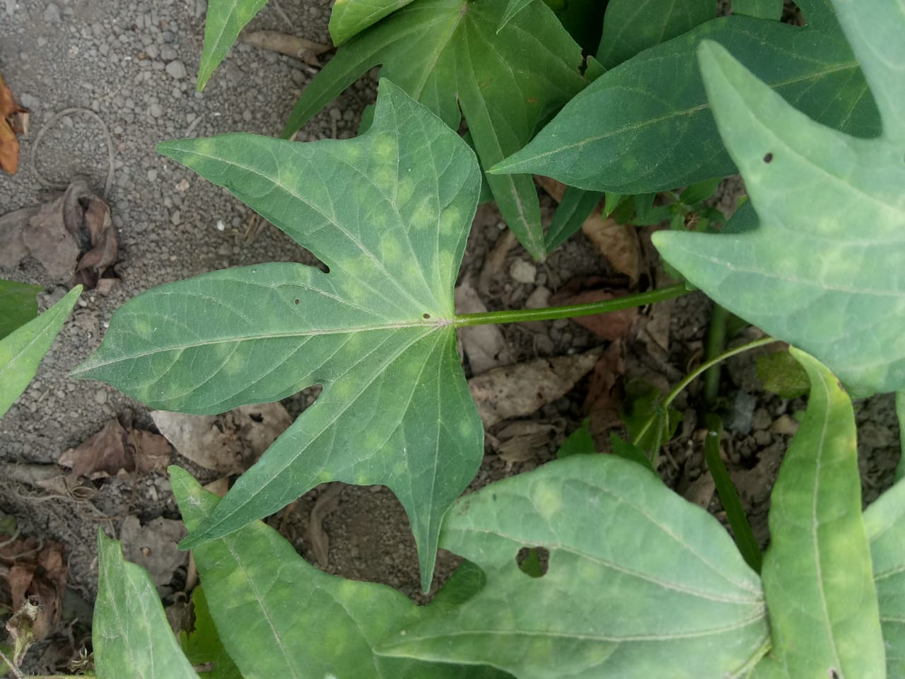

Figure 1.

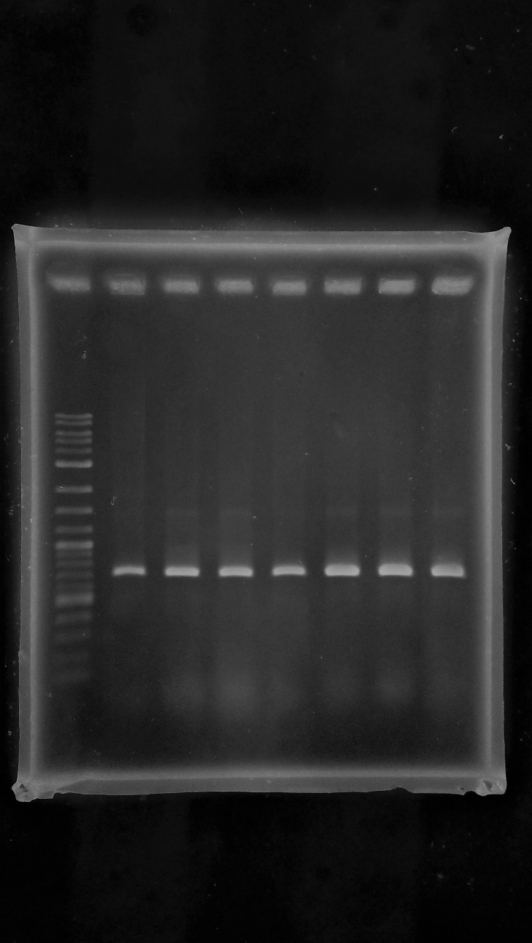
± 700 bp
± 500 bp
M 1 2 3 4 5 6 7 8 9 10

Figure 2.

