JURNAL PSIKOLOGI ISSN 2460-867X (online) ISSN 0215-8884 (print)

STATEMENT LETTER OF SUBMISSION / TRANSFER OF PUBLICATION RIGHTS

The undersigned below

Name : Tience Debora Valentina
Identity number : 5103056803790003
Type of identity : √ Identity card Driving license Passport Address : PS Psikologi Fak Kedokteran Universitas Udayana
Institution : Universitas Udayana

In respect to the scientific development in the field of Psychology, I hereby declare that,

- The entitled scientific work of
Making meaning of religious values in preventing a fatal suicide act of a bisexual youth with borderline personality disorder: A qualitative study
has never been published by any party. If there is a lawsuit and or loss of claim arising from another party in respect to the publication of this scientific work, the Faculty of Psychology Universitas Gadjah Mada is hereby exempted from any lawsuit that may arise in the future.

- I have have agreed to grant the Copyright Transfer Agreement and the Non-exclusive Royalty- free Right to the Faculty of Psychology Universitas Gadjah Mada upon my scientific work and the existing tools (if necessary).

- I hae approved the Faculty of Psychology Universitas Gadjah Mada to store, transfer to another media, administer it in a database, and to publish it as long as it includes the name and origin of my institution as author.
Thus, this consent statement is made in a conscious state, without any coercion from any party and will not be withdrawn.

Yogyakarta , 5 June 2020

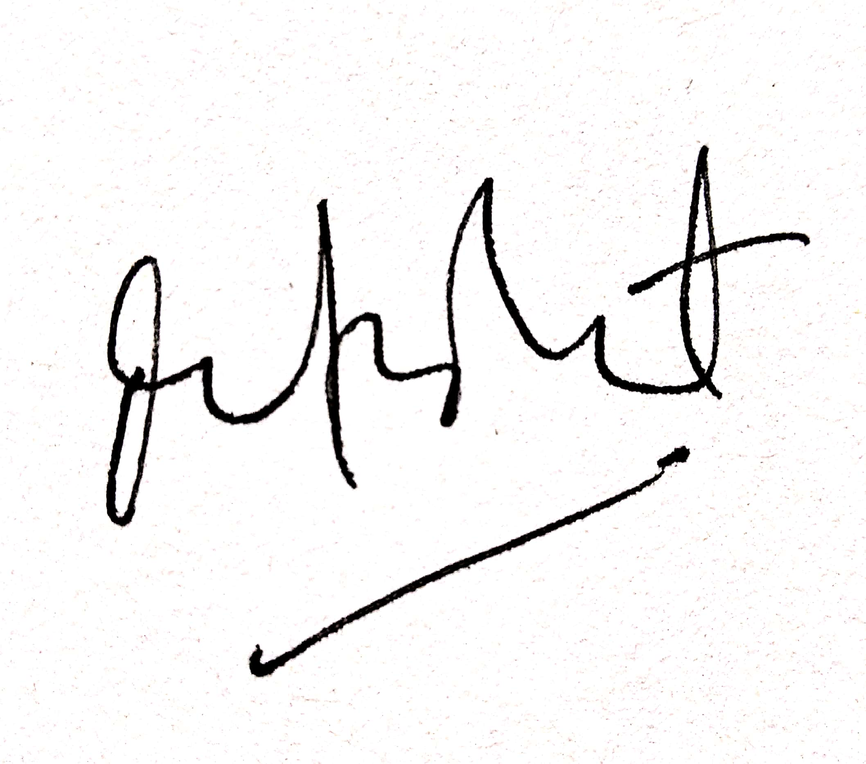

(Tience Debora Valentina)

https://jurnal.ugm.ac.id/jpsi jurnalpsikologi@ugm.ac.id

