Efforts to lose weight through regular gymnastics as an Overweight/Obesity Therapy in overweight/obese women aged 35-45 years

Yusni Yusni^{1*}, Amiruddin Amiruddin,² Razali Razali²

^{1*}Department of Physiology, Faculty of Medicine, Universitas Syiah Kuala, 23111 Banda Aceh, Indonesia
²Physical Education, Health and Recreation, Faculty of Teacher Training and Education, Universitas Syiah Kuala, 23111 Banda Aceh, Aceh, Indonesia

ABSTRACT
Background: The sedentary lifestyle is a risk factor for obesity and its comorbidities. Lifestyle modification by doing regular exercise is an easy and inexpensive way to lose weight. This service activity aims to change the community lifestyle from a sedentary lifestyle to an active lifestyle by increasing physical activity through regular exercise (gymnastics).
Methodes: The total participants were 19 people and divided into two groups: a group that did regular exercise (regular) as many as ten people and a group who did not do regular exercise (non-regular) as many as nine people. All participants were female and aged 30-45 years. All participants measured their body weight (BW), measured their height, and Body Mass Index (BMI) before and after giving gymnastics training. The type of activity carried out by participants was gymnastics modified from Zumba, Aerobic, and Salsa movements with a duration of 60 minutes per training session, 3-4 times per week, carried out at 05.00-06.00 p.m, for 12 weeks (3 months).
Results: The result was that the mean age of participants for the regular group was 35.3 years and for the non-regular group was 36.78 years. The results show that the body weight (BW) loss as much as 80% of participants in regular-group; otherwise, just as much as 22.22% of the participants who experienced BW loss in a non-regular group. The mean BW before and after gymnastics decreased by 3.65 kg in the regular group; on the other hand, the BW increased slightly by 0.06 kg in the non-regular group (68.25 and 84.6 vs 59.19 and 59.25 kg). BMI after gymnastics decreased by 1.53 kg/m² in the regular group, while BMI did not change in the non-regular exercise group (28.45 and 26.92 vs 27.01 and 27.01 kg/m²).
Conclusions: Modification of gymnastic movements Zumba, Aerobics, and Salsa movements can reduce the weight of women; therefore, it is necessary to sustain activities in order to help people reduce the risk of obesity. This activity has supported the activities of the government of Republic Indonesia to increase physical activity and avoid sedentary-lifestyle in community, helping to improve the health of society. Regular exercise is a preventive and curative effort for obesity in women.

Keywords: lifestyle, overweight, obesity, young women
- Introduction
Being overweight is particularly for obesity becomes a very frightening specter for every woman (Arora, 2019). Hormonal changes in young adult women (more than 30 years) accompanied by a lack of activity (sedentary lifestyle) provide an opportunity for risk of overweight/obesity and its comorbidities such as hypertension, diabetes, heart disease, and stroke, in consequence, it will increase the mortality rate (Gallagher et al., 2000; Salomé, Barnes, & Tremblay, 2017; Mark Stephen Tremblay, Colley, Saunders, Healy, & Owen, 2010). Excess body weight above 25% of ideal body weight is called obese (Lee & Ryu, 2018). Obesity is an abnormal accumulation of body fat or BMI that exceeds the threshold (>2 standard deviations) or usually, the amount of body fat percentage exceeds 20% for men and 25% for females and can harm health (Low, Chin, Ma, Heng, & Deurenberg-yap, 2002). Obesity is a condition of absolute or relative excess body fat (Aktar, Qureshi, & Ferdous, 2017; Low et al., 2002).
Obesity is a complex disease because it involves the interaction of several risk factors, including excess food intake, lack of movement or exercise (sedentary behavior), psychological factors, endocrine disorders, fat metabolism disorders, and genetics (Girdhar, Sharma, Chaudhary, & Bansal, 2016). Obesity does not only affect physical appearance and reduces the attractiveness of women but also becomes a public health problem in all age groups (Vasudevan, Klawans, Northrup, & Stotts, 2015). Obesity is caused by a multifactorial interaction between genetic and environmental factors, including eating habits high in calories, high in fat and low in fiber, physical inactivity or laziness, and socioeconomic factors (Mark S Tremblay, Pérez, Ardern, Bryan, & Katzmarzyk, 2005; Mark Stephen Tremblay et al., 2010).
Nowadays, changes in eating habits and also sedentary lifestyle are some of the main factors causing the increasing prevalence of obesity in almost all countries in the world, including Indonesia. Overweight and obesity occur due to energy intake is higher than the energy expended. The imbalance of intake and output energy will induce fat accumulation in adipose tissue. Highest energy intake is generally caused by consumption of high fat and high energy food, while low energy expenditure is due to lack of physical activity and sedentary lifestyle. Besides, the existence of modern facilities, such as: motorized vehicles, elevators, lift, air conditioning results in less energy being used to move. More than two million deaths each year are caused by lack of physical activity or sedentary lifestyle. Lack of physical activity and increasing sedentary lifestyle such as watching television, using computers, and playing games for a long time (>2 hours at a time) in adults also tend to increase the incidence of obesity. (Adiwinanto, 2008). Worldwide, the number of people who have a sedentary lifestyle range from 60% to 85%.
Obesity is world health and also a serious public health problem in developing countries, including Indonesia (Harbuwono, Pramono, Yunir, & Subekti, 2018). More than 1 billion adults worldwide are overweight, and over 300 million are obese. In the future, it is predicted that the obesity epidemic is not only familiar in developed countries but also will increase sharply in Asia countries, including Indonesia. Data from the World Health Organization (WHO) estimates that there are 1.6 billion adults are overweight, and over 400 million are obese (Girdhar et al., 2016). In 2014, as many as 13% of the adult population was obese where the prevalence is more in women (15%) than men (11%) (Girdhar et al., 2016). The prevalence of overweight in adults in the Asia Pacific has increased sharply, in the event of the incidence of overweight in 1990 was 34.6% then this figure has been increased dramatically to reach 40.9%. (Helble & Francisco, 2017). Approximately one-third (32.9%) or 72 million adult citizens of the United States are obese.
In Indonesia, obesity and obesity affect not only all age groups but also all socio-economic strata. The prevalence of obesity in Indonesia is around 23.1% (Harbuwono et al., 2018). From a total of 210 million people in Indonesia in 2000, gained as much as 76.7 million (17.5%) of the population is overweight and obese individuals achieve >9.8 million (4.7%). Based on data from Basic Health Research (Riskesdas) in 2007, the national prevalence of obesity in people aged ≥15 years is 10.3% (male 13.9%, female 23.8%) (Depkes RI, 2009). WHO states that obesity is one of 10 health problems that tend to increase the risk of other diseases in almost all countries by the world, and is also one of 5 health problems that are at risk of increase other diseases (comorbid) in several developing countries including, Indonesia.
Obesity will increase the risk of several comorbid diseases, such as hypertension, glucose intolerance, and atherosclerotic coronary heart disease, colorectal cancer, gout and arthritis, respiratory disorders in the elderly, low back pain, infertility, and decreased psychosocial function (Vasudevan et al., 2015). Obesity has developed into an epidemic in both developed and developing countries. Various methods are usually using to prevent and treat obesity, including variations between diet and exercise interventions. Exercise is an effective way to losing weight and preventing obesity (Zaharia, Dobrescu, & Rata, 2013). Other studies suggest that high-intensity interval training is an effective way for weight loss, body fat composition, and waist circumference (Domaradzki, Cichy, & Rokita, 2020). The results of research conducted by Anam et al. Stated that obese children have a low level of physical activity and physical fitness. Inadequate physical activity causes more body fat to be deposited on the tissue, while low physical fitness can affect the physical health of obese children. Research conducted in Austria by Widhalm, 2004 on 14 obese children who were boarded and given a strict exercise and diet program for three weeks, and the result was a weight loss of 4.7 kg.
Nowadays, various ways have been done by women to lose weight in order to get an ideal or normal body weight, including by way of surgery or liposuction. This method is high-cost accompanied by the risk of side effects if it is done by non-specialists. There are cheap and easy ways to lose weight or obesity therapy, including lifestyle modification through regular and measurable exercise accompanied by consuming foods that have anti-obesity effects (Swift, Johannsen, Lavie, Earnest, & Church, 2014). The increasingly sedentary lifestyle in Acehnese society can be the potential to increase the incidence of obesity and its comorbidities. Therefore, an effort is needed to empower these mothers or women to increase their activity and reduce sitting time to prevent overweight/obesity (Mazzeo, 2018; Wollaston et al., 2015). Doing regular exercises via gymnastics modified from Zumba, Aerobics, and Salsa becomes a way to control overweight for preventing obesity in women. This community service activity aims to reduce the body-weight of women overweight/obese. In consequence, it reduces the incidence of obesity in the community and prevents its comorbid diseases. This activity is beneficial for reducing the mortality and morbidity rates of obesity in young women.

- Methode
Participants were housewives from Darussalam around the Universitas Syiah Kuala campus. The total number of participants was 19 young women (aged 30-45 years). Participants have divided into two groups: one group was women who did regular exercise (a regular- gymnastics group) with ten women, and one group was women who did not do regular exercise (non-regular gymnastics group), amounting to 9 people. The regular exercise group is doing an exercise regularly, with a frequency of at least 3-5 times per week, the duration of 60 minutes per training session, and for three months (12 weeks). The non-regular exercise group was non=regular exercise women (exercise less than two times/week) for three months (12 weeks). The initial participants were 20 people (10 regular exercise groups and ten irregular exercise groups), but one woman from the routine exercise group is excluded because they were too fat (too extreme body-weight, around 115 kg). All participants were willing to volunteer to do exercise according to a predetermined schedule and sign a written informed consent.
Criteria participants were female, age between 30-45 years, physically and mental healthy based on the results of physical examination and anamnesis, not disabled, not suffered sports injuries or other physical injuries that can interfere with the activity of gymnastics, willing to be a participant with a willingness to sign a participant community service activity. The subject will be excluded if she is not willing to follow all the action through to completion, getting injury during the implementation of activities, need special medical treatment, or be treated for health problems.
This community service activity has carried out several examinations such as a physical examination and anamnesis, a physical fitness test, blood pressure measurements, and a blood laboratory examination. Blood laboratory tests include total cholesterol levels, high-density lipoprotein (HDL), low-density lipoprotein (LDL), and blood glucose levels. This paper only discusses the effect of regular exercise on weight loss and Body Mass Index (BMI) in women aged 30-45 years, while other examinations will publish in research journals. This activity provides benefits not only to provide non-pharmacological therapy (regular exercise) to lose weight for overweight/obese women as a form of community service but also to obtain research data that can publish in national and international scientific journals.
Physical examinations that were carried out were weighing (BW), height, and Body Mass Index (BMI) which were carried out twice, before and after 12 weeks of exercise (91st day). The form of service activities provided to partners is regular exercise modified from the Zumba, Aerobic, and Salsa exercises. The movement modification in question is that for one exercise, three types of exercise are carried out, namely 15 minutes for each type of gymnastic with a total of 45 minutes, while 15 minutes for warm-up and cool-down movements. Gymnastics is carried out with a duration of 60 minutes per training session, frequency 3-5 times per week (Monday-Friday), carried out at 05.00-06.00 pm, and for 12 weeks (3 months or 91 days). There have no dietary restrictions or dietary arrangements for all participants during the treatment (gymnastics). The venue for the activity was the Faculty of Medicine, Universitas Syiah Kuala, Darussalam, Banda Aceh. This activity was approved by the Medical and Health research ethics committee of the Medical Faculty, Universitas Syiah Kuala by its ethical registration number was 262/EA/FK-RSUDZA/2019.

- Results and Discussion
The results of the examination of participant community service activities can be seen, in Figure 1-5. Figure 1 shows that the age of the participants for both groups is 30-44 years old. The lowest age was 30 years, amounting to 4 people or around 21.05%, on the other hand, the highest age was amount 44 years or one person (5.26%) of the total number of subjects. The mean age of participants between both groups was different, about 35.3 years old for the regular-gymnastics group and around 36.78 years old for the non-regular gymnastics group.
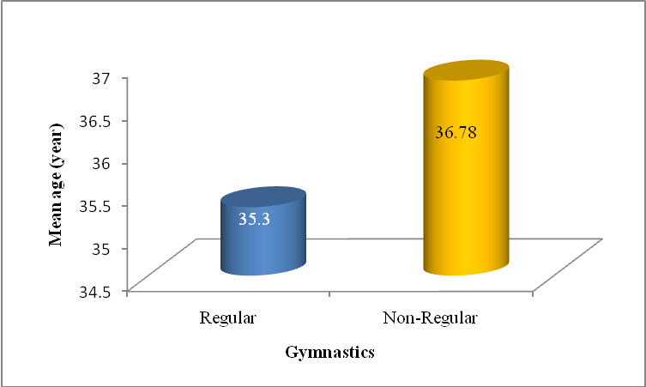
Fig. 1 Mean age in both groups

The BW measurement results for the regular gymnast group can be seen, in Figure 2. This figure shows that there was a difference between BW before and after gymnastics regularly. The average weight loss of the community service participants was 3.65 kg after 12 weeks of regular gymnastics. The results also showed that as many as 8 or 80% of the participants lost weight, only about 2 (20%) of the participants did not lose weight in the regular gymnastics group. Weight loss for each participant has varied from 1 to 10 kg.

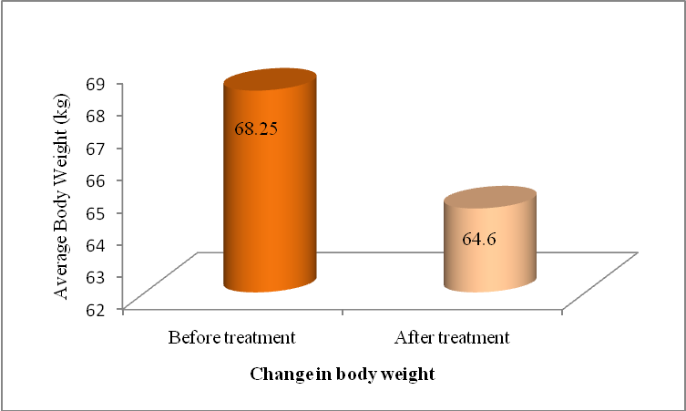
Fig 2. Overview of body weight before and after Gymnastics treatment in the regular gymnasts

The results of BMI examination, before and after 12 weeks in regular gymnastics group, as shown in Figure 3. The decrease in BMI varied between participants, where the lowest reduction was 0.40 kg/m², but the highest decline was 4.14 kg/m². These results indicate that regular gymnastics do not only reduce body weight but also reduce BMI values in women aged between 35-45 years. Therefore, gymnastics can be a non-pharmacological therapy for weight loss in women aged 35-45 years with overweight/obesity. Modification of aerobic, Zumba, and Salsa exercise movements can be a therapeutic modality for overweight/obese patients. Changes in lifestyle from a sedentary lifestyle to an active lifestyle reduced weight in consequence, it will be an impact on reducing the incidence of overweight/obesity in women. Regular physical activity is useful as a preventive and curative therapy for obesity in women.

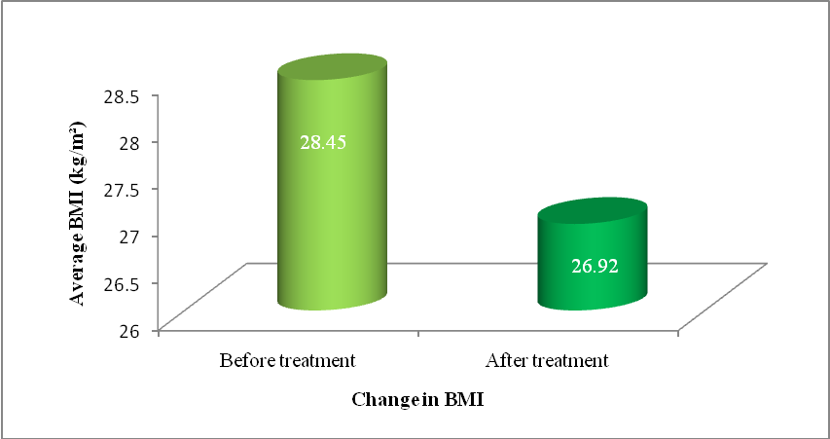
Fig 3. Overview of body mass index before and after treatment with Gymnastics in the regular gymnast group

The results of the BW examination in the non-regular gymnastics group can be seen, in Figure 4. The results indicate that out of a total of 9 participants only 2 participants or 22.22% experienced a decrease in body weight, while the remaining six people or 66.67% did not experience BW loss, there were even 1 (11.11%) of the participants whose BW increased by 2 kg after unregular gymnastics. These results indicate that irregular gymnastics (less than three times each week) cannot reduce body weight in overweight/obese women. Therefore, it is advisable to do regular exercise to reduce weight and BMI as a non-pharmacological therapy in overweight / obese women.

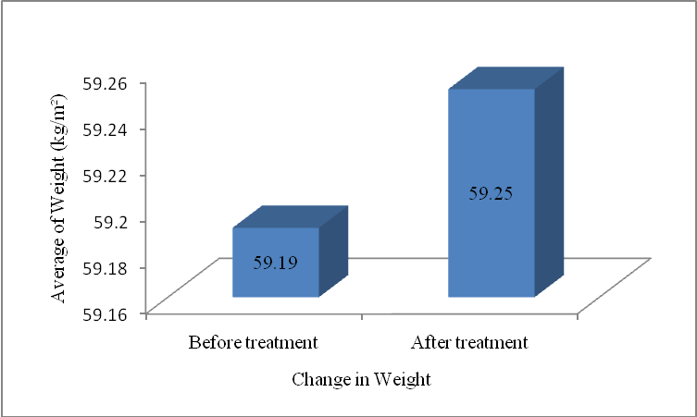
Fig 4. Overview of body weight before and after Gymnastics treatment in the non-regular gymnast group

The results of BMI measurement in the group with non-regular gymnastics shown in Figure 5. These results indicate that the BMI before and after the gymnastics did not change in the non-regular gymnastics group. This illustrates that irregular exercise did not affect weight loss and BMI in women overweight/obese.
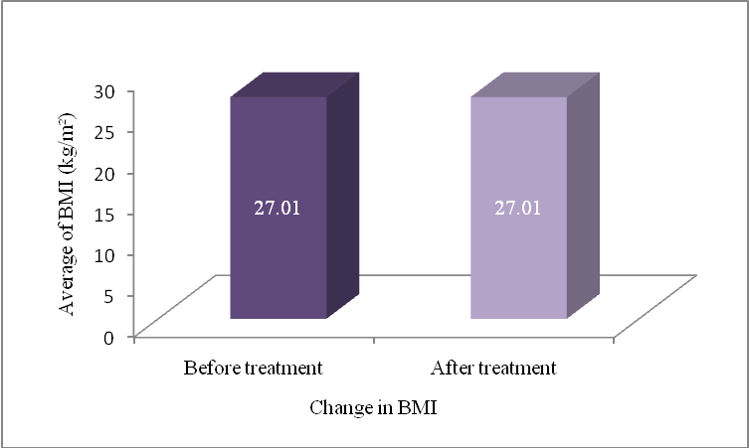
Fig 5. Overview of body mass index before and after Gymnastics treatment in the non-regular gymnast group

- Conclusion
This community service activity has been helped the community to increase physical activity and prevent sedentary lifestyle; therefore, it can control and prevent overweight/obesity in young women. This activity has helped government programs to change people's behavior from a sedentary lifestyle to an active lifestyle. It will be useful for the prevention and curative of overweight and obesity. These results were expected to help reduce the incidence of obesity and its comorbidities in society.

Acknowledgment
Thanks to the Institute of Research and Community Service of Universitas Syiah Kuala, which has funded the implementation of community service activities through grant funding sources dedication of Universitas Syiah Kuala with a grant number: 525/UN11/SPK/PNBP/2019 dated February 8, 2019. Thank you very much for the willingness of participants to volunteer to participate in this service activity. Without their help, this activity would not be carried out as expected.

Conflict of interests
The implementation and publication of this community service activity are known and approved by all teams; therefore, there is no conflict of interest in this activity.

REFERENCES
Aktar, N., Qureshi, N. K., & Ferdous, H. S. (2017). Obesity: A Review of Pathogenesis and Management Strategies in Adult. Delta Med Col J., 5(1), 35–48. https://doi.org/10.3329/dmcj.v5i1.31436
Arora, A. (2019). Fighting Obesity with a Smile. Acta Scientific Nutritional Health, 3(5), 64–70.
Domaradzki, J., Cichy, I., & Rokita, A. (2020). Effects of Tabata Training During Physical Education Classes on Body Composition, Aerobic Capacity, and Anaerobic Performance of Under-, Normal- and Overweight Adolescents. Int. J. Environ. Res. Public Health 2020,, 17(876), 1–11.
Gallagher, D., Heymsfield, S. B., Heo, M., Jebb, S. A., Murgatroyd, P. R., & Sakamoto, Y. (2000). Healthy percentage body fat ranges: an approach for developing guidelines based on body mass index. Am J Clin Nutr, 72, 694–701.
Girdhar, S., Sharma, S., Chaudhary, A., & Bansal, P. (2016). An Epidemiological Study of Overweight and Obesity Among Women in an Urban Area of North India. Indian Journal of Community Medicine, 41(2), 154–157. https://doi.org/10.4103/0970-0218.173492
Harbuwono, D. S., Pramono, L. A., Yunir, E., & Subekti, I. (2018). Obesity and central obesity in Indonesia: evidence from a national health survey. Medical Journal of Indonesia, 27(2), 114–120.
Helble, M., & Francisco, K. (2017). The Imminent Obesity Crisis in Asia and The Pacific: First Cost Estimates (pp. 1–33). Asian Development Bank Institute.
Lee, S. J., & Ryu, H. K. (2018). Relationship between dietary intakes and the double burden of malnutrition in adults of Malang, Indonesia: An exploratory study. Nutrition Research and Practice, 12(5), 426–435.
Low, S., Chin, M. C., Ma, S., Heng, D., & Deurenberg-yap, M. (2002). Rationale for Redefining Obesity in Asians. Annals Academy of Medicine, 38, 66–74.
Mazzeo, F. (2018). Current concept of obesity. Sport Science 9, 2(January 2016).
Salomé, A., Barnes, J., & Tremblay, M. (2017). New sedentary behaviour definitions: A terminology consensus project by the Sedentary Behaviour Research Network. Wellspring, 28(10), 1–5.
Swift, D. L., Johannsen, N. M., Lavie, C. J., Earnest, C. P., & Church, T. S. (2014). The Role of Exercise and Physical Activity in Weight Loss and Maintenance. Prog Cardiovasc Dis, 56(4), 441–447. https://doi.org/10.1016/j.pcad.2013.09.012.The
Tremblay, M. S., Colley, R. C., Saunders, T. J., Healy, G. N., & Owen, N. (2010). Physiological and health implications of a sedentary lifestyle. Appl. Physiol. Nutr. Metab., 35, 725–740. https://doi.org/10.1139/H10-079
Tremblay, M. S., Pérez, C. E., Ardern, C. I., Bryan, S. N., & Katzmarzyk, P. T. (2005). Obesity, overweight and ethnicity. Health Reports, 16(4), 23–34.
Vasudevan, D. A., Klawans, M. R., Northrup, T. F., & Stotts, A. L. (2015). Diagnosis and Management of Obesity among South Asians-A Paradigm. Journal of Family Medicine & Community Health, 2(7), 1–5.
Wollaston, S., Conservative, M. P., Cooper, R., Labour, M. P., Lancashire, W., George, A., West, B. N. (2015). Impact of physical activity and diet on health. House of Commons Health Committee, (March), 1–67.
Zaharia, A. ., Dobrescu, T., & Rata, G. (2013). The effectiveness of aerobic gymnastics means in preventing and fighting obesity. Bulletin of the Transilvania University of Braşov, 6(1), 1–4.

