DESIGN OF ENERGY-SAVING DISTILLER FOR PROCESSING PATCHOULI LEAVES INTO INDONESIAN STANDARDIZIED PATCHOULI OIL FOR SME IN KULONPROGO

ªKarna Wijaya, ^{b}Widi Kurniawati
Fakultas Matematika dan Imu Pengetahuan Alam, Universitas Gadjah Mada, Indonesia
ªkarnawijaya@ugm.ac.id, ^{b}widi.kurniawati@mail.ugm.ac.id
Nasih Widya Yuwono
Fakultas Pertanian, Universitas Gadjah Mada, Indonesia
nasih@ugm.ac.id
Farida
CV. Fruitanol Energy, Yogyakarta, Indonesia
farida89@mail.ugm.ac.id

ABSTRACT

Patchouli oil is an exporting commodity with high economic value that attracts interests in the field of business. In order to be marketed both for domestic and exporting consumptions, patchouli oil needs to be processed to fulfil requirements of the Indonesian National Standard (SNI). Various patchouli oil processing techniques have been developed by researchers but only a few actually meet the requirements of SNI. In this study patchouli leaves are processed into patchouli oil using an energy-saving distillers equipped with heat insulators. Patchouli oil was treated using bentonite-NaHCO₃ composite adsorbent through a hydrothermal process followed by calcination. The experiment was divided into two steps, namely the preparation of the distiller and adsorbent from bentonite and application of technology. The adsorbent material was prepared and analyzed at the Physics Chemistry Laboratory and the distiller was tested in CV. Fritanol Energy, Yogyakarta. Adsorbent and distiller were applied in the production process in Surya Wulan SME. The results of this study were that the distiller produced has a capacity of 15 kg, with costs saving of 35.5% and a time efficiency of 33.3% compared to the conventional technology in SME Surya Wulan. Patchouli oil produced also fulfils SNI quality requirements and was certified by LPPT UGM. The adsorbent of patchouli oil processing has been successfully made and meets the standards of adsorbent. It is able to reduce around 80% of the acid number of crude patchouli oil. In addition, networking and transfer of technology has been established between Universitas Gadjah Mada and Surya Wulan SME in Gerbosari, Kulonprogo.

Keyword: adsorbent, distiller, patchouli oil, transfer of technology.

1. INTRODUCTION
1.1 Background
The existence of patchouli oil is needed in the cosmetics and perfume industry as a fixative. Approximately 90% of today's global production of 1200‐1300 metric tonnes per annum is exported by Indonesia (Howarth, 2015; Lawrence, 2009). Patchouli oil is an essential oil obtained from the distillation process of leaves, stems and branches of patchouli plants. It is one of the essential oils whose function in the cosmetics especially perfume industries cannot be replaced by other synthetic substances since it has important role in determining the strength, properties and durability of the aroma produced. Patchouli oil becomes chemical substance or agent that stabilizes and preserves volatile components to bind scents of perfume so that it last longer (Kusuma et al., 2018). This is due to its characteristic that can form a harmonious aroma in a mixture, even it can actually be said to be perfume (Kusuma and Mahfud, 2016; Zhao et al., 2005). In the pharmaceutical industry, patchouli oil is used as an anti-inflammatory, anti-depressant, divertic, antifungal and antibacterial (Blank et al., 2011; Setiawan and Rosman, 2013). The demand for patchouli oil strengthens the existence of patchouli oil business groups to continue to exist and improve its production processes in order to manufacture products with qualities that fulfill SNI requirements in pursuance of entering national and international industrial markets. The price of patchouli oil export reaches Rp. 600,000 to Rp. 800,000 per kg with a net profit of Rp. 370,000 per kg (Chaidir, 2009) which is much higher in value than the price of patchouli leaves of Rp 1,200 per kg (Marbun, 2014).
Indonesia is one of the largest patchouli oil producers in the world and annually supplies around 70% to 90% of the world's need for the oil. Indonesia's patchouli oil supply to the world market reaches 2,000 tons per year. With such demand, patchouli oil processing plays a crucial role in the supply of patchouli oil. In order to enter the market of industry, specifically the perfume industry, the quality of processed patchouli oil must at least meet the Indonesian National Standard (SNI). The final quality of patchouli oil is determined by factors that arise pre and post-harvesting of leaves. Pre-harvest factors include the type of patchouli plants, cultivation techniques, methods, and harvest time a long with the surrounding environment. Meanwhile, post-harvest factors include handling methods, methods of processing, packaging, and storing.
1.2 Problem Analysis
Production of oil in Surya Wulan MSME currently still uses firewood as its main fuel. The use of a furnace stove system requires a continuous supply of wood and thus exhaustion of manpower. This causes the distillation process to be inefficient in terms of energy and time. Other main problem that the production faces is that the acid number of patchouli oil obtained is relatively high and not in accordance with SNI.
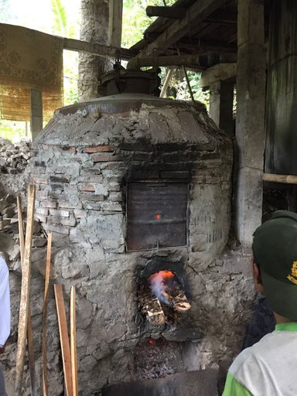
Figure 1. Distiller with wood furnace in Surya Wulan MSME
The distillation equipment owned by the MSME is also used for the distillation of clove oil. Hence, a cleaning process is required before it could be used for the distillation of patchouli oil. Consequently, patchouli oil is sometimes contaminated by clove oil that automatically decreases its quality and results in the failure to meet the SNI standard. Therefore, an efficient distillation plant is highly necessary, especially in patchouli oil production. It need to be simple and equipped with tools and materials for purification.
1.3 Technological Solution
The Dissemination of Appropriate Technology Program is expected to fulfill the wishes of Surya Wulan MSME as the distilling technology offered is relatively simple and energy efficient. The distilling installation provided was made of stainless steel equipped with a heat insulator. The heat insulator can reduce and prevent heat from escaping so that the distillation takes place effectively. This technology is equipped with patchouli oil purifier derived from Bentonite/NaHCO₃ composites to produce SNI products. The patchouli distiller and purifier installation had previously been developed by researchers at CV. Fruitanol Energy and proven to be able to produce patchouli oil that fulfils SNI 06-2385-1998.
2. METHODS
The object of patchouli oil distillation business study is Surya Wulan MSME in Gerbosari Village, Samigaluh District, Kulonprogo Regency. The social service program provided was divided into three parts, namely (1) preparation and testing of distiller in CV. Fruitanol Energy, (2) preparation of patchouli oil processing materials from bentonite and NaHCO3 and laboratory scale refining of patchouli oil and (3) transfer of technology to Surya Wulan MSME.
2.1 Patchouli oil distillation plant
The distillation plant that converts patchouli leaves into patchouli oil consists of a gas stove, patchouli leaf sample container, condenser and patchouli oil purifier. This system is equipped with water flow valves and thermometers. The working principle of this system is to distill patchouli oil from dried patchouli leaves using water vapor obtained from the heating of water up to 100°C. Water vapor will condensed and crude patchouli oil can be obtained. It is then separated from water through a purifying installation. The distiller was tested in CV. Fruitanol before being transferred to Surya Wulan MSME.
2.2 Bentonite/NaHCO3 composite adsorbent
The use of adsorbents aims to reduce acid number in patchouli oil so that they meet the quality requirements of the Indonesian National Standard (SNI). This alkaline composite material will absorb Fe metal so that the level can decrease, consequently decreasing the acid number. The material with a 20/80 bentonite/NaHCO3 ratio was manufactured a calcination process at a temperature of 300°C. The adsorbent material was formed like a pellet, dried in an oven, ready to be used to purify patchouli oil. The process of making adsorbents was carried out at the Physical Chemistry Laboratory of FMIPA UGM and the patchouli oil that had been purified was tested at LPPT UGM.
2.3 Transfer of technology to Surya Wulan MSME
The distiller which was previously tested in CV. Fruitanol Energy has been handed over to Surya Wulan MSME. Distiller operation training was also conducted at the MSME together with patchouli oil entrepreneurs in Gerbosari Village, Samigaluh, Kulonprogo.
3. RESULTS AND DISCUSSION
Patchouli oil distillation technique in Surya Wulan MSME had used a boiler system with primarily fuelwood. The process was relatively long, the level of fatigue required was also high because continuous supply of firewood was needed and the product obtained had high acid number. It might be simple, but high loss of energy and the product was not in accordance with SNI. Research-Based Community Service Grant and Utilization of Appropriate Technology Program in 2018 organized by the Directorate of Community Service UGM has facilitated the research team to introduce appropriate technology to Surya Wulan MSME in an effort to overcome the problems faced in patchouli oil production.
3.1 Patchouli oil distillation system
The research team has succeeded in introducing energy-saving distillation technology with a steam system that is integrated with condenser and purification devices and processing materials so that patchouli oil produced is SNI approved. This technology is simple and energy-efficient since the distillation process can be done in an hour with LPG gas and can produce clear yellow patchouli oil. This distiller has been successfully assembled and tested in CV. Fruitanol Energy.
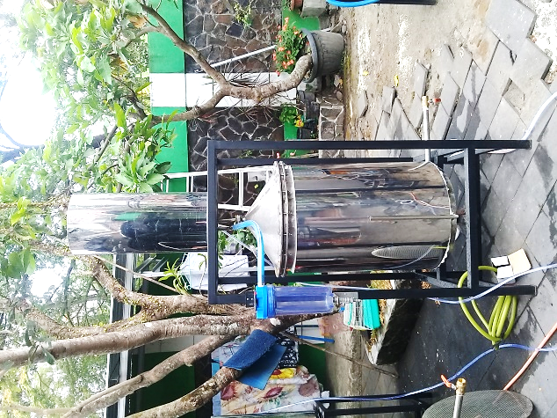
Figure 2. Patchouli oil distiller with a capacity 15 kg of dried patchouli leaves
The use of gas as fuel in the technology allows workers not to continuously supply wood, but merely replacing gas cylinder when necessary. One cylinder of 12 kg gas size can be used for 3 distillation processes with capacity of 15 kg of dried patchouli leaves for each process.
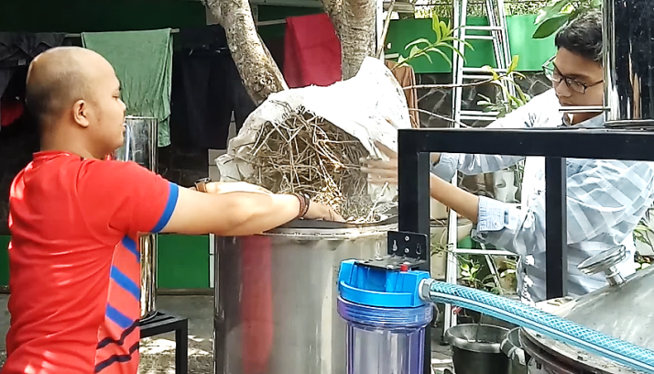
Figure 3. Distiller testing at CV. Fruitanol Energy
3.2 Bentonite / NaHCO₃ composite adsorbent
Bentonite material modified with NaHCO₃ through hydrothermal technique aims to increase its surface area and alkaline property thus rendering it more effective for Fe absorption from oil and decrease oil acid number. The absorbent has been successfully made and tested to purify patchouli oil on a laboratory scale. The results obtained are presented in Table 1: Patchouli Oil Test Results According to SNI 2006. The adsorbent has proven to effectively reduce the acid number of patchouli oil from 3.53 to 0.86 or decrease by 75.6%. In addition, Fe content in oil fell 1.34% from 0.373 mg/kg to 0.368 mg/kg.
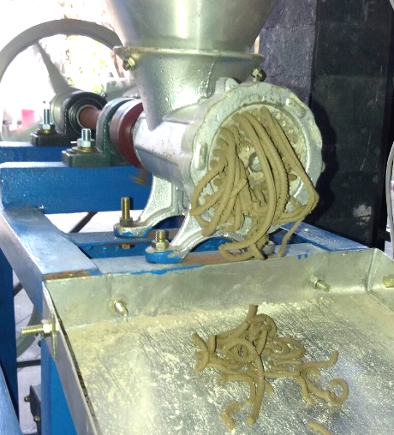
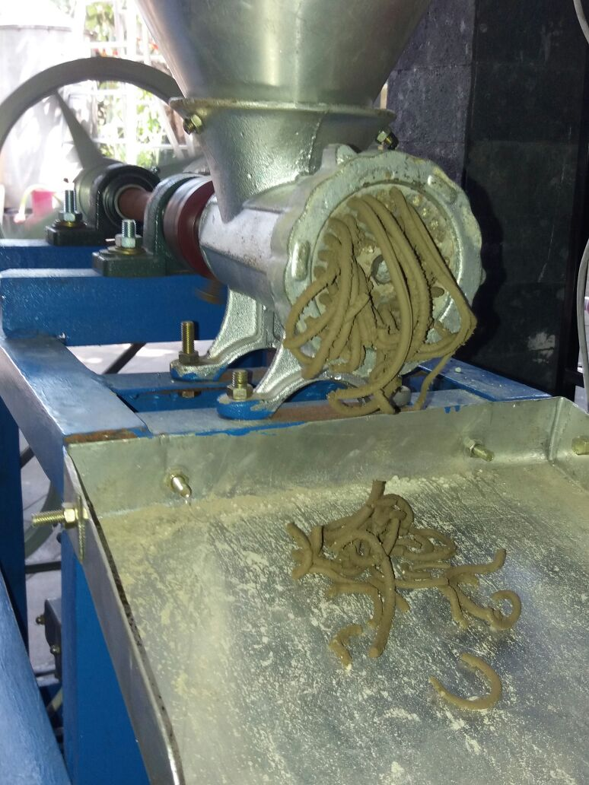
Figure 4. Adsorbent preparation
Figure 5. Crude Patchouli Oil
3.3 Transfer of technology to Surya Wulan MSME
The distiller that have been successfully tested in CV. Fruitanol then were ready to be installed at Surya Wulan SME. In addition, training on patchouli oil processing was conducted with Surya Wulan SME members and patchouli oil businesses actors in Gerbosari Village, Kulonprogo.

Table 1. Results of Patchouli Oil Characterization According to SNI 2006
No. | Jenis Uji | SNI | Minyak Nilam Awal | B (300) | NaHCO₃ (300) | B20-NaHCO₃80 (300)
1. | Warna | Kuning muda-coklat kemerahan | Kuning muda | Kuning muda | Kuning muda | Kuning muda
2. | Bobot jenis | 0,950-0,975 | 0,9548 | 0,9554 | 0,9556 | 0,9554
3. | Indeks bias | 1,507-1,515 | 1,53 | 1,54 | 1,53 | 1,51
4. | Kelarutan dalam etanol 90% | Larutan jernih atau opalesensi ringan dalam perbandingan volume 1:10 | 1:1 | 1:1 | 1:1 | 1:1
5. | Bilangan asam | Maks. 5 | 3,53 | 2,57 | 0,86 | 0,86
6. | Bilangan ester | Maks. 20 | 34,78 | 19,26 | 8,61 | 10,77
7. | Putaran optik | (-)48°- (-)65° | … | … | … | …
8. | Kadar Patchouli alcohol (%) | Min. 30 | 32,06% | 32,75% | 35,12% | 34,53%
9. | Kadar Fe (mg/kg) | Maks. 25 | 0,373 | 0,631 | 0,515 | 0,368

CONCLUSION
The conclusions obtained from this activity are as follows;
1. Patchouli oil distiller has been successfully manufactured with a capacity of 15 kg of dried patchouli leaves along with its purification device and has now been applied in CV Fruitanol Energy and Surya Wulan MSME.
2. Bentonite modified NaHCO₃ adsorbent has been successfully produced and used as a laboratory scale patchouli oil purifier.
3. Patchouli oil product has been tested and fulfil the SNI requirements.
SUGGESTIONS
This technology needs to be further refined, specifically in the design of the lid. Wherein the use of nuts and bolts can be reduced and combined with other techniques so that the process of closing and opening the lid of the distiller does not require a long time.
ACKNOWLEDGMENT
The authors would like to express gratitude towards the Directorate of Community Service of UGM for the Research-Based Community Service Grant and Utilization of Appropriate Technology in 2018, Surya Wulan and CV. Fruitanol Energy for its facilities and cooperation.
REFERENCES
Chaidir, A., 2009, Ignatius Susilo: dari Samigaluh Menjaga Mutu, Artikel dalam Majalah Trubus edisi 1 Agustus 2009.
Blank, A. F., Tricia, C. P. S., Priscilla, S. S., Maria, F. A. B., Ana, P. N. P., Hugo, C. R. J. and Pericles, B. A., 2011, Chemical characterization of the essential oil from patchouli accessions harvested over four seasons, Industrial Crops and Products, 34, 831-837.
Howarth, J., 2015, Natural product supply bulletin: patchouli, Mexican lime and the Crimean conflict, Perfum. Flavor., 40, 32‐37.
Kusuma, H.S. and Mahfud, M., 2016, Comparison of conventional and microwave-assisted distillation of essential oil from Pogostemon cablin leaves: Analysis and modelling of heat and mass transfer, Journal of Applied Research on Medicinal and Aromatic Plants, 4, 55-65.
Kusuma, H. S., Altway, A., and Mahfud, M., 2018, Solvent-free microwave extraction of essential oil from dried patchouli (Pogostemon cablin Benth) leaves, Journal of Industrial and Engineering Chemistry, 58, 343–348.
Lawrence, B. M., 2009, A preliminary report on the world production of some selected essential oils and countries, Perfum. Flavor., 34, 38‐44.
Marbun, J., 2014, Kulon Progo Kembangkan Budidaya Tanaman Nilam, Artikel Online, Republika.co.id edisi Minggu 23 Maret 2014.
Setiawan dan Rosman, R., 2013, Status Penelitian dan Upaya Peningkatan Kadar Patchouli Alkohol Pada Minyak Nilam, Perspektif, 2(12), 101.
Zhao, Z., Lu, J., Leung, K., Chan, C. L. and Jiang, Z., 2005, Determination of Patchoulic alcohol in Herba pogostemonis by GC – MS, Pharmaceutical Society of Japan, Japan.

