

COPYRIGHT TRANSFER AGREEMENT FORM

Jurnal Ilmu Pertanian (Agricultural Science) requires a copyright transfer agreement from the authors for the article submitted and published to Jurnal Ilmu Pertanian. Please complete and return this form:

|  |  |
| --- | --- |
| Article Title | : The Effect of Paclobutrazol Concentrations and Watering Frequencies on the Flowering Ratio of Cucumber Plants (*Cucumis Sativus* L.) |
| Author (s) | : Ratih Hartono Putri, Aziz Purwantoro, Valentina Dwi Suci Handayani, Dyah Weny Respatie |

1. I/we have read and agree with the term and conditions of this agreement, I/we hereby transfer all copyrights in and relating to the above-named manuscript in all form and media now or hereafter known, to the Jurnal Ilmu Pertanian (Agricultural Science) effective from the data stated below. I/we acknowledge that the Jurnal Ilmu Pertanian (Agricultural Science) are relaying on this agreement in publishing this manuscript.
2. I/we declare that this article has not already beenpublished elsewhere (except in abstract form or as part of a lecture, review, or thesis), not being submitted for publication elsewhere. All co-authors have agreed to publish in this journal and has a real contribution in the research and preparation of the manuscript. I/we also declare that there is no conflict of interest of this article.

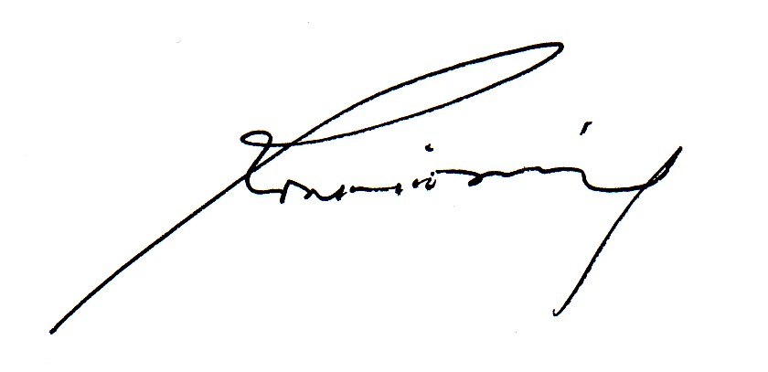

|  |  |
| --- | --- |
| Signature of copyright owner (s): | |
| Name of co-authors | Ratih Hartono Putri |
| Date | 06 Mei 2021 |

|  |  |
| --- | --- |
| Signature of copyright owner (s): |  |
| Name first authors | Ratih Hartono Putri |
| Date | 06 Mei 2021 |



|  |  |
| --- | --- |
| Signature of copyright owner (s): | |
| Name second authors | Aziz Purwantoro |
| Date | 17 Mei 2021 |

|  |  |
| --- | --- |
| Signature of copyright owner (s): | |
| Name third authors | Valentina Dwi Suci Handayani |
| Date | 06 Mei 2021 |

|  |  |
| --- | --- |
| Signature of copyright owner (s): | |
| Name fourth authors | Dyah Weny Respatie |
| Date | 06 Mei 2021 |