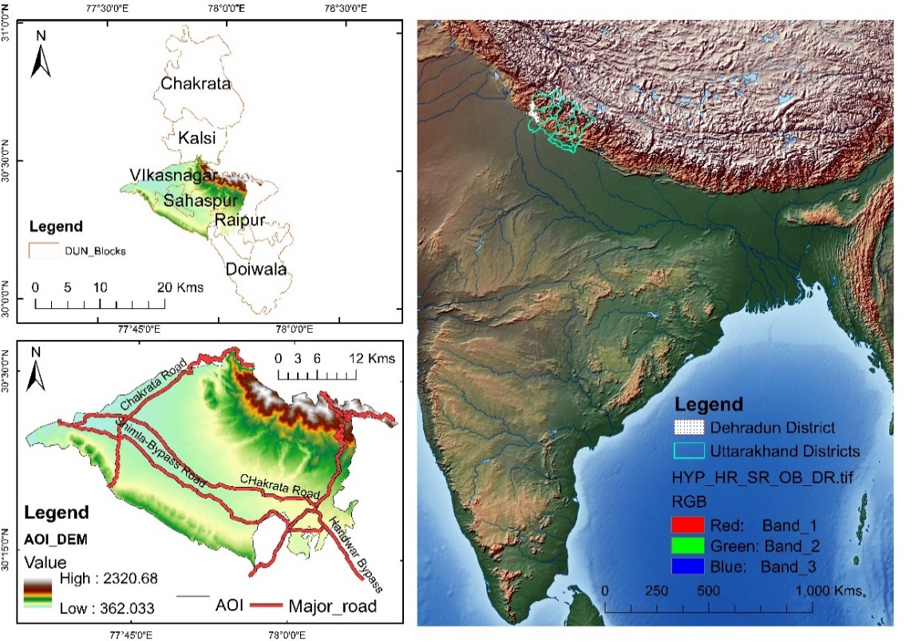
Figure 1-Location of the Area of Interest.

Figure 2: LULC change in the study area between 1989-2020. (1) AL (2) BUAs (3) O/SL (4) V/FC (5) WB.

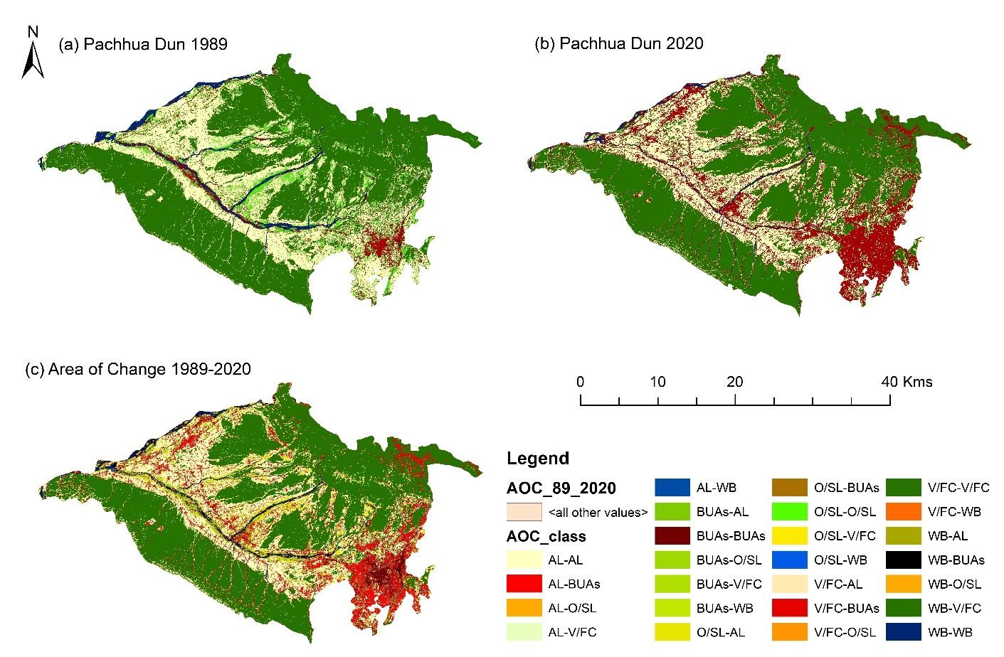
Figure 3 : Illustration of LULC change in the study area between (1989-2020) : Where (a) Landsat 5 image of year 1989; (b) Landsat image of year 2020 (c) represents the overall area of change map.

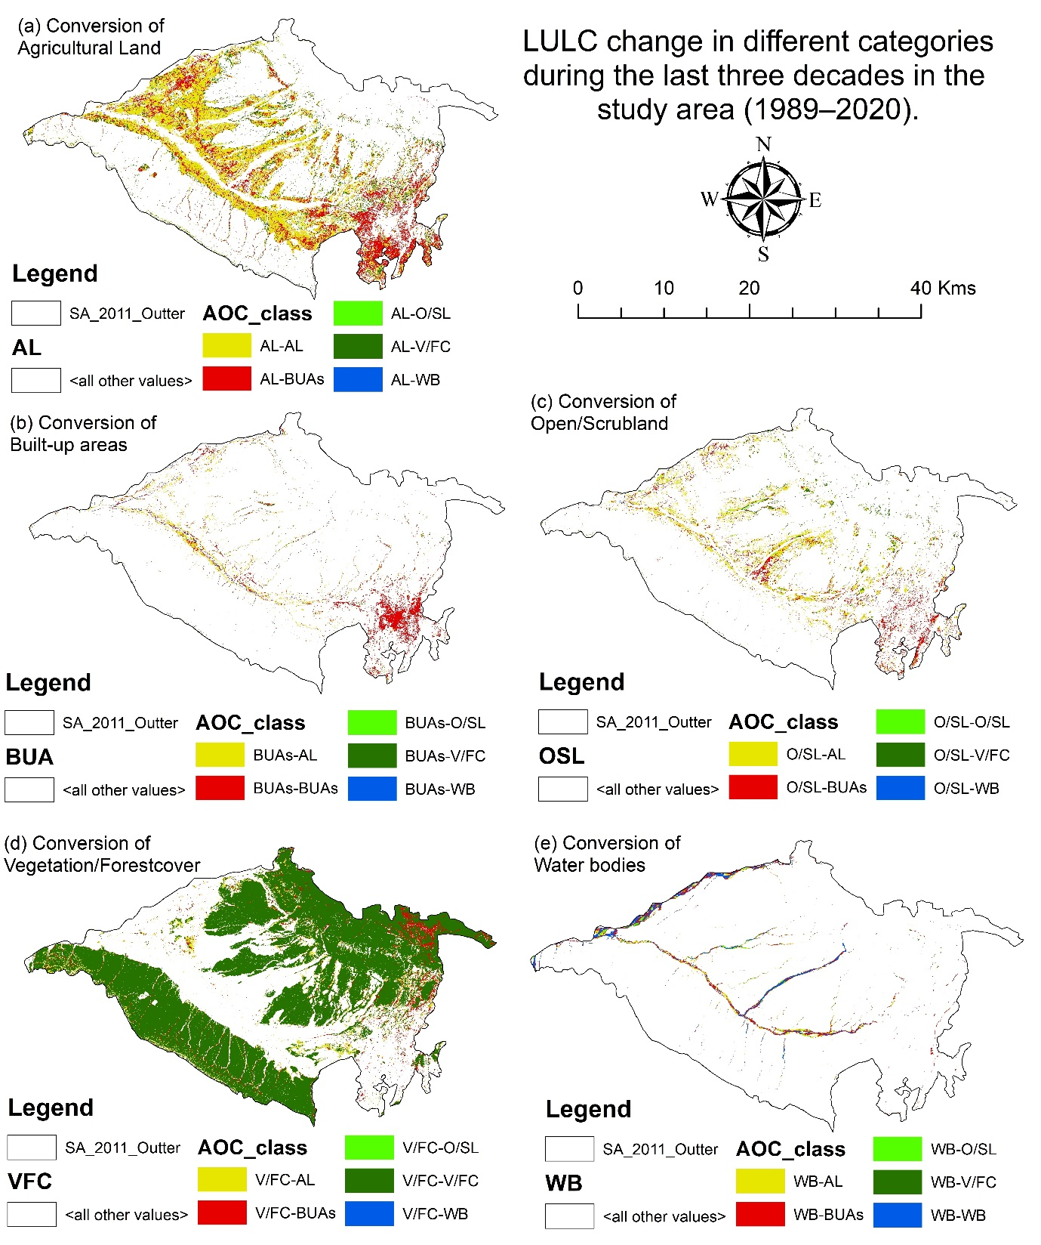
Figure 4. LULC in different categories during the last three decades in the study area (1989–2020) where, (1) AL (2) BUAs (3) O/SL (4) V/FC (5) WB.

