Date: March 27 2021

To: Chief editor of JCOEMPH

Dear Editor,

I am hereby pleased to to submit the manuscript entitled “The Screening of Heart Disease by Cardiac Auscultation and Electrocardiography Examination in Pregnant Women in Puskesmas Tegalrejo, Yogyakarta, Indonesia”. Seek to specify that I would be the corresponding author to this manuscript. I hereby confirm that the manuscript has been read and approved for submission and none of the paper's contents have been previously published. We assure that all the authors have reviewed the article and approved its contents.
In this paper, we emphasize the importance of 12-lead electrocardiography as an add-on routine integrated screening program for pregnant women. The maternal mortality of women in Jogjakarta showed a number that should be seriously considered. Cardiovascular disease was the vast majority of this mortality. Thus, here we showed that a cardiovascular screening, once during pregnancy showed a beneficial in early detection of cardiac abnormality leading to early management in pregnant mother. The pilot project in one of primary health center as part of community empowerment in this paper, found cases of previously undetected cardiac disease in asymptomatic pregnant mother using the simple method. We further expect that the project will be expanded into wider coverage.

Sincerely,

Corresponding author
Name: Dyah Wulan Anggrahini
Institutional Address: Department of Cardiology and Vascular Medicine, Faculty of Medicine, Public Health and Nursing Jl. Farmako Sekip Utara no 1. Yogyakarta 55281 Indonesia
Email: wulan.anggrahini@ugm.ac.id
Phone:+62811293349

The Screening of Heart Disease by Cardiac Auscultation and Electrocardiography Examination in Pregnant Women in Puskesmas Tegalrejo, Yogyakarta, Indonesia

Authors: L.K. Dinarti¹, D. S. Nurdiati², A. B. Hartopo¹, F. H. Assilmi¹, A. Salsabila¹, V. Dewanto^{1,}
A. Pritazahra¹, M. R. Hadwiono¹, M. G. Satwiko¹, E. A. Rochmat², Pravitasari², D. W. Anggrahini¹

Affiliation:
¹Department of Cardiology and Vascular Medicine, Faculty of Medicine, Public Health, and Nursing, Universitas Gadjah Mada, Dr Sardjito General Hospital, Yogyakarta, Indonesia
²Department of Obstetrics and Gynecology, Faculty of Medicine, Public Health, and Nursing, Universitas Gadjah Mada, Dr Sardjito General Hospital, Yogyakarta, Indonesia

Corresponding Author:
Name: Dyah Wulan Anggrahini
Institutional Address: Department of Cardiology and Vascular Medicine, Faculty of Medicine, Public Health and Nursing Jl. Farmako Sekip Utara no 1. Yogyakarta 55281 Indonesia
Email: wulan.anggrahini@ugm.ac.id
Phone:+62811293349

ABSTRACT
Background: Women adapt to pregnancy through multi-organ system physiologic changes, including cardiovascular changes. These changes affect differently to those with pre-existing cardiovascular problems, and subsequently lead to higher probability of death caused by cardiovascular diseases during pregnancy. Therefore, detection of cardiovascular disease early in pregnancy is important to lower maternal morbidity and mortality by providing prompt and adequate management.
Aim: This study aims to evaluate and test the feasibility of integrating 12-lead ECG examination and ANC screening as a simple and effective method for early detection of heart abnormality in pregnant woman using 12 lead electrocardiography.
Methods: Pregnant women in any trimester who attended antenatal care for a routine pregnancy examination in Puskesmas Tegalrejo Yogyakarta, were recruited in this study. The subject underwent primary screening which focused on cardiac auscultation and ECG, and those who had abnormal findings were further followed up in secondary screening by using trans-thoracal echocardiography to confirm heart abnormality.
Results: A total of 523 pregnant women from Puskesmas Tegalrejo were included in this study. 15 (2,8%) pregnant woman were suspected to have heart abnormalities, from those 3 (0,5%) was found with heart murmurs with abnormal ECG readings, 1 (0,19%) had heart murmurs with normal ECG results, and 11 (2,1%) had abnormal ECG readings only. The secondary screening of those patient resulted in 1 (0,19%) pregnant woman was diagnosed with Atrial Septal Defect.

Conclusions:
Our study found that 0,19% of patients who underwent ANC had newly diagnosed pre-existing cardiac abnormality. Our study concluded that this screening method is a simple and feasible integrated heart screening program that can be implemented widely. We hope this integrated heart screening program may benefit pregnant women who may have cardiac abnormalities to be detected as early as possible, thus reducing maternal morbidity and mortality.
Keywords: Cardiovascular diseases, pregnancy, electrocardiography, screening

- INTRODUCTION
Globally, the maternal mortality is considerably high. Based on WHO data in 2017, aapproximately 295,000 women died during and following pregnancy and labor. A great number of these death (94%) happened in low-resource settings and mostl of the cases were preventable. To battle the rising number of maternal mortality, as well as other concerning problems in the world, world leaders have agreed to propose certain targets to reach. The Millennium Development Goals (MDGs) target which was needed to be achieved for maternal mortality rate was 102 per 100.000 live birth rates by 2015. However, existing data showed that in Indonesia by 2015, maternal mortality rate was 305 per 100.000 live birth rate, which was three times higher than the MDGs target.¹ In 2015, at the United Nation Sustainable Development Summit a new agenda was adopted in the form of 17 Sustainable Develompent Goals (SDGs). One of the goals is to reduce the global maternal mortality ratio to less than 70 per 100 000 live births by 2030. All UN member states, including Indonesia, have pledged to implement SDGs. Therefore, Indonesia has been working hard to tackle causes of maternal mortality by conducting various regulations and health promotions.²
In pregnancy, various physiological changes occurred in blood volume, red cell mass, left ventricular mass and elevated cardiac output (CO) which will increase cardiovascular demand to meet the needs of the fetus.³ Mortality and morbidity of pregnant woman who have a pre-existing cardiac abnormality or develop cardiac problems during pregnancy are increasing worldwide.⁴
Cardiovascular disease (CVD) is one of cause of death during pregnancy in developed countries, and cardiovascular complications may develop in 0.2%–4% of pregnancies, even if no prior cardiac disease was detected.^{4,5} In other study, one of the diseases which commonly found in pregnancy is pulmonary arterial hypertension (PAH).² Congenital Heart Disease (CHD) is associated and included in PAH subgroup.² Data had showed that women are affected 3-4 times more frequently than men.² Pregnant women with PAH were reported to have high rates of maternal (30–56%) and fetal death (11–28%). Progressive pulmonary vascular obliteration can cause right heart failure and stroke from intracardiac shunting are examples of various causes of poor maternal outcomes.⁷
Data from the Indonesian Ministry of Health in 2015 showed that maternal mortality rate is 305 out of 100,000 births, and the maternal mortality rate due to heart disease in pregnancy ranges from 1–2%. The risk of maternal death increased in cases with pulmonary hypertension, Eisenmenger syndrome, coarctio aorta, and complicated Marfan syndrome.⁸ Datas acquired from Indonesia Ministry of Health in 2017 had stated that maternal mortality in Yogyakarta in the year of 2017 were 34 per 42.348 live birth rate (0,08%). The causes of death were mostly due to heart disease (29%), while 0,29% emboli, 14% bleeding, eclampsia 0,29%, and 0,9% caused by pre-eclampsia.¹ Cohard PH registry from single centre study in Indonesia showed that 780 (77%) of 1012 patients were females who were first diagnosed at reproductive age ranged between 18-40 years old and 67% have had PAH.⁹
One of the program in Indonesia that have been utilize to reduce maternal mortality rate in Indonesia was optimalization of Antenatal Care (ANC). ANC was performed routinely on schedule for pregnant women and focused on general physical examinations and obstetric examinations. Specific heart or cardiovascular examinations were rarely performed, thus patients with asymptomatic cardiovascular disease could be undetected. Several studies on cardiovascular abnormality screening methods have been performed by combining cardiac auscultation, 12 lead electrocardiography and echocardiography.^{7,10} Electrocardiography (ECG) is a simple, effective, and easy to perform for diagnosing cardiovascular heart disease. Based on our previous study, this program has been proven effective as a screening method of cardiovascular disease in children.¹⁰ However, in Indonesia this examination has never been performed routinely in pregnant women. Thus, the main purpose of this study is to evaluate and assess the ability of screening program by using cardiac auscultation and 12-leads electrocardiography to detect heart abnormality in pregnant women.

- METHODS
An observational-descriptive study was performed to analyse the application of cardiac abnormality screening method based on physical examination and electrocardiography pregnant woman in Yogyakarta. The screening program was conducted by a team of professional health providers in Puskesmas Tegalrejo, Yogyakarta. This screening program was integrated with routine antenatal care (ANC) in Puskesmas.
Purposive sampling was performed to pregnant woman who had ANC in Puskesmas Tegalrejo in Yogyakarta. Verbal and written consent have been collected from all participants. This screening method was integrated with ANC services in Puskesmas Tegalrejo and consisted of two stages, primary and secondary screening. Primary screening was performed on Mei 2019 - October 2019 and secondary screening was performed in November 2019.
Primary screening examination utilized physical examinations (inspection, percussion, palpation, and auscultation using cardiology stethoscope) and 12-lead electrocardiogram (ECG) examination. The 12-lead electrocardiogram was made up of three standard limb leads (I, II, III), three augmented limb leads (aVR, aVL and aVF) and six precordial leads (V1, V2, V3, V4, V5, V6). Secondary screening was given to pregnant women who showed abnormal ECG reading from primary screening and/or had abnormal heart murmurs. During secondary screening, to find and diagnose heart abnormality transthoracal echocardiography was used.
The 12-lead ECG and physical heart examinations were performed by general practitioners and midwives from Puskesmas Tegalrejo who previoulsy had been trained to use standard method. Interpretations of the ECG reading were categorized into normal and abnormal. Cardiologist then confirmed the abnormal ECG readings that had been found. The suspected pregnant woman with abnormal heart murmurs and/or confirmed abnormal ECG readings would undergo secondary screening by cardiologist.
Data analysis was performed using SPSS Statistics Version 22. Data were presented as means and standard deviations or median and interquartile ranges or proportions, as appropriate.

- RESULTS
A total of 523 pregnant women of any trimester from one primary health care center were included in the study. The mean of age was 28.59 (± 5,75) years old and most of the subject were multiparous, which was 312 (61.56%) pregnant women. The characteristics of the participants was shown in Table 1. From 523 participants, we found 15 (2,8%) pregnant woman were suspected to have heart abnormalities. Based on the result of primary screening 3 (0,5%) women was found with heart murmurs with abnormal ECG readings, 1 (0,19%) had heart murmurs with normal ECG results, and 11 (2,1%) had abnormal ECG readings only. The secondary screening of those patient resulted in 1 (0,19%) pregnant woman was diagnosed with Atrial Septal Defect. Table 2 showed the findings of the primary and secondary screening

 | N (%) | Mean (±SD)
Age (years old) |  | 28.59 (± 5,75)
Parity
Multiparous | 312 (61.56%)
Nulliparous | 211 (40.34%)
Heart Rate (x/min) |  | 83,86 (± 10,05)
Oxygen saturation (%) |  | 98,35 (± 1,50)

Table 1. Baseline characteristics

Screening | Incidence
Primary screening | 15/523 (2.87%)
Heart murmurs with abnormal ECG readings | 3 (0,57%)
Heart murmurs with normal ECG readings | 1 (0,19%)
Abnormal ECG readings only | 11 (2,10%)
Secondary screening | 1/523 (0.19%)
Congenital Heart Disease (Atrial Septal Defect) | 1 (0,19%)
Table 2. Incidence of cardiac abnormality during ANC

  - PICTURES AND FIGURES

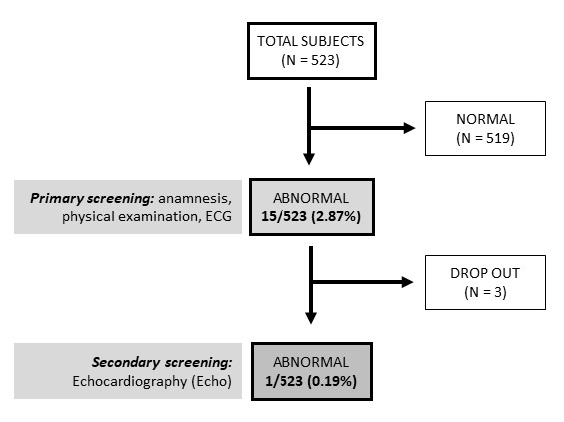

Figure 1. Study flowchart of integrated cardiac screening in ANC

Figure 2. Types of abnormal findings from primary screening

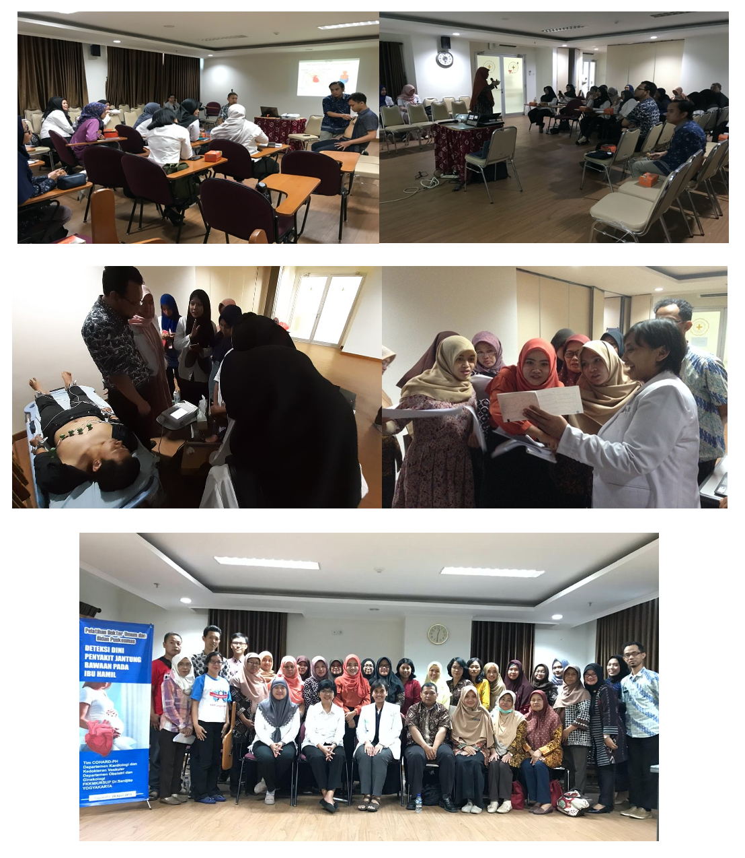
Picture 1. Training of primary health care doctors and midwives from Puskesmas Tegalrejo and Puskesmas Jetis
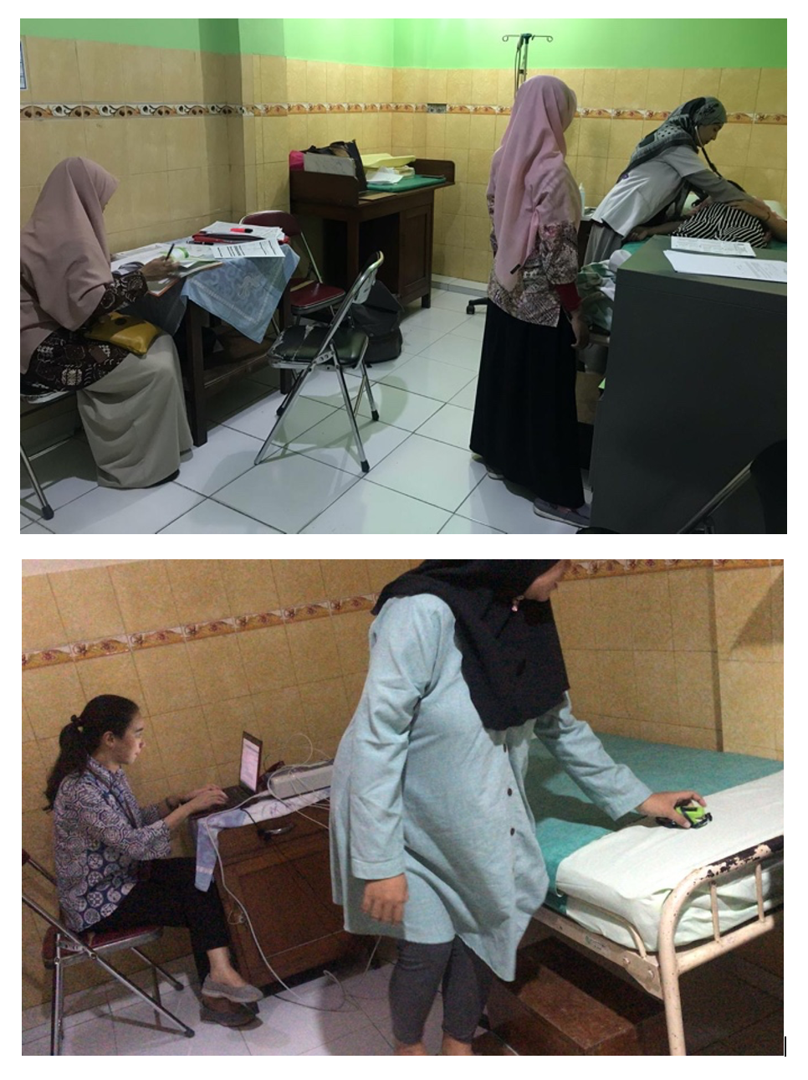
Picture 2. Screening in primary health care center Puskesmas Tegalrejo

4. DISCUSSION
The screening program of heart disease in pregnant women by using 12-leads ECG was the first systematic program that focused on heart abnormality in prengant women in Indonesia. With collaboration between midwives, general practioners, cardiologist and obstetrician this program had worked well and provide satisfactory results. This study found newly diagnosed cardiac abnormality rate among 523 subject who attended routine antenatal care, which was 1 (0,19%) participant with previously undiganosed congenital heart disease (CHD).
CVD is the leading cause of maternal death in the world. The variability of CVD among pregnant woman are different between countries according to European Society of Cardiology (ESC) and American College of Cardiology/American Heart Association (ACC/AHA) guidelines.⁶ In the Western countries, congenital heart disease (CHD) is the most common CVD during the pregnancy (75%–82%), whereas in non-Western countries, rheumatic heart disease (RHD) is the most common CVD (56%–89%).⁵ A study by Subbaiah et al. described that cardiac disease was found to complicate 3.8% of pregnancies. From their retrospective study, pregnant women were diagnosed with CVD in their third trimester.¹¹ Common complaints found at pregnancy could mimic symptoms in cardiovascular diseases, such as shortness of breath and heart palpitation. These symptoms were commonly occur during third semester of pregnancy, which could also resulted from pre-existing CVD. These are few of many reasons of delayed in diagnosing CVD in pregnany, which subsequently lead to inaccurate management. Thus resulting in high maternal morbidity and mortality caused by cardiovascular diseases.⁴
In developed countries several methods have been regulated to detect and manage cardiovascular disease during pregnancy. In the United States, one of many efforts to combate this problem is a toolkit that includes an overview of clinical assessment and management strategies for CVD based on risk factors and presenting signs and symptoms. The toolkit reccomends an algorithm for clinicians to use as a guide to differentiate sign and symptomps related to cardiac diseases and those of normal pregnancy, as well as further follow-up. The algorithm was based on risk factors, symptoms, vital sign abnormalities, and physical examination findings commonly identified in women who die of various types of cardiovascular disease. Study to asses the toolkit had been conducted and included 64 CVD induced maternal deaths. The study found that the use of algorithm have identified 56 out of 64 (88%) cases of CVD.¹² However, this algorithm primarily detect seriuos cases of CVD disease in late stage pregnancy.
The rate of CVD in pregnant women has also increased in developing countries. Many factors contributed to this transition, with the most prevalent was due to the increased number of women with congenital heart disease (CHD) reaching childbearing age and the adjustment in demographics associated with advancing maternal age resulted from improvement in health care services. A study in Turkey has found CVD rate of 5.2% among healthy women in the first trimester of pregnancy. The study enrolled pregnant women in their first trisemester, without cardiac symptoms and previously known CVD history. All patients underwent physical cardiac examinations, 12-leads ECG, and transthoracal echocardiography. The study suggested that based on their findings pregnant women who do not have any clinical risk or cardiac symptom, should be referred to a cardiologist and undergo ECG examination in their first trimester. Eventhough the cardiac screening required larger fund, it could be lifesaving as provided early recognizion of pre-existing CVD that may become aggravated in pregnancy.⁷
Several risk scores are available as an important step in recognizing the risk of maternal complications during and after pregnancy in patient with CVD, one of those is the modefied WHO (mWHO) risk classification. The stratification is based on the underlying diagnoses, therefore previous history of CVD should be known. Investigation before pregnancy should be carried out, and consist of thorough history taking, physical examination, an ECG, echocardiogram and exercise test. Complete physical examination is required to recognize heart murmurs, gallop sound, elevated central venous pressure, rales, hepatosplenomegaly and peripheral oedema. An ECG could provide prognostic information, for example if a new or known atrial fibrillation is found.13 We adopted two simple examination for this screening, cardiac auscultation and 12-lead electrocardiogram.
Due to the high mortality rate, Indonesian Government has established a proposal to reduce maternal mortality in the 2014-2019 National Medium-Term Development Plan (RPJMN). One of the programs is ANC (Antenatal Care). Indicators used to evaluate the access of pregnant women to ANC services are K1, the first contact in the first trimester and K4, 4 contacts in the final trimester. Nationally, the rate of coverage for antenatal care services is considerably high, K1 reaches 92.24% and K4 reaches 84.36%. Nevertheless, the current ANC program focuses on physical examinations and supporting examinations related to pregnancy problems, thus have limitations in detecting heart disease in pregnant women.¹ We integrated our heart screening program into the ANC, in order to save time and resources, as well as providing a more comprehensive care.
This finding highlights the feasibility and ability to perform and integrate the heart screening in prengant women with the current ANC program by using cardiac auscultation and 12-lead electrocardiogram. The team from Puskesmas Tegalrejo with the help of our team have successfully performed examinations of primary screening after being trained to refresh the technique to perform cardiac auscultation and 12-lead electrocardiogram and to recognize heart murmur and normal pattern of electrocardiogram reading. Several limitations has been observed regarding the cardiac screening. The ANC service is provided during working hours of Puskesmas, thus paralel with general polyclinics. The shortage of general practioners and available ECGs at the Puskesmas were the main problem of the program. Another limitation of this study is the possibility of bias and subjectivity of cardiac auscultation by primary health clinians or general practioners during primary screening. Trainings on heart auscultation prior to primary screening for primary health cares’ doctor is needed to improve their performance Nevertheless, this screening was well received by the participants and considerably uncomplicated and easy to perform.

5. CONCLUSIONS
Cardiovascular screening during pregnancy could use simple tool that effective, not expensive, and available even in rural area in Indonesia. Early detection of cardiac diseases during pregnancy can be lifesaving because cardiac problems is one of the major cause of maternal death in worldwide including Indonesia.
Based on our study, the cardiac abnormality rate is (n=1, 0,19%) among 523 healthy pregnant women in any trimester. This study showed that it is possible to integrate heart screening with ANC in pregnant woman in Yogyakarta city by using cardiac auscultation and 12-lead electrocardiogram. However, logistics availability as well as human resources are among things that need to be prepared for the primary health care center or government to integrate heart disease screening with ANC so that the program can be optimally implemented. Other important factors that need to be done is proposing standard algorithm for routine cardiac screening to diagnose cardiac abnormality early in pregnancy, to achieve maximum benefits.

ACKNOWLEDGMENT
Authors ackownledge the faacilitation and support of Puskesmas Tegalrejo. Authors deeply appreciated the contributions of general practitioners and midwives from Puskesmas Tegalrejo. Authors acknowledged the assistance Cardiology Residents on the excution of this program.

FINANCIAL RESOURCES
This study was supported by Hibah DAMAS Penelitian 2019 Faculty of Medicine, Public Health, and Nursing Universitas Gadjah Mada, Yogyakarta Indonesia for Lucia Kris Dinarti as principal investigator

CONFLICT OF INTEREST

None.

REFERENCES
- Dinas Kesehatan Daerah Istimewa Yogyakarta. Profil Kesehatan Daerah Istimewa Yogyakarta Tahun 2019. Yogyakarta. 2020; 21-31.
- Sustainable Development Goals [Internet]. Who.int. 2021 [cited 1 January 2021]. Available from: https://www.who.int/health-topics/sustainable-development-goals#tab=tab_1
- Hemnes A, Kiely D, Cockrill B, Safdar Z, Wilson V, Hazmi M et al. Statement on Pregnancy in Pulmonary Hypertension from the Pulmonary Vascular Research Institute. Pulmonary Circulation. 2015;5(3):435-465.
- Adam K. Pregnancy in Women with Cardiovascular Diseases. Methodist Debakey Cardiovasc J. 2017;13(4):209–15.
- Bouvier-Colle MH, Mohangoo AD, Gissler M, Novak-Antolic Z, Vutuc C, Szamotulska K, et al. What about the mothers? An analysis of maternal mortality and morbidity in perinatal health surveillance systems in Europe. BJOG An Int J Obstet Gynaecol. 2012;119(7):880–90.
- Gordon CA, Rosenthal AH, O’leary JL. Heart disease and pregnancy. Am J Surg. 1952;83(1):72–82.
- Bozkaya V, Kaplan Z, Özgü E, Engin-Üstün Y. The Screening And Evaluation Of Newly Diagnosed Cardiovascular Diseases In First Trimester Asymptomatic Pregnant Women In A Tertiary Antenatal Care Center In Turkey. The Anatolian Journal of Cardiology. 2019;.
- Seeland U, Bauersachs J, Roos-Hesselink J, Regitz-Zagrosek V. Update of the ESC guidelines 2018 on cardiovascular diseases during pregnancy: Most important facts. Herz. 2018;43(8):710–8.
- Dinarti LK, Hartopo AB, Kusuma AD, Satwiko MG, Hadwiono MR, Pradana AD, et al. The COngenital HeARt Disease in adult and Pulmonary Hypertension (COHARD-PH) registry: A descriptive study from single-center hospital registry of adult congenital heart disease and pulmonary hypertension in Indonesia. BMC Cardiovasc Disord. 2020;20(1):1–11.
- Dinarti LK, Murni IK, Anggrahini DW, Dewanto VC, Pritazahra A, Hadwiono MR, et al. The screening of congenital heart disease by cardiac auscultation and 12-lead electrocardiogram among Indonesian elementary school students. Cardiol Young. 2020;1–10.
- Subbaiah M, Sharma V, Kumar S, Rajeshwari S, Kothari SS, Roy KK, et al. Heart disease in pregnancy: Cardiac and obstetric outcomes. Arch Gynecol Obstet. 2013;288(1):23–7.
- Hameed AB, Morton CH, Moore A. Improving Health Care Response to Cardiovascular Disease in Pregnancy and Postpartum. California Maternal Quality Care Collaborative. 2017;(November).
- Van Hagen IM, Roos-Hesselink JW. Pregnancy in congenital heart disease: Risk prediction and counselling. Heart. 2020;106(23):1853–61.

