Community Based Intervention: Local Village Preparedness in Prevention and Control of COVID-19

Rasdiyanah¹, Muhammad Jauhar²*, Lita Heni Kusumawardani³, Utami Rachmawati⁴,
I Gusti Ayu Putu Desy Rohana⁵

¹Nursing Department, Faculty of Medicine and Health Sciences, Universitas Islam Negeri Alauddin Makassar , Indonesia
²Nursing Department, Health Polytechnic of Ministry of Health Semarang, Semarang, Indonesia
³Nursing Department, Faculty of Health Sciences, Universitas Jenderal Soedirman, Purwokerto, Indonesia
⁴Faculty of Nursing, Universitas Indonesia, Depok, Indonesia
⁵Nursing Department of Baturaja, Health Polytechnic of the Ministry of Health Palembang, Baturaja, Indonesia

ABSTRACT COVID-19 pandemic has became the global concern as its largedly affected the various aspects of such as health, economy, social, culture, and religion. Community empowerment in breaking the chain of region-based COVID-19 spread is an effective approach that can be taken. This intervention is alternatively important measure to slower the morbidity and mortality of COVID-19 that is remained predominantly in Indonesia. This article aims to describe the implementation of a community-based COVID-19 prevention program that was carried out on 280 families in six sub-districts in Brebes Regency from May to June 2020. The assessment used a questionnaire of COVID-19 transmission risk, with a total of 29 indicators developed based on references from the Indonesian Ministry of Health. The preliminary assessment of our program found several things that were related to the risk of COVID-19 transmition in the village and observed that there was insufficient public knowledge about COVID-19 including poor practice of health protocols and the negative stigma of society towards COVID-19 patients. The community-based program consisted of several activities namely consisted of program introduction, coordination with stakeholders, community assessments, group discussions, village community deliberations, health education of COVID-19 and 6 step hand washing, distribution of cloth masks, socialization of mask usage and care, socialization of pregnancy checks during the pandemic, provision of hand washing facilities in front of the house, activities evaluation, follow-up plans, and closings. Furthermore, the aforementioned activities also used videos, posters, leaflets, WhatsApp, as well as Zoom Cloud Meetings as the media. Evaluation phase of the program showed a better understanding related to COVID-19 and health protocol practice in each region. Community empowerment and collaboration with health care facilities can be pursued as a frontline solution to tackle the transmission of COVID-19. Good support and active community participation can contribute to improve the public health status.

KEYWORDS COVID-19, community, empowerment, prevention, preparedness

- Introduction
Corona Virus Disease 2019 or COVID-19 is a disease caused by infection with the latest type of Severe Acute Respiratory Syndrome Virus 2 (SARSCOV-2), which is currently referred to as novel coronavirus (2019-nCoV) (1). The swift spread of this disease has infected 11.84,226 people and caused death to 545,481 people worldwide (Case Fatality Rate / CFR 4.6%) (2). In addition, Indonesia is the country with the highest COVID-19 cases in Southeast Asia. One of the factor related to this situation is that Indonesia is located on the international route to China so that it has a high risk of transmitting the COVID-19 virus (3). Indonesia reported 1,051,795 confirmed cases with 29,518 deaths as of January 30, 2021 (4). The Indonesian government has annoounced a Public Health Emergency (Kedaruratan Kesehatan Masyarakat in Bahasa Indonesia, KKM in short) and established a COVID-19 KKM in Indonesia, which must be taken into account (5). The spread of COVID-19 has almost reached all provinces in Indonesia with the number of cases and/or the number of deaths increasing and having an impact on political, economic, social, cultural, defense and security aspects, as well as the welfare of the people in Indonesia (5).
The prevention of KKM is carried out through the implementation of quarantine and the implementation of Clean and Healthy Living Behaviors (PHBS), but it is considered not optimal to break the chain of COVID-19 transmission due to the increasing number of positive confirmations in Indonesia (6). Various policies have been issued by the government in an effort to tackle COVID-19. The countermeasures that have been pursued include the imposition of Large-Scale Social Restrictions (PSBB), replacing office and school activities with online-based activities known as Work Form Home (WFH), mandatory wearing masks for people who still have to do activities outside the house, social distancing which is currently changing to physical distancing, and the provision of handsainitizers in public places to build the habid of hand washing (7). The lack of information related to objectives and the government's participation in implementing policies makes people less likely to comply, because they must continue to be active in order to fulfill their daily needs (8).
The key success of breaking COVID-19 chain of transmission requires community empowerment to implement preparedness in the community. Communities who are involved in the empowerment process will have a greater ability to control and participate in the decision-making process about disease management and life (9). The implementation of empowerment requires support from the closest people and information through clear and structured education so that the enthusiasm and life expectancy of clients who experience health problems will increase (10). Delivery of targeted information will increase knowledge and interest as well as in efforts to implement PHBS to prevent transmission of COVID-19 (11). The implementation of community service with the concept of empowering the Youth Organization in preventing the transmission of COVID-19 in Wonogiri is able to increase knowledge and community activeness to be involved in these activities.
Brebes Regency is the second district with the largest population in Central Java Province, namely 1,809,096 people live within the area of ​​176,962.89 hectares (Central Bureau of Statistics, Brebes Regency, 2020). The average rate of population growth is 0.4 with a sex ratio (F/M) of 101.39 and an average length of schooling is 6.20 years, thus indicating the need to increase the potential of population resources in terms of skill development and education. Most of the area of ​​Brebes Regency is lowland with an average rainfall of 18.94 mm per month. This condition makes the area very potential for the development of agricultural products such as rice, horticulture, plantations, fisheries, animal husbandry and so on. The agricultural sector is supported by a rice field area that reaches 63,635.04 hectares, with the main products being rice and shallots. In the livestock sector, there are more broilers, layer breeds and native chickens.
Brebes Regency held the status of the COVID-19 red zone in early May 2020. Meanwhile, the data shows that the availability of health service facilities per 100,000 population, 1 polyclinic, 2 Community Health Centre (Puskesmas), and 3 Satelite Puskesmas, with a hospital availability ratio of 0.72. Statistic Bureau data of 2019 also shows that the top 3 diseases experienced by the population are infectious diseases in the form of diarrhea, TB and DHF. Based on environmental studies and literature, Brebes District needs community-based COVID-19 prevention preparedness efforts.

- Method
This activity is integratedly carried out during interprofessional education and collaborative practice of the field practice service program (KKN) held by the Poltekkes of the Ministry of Health in Semarang during the COVID-19 pandemic. This activity was attended by 11 final year applied health science undergraduate students from nursing, dental nursing, environmental health, midwifery, radiology, and nutrition majors. Students were assigned as volunteers for the COVID-19 village in their respective residences. This activity was carried out in May-June 2020 in Larangan, Tonjong, Bumiayu, Brebes, Paguyangan, Bantarkawung, Brebes Districts. Village volunteers coordinated with stakeholders; conducted studies, group discussions, and community meetings; implemented programs, evaluated, and published the activities. This activity is funded by the 2020 Ministry of Health's DIPA Poltekkes Semarang funds and non-binding community organizations.
The village volunteers have been trained in the form of one-day online seminar with the topics of interprofessional health collaboration in dealing with health problems from the Indonesian Ministry of Health also the transmission of COVID-19 infection from the Poltekkes Ministry of Health Semarang, and lastly promotional and preventive efforts of COVID-19 from the COVID-19 Central Java Provincial Health Task Unit. From day 2 to 5, village volunteers conduct assessments on families by practicing strict health protocols. The assessment process used a COVID-19 risk of transmission questionnaire encompassing 29 indicators that was developed base on references from the Ministry of Health using the Guttman scale. Moreover, the following day 7 to 19 was spent to conduct group discussions, community meetings, and the program implementation.
The programs that have been carried out are health education on the prevention and transmission process of COVID-19, simulating 6-step hand washing using soap, providing hand washing facilities in front of the house, distributing cloth masks, socializing the usage and care of cloth masks, and socializing pregnancy checks during the COVID-19 pandemic as they are one of the vulnerable groups. In addition, some of these activities were carried out online and offline with the use of supporting media such as videos, posters, leaflets, WhatsApp, and Zoom Cloud Meetings. Lastly, during day 20 to 22, village volunteers conducted activity evaluations, draw up follow-up plans, and reporting the whole completed activities before finally held an online wrapped up session of the program at the 23rd day.

- Results
Risk factors of COVID-19 transmission in the community
Table 1. Risk factors of COVID-19 transmission in the community (n = 280)
Risk factors | f | %
Domestic/international travel history  Yes  No | 0  280 | 0  100
Meeting foreign tourists  Yes  No | 0  280 | 0  100
Contact with COVID-19 patient history  Yes  No | 1  279 | 0.4  99.6
Health Issues  Fever  Yes  No  Cough  Yes  No  Sore throat  Yes  No  Shortness of breath  Yes  No  Cough or runny nose  Yes  No | 4  276  4  276  1  279  3  277  4  276 | 1.4  98.6  1.4  98.6  0.4  99.6  1.07  98.93  1.4  98.6
Medical History (Comorbid)  Diabetes mellitus  Yes  No  Hypertension  Yes  No  Heart Disease  Yes  No  Kidney Disease  Yes  No  Bronchitis / asthma / pneumonia  Yes  No | 4  276  29  251  3  277  2  278  1  279 | 1.4  98.6  10.3  89.7  1.07  98.93  0.7  99.3  0.4  99.6
Vulnerable groups  Pregnant women  Yes  No  Breastfeeding Mother  Yes  No  Know how to breastfeed  Yes  No  Do online pregnancy checks  Yes  No | 4  276  17  263  3  277  1  279 | 1.4  98.6  6.07  93.93  1.07  98.93  0.4  99.6
Risk-prone behaviors  Travel history to the COVID-19 red zone  Yes  No  Residing in the COVID-19 red zone  Yes  No  Receiving guests from the COVID-19 red zone  Yes  No  Visiting sick people  Yes  No  Undergo dental checks  Yes  No  Meeting with >10 people  Yes  No | 13  267  142  138  10  270  13  267  117  163  95  185 | 4.64  95.36  50.7  49.3  3.6  96.4  4.64  95.36  41.8  58.2  33.9  66.1
COVID-19 related Knowledge  Definition of COVID-19  Yes  No  Causes of COVID-19  Yes  No  Transmission of COVID-19  Yes  No  Prevention of COVID-19  Yes  No | 179  102  176  104  200  80  197  83 | 63.6  36.4  62.9  37.1  71.4  28.6  70.4  29.6
COVID-19 prevention behavior  Availability of hand washing facilities  Yes  No  6 step hand washing knowledge  Yes  No  Availability of masks  Yes  No  Wearing masks when outdoors  Yes  No  Nutritious food consumption  Yes  No  Sunbathing in the morning  Yes  No | 86  194  129  151  260  20  208  72  187  93  58  222 | 30.7  69.3  46.07  53.93  92.9  7.1  74.3  25.7  66.8  33.2  20.7  79.3
COVID-19 related perception  Agreeing to ostracize COVID-19 patients  Yes  No | 58  222 | 20.7  79.3
Total | 280 | 100
Table 1 shows that all families (100%) have never traveled domestically or internationally in the last 14 days and have never met foreign tourists. There is 1 person (0.4%) who has a history of contact with a person who is positive for COVID-19. Data on health issues related to COVID-19 symptoms were obtained, namely 4 people (1.4%) had fever, 4 people (1.4%) had cough symptoms, 1 person (0.4%) had sore throat, 3 people (1.07%) complained of shortness of breath, 4 people (1.4%) complained of coughs and colds. Furthermore, we also observed the medical history such as diabetes mellitus (1,4%), hypertension (10.3%), heart disease (1.07%), kidney disease (0.7%), and lastly bronchitis (0.4%). In addition, there were 4 people (1.4%) who were pregnant, only 1 person (0.4%) had an online pregnancy check up. As many as 17 people (6.07%) were breastfeeding, 98.93% of them did not know how to breastfeed their babies during the pandemic.
Furthermore, Table 1 also explains that as many as 13 people (4.64%) have a history of travel to the COVID-19 red zone, 142 people (50.7%) live in the COVID-19 red zone, 10 people (3.6%) have received guests from the COVID-19 red zone. Further assessment of the COVID-19 related knowledge also found 29.6% of the villager did not know about the COVID-19 preventive procedures whilst the 4.64% of them visited the sick person in the neighborhood. Preventive behaviors related to COVID-19 are still lacking, as shown by 9.3% do not have hand washing facilities in front of the house, 53.93% do not practice 6 step hand washing, 7.1% did not have a mask, 25.7% did not use a mask when leaving the house, 33.2% did not consume nutritious food, and lastly 42.5% did not sunbathe every morning.
Poor understanding of COVID-19 poses a risk of spreading COVID-19 in the community as it leads to low practice of health protocols. This was indicated by as many as 102 people (36.4%) did not know the meaning of COVID-19, 104 people (37.1%) did not know the cause of COVID-19, 80 people (28.6%) did not know how COVID-19 was transmitted, besides 117 people (41.8%) still undergo dental examinations at the clinic and 95 people (33.9%) still held meetings with more than 10 people. Furthermore, as many as 58 people (20.7%) agreed that COVID-19 patients should be ostracized.

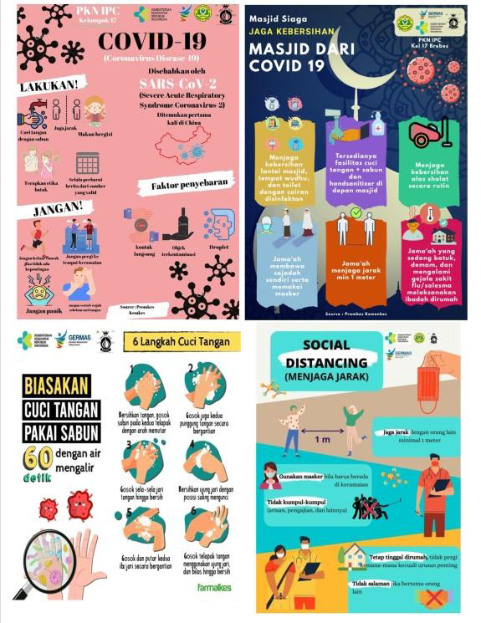  Figure 1. Educational media | 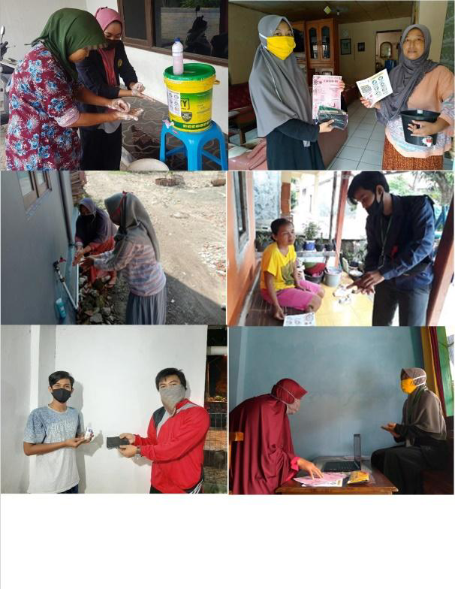  Figure 2. Handwashing and Mask Usage Socialization
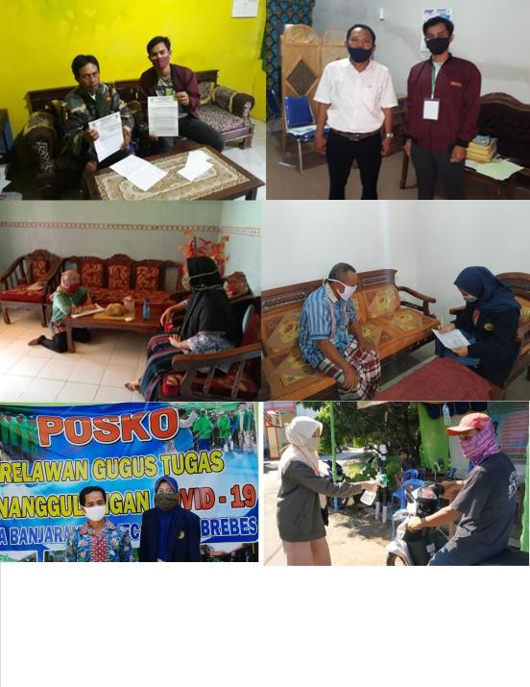  Figure 3. Coordinating Local Permission and Community Data Collection | 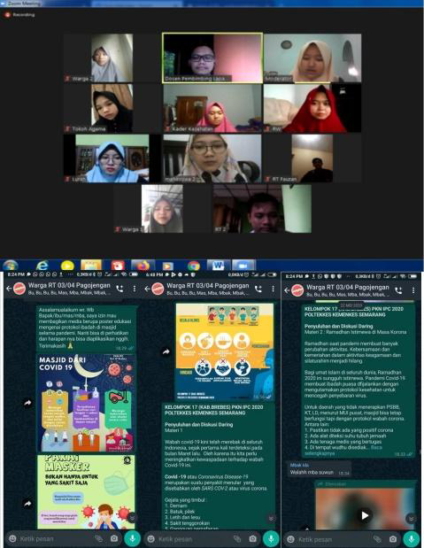  Figure 4. Online Meeting and Program Implementation

- Discussions
Overview of Health Problems in the Community
The assessment results and problems arising from the COVID-19 pandemic were found in six district of Brebes encourages various activities to handle and prevent the spread of COVID-19 that is remain increasingly spread. Health problems that arise based on the results of the study are: 1) lack of knowledge about COVID-19 as indicated by 36.4% of the public do not understand the meaning of COVID-19, 37.1% of the public do not know the causes of COVID-19, and 28.6% of the villager do not know how COVID-19 transmitted; 2) Health behaviors tend to be at risk, indicated by 69.3% of people who do not have hand washing facilities in front of the house, 53.93% of people do not know and practice washing hands 6 steps, 7.1% of people do not have masks, 25.7% of people do not use masks when leaving the house, 41,8% still had dental checked at the clinic, 33.9% still had meetings with more than 10 people; 3) The ineffectiveness of dietary management as indicated by 33.2% of people not consuming nutritious food during the COVID-19 pandemic; and lastly 4) The risk of disease is characterized by several people having comorbidities such as diabetes mellitus, hypertension, heart disease, kidney disease, lung disease and some of the woman are pregnant.
Based on the results of the study, 1 person (0.4%) had a history of contact with people who were positive for COVID-19. A history of contact with a person who is confirmed positive for COVID-19 can increase the risk of transmitting COVID-19. Judging from the mode of transmission, transmission occurs through droplets from the nose or mouth of a person with COVID-19 while breathing or coughing (12). They can enter the body directly through inhalation from an infected person. Indirect transmission occurs because the splashed droplets falls from the patient and sticks to the surface of objects around the patient (13). Someone who touches these objects/surfaces will get infected if they touch the eyes, nose or mouth.
The results of the study also showed that 4.64% had a history of travel to the COVID-19 red zone, 50.7% lived in the COVID-19 red zone, 3.6% had received guests from the COVID-19 red zone, and 4.64% visited the sick. In addition, as many as 29.6% did not know how to prevent COVID-19, 69.3% did not have hand washing facilities in front of the house, 53.93% did not practice the 6 step handwashing, 7.1% did not have a mask, 25.7% did not use a mask when leaving the house, 33.2% did not consume nutritious food, 42.5% do not sunbathe every morning. These indicators found from the assessment are not in accordance with the Clean and Healthy Behavior (PHBS) practice that should have been perform during the COVID-19 pandemic. PHBS is one of the prominent health program for the prevention of the COVID-19 that can be in the form of proper and correct hand washing, practicing cough etiquette, maintaining safe physical distance, sunbathing every morning, consuming a balanced nutritious diet, and maintaining personal hygiene (14–16). For this reason, providing education about PHBS can be done through health education with the use of printed media (posters), direct socialization, and virtual implementation (online).

Description of the Implementation of COVID-19 Prevention Activities in the Community
Based on the results of the health problems analysis, the aforementioned action plan consists of: 1) online health education on COVID-19 prevention and transmission via WhatsApp and offline activity through home visits with the used of educational media such as posters and videos; 2) The 6-step hand washing offline simulation using soap and the provision of hand washing facilities in front of the house through home-visit; 3) Offline activity of distributing cloth masks and socializing its use through home visits and COVID-19 standby posts at the village level; 4) Online socialization of antenatal care during the COVID-19 pandemic for pregnant women as one of the vulnerable groups via WhatsApp and offline activity through home visits. The used intervention media are educational posters and videos. Each activity involved community leaders, religious leaders, health cadres, COVID-19 officers at the village level, students, and the local community.
The various carried out activities include health education, empowerment and partnerships. Nies and Mc. Ewen stated that the approach in handling the prevention and control of infectious diseases is in the form of community nursing interventions, namely by carrying out health education, community empowerment, group processes and partnerships (17). Prevention and control of COVID-19 in the community through health education interventions involving various parties such as community leaders, religious leaders, health cadres, COVID-19 officer units at the village level, students, and the local community were carried out with an active and continuous approach. Efforts to provide COVID-19 education must be carried out with a proactive approach and focus on the consistency of information provided by the government and related parties (18). Our program was emphasizing the importance of health education as the first step in raising public awareness and promoting health to address health challenges (19).
Public health education during the pandemic was carried out through the use of social media (WhatsApp) and home visits. Institutions or governments can use social media in providing health education to the public, especially in preventing the transmission of COVID-19 (19). Social media has a great role in public health education as its enabling the vast and speedy information dissemination related to COVID-19. This is only possible because social media has replaced the function of some people as facilitators in disseminating health information (20).
In addition to using social media such as WhatsApp, health education in preventing the transmission of COVID-19 is also carried out through home visits in coordination with local health and village officials. Home visits are useful for monitoring public health, disseminating health information, providing hand washing facilities in front of community houses, distributing cloth masks and socializing its use and care as well as socializing pregnancy checks during the COVID-19 pandemic for pregnant women. Monitoring is carried out through visits by health workers in primary care settings in the form of body temperature checks and daily symptom screening (3).

Overview of the Evaluation of COVID-19 Prevention Activities in the Community
Most of the community plays an active role in the activities that have been planned. The community responded well in receiving health information provided by village volunteers. The success of providing health education to the public cannot be separated from the role of the used educational media. Apart from the use of social media, the use of print and electronic media such as posters or infographics and health videos greatly supports the success of the information provided. The use of infographics and videos was higher in effectiveness and provided 86% satisfaction compared to monologue formats in providing health information related to COVID-19 (21). Educational media is part of a communication strategy in disseminating health information. Educational media such as posters, flyers, infographics and health videos are more effective in encouraging and directing the community. In addition, these educational media have a wide reach and may possibly help in raising the awareness. The use of graphic design accompanied by images on educational media can provide illustrations, visualize health interventions in the community, enhance health campaigns and can recruit people to jointly disseminate health information (22).
Providing health education is accompanied by the application of community empowerment interventions and partnerships or cross-sectoral cooperation, this aims to encourage community participation in increasing preventive behavior against the spread of COVID-19. Community empowerment is carried out with the aim of exploring the potential of the community so that it is able to empower and encourage participate in preventing the transmission of COVID-19. Program activities were carried out in accordance with the guidelines for community empowerment set by the Ministry of Health. Community empowerment is carried out by collecting public health data, exploring factors that cause COVID-19 transmission and regional potential, conducting community meetings, draw up activity plans, carrying out activities to prevent COVID-19 transmission, and maintaining activities sustainability (6).
The implementation of education and community empowerment in the prevention of COVID-19 is strengthened by conducting partnerships or cooperation across sectors. Prevention of transmission and health education at the community level are essential for the implementation of cross-sector collaboration (23). In this activity, the implementation of cross-sector cooperation includes the involvement of community leaders, religious leaders, health cadres, sub-district level COVID-19 officers, students, local community and especially the local government. Many health problems are handled by governments, demanding cooperation between national, regional or multilateral organizations (24), the strength of stakeholders and their networks, and the ability to map problems and solutions, play an important role in health policy (25), related to COVID- 19. The right policy is urgently needed for public health, this requires collaboration between complex sectors and government agreement through various parties, the right collaboration has proven to be able to work well in dealing with COVID-19 even though there are differences in views between sectors or politics among stakeholders (26). In addition, there is a need for follow-up so that the program can be preserved, especially the implementation of health protocols in the new normal such as maintaining a minimum distance of 1.5 meters, using a mask, and washing hands in 6 steps. Supports from all levels of society are definitely demanded for a sustainable efforts to prevent the transmission of COVID-19 in their respective regions.

- Conclusion
Community knowledge and behavior to prevent COVID-19 is needed as an effort to increase public awareness about preventing COVID-19 transmission. Public health education continues to be carried out with various appropriate and efficient strategies so that people can easily understand the prevention of COVID-19 transmission. Local community is persistently urged to always performing preventive measures, including a proper handwashing practice, wearing masks, limiting outdoor activities, avoiding crowds, sunbathing, keeping physical distance followed by the process of studying, working, and praying at home and disinfecting objects/surfaces suspected of being infected by the corona virus. Empowerment and community cooperation with health services are expected to be able to prevent COVID-19 transmission.

Acknowledgment
We express our gratitude for the Center of Research and Community Services Health Polytechnic of Ministry of Health for providing funding.

Conflict of interest
There is no conflict of interest to declare.

References
1. Betz CL. COVID-19 and school return: The need and necessity. J Pediatr Nurs [Internet]. 2020; 19–21. Available from: https://doi.org/10.1016/j.pedn.2020.07.015
2. McGarrigle L, Boulton E, Todd C. Map the apps: a rapid review of digital approaches to support the engagement of older adults in strength and balance exercises. BMC Geriatr. 2020; 20 (1): 1–12.
3. Indonesian KKRI. Guidelines for Community Empowerment in Prevention of Covid-10 in RT / RW / Village. Directorate General of Public Health, Directorate of Health Promotion and Community Empowerment. 2020. 0–36 p.
4. Fadli F, Safruddin S, Ahmad AS, Sumbara S, Baharuddin R. Factors Influencing Anxiety in Health Workers in Covid-19 Prevention Efforts. J Indonesian Nursing Educator. 2020; 6 (1): 57–65.
5. Syandri S, Akbar F. Using a face mask during prayers as a measure to prevent the Covid-19 Coronavirus Outbreak. SALAM J Sos and Syar-i Culture. 2020; 7 (3).
6. Indonesian KKRI. Guidelines for the Prevention and Control of Coronavirus Disease (COVID-19). Directorate General of Disease Prevention and Control. 2020; 0–115.
7. Li H, Zheng S, Liu F, Liu W, Zhao R. Fighting against COVID-19: Innovative strategies for Clinical Pharmacists. Res Soc Adm Pharm [Internet]. 2020; (April): 1–6. Available from: https://doi.org/10.1016/j.sapharm.2020.04.003
8. Luo Y, Yao L, Zhou L, Yuan F, Zhong X. Factors influencing health behaviors during the coronavirus disease 2019 outbreak in China: an extended information-motivation-behavior skills model. Public Health [Internet]. 2020; 185 (June): 298–305. Available from: https://doi.org/10.1016/j.puhe.2020.06.057
9. Maugeri G, Castrogiovanni P, Battaglia G, Pippi R, D'Agata V, Palma A, et al. The impact of physical activity on psychological health during Covid-19 pandemic in Italy. Heliyon [Internet]. 2020; 6 (6): e04315. Available from: https://doi.org/10.1016/j.heliyon.2020.e04315
10. Anderson, E, T. and Mcfarlane J. Community As Patner Theory and Practice in Nursing. Philadelphia: Lippincott Williams & Wilkins; 2011. 399 p.
11. Triyanto E, Kusumawardani LH. An Analysis Of People 'S Behavioral Changes To Prevent Covid -19 Transmission Based On Integrated Behavior Model. 2020;
12. Bonell C, Melendez-Torres GJ, Viner RM, Rogers MB, Whitworth M, Rutter H, et al. An evidence-based theory of change for reducing SARS-CoV-2 transmission in reopened schools. Health Place [Internet]. 2020; 64 (July): 102398. Available from: https://doi.org/10.1016/j.healthplace.2020.102398
13. Cuevas E. An agent-based model to evaluate the COVID-19 transmission risks in facilities. Comput Biol Med [Internet]. 2020; 121 (April): 103827. Available from: https://doi.org/10.1016/j.compbiomed.2020.103827
14. Chang KC, Strong C, Pakpour AH, Griffiths MD, Lin CY. Factors related to preventive COVID-19 infection behaviors among people with mental illness. J Formos Med Assoc [Internet]. 2020; (xxxx). Available from: http://www.sciencedirect.com/science/article/pii/S0929664620303442
15. Prasetyo YT, Castillo AM, Salonga LJ, Sia JA, Seneta JA. Factors Affecting Perceived Effectiveness of COVID-19 Prevention Measures among Filipino during Enhanced Community Quarantine in Luzon, Philippines: Integrating Protection Motivation Theory and Extended Theory of Planned Behavior. Int J Infect Dis [Internet]. 2020; Available from: http://www.ncbi.nlm.nih.gov/pubmed/32768695
16. Park T, Ju I, Ohs JE, Hinsley A. Optimistic bias and preventive behavioral engagement in the context of COVID-19. Res Soc Adm Pharm [Internet]. 2020;(June). Available from: https://doi.org/10.1016/j.sapharm.2020.06.004
17. Nies, MA & McEwen M. Community/public health nursing: Promoting the health of populations. 6th ed. St. Louis: Elsevier Saunders; 2015.
18. Azlan AA, Hamzah MR, Jen T, Id S, Hadi S, Id A. Public knowledge , attitudes and practices towards COVID-19 : A cross-sectional study in. 2020;1–15. Available from: http://dx.doi.org/10.1371/journal.pone.0233668
19. Saxena A, Alhaboby ZA, Saxena A. Advocating the use of social media for health education in consideration of the SARS CoV-2 pandemic. :532–4.
20. Sampurno MBT, Kusumandyoko TC, Islam MA. Budaya Media Sosial, Edukasi Masyarakat, dan Pandemi COVID-19. SALAM J Sos dan Budaya Syar-i. 2020;7(5).
21. Peyravi M, Ahmadi Marzaleh M, Shamspour N, Soltani A. Public Education and Electronic Awareness of the New Coronavirus (COVID-19): Experiences from Iran. Disaster Med Public Health Prep. 2020;4–5.
22. Departemen Of Communication World Health Oraganization. WHO Strategic Communications Framework for effective communications. World Health Organization. 2017. 0–56 p.
23. Wahid EA. Pencegahan COVID19 di Komunitas. 2020
24. Buse K, Mays N, Walt G. Making Health Policy. 2016. DOI: 10.1163/9789004333109
25. Parkhurst J, Ettelt S, Peters G. Evidence use in health policy making - International Series on Public Policy. 2018.
26. Raoofi A, Takian A, Sari AA, Olyaeemanesh A, Haghighi H. IRANIAN COVID-19 Pandemic and Comparative Health Policy Learning in Iran. Acad Med Sci IR Iran [Internet]. 2020;23(4):220–34. Available from: https://doi.org/10.34172/aim.2020.02

