The Effect of Horizontal Vulnerability on the Stiffness Level of Reinforced Concrete Structure on High Rise Building
Fanny Monika^{1,*}, Martyana Dwi Cahyati¹, Yanuar Ade Putra¹, Berkat Cipta Zega², Hakas Prayuda¹

¹ Department of Civil Engineering, Faculty of Engineering, Universitas Muhammadiyah Yogyakarta, INDONESIA
² Department of Civil Engineering, Faculty of Engineering, Universitas Negeri Surabaya, INDONESIA
*Corresponding authors: fanny.monika.2007@ft.umy.ac.id
SUBMITTED xx xxxxxxxxxx xxxx REVISED xx xxxxxxxxxx xxxx ACCEPTED xx xxxxxxxxxxxx xxxx
ABSTRACT Buildings have an important function, i.e., as a place for people to carry out various activities in the form of social, economic, and other religious activities. In the building construction plan, it is necessary to consider various factors from the strength to architecture. The issue of limited land in some areas has made the building constructed vertically or often known as high rise buildings. High-rise building construction certainly needs to pay attention to various levels of vulnerability, especially for development in earthquake-prone areas. In this study, the level of vulnerability and vertical irregularity plan of high-rise buildings will be analyzed against structural rigidity for reinforced concrete structures. The building model used is divided into three main building models that are most commonly applied, namely: the cube building model, the L building model and the U building model. The STERA 3D program functions as assistant software to determine the strength values of the structure by providing earthquake loads using the time history method on each structure model. The El Centro and Kobe earthquake were earthquakes tested in this structural model because they contribute the most exceptional damage value in the history of disasters caused by the earthquake. The focus things of the assessment of the structural model being tested are the value of structural stiffness, the largest displacement in the structure, the maximum displacement and load relations experienced by the construction and the hysterical energy experienced by the structure. Therefore, in the end, the most powerful structural model in resisting the workload can be concluded. The results showed that the U building model had the greatest stiffness value with an increase in stiffness of 7.43% against the box building model and 3.01% against the L building model.
KEYWORDS High rise building; Horizontal Vulnerability; Stiffness; STERA 3D; Time History.

© The Author(s) 2018. This article is distributed under a Creative Commons Attribution-Share Alike 4.0 International license.

INTRODUCTION
Buildings are an important thing in this period because they support the function of various human activities, i.e., economic, social, housing, etc. According to FEMA-426 (2011), the architecture of Buildings and Infrastructure Protection Series can be divided into several main groups based on the layout then, and buildings can be grouped into several forms so that the study of the strength of buildings with variations in horizontal cross-section can be carried out. The horizontal system includes horizontal bracing stiffeners in the form of the storey and deck framing systems commonly called horizontal diaphragms (Majore, 2015).
According to Weningtyas (2017) in her study, beam-column joints in precast concrete is used to determine the value of ductility, energy dissipation, stiffness, strain stress, and crack patterns based on variations in column dimensions to assess the strength of the structure due to the forces acting on each dimensional change gradually. The existence of forces that occur at these levels will result in displacement and deviation (Cornelis and Umbu, 2014).
One of the essential things in constructing an earthquake-resistant building is knowing the peak ground acceleration by determining the greatest acceleration value produced by an earthquake on the surface of a particular area and time (Massinai, et al., 2016). Kapojos et al. (2015) stated that in earthquake-resistant buildings, the value of ground velocity could be calculated by the approach of historical earthquake data. Saito (2016) analyzed the characteristic of high-level buildings on the movement of land in a long time; the study was conducted by using a 37-storeys building simulation by analyzing the time history of the structure. The study was conducted with the help of 3D STERA software.
The research on the behavior of reinforced concrete structures has been done before by several researchers, including Louzai & Abed, (2014) who researched the behavior of multilevel reinforced concrete structures with a ratio of three, seven, and nine-storeys building. The results for the dynamic incremental analysis method for 3-storeys buildings are 2.32, 7-storeys building are 2.43 and 9-storeys building are 2.48. Meanwhile, Pavel, (2018) conducted a study of reinforced concrete that was designed in seismic conditions used 5-11 storeys building. The results show that the building collapse rate for the four structural models analyzed is in the range of 4×10⁻⁴ to 10⁻⁵ cm.
Li, et al. (2016) researched the optimization of high-rise buildings at collapsing capacity for seismic designs. The results show that the reduction in the building collapse reaches a range of 23.75-44.18% for RC structure building framework of 4 to 10 storeys. Brunesi, et al. (2016) conducted research on seismic analysis in high-level repetitive buildings with the addition of mega-cores. The results show peak displacement in the highest cases of 0.77 meters and 1.83 meters. Lu, et al. (2015) conducted research on shear wall elements by non-linear analysis in high-rise buildings. The result is that displacement experienced by the peak of the structure is 1,791 meters for the X direction and 1,580 for the Y direction.
In this study, an analysis will be conducted on three types of building construction plan variations, namely Cube, L and U building model in each building having a height of 60 meters in the same area. The level of stiffness up to displacement will be measured using historical time earthquake records from El-Centro and Kobe. This study aims to compare the results of stiffness and displacement from the variations of high-rise buildings which have been treated with the same type of earthquake. It is expected that this research can provide information about the level of vulnerability of buildings due to the irregularity of the building construction plan used.

METHODS

Building Information
This study used three building models that vary in horizontal planes, namely cube, L and U. The number of storeys in the building is 12 with a total height of 60 meters. Table 1 is general data from each building as the modelling. Meanwhile, Table 2 is the material data used in this study. By using the STERA application, it only requires a small amount of material data to facilitate the modelling process. The building data used is general data that had been previously surveyed.
Table 1. Data structure model
Building Description | Dimensions of Structure Models
 | Cube Model | L Model | U Model
The number of storeys | 12 Storeys | 12 Storeys | 12 Storeys
Total Building Height | 60 meters | 60 meters | 60 meters
Storey height | 5 meters | 5 meters | 5 meters
Total Building Width | 20 meters | 25 meters | 30 meters
Panjang Bangunan Total | 20 meters | 25 meters | 15 meters
Total Building Area | 400 m² | 400 m² | 400 m²

Table 1. Material data used
Information | Structure Element
 | Column | Beam
High | 600 cm | 600 cm
Wide | 600 cm | 600 cm
Concrete covers | 40 mm | 40 mm
Concrete Quality | 24 N/mm² | 24 N/mm²
Number of main reinforcement | Four items | Four items
The diameter of the primary reinforcement | 22 mm | 22 mm
Shear reinforcement diameter | 13 mm | 13 mm

Structure Modeling
Structural modelling is carried out in several stages. The initial step that must be done is to determine the dimensions of the building. Figure 1 is the result of the dimensions of the building used. This study uses different building dimensions, but the total building area of the three variations is the same. The test was done by modelling method; this method can produce a comparison on each test. The structure is modelled with an open structure frame system with force derived from the structure's weight and earthquake. The program used in this study is STERA 3D v9.6.
(a)(b)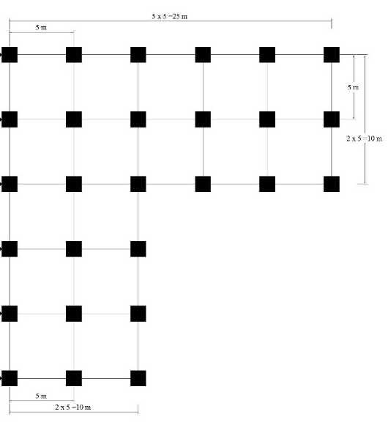
(c)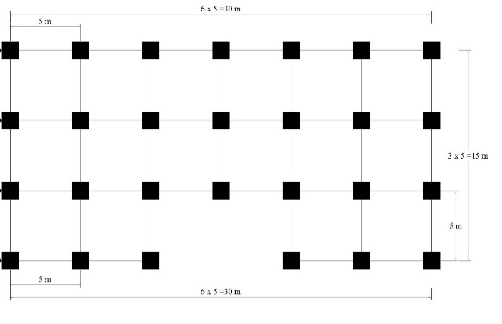
Figure 1. Blueprint of (a) cube; (b) L; (c) U building model
(a)(b)(c)
Figure 2. The 3-dimensional of (a) cube; (b) L; (c) U building model

Figure 2 is a 3-dimensional view taken from the STERA application. These models have the same area of each storey; thus, the variations are given only on the building plan. The load used in this study is the historical time earthquake load. The north-south part of the building is vertically burdened, and in the east-west part it uses the El-Centro and Kobe loads, so the effects that are close to real conditions will be known. The El Centro earthquake has an accelerating force: 210.1 cm/sec² in the east-west direction, 314.7 cm/sec in the north-south direction and 206.3 cm/sec² in the vertical direction. The Kobe earthquake has a much greater acceleration than the El Centro earthquake, namely: 617.1 cm/sec² in the east-west direction, 817.8 cm/sec² in the north-south direction and 332.2 cm/sec² in the vertical direction. The loading is done by providing a three-way earthquake model in the cube, L, and U building model vertical irregularity; then, the properties shown by each structural building model can be seen directly.

RESULTS AND DISCUSSIONS

Building Stiffness
Stiffness is modelled by giving a load gradually in the X-axis direction until the model shows damage in certain calculations. Figure 3 is the relationship between step calculations with the story drift produced by each storey. Each storey from modelling method shows the different results. For each model tested, there was a significant difference in the stiffness of the first storey of each model. Figure 4 is the result of stiffness for each model and Figure 4 (a) the stiffness produced on each storey, while in Figure 4 (b) is the highest stiffness obtained. The U building model shows the greatest value of stiffness compared to other models, i.e., 2125 kN. That stiffness value has a stiffness increase of 7.43% over the cube building model and 3.01% towards the L building model. This phenomenon occurred because the U building model having a greater cross-section in the X-direction.
(a)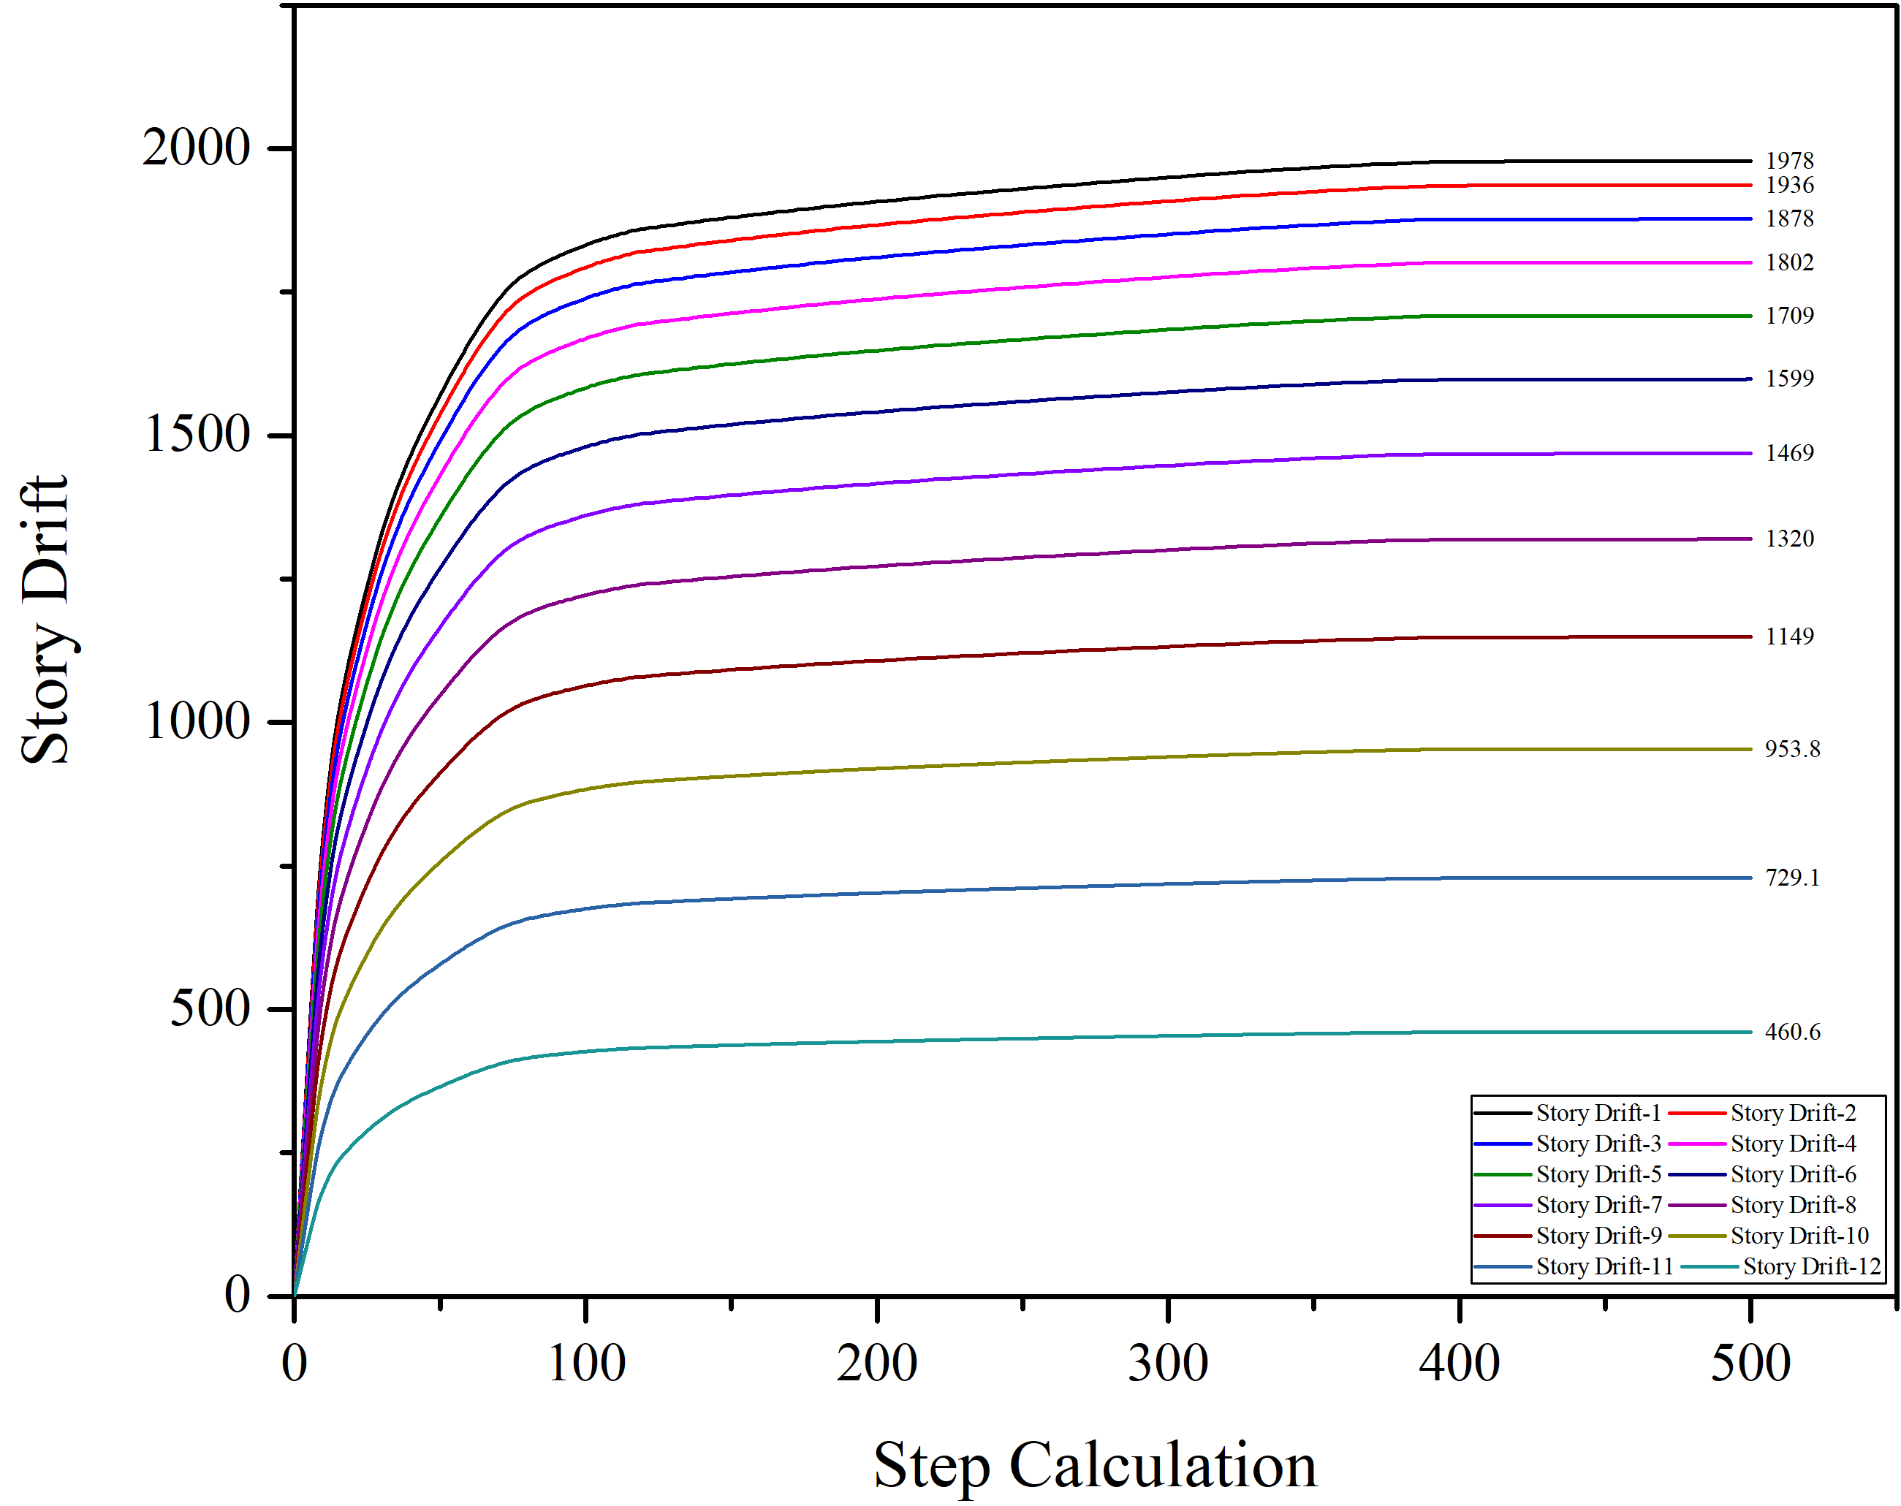(b)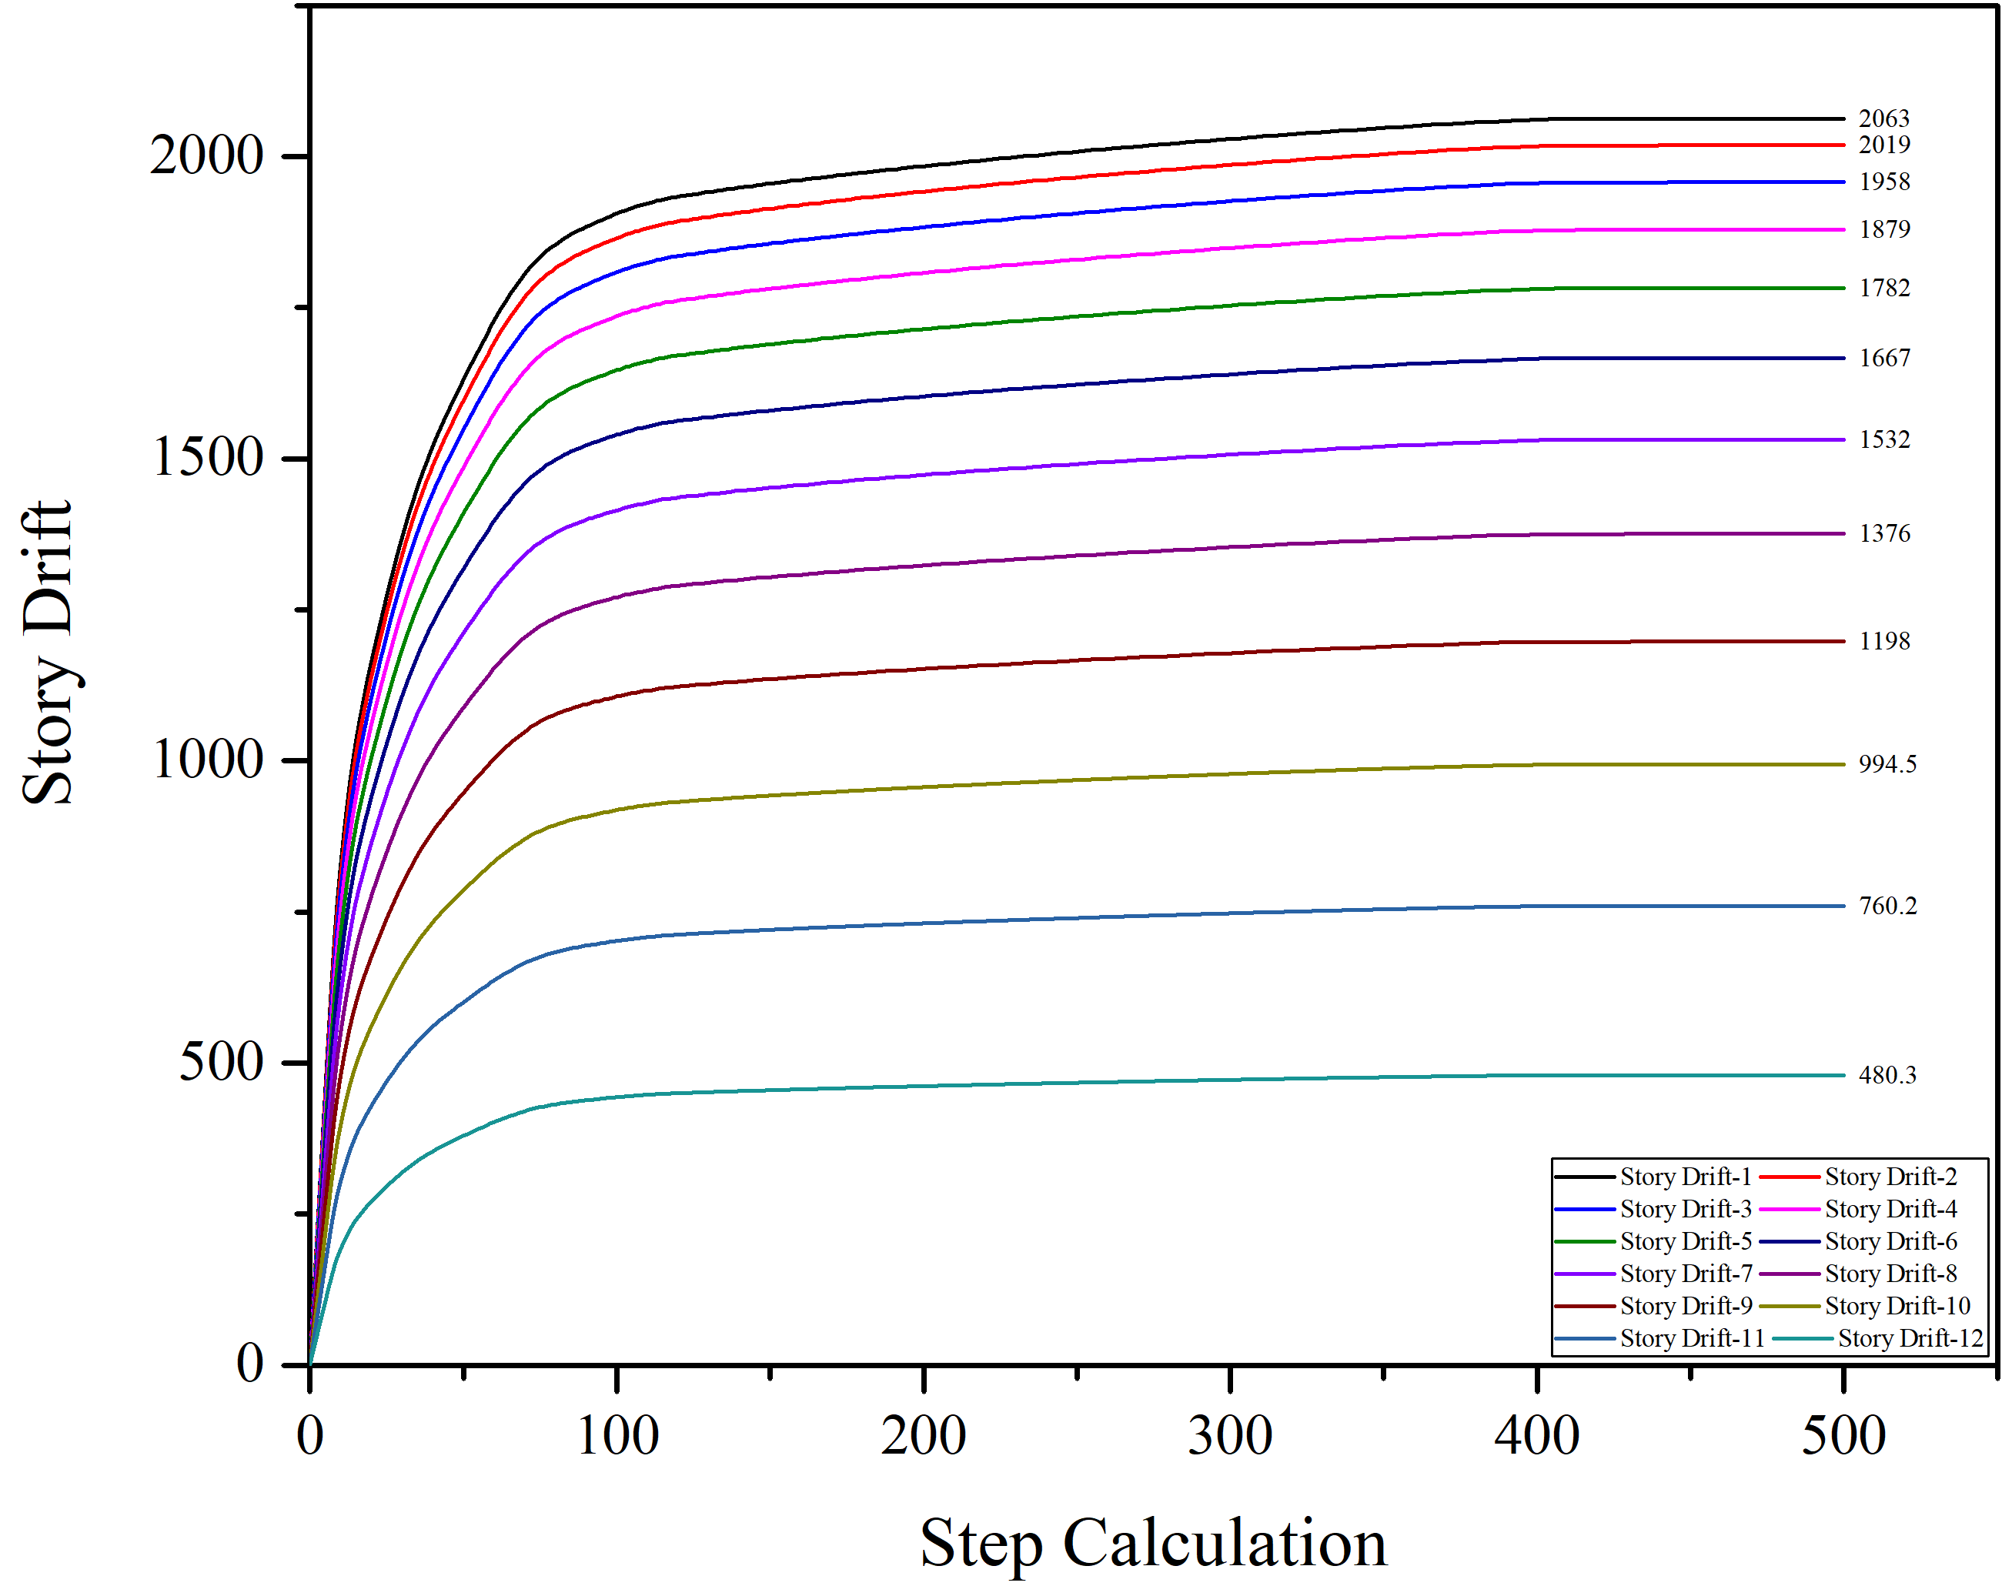
(c)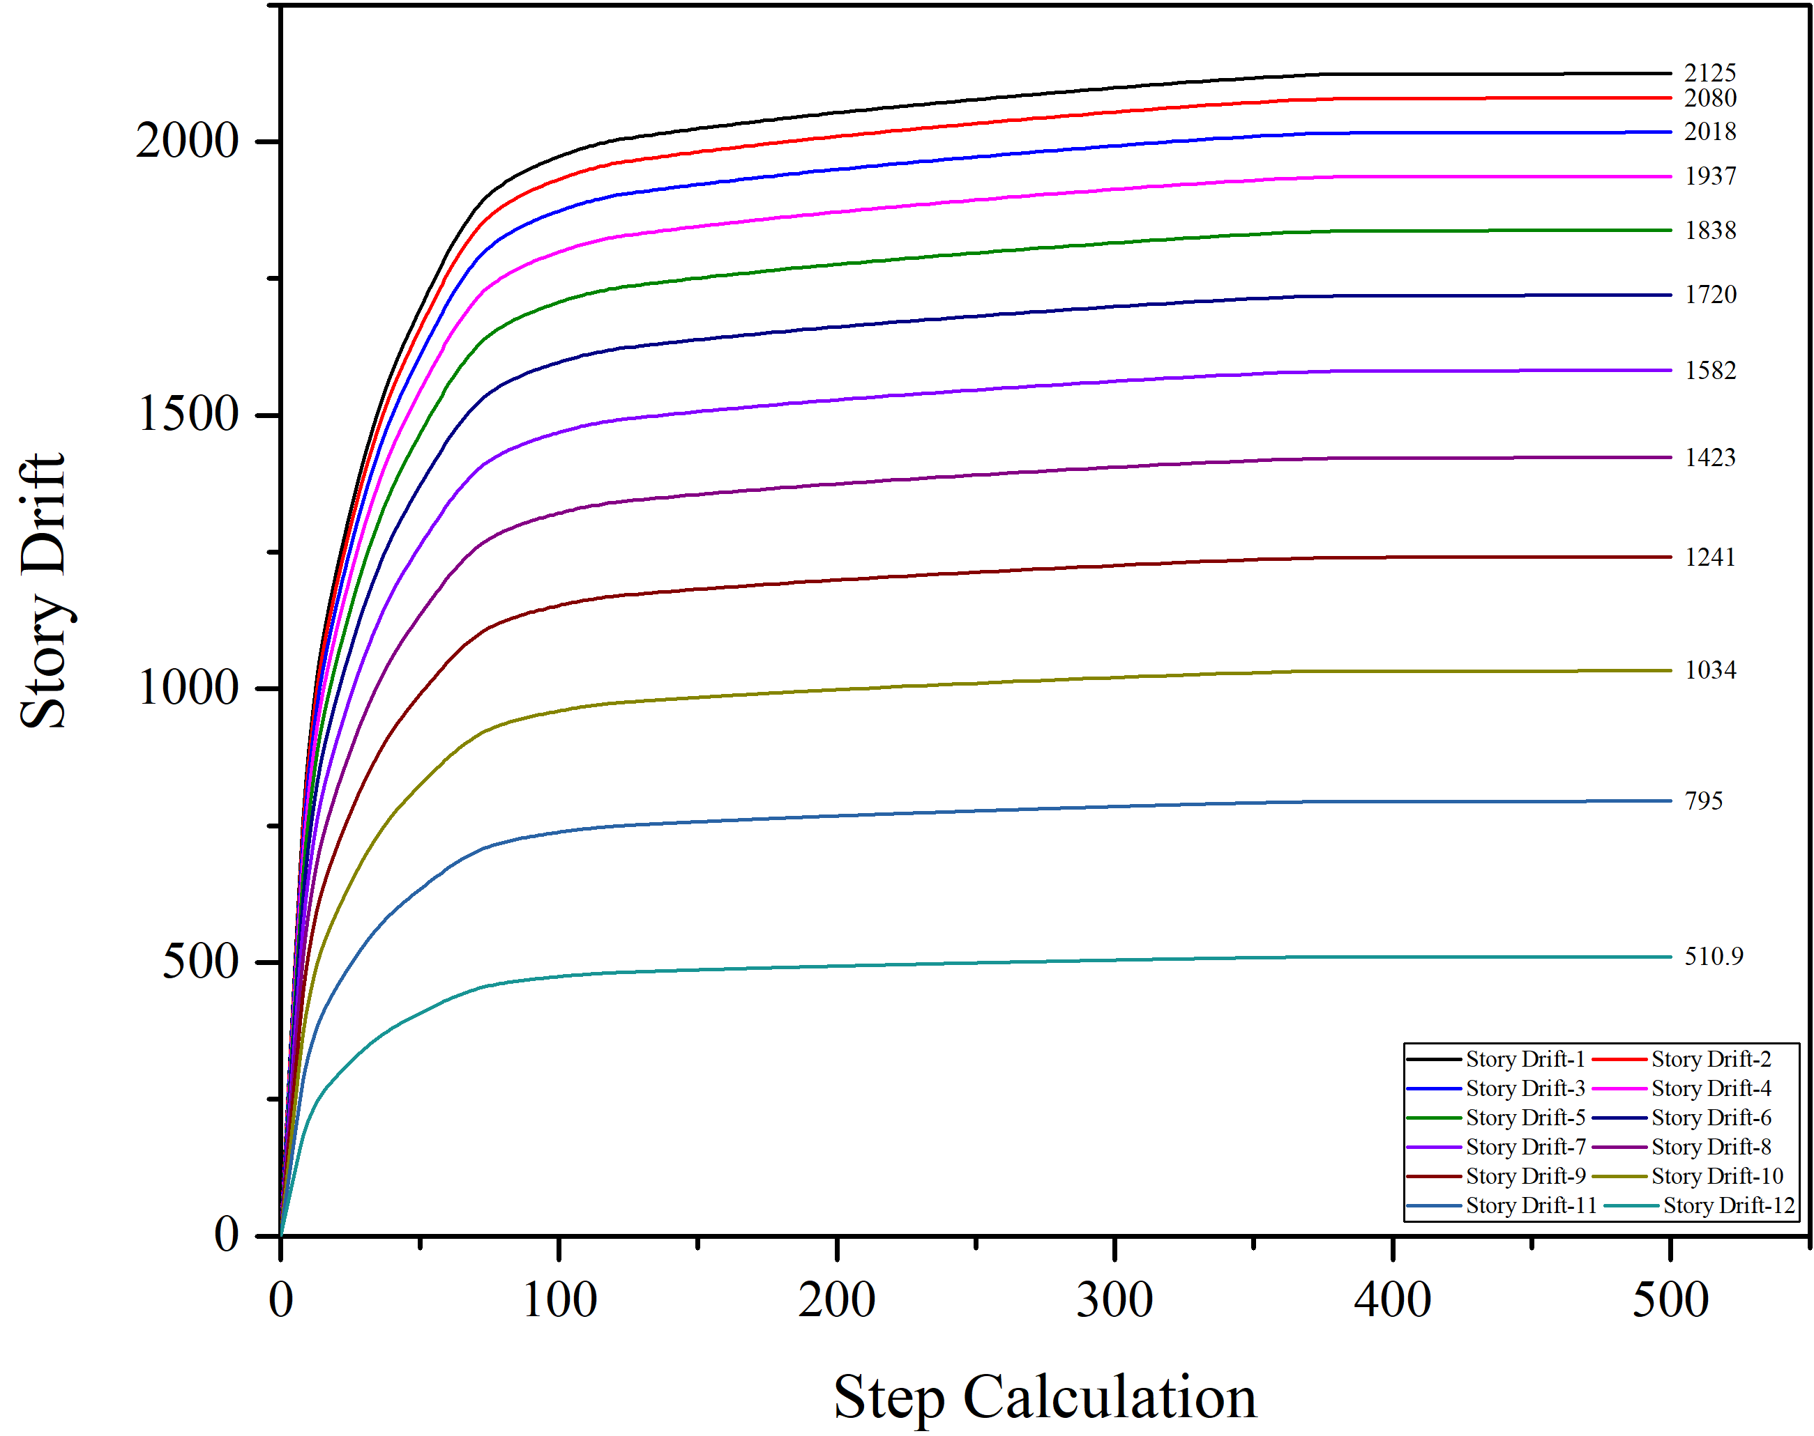
Figure 3. The relationship between storey drift and step calculation in term of stiffness among (a) cube; (b) L; and (c) U building model

Figure 4. (a) Stiffness values on each storey; (b) the value of maximum stiffness

Displacement Value
Displacement is one of the requirements used to know building security. By knowing the value of displacement, how big is the building stiffness level can be known. The displacement resulted from the force received from the structure is calculated against a certain displacement from the control point called the displacement target as the maximum displacement that can occur in the structure at the time the planned earthquake occurs. Displacement provides information about the maximum natural distance by the structure model so that finally the best structure with the smallest displacement can be known. The results of the study show the displacement value of the top storey of the building due to the force exerted on the ground by the existence of the earthquake, the displacement will indicate the maximum value of displacement experienced by the model.
The largest displacement that occurred from 3 (three) models above after being given the same earthquake force is as follows; the largest displacement in the X direction was the Cube model of 15.85 cm, and the smallest in the X direction was the U Model of 15.15 cm. Meanwhile, the largest displacement in the Y direction was the U model of 19.5 cm, and the smallest displacement in the Y direction was the Cube model of 18.97 cm, as shown in Table 3. Table 4, which is the displacement due to the Kobe earthquake shows a significant difference in displacement from the El Centro earthquake so that its maximum displacement has a greater value than the El Centro earthquake. The largest displacement produced in the X direction was the L model which was 23.81 cm, and the largest displacement in Y direction was U model which was 36 cm.
Table 3. The result of displacement and base shear force of the El Centro and Kobe earthquake models
Building | Direction | Maximum Displacement (cm)  El-Centro | Maximum Base Shear Force (kN  El-Centro | Maximum Displacement (cm)  Kobe | Maximum Base Shear Force (kN)  Kobe
Cube Model | X | 15.85 | 1869 | 23.4 | 2877
 | Y | 18.97 | 2020 | 35.64 | 2774
L Model | X | 15.72 | 1934 | 23.81 | 3062
 | Y | 19.20 | 2126 | 35.44 | 2937
U Model | X | 15.98 | 1825 | 23.71 | 2897
 | Y | 20.17 | 1974 | 35.87 | 2802

The results of the study show the value of the top storey displacement of the building and the base shear forces generated by the earthquake force given to each model. The biggest displacement that occurred from 3 (three) models above after being given the same earthquake force was that the biggest displacement in the X direction was the U model of 15.98 cm with a base shear force of 1825 kN and the smallest displacement was the L model of 15.72 cm with a base shear force was 1934 kN. As for the Y direction, the largest displacement was the U model of 20.17 cm with the base shear force being 1974 kN and the smallest displacement was the Cube model of 18.97 cm with the base shear force being 2020 kN.
Modelling using the Kobe earthquake as a force on the ground of the structure provided a large enough displacement and force that has a significant impact on each structural model, namely: Displacement caused by the force of the Kobe earthquake resulted in a greater displacement than the El Centro earthquake. The largest displacement due to earthquake in the Cube model in the X direction was 23.4 cm with a maximum base shear force of 2877 kN and in the Y direction was 35.64 with a maximum base shear force of 2774 kN. Model L produced a displacement in the X direction of 23.81 cm with a maximum base shear force of 30.62 and in the Y direction of 35.44 cm with a maximum base shear force of 2937 kN. The U model produced a displacement in the X direction of 23.71 cm with a maximum base shear force of 2897 kN and in the Y direction of 35.87 cm with a maximum base shear force of 2802 kN. Figures 5 to 7 are the relationship between displacement and vibration time for each type of model. The deviation was from the X and Y directions of the El-Centro and Kobe earthquakes.
Acceleration Y-Kobe (cm)
Acceleration Y-El Centro (cm)
Acceleration X-Kobe (cm)
Acceleration X-El Centro (cm)
Figure 5. Relationship of the earthquake displacement and earthquake vibration time of Cube model
Acceleration Y-Kobe (cm)
Acceleration Y-El Centro (cm)
Acceleration X-Kobe (cm)
Acceleration X-El Centro (cm)
Figure 6. Relationship of displacement and earthquake vibration time of the L model
Acceleration Y-Kobe (cm)
Acceleration Y-El Centro (cm)
Acceleration X-Kobe (cm)
Acceleration X-El Centro (cm)
Figure 7. Relationship of displacement and earthquake vibration time of the U model

Maximum Acceleration
The acceleration of a structure is influenced by the ratio between responses that occur between one storey and the storey below. The smaller the ratio between storeys, the greater the maximum acceleration value that the structure has before the structure is damaged. The relationship of the acceleration value with the number of storeys can be seen in Figure 8 to Figure 10. Figure 8 is the relationship of the maximum acceleration value with the number of storeys for square-shaped buildings. Figure 9 is the maximum acceleration relationship for L-shaped buildings, while U-shaped buildings can be seen in Figure 10.
(a)(b)
Acceleration Y
Acceleration Y
Acceleration X
Acceleration X
Figure 8. (a) Acceleration of cube model in the El Centro earthquake (b) Acceleration of cube model in the Kobe earthquake
The results of the acceleration of each structural model with the El Centro earthquake show the lowest acceleration values always occur in the middle of the modelling storeys, namely the 7th storey for the X direction and the 8th storey for the Y direction. The highest acceleration value always occurs on the lower storeys of each modelling, namely the 1st storey for X direction and the 2nd storey for the Y direction. When using the Kobe earthquake, it can be seen that the greatest acceleration occurs on the first storey with the value of each model not significantly different. The largest acceleration value occurs in the first storey Cube model in Y direction of 760.8 cm / s2, and the smallest acceleration occurs in the L model of the eighth storey in X direction of 141.8 cm / s2.
(a)(b)
Acceleration Y
Acceleration X
Acceleration Y
Acceleration X
Figure 9. (a) Acceleration of the L model with El Centro Earthquake (b) Acceleration of L model L with Kobe Earthquake
(a)(b)
Acceleration Y
Acceleration X
Acceleration Y
Acceleration X
Figure 10. (a) Acceleration of U model with El Centro Earthquake (b) Acceleration of U model with Kobe Earthquake

Hysteresis Energy
Hysteresis Energy is the total area of the amount of energy which occurs in each cycle. The ability of the structure to absorb and muffle the load becomes a review to find out the ability to maintain the structure. The trapezoidal method with many piles is used to calculate hysteresis energy based on the total energy area and using numerical integration. The results of the hysteresis energy calculation on the structure of the L model, the Cube model and the U Model can be seen in Table 5 and Table 6. Structural modelling with El Centro earthquake shows that the U model has the highest hysteresis energy value of 60772210 Nmm, then the L model structure has a hysteresis energy value of 57023820 Nmm, and the Cube model has the smallest hysteresis energy of 57023820 Nmm. The differences owned by each structural model are quite large due to the burden that is not well distributed throughout the model.
Table 5. Hysteresis Energy value of the El Centro earthquake analysis
Objects | Loading | Lateral Displacement | Hysteresis Energy (HE)
 | (N) | (mm) | Total (N.mm)
L Model | 311900 | 192 | 59884800
Cube Model | 300600 | 189,7 | 57023820
U Model | 301300 | 201,7 | 60772210

Table 6. Hysteresis Energy values from the Kobe earthquake analysis
Objects | Loading | Lateral Displacement | Hysteresis Energy (HE)
 | (N) | (mm) | Total (N.mm)
L Model | 311900 | 354,4 | 110537360
Cube Model | 300600 | 356,4 | 107133840
U Model | 301300 | 360 | 108468000
The results of the modelling with earthquake load show that the greatest hysteresis energy value is owned by the L model with hysteresis energy of 110537360 Nmm. The greater the hysteresis energy which occurs in the structural model, the structure has a lower collapse rate, has a more rigid rigidity and has large lateral displacement, so it can be seen that the smaller the hysteresis energy value, the higher the structural collapse rate and the lower the stiffness. Hysterical energy shows the difference produced by the model with the El Centro and Kobe earthquake loading. Thus, it can be seen that in the El-Centro earthquake loading, the largest hysterical value of the energy produced is owned by the L model while in the Kobe earthquake the largest hysteresis energy value is generated by the U model. Figure 11 is a comparison between the hysteretic energy value produced as a result of the El-Centro and Kobe earthquake force.
(a)(b) Figure 11. Relationship of hysterical energy values of model L, Cube model, U model with (a) El Centro earthquake; (b) the Kobe earthquake

CONCLUSIONS
Based on the modelling of horizontal cross-section variations with the help of STERA 3D software, the following conclusions can be drawn.
- The L type structure model has the highest stiffness value of 2063 kN, the Cube type structural model has a stiffness value of 1978 kN, and the U type structure model has a stiffness value of 2125 kN. El Centro earthquake displacement: the U model produces the largest displacement of 20.17 cm. Kobe earthquake displacement: the U model produces the largest displacement of 35.87 cm,
- The relationship between force and displacement that occurs shows that the L type model has the greatest stiffness in terms of the base shear force showed in the El Centro earthquake that is a lateral deviation value of 19.20 with a load of 2126 kN, whereas in the Kobe earthquake the L model has a stiffness by showing a lateral deviation of 23.81 cm with a load of 3062 kN.
- The biggest acceleration that occurred in the structure in the El Centro earthquake was produced by the U model structure with the biggest acceleration was 338.3 cm / s2, and in the Kobe earthquake it was produced by the cube model structure with the biggest acceleration was 760.8 cm / s2. The smallest hysteresis energy produced by the El Centro earthquake was generated by the Cube type structural model of 57023820 Nmm, and the Kobe earthquake produced the smallest hysteresis energy at the Cube type of 107133840 Nmm.
- The Cube type structure model has the most stable structure because the Cube type structure model produces a relatively small lateral deviation in the El Centro earthquake which was 15.85 cm with a loading of 1869 kN in the X direction and 18.97 with the loading of 2020 in the Y direction. Meanwhile, in the Kobe earthquake, the deviation was 23.4 cm with the loading of 2877 kN in the X direction and 35.64 cm with the loading of 2774 kN in the Y direction. The stiffness value possessed by the structural model is 1978 kN, and the hysteresis energy value that occurs is 57023820 Nmm in the El Centro earthquake and 107133840 Nmm in the Kobe earthquake.

REFERENCES
Brunesi, E. Casagrande, L. & Nascimbene, R. (2016). Seismic analysis of high-rise mega-braced frame-core buildings. Engineering Structures 115, 1–17.
Cornelis, R. B., & Umbu, T. B. (2014). Analisis Perbandingan Gaya Geser Tingkat, Gaya Geser Dasar, Perpindahan Tingkat, dan Simpangan Antar Tingkat Akibat Beban Gempa Berdasarkan Peraturan Gempa SNI 1726-2002 dan SNI 1726-2012. Jurnal Teknik Sipil Vol. III, No. 2, 205-216.
Federal Emergency Management Agency. (2011). Reference Manual to Mitigate Potential Terrorist Attacks Against Buildings. The U.S. Department of Homeland Security (DHS).
Kapojos, C. G., Tamuntuan, G., & Pasau, G. (2015). Analisis Percepatan Tanah Maksimum dengann Menggunakan RUmus Esteva dan Donovan (Studi Kasus pada Semenanjung Utara Pulau Sulawesi). Jurnal Ilmiah Vol. 15 No. 2, 99-104.
Li, S., Yu, B., Gao, M., & Zhaia, C. (2019). Optimum seismic design of multi-story buildings for increasing collapse resistant capacity. Soil Dynamics and Earthquake Engineering 116, 495–510.
Louzai, A., & Abed, A. (2014). Evaluation of the seismic behavior factor of reinforced concrete frame structures based on comparative analysis between non-linear static pushover and incremental dynamic analyses. Bulletin Earthquake Engineering, 1773–1793.
Lu, X., Xie, L., Guan, H., Huang, Y., & Lu, X. (2015). A shearwallelementfornonlinearseismicanalysisofsuper-tall buildings usingOpenSees. Finite Elements in Analysis and Design. 98. 14–25.
Majore, B. O. (2015). Studi Perbandingan Respons Dinamik Bangunan Bertingkat Banyak dengan Variasi Tata Letak Dinding Geser. Jurnal Sipil Statik Vol.3 No.6, 435-446.
Massinai, M. M., Massinai, K., Virman, Lantu , & Muhammad , F. I. (2016). Analisis Percepatan Tanah Maksimum, Kecepatan Tanah Maksimum dan MMI Di Wilayah Sulawesi Utara. Vol 5 (2016): Prosiding Seminar Nasional Fisika.
Pavel, F. (2018). Simplified Seismic Collapse Evaluation of Code Conforming Reinforced Concrete Structures in Bucharest, Romania. Iranian Journal of Science and Technology, Transactions of Civil Engineering, 1-6.
Saito, T. (2016). Response of High-Rise Buildings under Long Period Earthquake Ground Motions. International Journal of Structural and Civil Engineering Research Vol. 5, No. 4, November 2016, 308-314.
Weningtyas, E. R. (2017). Studi Numberik Sambungan Balok Kolom Beton Bertulang Pracetak Eksterior dengan Variasi Penampang Balok Menggunakan Beban Statik. Department of Civil Engineering, 1-11.

