RESEARCH ARTICLE

**Deforestation Characteristic during a Period 2006 - 2020 over Tropical Forest in Central Kalimantan, Indonesia**

**Hendrik Segah1,2,*, Afentina1,3, Fatkhurohman4, Yusuf Aguswan1,2**

1Forestry Department, Faculty of Agriculture, University of Palangka Raya, Indonesia

2Center for Development of Science, Technology and Peatland Innovation (PPIIG), University of Palangka Raya, Indonesia

3Research and Community Services (LPPM), University of Palangka Raya, Indonesia

4Environment & GIS Expert. Palangka Raya, Central Kalimantan, Indonesia

*Correspondent email: [segah@for.upr.ac.id](mailto:segah@for.upr.ac.id)

**Submit:** ……….. **Received:** ……………. **Accepted:** ……………..

**Abstract** Deforestation brings vast and detrimental impact on the environment, economy, and social aspects of community. Thus, it is important to assess and analyze deforestation to inform the decision maker that oversees issued policy and development strategies. The present study aims to characterize deforestation in Central Kalimantan between 2006 - 2020. Utilized land cover map issued by Indonesian Ministry of Environment and Forestry, we calculated and analyzed the change in natural forest cover using Remote Sensing and Geographical Information System (GIS) to find the rate the trend, location, and land cover replacement of deforestation, reforestation and degradation in Central Kalimantan Province, Indonesia. The research found that during a period of 2006 – 2020, Central Kalimantan lost 1.5 million ha of natural forest with the rate of deforestation 117,000 ha/year. In general, the deforestation shown decrease trend and fluctuated during the period. Deforestation majority takes place at secondary swamp and dry forest that are located at south part of the island. Most of deforestation resulted shrubs, plantations, and agriculture land. The finding of this research could be used as a base to determine the target location for rehabilitation strategy and approach to prevent further deforestation.

©2022 by the authors. Licensee Indonesian Journal of Geography, Indonesia.

This article is an open access article distributed under the terms and conditions of the Creative Commons

Attribution(CC BY NC) licensehttps://creativecommons.org/licenses/by-nc/4.0/.

**Key words:** Deforestation; Forest Fires; Central Kalimantan; Land Use and Land Cover Change

**1. Introduction**

The tropics are seeing fast economic growth, which naturally puts great strain on the region's natural resources, most notably its forests. Pressures on the land have massive effects on ecosystem resilience, soil and water sustainability, and tropical peatland in Indonesia, all of which have significant social and economic effects. Reducing deforestation can generate multiple economic, social and ecological benefits by safeguarding the climate and other ecosystem services provided by forests. Understanding the relative contribution of different drivers of deforestation is needed to guide policies seeking to maintain natural forest cover (Doggart et al., 2020; Lawrence et al., 2022; Silva Junior et al., 2021). Therefore, monitoring land status or condition is desired in the context of sustainable land use. The only practical and affordable way to get the essential data on the environment is through satellite remote sensing, given the geographical and temporal scales of relevance (G. M. Foody, 2003; Giles M Foody et al., 2001).

For at least the next 100 years, the biggest threat to ecological systems will come from changing land cover, one of the most significant drivers of environmental change (Chapin et al., 2000). The serious degradation of the vast peatlands of Indonesia since the 1990s is the proximate cause of the haze that endangers public health in Indonesian Sumatra and Borneo, and also in neighboring Singapore, Malaysia and Thailand. Moreover peatlands that have been drained and cleared for plantations are a major contributor to greenhouse gas emissions (Chapin et al., 2000; Mitchard, 2018). Remote sensing has been extensively utilized to track significant land cover changes, as those brought on by deforestation. But these are only some of the problems. Land cover change has two parts: those where the land cover is amended and those where the cover type is changed. The majority of remote sensing studies have concentrated on changes in land cover rather than those that could have an equal or greater environmental impact (Lambin, 1999). The soil and water systems are extremely vulnerable to changes in vegetation, and especially for forest covering, in tropical areas due to the large and frequently heavy rainfall as well as quick biochemical and mineral breakdown processes (Taddese, 2001).

Based on studies by (Moutinho, 2005; Prabowo et al., 2017), deforestation is affected by policy, social economic, season of event and spatial aspects. The rate of deforestation strongly correlated to location, distance from village or city, road accesses and connectivity (Poor et al., 2019). As result, the intensity of deforestation greatly varies between different location, regions, and period of time (Reddy et al., 2019). Some researchers analyzed that deforestation in Indonesia strongly influenced by legislation and law, and political setting (A., 2001).

Deforestation is a forest cover change into non-forest area or region to other use permanently. However, term of deforestation is still debatable (W.D. & I.A.P., 1997). FAO states that deforestation is conversion of forest to other land use. Deforestation is also interpreted as a reduction of tree canopy cover to less than minimum threshold of 10% for a long term with a minimum tree height of 5 meters at minimum area of 0.5 ha (Ferraz et al., 2009; Puyravaud, 2003; W.D. & I.A.P., 1997). Deforestation is also defined as forest cover (land cover) causing changes in form of permanent lost cover at both forest cover intact, fragmented and scattered. Deforestation in this study defined as the conversion of natural forest into other land covers, this imply that the logging in plantation forest do not considered as deforestations, otherwise, the conversion of natural forest into plantation forest count as deforestation (Kemen G. Austin et al., 2019; Basuki et al., 2022; Wegscheider et al., 2019).

Impact of deforestation is huge and covered multiple aspects including economy, biodiversity, and local communities’ livelihood (Carlson et al., 2000; Ridder, 2007). Global communities are also affected by the deforestation as it accelerates climate change (Thomas et al., 2004). Furthermore, concern rises due to the increase of environmental disaster associate to climate change such as flooding, hurricane, and dryness (Iwata et al., 2014; Suk et al., 2020; Suwarno et al., 2015; Yoshioka et al., 2021). Among anthropogenic activities, Land Use and Land Cover Change (LULC) and deforestation are the main triggered of biodiversity decline. The alteration of forests into plantation or cultivated area has created fragmentation and loss of habitat and resulted decline in biodiversity on earth. Furthermore, loss of biodiversity leads to loss of ecosystem services such as climate regulation, water purifying and many forest products (Jaenicke et al., 2010).

Indonesia particularly Central Kalimantan has a central role in climate change mitigation due to its large forest cover (Koh et al., 2015; Ridder, 2007; Wegscheider et al., 2019). As the largest province in Indonesia, Central Kalimantan owns more than 7 million ha forest cover that accounted approximately 49% from the total area of Central Kalimantan. On other hand, this province is also recognized as the largest Green House Gases (GHGs) emitter produced from deforestation and forest fire during a period 1990-2015 (Wegscheider et al., 2019). Beside large forest cover, Central Kalimantan also consists of 30% peatland which is rich in carbon stock. The carbon stored in peat has a positive correlation with the thick of the peat (Wegscheider et al., 2019). Thus, mitigation program in Central Kalimantan should focused on decreasing degradation and conserving forest carbon stock. Such kind of program will significantly mitigate the production of GHGs.

Government of Indonesia (GoI) develops some programs and initiative as a mean to tackle climate change. The commitment of GoI in mitigating climate change is reflected in the National Determined Contribution (NDC). Indonesia has strong commitment to reduce GHGs emission by 29% unconditionally and 41% with support from international funding. Some programs include Reduction Emission from Deforestation and Forest Degradation plus (REDD+), low carbon development program, peat restoration program and revegetation (Basuki et al., 2022; Suroso et al., 2022). The program is run by various sectors encompassing government institutions, NGOs, private sector, universities, and local communities.

The management of areas, especially forests, has an influence on the occurrence of disasters in Central Kalimantan. Most of the disasters in Central Kalimantan were caused by anthropogenic activities such as the conversion of forest areas and damage to river basins. Natural disasters that often occur in Central Kalimantan in 2020 are floods and forest and land fires, while the types of natural disasters that rarely occur are landslides, tornadoes, and high tides. Floods most frequently occur in Kotawaringin Barat and Seruyan Districts, while forest fires in 2020 are relatively rare. The number of residents affected by floods in 2021 was recorded at 370,004 people spread across 725 villages/wards throughout Central Kalimantan. Forest and land fires have been relatively rare since 2020, one of the reasons being the high rainfall throughout the year and the short dry season (BPS Kalteng, 2022; Kusin et al., 2022; SI, 2015; Venelia et al., 2021).

Central Kalimantan Province, through various schemes has attempted to contribute to the achievement of emission reduction target or NDC. With a significant forested area, Central Kalimantan has great opportunities in mitigating climate change in Indonesia. However, there is much that needs to be done, including preparing an emission reduction strategy, institutional strengthening, and the preparation of Forest Reference Level (FRL) using the latest methods according to guidance developed by the Ministry of Environment and Forestry (Suroso et al., 2022; Wegscheider et al., 2019).

Identify and characterize the cause of GHGs emission is crucial in determining the mitigations strategy. For instance, deforestation as the main cause of GHGs emission in Central Kalimantan need to be identify, measure and classified in order to find the best strategy to slow down the deforestation and rehabilitate degraded forest. Another benefit by characterized deforestation is the support of land-based data to measure the target of mitigation programs (Liu et al., 2019; Touma et al., 2021; Ullah et al., 2022). By implementing these approaches, the probability of achieving the NDC target will increase. The study aims to characterize deforestation in Central Kalimantan by assessing the trend of deforestation, the location, and the cause of deforestation.

**2. Methods**

Research Setting

This research was located in Central Kalimantan as unit analysis. Based on Indonesian Internal Affair Ministry Degree Number 58 in 2021, Central Kalimantan cover an area of 153.413,06 km2, that divided into 13 Districts and 1 Municipal (shown in **Figure 1**). In 2021, the total residents of Central Kalimantan Province accounted for 2.70 million with the rate of resident increments 0.90% (BPS Kalteng, 2022; SI, 2015).

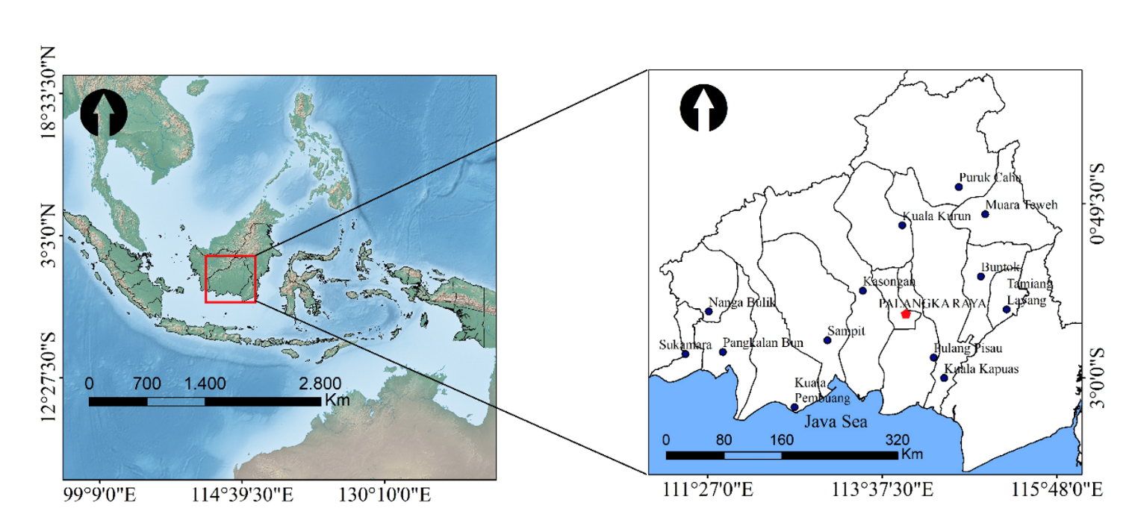

Figure 1. Map of research site in Central Kalimantan Province, Indonesia

Central Kalimantan has a tropical climate with the temperature ranged from 21.20 C to 34.80 C (Hendrik et al., 2010; Hirano et al., 2012; Page et al., 2004; Tawaraya et al., 2007). The sunlight available abundantly ranged from 52% - 69%, creating favorable conditions for agriculture and plantations. The condition of social and ecosystem condition influenced by the river. The south part of Central Kalimantan is flat low land with altitude 1-9 meter above sea level. Whist the north side is mountain area and hilly contour. Beside rivers, the altitude and contour also have influence on the type of ecosystem. Peat swamp forest and low land forest dominated South area and high land dipterocarps forest is dominant at north side (BPS Kalteng, 2022).

Central Kalimantan's ecosystem is heavily influenced by the presence of rivers. From a socio-economic perspective, rivers also play an important role for the community. In some areas where there is no land access yet, rivers still play an important role in transportation so that in general, many settlements for the people of Central Kalimantan are located on riverbanks. Rivers also play an important role from an economic standpoint, rivers where people catch fish, look for gold and provide water for their daily needs. There are 11 major rivers and 33 tributaries spread throughout the Central Kalimantan region. The longest river is the Barito River with a length of 900 km, while the shortest river is the Kumai River with a length of 175 km. Central Kalimantan contains about three million hectares of peatland which is one of the largest unbroken peatland in the world and located between 0º 45’ N and 3º 3’ S, between 111º and 116º E (Boehm & Siegert, 2001; BPS Kalteng, 2022).

Based on the Central Kalimantan Provincial Spatial Plan for 2021, the total allocation for protected forest is 3,630,142 ha and 12,120,330 ha for productive forest area. As shown in **Table 1**, from the proportion of protected forest areas, the provincial government allocated 600,000 ha for Customary Forests and 35,627 for Grand Forest Parks (or Taman Hutan Rakyat/TAHURA). It is hoped that in the future the role of indigenous peoples in managing and conserving nature will be increased (BPS Kalteng, 2022; Laksminarti, 2019; Supriatna et al., n.d.).

**Table 1.** Forest area classification in Central Kalimantan.

|  |  |
| --- | --- |
| Central Kalimantan Provincial Spatial Plan | Area (ha) |
| A. Protected Forest Area | |
| 1. Protection Forest | 1,391,604 |
| 2. Customary Forest | 600,000 |
| 3. Wildlife Sanctuary | 57,389 |
| 4. Strict Nature Reserve | 198,597 |
| 5. National Park | 1,168,284 |
| 6. Nature Recreation Park | 2,954 |
| 7. Grand Forest Park | 35,627 |
| 8. Natural reserve on Ex-Mega Rice Project | 154,002 |
| 9. Black water conservation | 17,626 |
| 10. Reserve Region | 23 |
| 11.Other Protected Area | 4,036 |
| Total A | 3,630,142 |
| B. Production Forest Area | |
| 1. Limited Production Forest | 3,335,571 |
| 2. Production Forest | 3,896,706 |
| 3. Convertible Production Forest | 2,258,274 |
| 4. Other Area | 2,629,779 |
| Total B | 12,120,330 |
| Total A + B | 15,750,472 |

Data and Analysis

We used land cover maps issued by Ministry of Forestry and Environment (MoFE) Republic of Indonesia. The period time of deforestation analysis followed procedure of the 2nd FRL of Indonesia, which are 2006 – 2020 (Murdiyarso et al., 2011). However, the Ministry of Environmental and Forestry (MoEF) did not publish land cover maps of 2007, 2008 and 2010.

MoEF classified natural forest land cover into 6 classes: primary dryland forest, secondary dry land forest, primary swamp forest, secondary swamp forest, primary mangrove forest and secondary mangrove forest. Meanwhile non-natural forest cover classified into 15 classes: plantation forest, pure dry agriculture, mixed dry agriculture, dry shrub, wet shrub, savanna and grasses, paddy field, open swamp, fishpond/aquaculture, transmigration areas, settlement areas, port and harbor, mining areas, bare ground, and open water (Margono et al., 2014).

We calculated deforestation in each year by overlaying the landcover map of the previous year (T0) with the landcover map of following year (T1). Using ArcGIS version 10.2, we measured the conversion from natural forest category into non-natural forest category. We also identified the land cover post deforestation to tract the cause of deforestation. The interpretation of the Landsat LDCM (Landsat Data Continuity Mission) data served as the basis for the estimation of the deforestation rate for the years 2006 – 2020 (Ardiyanto et al., 2022).

Equation of annual forest cover change is used to calculate the annual deforestation rate. It comes from the compound interest rule (Ferraz et al., 2009; Puyravaud, 2003). Annual deforestation rate (r) is recommended because it is more intuitive than previous formula used by FAO (q) (Puyravaud, 2003). R value is always higher than q. In many cases, the difference in the two formulas is lower than it of sampling error. Rate of forest cover change yearly (r, %/year) is calculated based on forest cover initial (A1, ha) in early period (T1, year) and extensive forest cover end (A2, ha) in final period (T2, year). It is formulated as follows (Puyravaud, 2003):



Field observation was conducted to identify the land use type and validate the result from satellite images. Before the preprocessing of satellite imagery, an extensive field activity was performed throughout the study area using GPS equipment and an unmanned aerial vehicle (UAV/drone) for this activity. This field activity was performed to: (1) obtain accurate location of point data for each land cover class included in the classification scheme, (2) establish training sites and (3) create an independent data set reserved for accuracy assessment. The land cover categories of focus were burnt areas, peat swamp forest, resettlement, barren land, mangrove and herbaceous land. Result from land cover change analysis then analyzed further using statistic descriptive to calculate the average deforestation each year and the standard error.

**3. Result and Discussion**

Data indicated that deforestation rates in Central Kalimantan had fluctuated in each computation. This takes place because of the dynamic changes in land cover brought on by human activities that result in the loss of forest cover. In total, between the period 2006 – 2020 natural forest in Central Kalimantan has reduced 1.5 million hectares. Swamp secondary forest and dry secondary forest experienced deforestation the most, while mangrove primary forest and mangrove secondary forest less deforested (see **Figure 3**). The rate of deforestation fluctuated during the period of analysis, however in general showed a decreasing trend. As **Table 2** shows between 2006 – 2009 to 2011 – 2012 deforestation decrease sharply, falling from 418,524 ha/year to 56,421 ha/year. The trend then rises slightly to 86,305 ha/year in 2012 – 2013.

**Table 2.** The change of natural forest cover between 2006 – 2020 (in hectares).

|  |  |  |
| --- | --- | --- |
| **Type of Forest** | **2006** | **2020** |
| Primary Dry Land Forest | 1,204,400 | 1,058,780 |
| Primary Swamp Forest | 44,339 | 32,373 |
| Primary Mangrove Forest | 2,796 | 1,777 |
| Secondary Dry Land Forest | 4,874,912 | 4.287.854 |
| Secondary Swamp Forest | 2,355,643 | 1,706,985 |
| Secondary Mangrove Forest | 21,940 | 21,148 |
| **Total** | **8,504,029** | **7,108,917** |

Considering the rise and the down of the trend, deforestation in Central Kalimantan could categorized into decrease period and increase period. Decreased era occurred in period 2006 – 2012, 2013 – 2014, 2015 – 2016 and 2018 – 2020. On other hand, **Figure 2** showsincreasing trends take place in 2012 – 2013, 2014 – 2015, and 2016 – 2018. Interesting phenomena occurred between 2019 – 2020 where deforestation rate recorded negative 35,812 ha. This indicated that between this period covered natural forest is increasing. This trend of deforestation continues to decline until 2019-2020 due to various causes, both anthropogenic, natural and government policies.

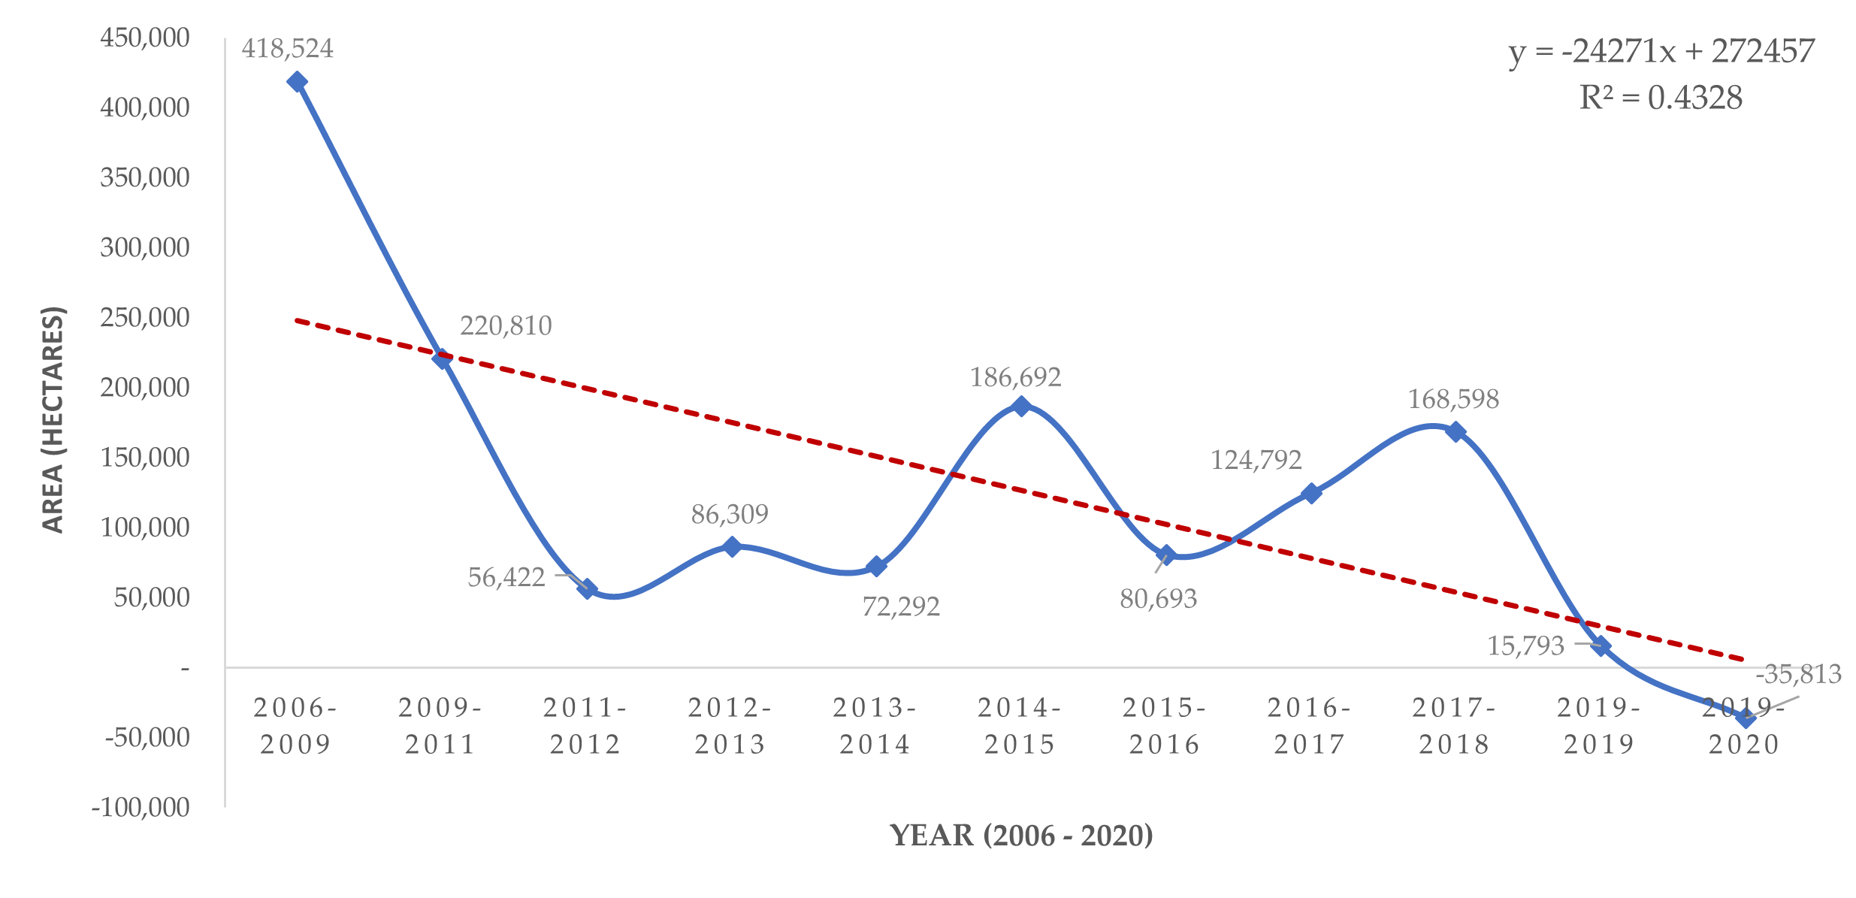

**Figure 2.** The trend of deforestation in Central Kalimantan, Indonesia

Table 3. The rate of annual deforestation between 2016-2020 (in hectares)

|  |  |  |
| --- | --- | --- |
| **Type of Forest** | **Deforestation (ha yr-1)** | **SE (ha yr-1)** |
| Primary Dry Land Forest | 312.74 | 96.86 |
| Primary Swamp Forest | 976.08 | 490.46 |
| Primary Mangrove Forest | 7.53 | 6.56 |
| Secondary Dry Land Forest | 55,938.56 | 11,125.25 |
| Secondary Swamp Forest | 902.61 | 262.97 |
| Secondary Mangrove Forest | 59,317.81 | 11,574.10 |
| **Total** | **117,455.33** | **23,556.20** |

*Note: SE (Standard Error)*

Total rate of deforestation in Central Kalimantan was 117,445 ha/yr. Usually the process of deforestation initiates forest degradation, the change from primary forest into secondary forest. When the detriment continues, the secondary forest converts into other land covers such as plantation and agriculture (see in **Table 3**). However, deforestation also could happen from primary forest that change into other land cover type. Our analysis found that dry primary forest and swamp primary forest experienced deforestation. All natural forest criteria, mangrove forest experienced a relatively small rate of deforestation.

Analysis on the change of land cover, this research found that natural forest in Central Kalimantan had converted into 15 land use types. The dominant land use resulting from deforestation were shrubs, open area, plantations, and agriculture land. Besides that, natural forest clearing especially in swamp forest generates swamp area and water body such as lake and water pond.

The average amount of deforestation in each forest category is presented in **Table 4**. As we can see from that table swamp secondary forest and dry secondary forest had the highest deforestation rate 59,317.81 ha/year and 55,938.56 ha/year respectively. Mangrove forests suffered less from deforestation because mangrove ecosystem was less favorable for plantations. Large scale oil palm plantations or forest plantations require fertile soil with sufficient water supply, thus low land and dry land forest are favorable.

Table 4. The land use type resulted from deforestation in Central Kalimantan, Indonesia

|  |  |  |
| --- | --- | --- |
| **Strata** | **AD post deforestation (ha yr-1)** | **SE (ha yr-1)** |
| Port and Harbor | 0.00 | 0.00 |
| Plantation forest | 1,369.55 | 1,187.90 |
| Paddy Field | 35.87 | 22.95 |
| Bare ground | 28,507.95 | 10,588.18 |
| Savanna and Grasses | 0.00 | 0.00 |
| Settlement areas | 90.96 | 83.04 |
| Perennial crops | 10,855.18 | 2,951.76 |
| Mining areas | 3,217.44 | 690.18 |
| Dry cultivation | 593.53 | 290.78 |
| Dry cultivation and Shrub | 10,624.07 | 5,016.19 |
| Swamp | 1,419.46 | 294.19 |
| Shrub | 30,271.34 | 5,399.42 |
| Wetland Shrub | 30,424.46 | 5,974.28 |
| Fishpond/aquaculture | 5.13 | 5.06 |
| Transmigration Areas | 22.72 | 23.58 |
| Open Water | 17.67 | 12.76 |
| **Total** | **117,455.33** | **32,540.27** |

Notes: AD (After Deforestation); SE (Standard Error)

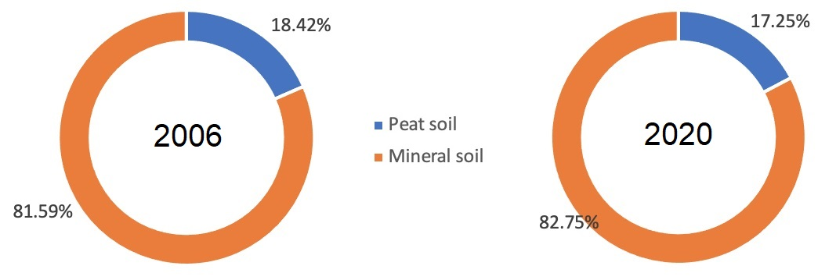

**Figure 3.** Comparison of deforestation on mineral soil and peat soil between 2006 and 2020 in Central Kalimantan (Indonesia)

Of the 1.5 million natural forests that converted into other land use system 373,816.39 hectare were taken in peatland soil. On other words, as much as 24% of deforestation in Central Kalimantan targeted peat ecosystem that rich in carbon stock and as consequences, emit higher GHGs into the atmosphere. **Figure 3** shows comparing the proportion of forest on peat soil and mineral soil, we found that forest in 2006 has slightly different from forest in 2020. In 2006 the proportion of forests on peat soil was to some extent higher than forest on peat soil in 2020. This figure shows that mineral soil is more desirable than peat soil due to forest clearing for various purposes.

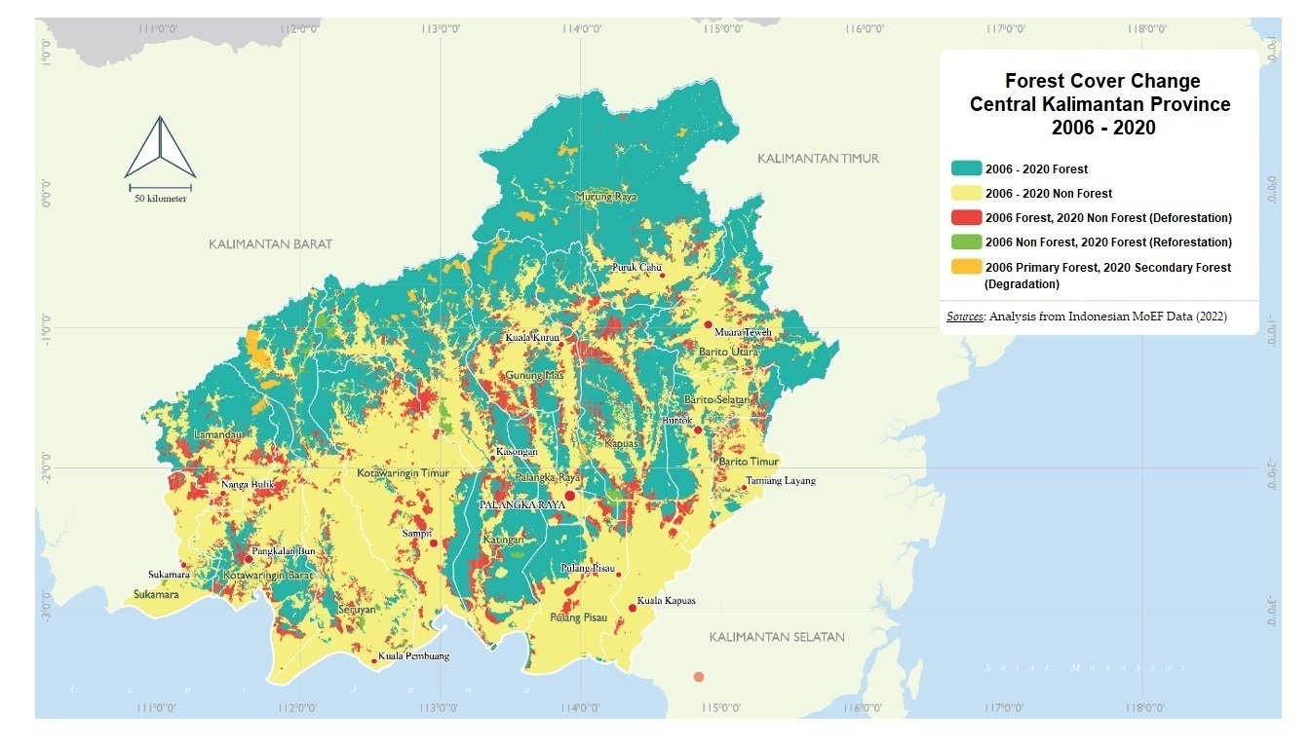

**Figure 4.** Map of Deforestation and Forest Degradation in Central Kalimantan Province, Indonesia

(2006 – 2020).

This research found that most of deforestation in Central Kalimantan within range time 2006 – 2020 arisen in secondary swamp and dry forest, which is located mostly at low land area in south part as shown in **Figure 4**. This figure also shows several areas that experienced reforestation during the 2006 - 2020 period, both those that occurred naturally and from reforestation activities. This finding is consistent with the finding that from 2010 to 2015, just 18% of forests were replaced by plantations, down from 54% between 1995 and 2000. Additionally, it is estimated that 30.2 million hectares of non-forest land across the country match the biophysical requirements for oil palm development (K. G. Austin et al., 2017; Poor et al., 2019).

There were four types of disturbances distinguished during field and aerial observation on the study areas; (1) no disturbance: tall and large peat swamp forest trees; rather closed canopy; no sign of human exploitation; (2) old, exploited forests (timber extraction was conducted more than 25 years prior to the survey): ex-logging railways and stamping areas colonized by pioneer tree species in Sebangau Catchment such as *Combretocarpus rotundatus* (tumeh) and *Macaranga* sp. In several locations (crown shape and color easily distinguishable from other tree species), some emergent trees; (3) land clearing by the local community for agriculture and settlement; and (4) burnt areas affected by El-NINO fire events.

The low land forest is inhabited more than high land parts. In addition, low elevation, access and soil condition make lowland forest of Central Kalimantan favorable for oil palm and timber plantations (Kemen G. Austin et al., 2019; Curran et al., 2004; Gaveau et al., 2009; Margono et al., 2014). Protected forest in lowland Kalimantan decreased by 56% in period of 1985 – 2001 (Curran et al., 2004). The rate of oil palm plantation expanded was 450,000 ha/year and replacing forested area in lowland area (K. G. Austin et al., 2017; Kemen G. Austin et al., 2019).

As of 2015, Central Kalimantan, the largest of the five provinces in Kalimantan/Borneo (~15.3 million hectares), still had the third-largest relative forest cover (~49% of the total provincial area), the greatest absolute forest cover (~7.5 million ha), and the highest percentage of forests (~7.5 million ha). Additionally, it is the province that contributed the biggest percentage (38%) of all emissions from deforestation for the whole analyzed period from 1990 to 2015 (BPS Kalteng, 2022; Wegscheider et al., 2019). Central Kalimantan has two national parks in the lowland area, Sebangau National Park, and Tanjung Puting National Park. The two protected areas play as bulwark, holding and resisting deforestation. However, concern arises for the conservation of these two national parks since rapid deforestation occurred in surrounding and buffer zone areas.

The deforestation rate was relatively high in the period 2006 – 2011 because of policy and development priority from the government. During this range of time, the government is creating investment ambience, high incentive and attractive leases inviting investors to develop large scale oil palm and timber plantations (Bissonnette & De Koninck, 2015). In comparison to what actually happened, it was estimated that a European ban on high-deforestation palm oil from 2000 to 2015 would have resulted in a global price premium of 8.9% on low-deforestation palm oil, preventing 21 374 ha (1.60%) less deforestation and 21.1 million tCO2 (1.91%) less deforestation-related emissions in Indonesia (Busch et al., 2022; Murdiyarso et al., 2011).

Oil palm is a lucrative and highly profitable commodity and has become the main reason for the expansion of this commodity in Kalimantan. It works closely with the cooperative sector and individual farmers, producers of palm oil production (Indonesia is the world’s largest producer and plans to increase its production up to 40 million tons annually by 2020) (Pachmann, 2021). After 2011, deforestation rate slowed down, following moratorium policy. Government banned the establishment of oil palm plantation on primary and peatland (Murdiyarso et al., 2011). However, deforestation rose again between 2015 – 2019 as a result widespread forest fire that triggered by ENSO (*El Niño–Southern Oscillation*) condition (Susilo et al., 2013). It has become obvious that the incidence of more frequent ENSO events, coupled with major land development projects that involve drainage of the surface peat, is leading to an increased risk of repeated fire events in tropical peatland areas (Hendrik et al., 2010). Furthermore, forest fires are an important cause of environmental alteration and land degradation or conversion through human activities.

The combination of degraded ecosystem generated from previous deforestation and long dry season caused forest fire uncontrolled. Even though Kalimantan's deforestation and emission rates have decreased overall from 1990 to 2015, this trend is not uniformly present across the five provinces. Even the rates in West and North Kalimantan appear to be rising. Thus, each province on Kalimantan Island has a different chance of meeting its carbon reduction goals (Wegscheider et al., 2019). After 2019, the deforestation in Central Kalimantan slowed down and even negative that associated with the absence of long dry season and the occurring of COVID-19 pandemic. But otherwise, evidence reveals that the COVID-19 epidemic has prompted illegitimate, opportunistic forest cutting and mining in tropical nations, endangering forest ecosystems and the inhabitants that depend on them (Brancalion et al., 2020a, 2020b; Céspedes et al., 2022; CI, 2020; Laudares, 2020; M et al., 2021).

Considering the negative effect of deforestation, recently the Government of Indonesia launched program called FOLU Net Sink. This program aims to sequestrate GHGs bigger than the emission from forestry and other land use sectors. The goal of FOLU net sink articulate in 5 main strategies: reduction emission from deforestation and forest degradation, establishment of forest plantations, sustainable forest management, forest rehabilitation and management of peat ecosystem(BPS Kalteng, 2022; *Submission by Indonesia NATIONAL FOREST REFERENCE LEVEL FOR DEFORESTATION , FOREST Editor in Chief*, 2022). Forest vegetation and soils continue to be important on carbon sinks, even though deforestation and forest degradation contribute to around 17% of the world's greenhouse gas emissions. Together, tropical and subtropical forests hold more than half of the carbon dioxide (CO2) in the atmosphere.

The result of this research may contribute to the achievement of the Indonesia NDC by inform the decision makers about the characteristic of deforestation in Central Kalimantan as the largest province in Indonesia. Additionally, the primary causes of land-use changes are the increase of agriculture and deforestation. Given that peat swamp forest ecosystems in Central Kalimantan also could support extraordinarily high biodiversity and enormous amounts of carbon, deforestation in this area has the potential to have negative effects on the entire planet (DeFries et al., 1999; Miettinen et al., 2011). Research on the causes of the unsuccessful forest law enforcement policies and initiatives over the past 20 years, beginning with the first Forest Law Enforcement, Governance and Trade conference held in Bali in 2001, would help Indonesia's efforts and those of other nations (Kemen G. Austin et al., 2019; Pachmann, 2021; Wijaya et al., 2019). Government policies in this case handling and preventing deforestation and forest degradation at the provincial level include, among others, through mainstreaming green growth and low carbon development in all planning documents, both regional development planning (province and district levels) and sectoral development planning (forestry, energy, environment, agriculture, tourism, etc.), including protection and restoration management of peat and mangrove ecosystems.

There are several difficulties in this deforestation study, especially in Central Kalimantan Province, including the rapid changes in policies related to the use of forests and land for other uses such as national policies on food estate programs, forest and land fires that occur due to the long drought (ENSO), as well as forest encroachment for agriculture, settlements, and illegal mining. So further and detailed research is needed on serial and integrated spatial analysis of land use changes in Central Kalimantan using ecological, economic and socio-cultural approaches with the involvement of experts from various scientific disciplines.

One of the challenging questions is what will be the form, speed and mode of deforestation and forest degradation in the future in Central Kalimantan in the face of the relocation of Indonesia's capital city to East Kalimantan, as well as various strategic policies to face the increasing food crisis, people migration and drought? (Kodir et al., 2021; Rahmat et al., 2021)

**4. Conclusion**

Deforestation in Central Kalimantan as the largest province in Indonesia in the period 2006 – 2020 has shown a decline trend that influenced by policy and anthropogenic activities. From the total of 1.5 million ha forest loss within the analysis period, deforestation mostly occurred in peat swamp and dry secondary forest were human activities relatively high. Deforestation resulted in degraded areas such as shrubs, open areas and savanna and cultivated systems including agriculture and plantations.

Government policies, especially regulations regarding the eradication of illegal logging, forest and land fires, social forestry, carbon economic value, and the involvement of all forestry related stakeholders are at least able to reduce deforestation and changes in land use in the study area from forest to non-forest. The finding of this research could be used as a base to determine the target location for rehabilitation strategy and approach to prevent further deforestation.

**Acknowledgement**

We would like to thank our colleagues from the Central Kalimantan Provincial Forestry Service, the Central Kalimantan Regional Planning and Research Agency (BAPPEDALITBANG) and developing partners (Non-Government Organizations and International Organizations) in Central Kalimantan, as well as from the Center for Development of Science, Technology and Peatland Innovation (PPIIG) University of Palangka Raya, Indonesia for their support and collaborations.

**References**

A., C. (2001). Decentralisation of policies affecting forests and estate crops in Kutawaringin Timur district, Central Kalimantan. In *Decentralisation of policies affecting forests and estate crops in Kutawaringin Timur district, Central Kalimantan*. https://doi.org/10.17528/cifor/001057

Ardiyanto, S. Y., Saraswati, R., & Soponyono, E. (2022). Law Enforcement and Community Participation in Combating Illegal Logging and Deforestation in Indonesia. *Environment and Ecology Research*, *10*(4), 450–460. https://doi.org/10.13189/eer.2022.100403

Austin, K. G., Mosnier, A., Pirker, J., McCallum, I., Fritz, S., & Kasibhatla, P. S. (2017). Shifting patterns of oil palm driven deforestation in Indonesia and implications for zero-deforestation commitments. *Land Use Policy*, *69*(September), 41–48. https://doi.org/10.1016/j.landusepol.2017.08.036

Austin, Kemen G., Schwantes, A., Gu, Y., & Kasibhatla, P. S. (2019). What causes deforestation in Indonesia? *Environmental Research Letters*, *14*(2). https://doi.org/10.1088/1748-9326/aaf6db

Basuki, I., Adinugroho, W. C., Utomo, N. A., Syaugi, A., Tryanto, D. H., Krisnawati, H., Cook‐patton, S. C., & Novita, N. (2022). Reforestation Opportunities in Indonesia: Mitigating Climate Change and Achieving Sustainable Development Goals. *Forests*, *13*(3). https://doi.org/10.3390/f13030447

Bissonnette, J.-F., & De Koninck, R. (2015). Large plantations versus smallholdings in Southeast Asia: historical and contemporary trends. *Conference on Land Grabbing, Conflict and Agrarian-Environmental Transformations: Perspective from East and Southeast Asia*, *12*.

Boehm, H., & Siegert, F. (2001). Ecological impact of the One Million Hectare Rice Project in Central Kalimantan, Indonesia, using Remote Sensing and GIS. *Paper Presented at the 22nd Asian Conference on Remote Sensing*, *5*(November), 6. http://www.crisp.nus.edu.sg/~acrs2001/pdf/126boehm.pdf

BPS Kalteng. (2022). Provinsi Kalimantan Tengah Dalam Angka. *Provinsi Kalimantan Tengah Dalam Angka*.

Brancalion, P. H. S., Broadbent, E. N., de-Miguel, S., Cardil, A., Rosa, M. R., Almeida, C. T., Almeida, D. R. A., Chakravarty, S., Zhou, M., Gamarra, J. G. P., Liang, J., Crouzeilles, R., Hérault, B., Aragão, L. E. O. C., Silva, C. A., & Almeyda-Zambrano, A. M. (2020a). Emerging threats linking tropical deforestation and the COVID-19 pandemic. *Perspectives in Ecology and Conservation*, *18*(4), 243–246. https://doi.org/10.1016/j.pecon.2020.09.006

Brancalion, P. H. S., Broadbent, E. N., de-Miguel, S., Cardil, A., Rosa, M. R., Almeida, C. T., Almeida, D. R. A., Chakravarty, S., Zhou, M., Gamarra, J. G. P., Liang, J., Crouzeilles, R., Hérault, B., Aragão, L. E. O. C., Silva, C. A., & Almeyda-Zambrano, A. M. (2020b). Emerging threats linking tropical deforestation and the COVID-19 pandemic. *Perspectives in Ecology and Conservation*, *18*(4). https://doi.org/10.1016/j.pecon.2020.09.006

Busch, J., Amarjargal, O., Taheripour, F., Austin, K. G., Siregar, R. N., Koenig, K., & Hertel, T. W. (2022). Effects of demand-side restrictions on high-deforestation palm oil in Europe on deforestation and emissions in Indonesia. *Environmental Research Letters*, *17*(1). https://doi.org/10.1088/1748-9326/ac435e

Carlson, D. S., Kacmar, K. M., & Williams, L. J. (2000). Construction and Initial Validation of a Multidimensional Measure of Work-Family Conflict. *Journal of Vocational Behavior*, *56*(2). https://doi.org/10.1006/jvbe.1999.1713

Céspedes, J., Sylvester, J. M., Pérez-Marulanda, L., Paz-Garcia, P., Reymondin, L., Khodadadi, M., Tello, J. J., & Castro-Nunez, A. (2022). Has global deforestation accelerated due to the COVID-19 pandemic? *Journal of Forestry Research*. https://doi.org/10.1007/s11676-022-01561-7

Chapin, F. S., Zavaleta, E. S., Eviner, V. T., Naylor, R. L., Vitousek, P. M., Reynolds, H. L., Hooper, D. U., Lavorel, S., Sala, O. E., Hobbie, S. E., Mack, M. C., & Díaz, S. (2000). Consequences of changing biodiversity. In *Nature* (Vol. 405, Issue 6783). https://doi.org/10.1038/35012241

CI. (2020). Poaching, deforestation reportedly on the rise since COVID-19 lockdowns. In *Conservation International (CI)*.

Curran, L. M., Trigg, S. N., McDonald, A. K., Astiani, D., Hardiono, Y. M., Siregar, P., Caniago, I., & Kasischke, E. (2004). Lowland Forest Loss in Protected Areas of Indonesian Borneo. *Science*, *303*(5660). https://doi.org/10.1126/science.1091714

DeFries, R. S., Townshend, J. R. G., & Hansen, M. C. (1999). Continuous fields of vegetation characteristics at the global scale at 1-km resolution. *Journal of Geophysical Research Atmospheres*, *104*(D14). https://doi.org/10.1029/1999JD900057

Doggart, N., Morgan-Brown, T., Lyimo, E., Mbilinyi, B., Meshack, C. K., Sallu, S. M., & Spracklen, D. V. (2020). Agriculture is the main driver of deforestation in Tanzania. *Environmental Research Letters*, *15*(3). https://doi.org/10.1088/1748-9326/ab6b35

Ferraz, S. F. de B., Vettorazzi, C. A., & Theobald, D. M. (2009). Using indicators of deforestation and land-use dynamics to support conservation strategies: A case study of central Rondônia, Brazil. *Forest Ecology and Management*, *257*(7), 1586–1595. https://doi.org/10.1016/j.foreco.2009.01.013

Foody, G. M. (2003). Remote sensing of tropical forest environments: Towards the monitoring of environmental resources for sustainable development. *International Journal of Remote Sensing*, *24*(20), 4035–4046. https://doi.org/10.1080/0143116031000103853

Foody, Giles M, Cutler, M. E., Mcmorrow, J., Pelz, D., Tangki, H., Boyd, D. S., & Douglas, I. A. N. (2001). *Mapping the biomass of Bornean tropical rain forest from remotely sensed data ESTIMATION AND MAPPING*. 379–387.

Gaveau, D. L. A., Epting, J., Lyne, O., Linkie, M., Kumara, I., Kanninen, M., & Leader-Williams, N. (2009). Evaluating whether protected areas reduce tropical deforestation in Sumatra. *Journal of Biogeography*, *36*(11). https://doi.org/10.1111/j.1365-2699.2009.02147.x

Hendrik, S., Tani, H., & Hirano, T. (2010). Detection of fire impact and vegetation recovery over tropical peat swamp forest by satellite data and ground-based NDVI instrument. *International Journal of Remote Sensing*, *31*(20), 5297–5314. https://doi.org/10.1080/01431160903302981

Hirano, T., Segah, H., Kusin, K., Limin, S., Takahashi, H., & Osaki, M. (2012). Effects of disturbances on the carbon balance of tropical peat swamp forests. *Global Change Biology*, *18*(11), 3410–3422. https://doi.org/10.1111/j.1365-2486.2012.02793.x

Iwata, K., Ito, Y., & Managi, S. (2014). Public and private mitigation for natural disasters in Japan. *International Journal of Disaster Risk Reduction*, *7*. https://doi.org/10.1016/j.ijdrr.2013.12.005

Jaenicke, J., Wösten, H., Budiman, A., & Siegert, F. (2010). Planning hydrological restoration of peatlands in Indonesia to mitigate carbon dioxide emissions. In *Mitigation and Adaptation Strategies for Global Change* (Vol. 15, Issue 3, pp. 223–239). https://doi.org/10.1007/s11027-010-9214-5

Kodir, A., Hadi, N., Astina, I. K., Taryana, D., Ratnawati, N., & Idris. (2021). The dynamics of community response to the development of the New Capital (IKN) of Indonesia. *Development, Social Change and Environmental Sustainability*, *Nugroho 2020*, 57–61. https://doi.org/10.1201/9781003178163-13

Koh, J. H. L., Chai, C. S., Benjamin, W., & Hong, H. Y. (2015). Technological Pedagogical Content Knowledge (TPACK) and Design Thinking: A Framework to Support ICT Lesson Design for 21st Century Learning. *Asia-Pacific Education Researcher*, *24*(3). https://doi.org/10.1007/s40299-015-0237-2

Kusin, K., Sulistiyanto, Y., Usup, A., & Ardianor. (2022). Carbon Monoxide (CO) and Particulate Matter (PM2.5) Concentration at Central Kalimantan, Indonesia. *IOP Conference Series: Earth and Environmental Science*, *1111*(1). https://doi.org/10.1088/1755-1315/1111/1/012006

Laksminarti, L. (2019). Rekonstruksi Hukum Pengaturan Rencana Tata Ruang Wilayah Provinsi Kalimantan Tengah Berbasis Keberlanjutan Lingkungan. *Restorica: Jurnal Ilmiah Ilmu Administrasi Negara Dan Ilmu Komunikasi*, *5*(2). https://doi.org/10.33084/restorica.v5i2.1074

Lambin, E. F. (1999). Monitoring forest degradation in tropical regions by remote sensing: Some methodological issues. *Global Ecology and Biogeography*, *8*(3–4), 191–198. https://doi.org/10.1046/j.1365-2699.1999.00123.x

Laudares, H. (2020). Is deforestation spreading COVID-19 to the indigenous peoples? *Covid Economics: Vetted and Real-Time Papers*, *53*.

Lawrence, D., Coe, M., Walker, W., Verchot, L., & Vandecar, K. (2022). The Unseen Effects of Deforestation: Biophysical Effects on Climate. *Frontiers in Forests and Global Change*, *5*(March), 1–13. https://doi.org/10.3389/ffgc.2022.756115

Liu, D., Guo, X., & Xiao, B. (2019). What causes growth of global greenhouse gas emissions? Evidence from 40 countries. *Science of the Total Environment*, *661*. https://doi.org/10.1016/j.scitotenv.2019.01.197

M, L., Almukthar, N., Edbey, K., C, F., Rafa, A. Y., Mashori, G. R., & Yurevich, L. O. (2021). Deforestation, Air Pollution And Brasiliant Covid-19 Variant. *INTERNATIONAL JOURNAL OF MEDICINE AND HEALTHCARE REPORTS*, *01*(01). https://doi.org/10.51521/ijmhr.2021.1103

Margono, B. A., Potapov, P. V., Turubanova, S., Stolle, F., & Hansen, M. C. (2014). Primary forest cover loss in indonesia over 2000-2012. In *Nature Climate Change* (Vol. 4, Issue 8). https://doi.org/10.1038/nclimate2277

Miettinen, J., Shi, C., & Liew, S. C. (2011). Deforestation rates in insular Southeast Asia between 2000 and 2010. *Global Change Biology*, *17*(7). https://doi.org/10.1111/j.1365-2486.2011.02398.x

Mitchard, E. T. A. (2018). The tropical forest carbon cycle and climate change. *Nature*, *559*(7715), 527–534. https://doi.org/10.1038/s41586-018-0300-2

Moutinho, P. (2005). (1) (PDF) Tropical Deforestation and Climate Change. In *Instituto de Pesquisa Ambiental da Amazônia and Environmental Defense*.

Murdiyarso, D., Dewi, S., Lawrence, D., & Seymour, F. (2011). Indonesia’s Forest Moratorium: A Stepping Stone to Better Forest Governance? In *Working Paper*.

Pachmann, A. (2021). Corruption and Deforestation in Indonesia. *Regional Formation and Development Studies*, *2*(2), 55–62. https://doi.org/10.15181/rfds.v25i2.1745

Page, S. E., Wust, R. A. J., Weiss, D., Rieley, J. O., Shotyk, W., & Limin, S. H. (2004). A record of Late Pleistocene and Holocene carbon accumulation and climate change from an equatorial peat bog (Kalimantan, Indonesia): Implications for past, present and future carbon dynamics. *Journal of Quaternary Science*, *19*(7), 625–635. https://doi.org/10.1002/jqs.884

Poor, E. E., Jati, V. I. M., Imron, M. A., & Kelly, M. J. (2019). The road to deforestation: Edge effects in an endemic ecosystem in Sumatra, Indonesia. *PLoS ONE*, *14*(7). https://doi.org/10.1371/journal.pone.0217540

Prabowo, D., Maryudi, A., Senawi, & Imron, M. A. (2017). Conversion of forests into oil palm plantations in West Kalimantan, Indonesia: Insights from actors’ power and its dynamics. *Forest Policy and Economics*, *78*, 32–39. https://doi.org/10.1016/J.FORPOL.2017.01.004

Puyravaud, J. P. (2003). Standardizing the calculation of the annual rate of deforestation. *Forest Ecology and Management*, *177*(1–3), 593–596. https://doi.org/10.1016/S0378-1127(02)00335-3

Rahmat, H. K., Widana, I. D. K. K., Basri, A. S. H., & Musyrifin, Z. (2021). Analysis of potential disaster in the new capital of indonesia and its mitigation efforts: A qualitative approach. *Disaster Advances*, *14*(3), 40–43.

Reddy, C. S., Bird, N. G., Sreelakshmi, S., Manikandan, T. M., Asra, M., Krishna, P. H., Jha, C. S., Rao, P. V. N., & Diwakar, P. G. (2019). Identification and characterization of spatio-temporal hotspots of forest fires in South Asia. *Environmental Monitoring and Assessment*, *191*. https://doi.org/10.1007/s10661-019-7695-6

Ridder, R. M. (2007). *Forestry Department Food and Agriculture Organization of the United Nations GLOBAL FOREST RESOURCES ASSESSMENT 2010 OPTIONS AND RECOMMENDATIONS FOR A GLOBAL REMOTE SENSING SURVEY OF FORESTS*. www.fao.org/forestry

SI. (2015). Central Kalimantan In Figures 2015. *Statistics Indonesia*.

Silva Junior, C. H. L., Pessôa, A. C. M., Carvalho, N. S., Reis, J. B. C., Anderson, L. O., & Aragão, L. E. O. C. (2021). The Brazilian Amazon deforestation rate in 2020 is the greatest of the decade. *Nature Ecology and Evolution*, *5*(2), 144–145. https://doi.org/10.1038/s41559-020-01368-x

*Submission by Indonesia NATIONAL FOREST REFERENCE LEVEL FOR DEFORESTATION , FOREST Editor in Chief*. (2022).

Suk, J. E., Vaughan, E. C., Cook, R. G., & Semenza, J. C. (2020). Natural disasters and infectious disease in Europe: A literature review to identify cascading risk pathways. In *European Journal of Public Health* (Vol. 30, Issue 5). https://doi.org/10.1093/eurpub/ckz111

Supriatna, T., Lukman, S., & Daraba, D. (n.d.). *Planning Strategy Spatial Plan for the Province of Central Kalimantan*. 8705–8715.

Suroso, D. S. A., Setiawan, B., Pradono, P., Iskandar, Z. S., & Hastari, M. A. (2022). Revisiting the role of international climate finance (ICF) towards achieving the nationally determined contribution (NDC) target: A case study of the Indonesian energy sector. *Environmental Science and Policy*, *131*. https://doi.org/10.1016/j.envsci.2022.01.022

Susilo, G. E., Yamamoto, K., Imai, T., Ishii, Y., Fukami, H., & Sekine, M. (2013). The effect of ENSO on rainfall characteristics in the tropical peatland areas of Central Kalimantan, Indonesia. *Hydrological Sciences Journal*, *58*(3). https://doi.org/10.1080/02626667.2013.772298

Suwarno, A., Hein, L., & Sumarga, E. (2015). Governance, decentralisation and deforestation: The case of central Kalimantan Province, Indonesia. *Quarterly Journal of International Agriculture*, *54*(1).

Taddese, G. (2001). Land degradation: A challenge to Ethiopia. In *Environmental Management* (Vol. 27, Issue 6). https://doi.org/10.1007/s002670010190

Tawaraya, K., Turjaman, M., & Ekamawanti, H. A. (2007). Effect of arbuscular mycorrhizal colonization on nitrogen and phosphorus uptake and growth of Aloe vera L. *HortScience*, *42*(7), 1737–1739. https://doi.org/10.21273/hortsci.42.7.1737

Thomas, C. D., Cameron, A., Green, R. E., Bakkenes, M., Beaumont, L. J., Collingham, Y. C., Erasmus, B. F. N., Ferreira De Siqueira, M., Grainger, A., Hannah, L., Hughes, L., Huntley, B., Van Jaarsveld, A. S., Midgley, G. F., Miles, L., Ortega-Huerta, M. A., Peterson, A. T., Phillips, O. L., & Williams, S. E. (2004). Extinction risk from climate change. *Nature*, *427*(6970), 145–148. https://doi.org/10.1038/nature02121

Touma, D., Stevenson, S., Lehner, F., & Coats, S. (2021). Human-driven greenhouse gas and aerosol emissions cause distinct regional impacts on extreme fire weather. *Nature Communications*, *12*(1). https://doi.org/10.1038/s41467-020-20570-w

Ullah, A., Raza, K., Nadeem, M., Mehmood, U., Agyekum, E. B., Elnaggar, M. F., Agbozo, E., & Kamel, S. (2022). Does Globalization Cause Greenhouse Gas Emissions in Pakistan? A Promise to Enlighten the Value of Environmental Quality. *International Journal of Environmental Research and Public Health*, *19*(14). https://doi.org/10.3390/ijerph19148678

Venelia, H., Nisa, K., Wibowo, R. A., & Muda, M. A. (2021). Robust Biplot Analysis of Natural Disasters in Indonesia from 2019 To 2021. *Jurnal Aplikasi Statistika & Komputasi Statistik*, *13*(2). https://doi.org/10.34123/jurnalasks.v13i2.349

W.D., S., & I.A.P., R. (1997). Laju dan penyebab deforestasi di Indonesia: penelaahan kerancuan dan penyelesaiannya. *Laju Dan Penyebab Deforestasi Di Indonesia: Penelaahan Kerancuan Dan Penyelesaiannya*, *9*(9). https://doi.org/10.17528/cifor/000057

Wegscheider, S., Purwanto, J., Margono, B. A., Nugroho, S., Budiharto, Buchholz, G., & Sugardiman, R. A. (2019). Current achievements to reduce deforestation in Kalimantan. *Indonesian Journal of Geography*, *50*(2), 109–120. https://doi.org/10.22146/ijg.23680

Wijaya, A., Firmansyah, R., Said, Z., & Nathania, B. (2019). Monitoring of Indonesia tropical rainforests and land cover change using hybrid approach of time series landsat data. *International Geoscience and Remote Sensing Symposium (IGARSS)*, *2019*-*July*. https://doi.org/10.1109/IGARSS.2019.8900121

Yoshioka, N., Era, M., & Sasaki, D. (2021). Towards integration of climate disaster risk and waste management: A case study of urban and rural coastal communities in the Philippines. *Sustainability (Switzerland)*, *13*(4). https://doi.org/10.3390/su13041624