**Water Balance Supporting the Irrigation Water Demand in Java Island, Indonesia**

**Yudha Mediawan**\*1**, Lily Montarcih1, Widandi Soetopoi1, Tri Budi Prayogo1**

Civil Engineering Department, Faculty of Engineering, Brawijaya University, Indonesia

*) Correspondence author: Yudha Mediawan (yudhamediawan99@gmail.com)

***Abstract***

*Java, the most densely-populated island in Indonesia, has the largest irrigation area in Indonesia. However, it is also the island with the largest water deficit. Hence, the analysis about the water availability is imperative to investigate the water status on this island. In this research, irrigation water potential is calculated based on water balance between the water availability and water needs for Domestic, Municipal and Industrial use and irrigation. This research is performed by calculating the water availability using WFLOW hydrology simulation and the water needs using population statistics. This research found that there is generally water surplus in Java even though several river basins (referred as WS) showed that there is water deficit, namely in the WS Kepulauan Seribu, WS Wiso Gelis, and WS Welang Rejoso. The trend shows that areas have a direct correlation with water availability, whereas population density is directly connected to water demands. According to the Central Bureau of Statistics (BPS), the agricultural area in Java is reduced by an average of 20 thousand hectares per year, making the demand for irrigation water on the island of Java will also decrease even more. It is suggested that the water surplus from irrigation in the future is diverted to be used for DMI, which has a tendency to increase based on the population. Furthermore, if the irrigation area were to be expanded, it is better to be done in the WS which has a large area since it has more water resources.*

**Key words**: Water availability, water demand, water balance, Irrigation, Java Island

***Abstrak***

*Jawa adalah pulau terpadat dengan persentase lahan sawah terbesar di Indonesia, lahan pesawahan di Pulau Jawa sering mengalami kekurangan air sehingga dibutuhkan analisis mengenai potensi ketersediaan air di Pulau jawa. Pada penelitian ini potensi air irigasi di pulau jawa dihitung berdasarkan neraca kesetimbangan air antara ketersediaan air dan kebutuhan air DMI dan Irigasi Pulau Jawa. Penelitian ini dibagi menjadi 2 bagian: analisis ketersediaan air menggunakan simulasi hidrologi WFLOW dan analisis kebutuhan air berdasarkan statistik kependudukan. Berdasarkan penelitian ini, disimpulkan bahwa keseimbangan air antara sumber daya air dan permintaan irigasi di Pulau Jawa masih surplus, meskipun terdapat defisit di beberapa wilayah sungai (WS): di WS Kepulauan Seribu, WS Wiso Gelis, dan WS Welang Rejoso. WS dengan ketersediaan air paling banyak umumnya berada pada WS yang luas, sementara WS dengan kebutuhan air paling banyak umumnya berada pada WS dengan populasi paling padat. Menurut Badan Pusat Statistik (BPS), luas pertanian di Jawa berkurang rata-rata 20 ribu hektar per tahun sehingga permintaan air irigasi di pulau Jawa juga akan semakin berkurang. Maka kelebihan potensi air di Pulau Jawa perlu dialokasikan untuk pemenuhan kebutuhan DMI yang semakin meningkat setiap tahunnya. Selain itu berdasarkan hasil penelitian ini untuk pengembangan daerah irigasi kedepannya disarankan pada WS yang luas sehingga memiliki potensi air irigasi yang cukup banyak.*

**Kata kunci**: Ketersediaan air, kebutuhan air, neraca air, irigasi, pulau Jawa

**1. Introduction**

Global demand for water has tripled since the 1950s, but raw water supply has been declining (Gleick, 2003). Half a billion people live in water-stressed or water-scarce countries, and by 2025 that number will grow to three billion due to an increase in population. However, due to overexploitation, pollution, and climate change, the availability of global water resources has been under serious pressure (Qureshi and Hanjra, 2010). Over the past several decades alone, the use of water has increased beyond the natural replenishing rate, resulting in water scarcity in many parts of the world (York et al., 2009). Irrigated agriculture is the dominant user of water, accounted for about 80% of global water use (Molden, 2007).

The cost of an irregular distribution of worldwide water resources are evident. Even in parts of the planet where water resources are abundant, the problems of availability or scarcity are common due to water mismanagement practices and anthropic activities (Aparicio, 2018). Water resources assessment is the key to the analysis of catchment management (Wurbs, 2005). In this regards, hydrologic model is a tool that could be used to support a better water resources management.

The water supply is calculated using a hydrological method whereas the water demands is calculated based on each sector’s water demand and environmental water demand. There are several common hydrological models: Soil and Water Assessment Tool (SWAT), National Rural Electric Cooperative Association (NRECA), (FJ. Mock, 1973), and WFLOW. The SWAT model uses parameters such as land use change, global change, and land conservation techniques (Neitsch et al., 2011) The NRECA uses an index of the soil moisture storage capacity, the rate of discharge from groundwater storage to a stream, daily rainfall data, and potential evapotranspiration data (Komariah et al., 2019). The FJ. Mock model uses daily rainfall data, evapotranspiration, and hydrologic watershed characteristics. WFLOW is Deltares solution to model hydrological processes, allowing users to modify precipitation, interception, snow accumulation and melt, evapotranspiration, soil water, surface water and groundwater recharge in a fully distributed environment (Schellekens, 2019). However, due to the limitation of the tools, this research does not include water availability from deep groundwater. A similar method was already used by Radhika et al. (2017) for the calculation of water availability in Indonesia, but that research did not specifically analyze the water balance with the scale of river basins (hereby after referred to as Wilayah Sungai (WS)) even though the water management in Indonesia is divided based on its WS. The irrigation water potential research in Java was limited to only the scale of irrigation areas (Faishal et al ,2013; Tampubolon et al., 2017) or watershed areas (Rahmawan, et al., 2016; Taufik, et al., 2019). The water balance calculation for Java has been published by Hidayat, et al., (2018), but not in the scale of river basin.

The purpose of this study is to analyze water potential in Java for irrigation water needs in every river basin. The analysis of water availability was performed using WFLOW and the calculation of water needs used the population data from Central Bureau of Statistics of Indonesia for every WS in Indonesia to determine the available water for irrigation in each WS.

**2. Study Area**

Indonesia is the largest archipelago in the world with more than 17.000 islands. Five major islands in Indonesia from the largest to the smallest are: Kalimantan, Sumatera, Papua, Sulawesi and Java. Even though java is the smallest island among the five, Java is the most densely-populated island in Indonesia with more than 50% of Indonesian populations. The water management in Indonesia is divided by their resepective River Basins (*Wilayah Sungai*, hereby after referred by WS). Based on the Ministry of Public Works and Housing (2015), Indonesia is divided into 131 river basin territories (WS). Java itself is divided into 24 river basins (WS). Out of 24, 4 are regarded as very srategic nationally: WS Citarum, WS Jratunseluna, WS Serayu Bogowonto and WS Brantas. In addition, 6 of the 24 are included in the Cross Provincial WS and 11 WS Cross District / City WS (Fig. 1). Due to its populations, Java has the largest paddy field area with the highest irrigation water demand (Central Bureau of Statistics, 2019). Approximatley 84% of the Java paddy fields use irrigation water with the rest use rainwater (Asian Development Bank, 2016). While Java acts as the central of Indonesian food production, it only has 4% of Indonesian water resources. Due to that, the water availability analysis is very important for irrigation planning.

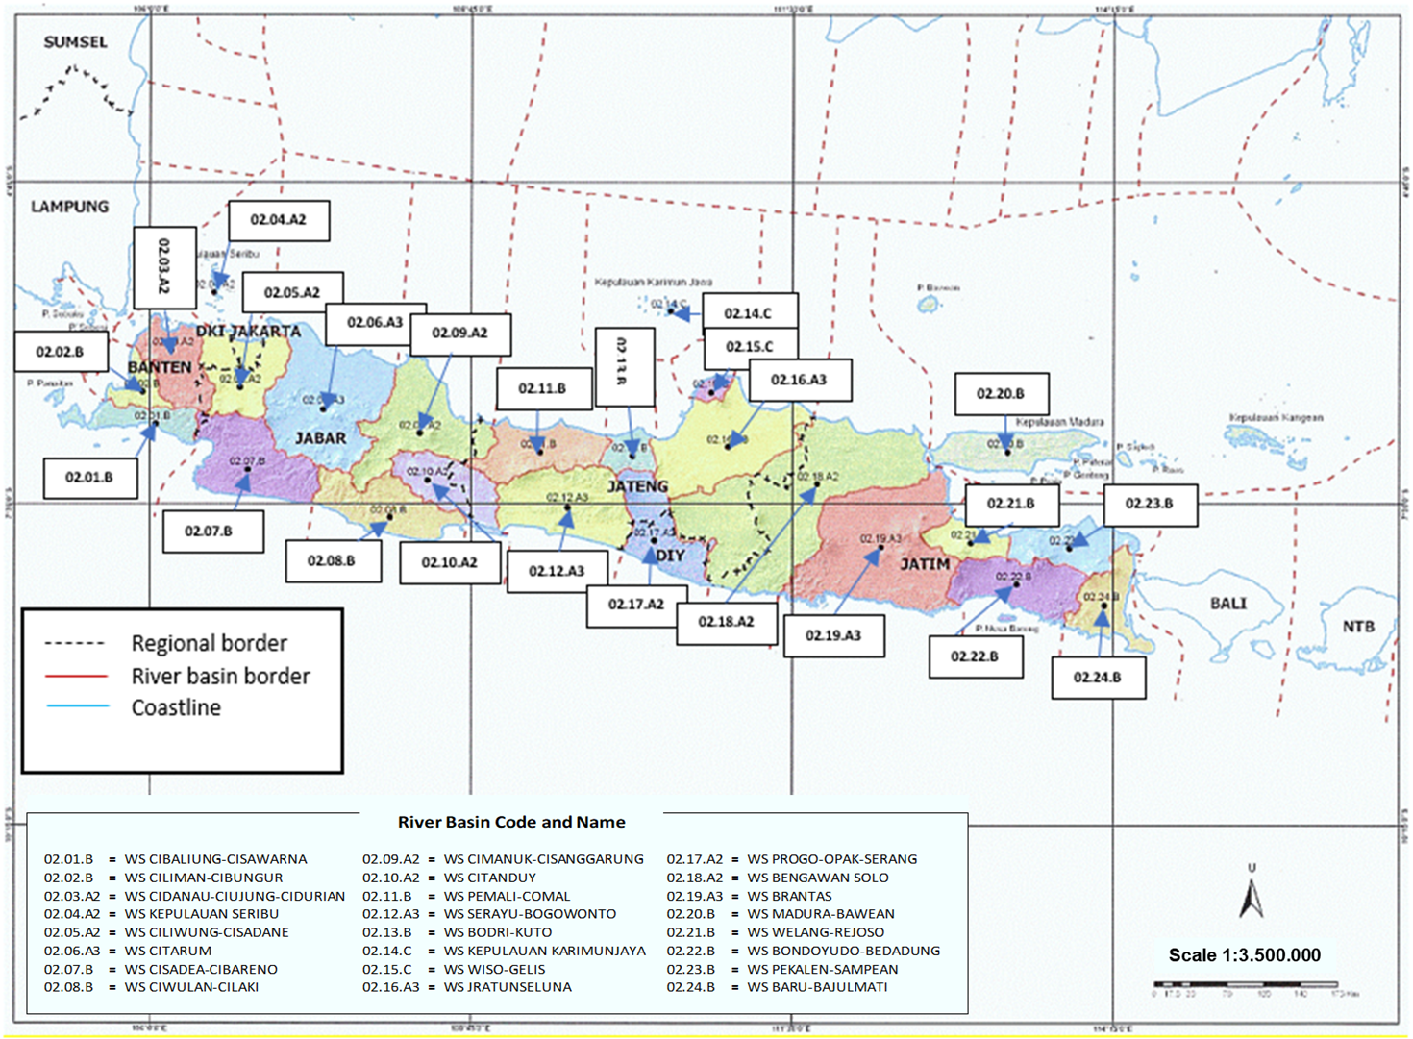

**Figure 1.** River basins in Java Island Indonesian Government, (2012)

**3. Data**

**3.1 Data for Water Availability Analysis**

Rain data

The TRMM satellite rain data covering all Indonesia regions was used because the accuracy is satisfactory to be used for meteorological analysis (Vernimmen et al., 2012). The data was collected from 1 January 2003 to 31 December 2018.

Evapotranspiration data

Evapotranspiration data was obtained from CGIAR satellite. This potential evapotranspiration value is the result of average climate from the last 50 years in the region.

Digital Elevation Model Map

The map used is based on NASA SRTM data with a resolution of 90m. By using QGIS software, other data including river flow map, watershed / sub-watershed, and outlet points could be extracted.

Land-Use Map

The land use map used is based on data from Bakosurtanal (2007). It could be classified into 6 general land-use classes: forest, irrigation agriculture, rainfed agriculture, grassland / bush, paved area / built area, and water body.

Map of soil type

The map of soil types used is based on data from FAO (2007) with a resolution of 1: 5,000,000. The map of soil types shown is classified into clay, loam, clayey loam, sandy loam, loamy sand, and sandy loam.

Discharge Data Observation Post for Calibration

The discharge data was calibrated using data from 7 river gauging station (hereby after refeered as PDA). The criteria for the chosen PDAs were:

1. Good data quality

2. Data Availability (2003-2018)

3. The variation of soil types and land uses

List and Map of PDA used are presented in the following Figure 2 and Table 1

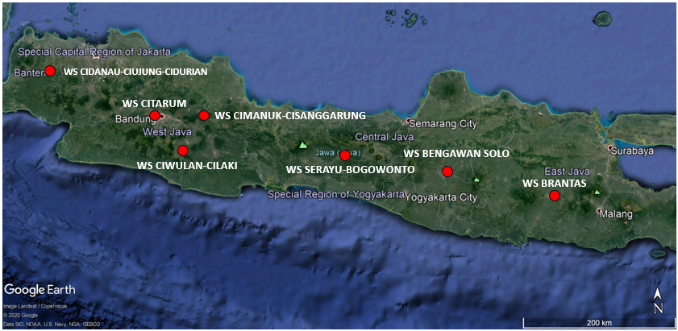

**Figure 2.** Map of PDA locations used for model calibration (Google Earth, 2020)

**Table 1.** List of PDAs used for calibration

| **No** | **PDA** |
| --- | --- |
| 1 | Cimanuk-Wado |
| 2 | Cisadane-Batubeulah |
| 3 | Citanduy-Cirahong |
| 4 | Citarum-Nanjung |
| 5 | B.Solo-Jurug |
| 6 | Ciujung-Rangkasbitung |
| 7 | Cimanuk-Leuwi Daun |

**3.2 Data for Water Demand Analysis**

Data for Urban and Industrial Household Water Demand

The main source of the data to analyze the urban and household water demand was from The Central Bureau of Statistics (*Badan Pusat Statistik*) in 2018. The domestic, urban, and industrial water demand was calculated by using Indonesian National Standard (*Standar Nasional Indonesia*, hereby after referred to as SNI) SNI 6728.1-2015 (Badan Standardisasi Nasional, 2015). The population and average water use per capita data were used to calculate the household and urban water demand. Additionally, to calculate the industrial water demand, the data regarding the number of regency / industries, the number of regency / industrial workers, and the average industrial water demand divided by industry type were used.

Data for Irrigation Water Demand

The main source of the spatial data for irrigation water demand analysis was obtained from PUSDATIN (2014). However, the quality of the data was not adequate due to the overlapping irrigations in several WSs. Hence, the data was updated with the data from Basin plan reports to obtain the most up-to-date data.

**4. Methods**

**4.1 Water Availability Analysis**

The surface water availability is calculated using WFLOW model calibrated with river flow discharge data from river gauging station. The water availability of each river basin in Indonesia was expressed as: the average monthly flow height, the dependable flow of Q80% and the dependable flow of Q90%. The steps for the calculation of surface water availability in this research are:

1) Water discharge data collection

• Collection of daily river flow data

• Choosing the appropriate PDA for water discharge data to be used for model calibration

2) Rain and evapotranspiration data collection

• TRMM satellite rainfall data was collected from 2002 – 2018

• The collection of evapotranspiration data from CGIAR satellites (2009)

3) Soil types and land use data collection

• The soil type map was obtained from FAO Digital Soil Map of the World (2007)

• The land use map was collected from BAKOSURTANAL (2007)

4) WFLOW Modeling, Calibration, and Verification Steps

• Build a WFLOW model for Java Island

• Perform model calibration using data from selected PDA’s discharge data

• Model verification with Indonesian Meteorological and Geophysical Agency (BMKG) rain data

• Generating a discharge flow per watershed and / or sub-watershed in the river basin

Model calibration is conducted by comparing the observation discharges at the river gauging station (PDA) with the modeling discharge at the same outlet. The model was calibrated by:

1. Graphics comparison

The flow pattern of the discharge simulation was compared to the observed discharge.

2. Statistical comparisons

Statistical measures are used to see the similarities between the results of simulation and observation. Some statistical measures used are Correlation, Size of Prediction Accuracy, Mean Absolute Deviation (MAD), Mean Squared Error (MSE), and Mean Absolute Percentage Error (MAPE).

**4.2 Water Demand Analysis**

Household, urban, and industrial water demand were calculated using population statistics. The results of the calculation of raw water demands are compared with the data of raw water distribution by the Regional Raw Water Companies (Perusahaan Daerah Air Minum, PDAM).

Household Water Demand

To calculate the water demand, the average population data in Java was used, which was obtained from Badan Pusat Statistik (2019). The amount of household raw water demand depends on the city category based on the population in Liter/ Person/ Day (L / P / D) unit (Table 2). The water losses was also taken into consideration to calculate the total household raw water demand. The losses could come from:

1. The loss in the process of 6%;

2. Uncountable water loss (25%)

**Table 2.** Household Raw Water Demand per Person Per Day by City Category

|  |  |  |  |
| --- | --- | --- | --- |
| **No.** | **City Category** | **Total Population (Life)** | **Raw Water Demand (L/P/D)** |
| 1 | Semi Urban (Capital District / Village) | 3.000 – 20.000 | 60 - 90 |
| 2 | Small City | 20.000 – 100.000 | 90 – 110 |
| 3 | Medium City | 100.000 – 500.000 | 100- 125 |
| 4 | Big City | 500.000– 1.000.000 | 120 – 150 |
| 5 | Metropolis | > 1.000.000 | 150 – 200 |

Source: Badan Standardisasi Nasional (2015)

Urban Water Demand

The water demand for daily life include water use for commercial and social aspects such as, but not limited to: shops, warehouses, workshops, schools, hospitals, and hotels which are assumed to demand between 15% to 30% of total household water use. In this study, the upper limit value of 30% was used.

Industrial Water Demand

Water in industrial fields was mainly used for production activities which include the use to process raw materials and other industrial support demands (Gunawan, 2008). According to Standar Nasional Indonesia (SNI) 6728.1-2015, to get a precise calculation of industrial water demand, data regarding total worker, industrial area, and industrial type are needed. However, if the data are limited, the estimation could be made by using water usage predictions.

The industrial water demand was assumed to be 30% - 70% of the total household and urban water demand. Due to the limited data of industries in Indonesia, the classification of industrial area was adapted from the national spatial planning approach (Indonesian Government decree no. 26/2008). Based on the afore-mentioned decree, three are three types of activity center in Indonesia depending on their scale. The largest activity center is called National Activity Center (*Pusat Kegiatan Nasional*, PKN). PKN is an urban area that is intended to provide international, national, and provincial scale demand. In the smaller scale, Regional Activity Center (*Pusat Kegiatan Wilayah*, PKW) is an urban area that has a function to serve provincial or several district/city scale activities. Lastly, the smallest area is named Local Activity Center (Pusat Kegiatan Lokal, PKL), which has an activity in the scale of district/subdistrict.

Based on the classification, it is assumed that the amount of industrial water demand for the regions in PKN group is higher than both the PKW and PKL areas. Areas that are included in the PKN category are assumed to have an industry water demand value of 50% of the total water household demand, while areas that are in the PKW category are assumed to have an industry water demand value of 40% of the total water demand of that a household. If an area is in PKL category, then the region is assumed to have an industrial water demand value of 30% of the total household water demand.

Irrigation Water Demand

Irrigation water demand are calculated based on KP01 Irrigation Planning Guidelines Ministry of Public Work and Housing (2013). The demand is affected by planting area, planting schedules, reference evapotranspiration, effective rain, soil type, and irrigation channel efficiency. The results of the calculation of irrigation water needs are then compared with data on water withdrawal for irrigation from dams.

Irrigation water is used for agriculture, livestock, and fisheries. However, in this research, the calculation is limited only for agricultural use. Irrigation water demand are influenced by several factors, namely the demand for land preparation (IR), the demand for plant water consumption (Etc), percolation (P), the demand for water to replace the water layer (RW), effective rainfall (ER), water efficiency irrigation (IE) and irrigated land area (A). The amount of irrigation water demand is calculated based on the following equation:



with

IG = Irrigation water demand, (m3)

Etc = Consumptive water requirements, (mm/day)

IR = Water requirements for land preparation, (mm/day)

RW = Demand for water to replace the water layer, (mm/day)

P = percolation, (mm/day)

ER = Effective rain, (mm/day)

IE = irrigation efficiency

A = Area of ​​irrigation area, (m2)

Irrigation water demand is the amount of water demanded to cultivate paddy rice plus the loss of water in the irrigation network. To calculate irrigation water demand according to the planned cropping pattern, there are several factors that needs to be considered including: the planned cropping pattern, area of irrigation, percolation, effective rainfall, and irrigation efficiency.

1. Planting Pattern

Based on the planting plan data, the planned crop pattern in the area is paddy-secondary crops. The first planting season (*Masa Tanam*, MT) group I started in October, MT II group one started in March. Secondary crops were planted during the dry season. The paddy rice type used for MT I and MT II is different. In MT I, rendeng paddy was used whereas gadu paddy was used in MT II. Regarding the duration, MT I lasted for 5 months and MT II lasted slightly shorter at 4.5 months. The land preparation period is carried out for one month for MT I and MT II.

1. Irrigated land area

The total irrigated area was obtained from PUSDATIN (2014).

1. Percolation

The rate of percolation is highly dependent on the nature of the soil in the research area, which is influenced by its geomorphological characteristics and land use patterns. In heavy clay soils with good characteristics, the percolation rate can reach 1-3 mm/day. In lighter soil types, the percolation rate can be higher.

1. Irrigation water efficiency

Irrigation water efficiency is the percentage of water reaching the rice fields compared to the total water entering the irrigation. The efficiency value used is 0.65.

1. Effective Rainfall

Based on KP01 Irrigation Planning Guidelines Ministry of Public Work and Housing (2013), effective rainfall value is 70% of R80 for rice plant and 70% of R50 value for secondary corps. Calculation of effective rainfall is as follows:

Re rice = (0.7 x R80)/15

Re secondary crops= (0.7 x R50)/15

with the formula for the effective rainfall R80 and R50 calculation is as follows:

R80 and R50 Probability = m/(n + 1)

with

n = number of years of rainfall data

m = sequence number from large to small

At the study area, rainfall data used for effective rainfall calculation was obtained from TRMM satellite data (2003-2018).

**4.3 Water balance**

Water balance illustrates the difference between the water availability and water demand. The amount of available water was obtained from the calculation of the dependable flow of Q80%, while the value of water demand is obtained from a total of various water uses including household, urban, industrial use, and irrigation. The difference between water availability and water demand can be classified into two classes: deficit and surplus. If the water availability is less than the water demand, it is classified as deficit. On the other hand, if the value of water availability is greater than the value of water demand, then it is classified as surplus.

**5. Results and Discussion**

**5.1 Water Availability**

Wflow Modelling and Calibration

The Wflow discharge model were compared to observed discharge at the river gauging station (PDA). If the discharge value generated by Wflow greatly differs from the observation data, the WFLOW parameters were adjusted. The flexible variables include: First zone capacity and First zone minimum capacity, Canopy gap fraction, First Zone KsatVer, Infilt capsoil, N & N_River, ThetaS and ThetaR, and Max Canopy Storage. The parameter was then modified to see the extent of its effect on the Wflow results. After the discharge result obtained from Wflow is similar to the observed discharge, the calibrated Wflow result is obtained.

Calibration on the Java Island was carried out using 6 (six) River gauging stations in which the data had been statistically tested (Fig. 3). The alleged water posts are Solo-Jurug PDA, Citarum-Nanjung PDA, Cimanuk - Leuwidaun PDA, Cimanuk- Wado PDA, Ciujung - Rangkasbitung PDA, and Serayu-Banjarnegara PDA. The calibration result is presented on table 3-table 7.

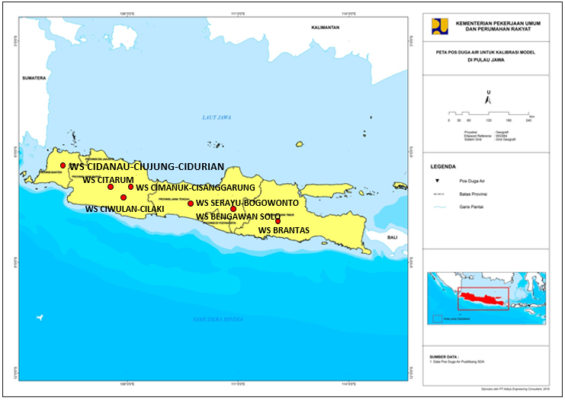

**Figure 3.** Locations of Calibration Points in Java

**Table 3.** Comparison of WFLOW Simulation Results with Observation Data in Citarum – Nanjung PDA

|  |  |  |  |  |
| --- | --- | --- | --- | --- |
|  | **Throughout the year** | **Dry Season (April-September)** | **Rainy Season (October-March)** | **3 Dry Months (July - September)** |
| R2 | **91%** | **94%** | **87%** | **98%** |
| MAE | **23.04** | **14.13** | **31.76** | **8.21** |
| MSE | **1002.23** | **409.04** | **1583.31** | **165.78** |
| MAPE | **0.31** | **0.33** | **0.28** | **0.41** |
| RMSE | **31.66** | **20.22** | **39.79** | **12.88** |

Source: Result of Analysis, 2019.

**Table 4**. Comparison of WFLOW Simulation Results with Observation Data in Ciujung - Rangkas Bitung PDA

|  |  |  |  |  |
| --- | --- | --- | --- | --- |
|  | **Throughout the year** | **Dry Season (April-September)** | **Rainy Season (October-March)** | **3 Dry Months (July - September)** |
| **R2** | 38% | 45% | 21% | 51% |
| **MAE** | 26.00 | 20.51 | 31.32 | 16.80 |
| **MSE** | 1240.95 | 843.62 | 1625.47 | 608.89 |
| **MAPE** | 1.20 | 1.31 | 1.10 | 1.33 |
| **RMSE** | 35.23 | 29.05 | 40.32 | 24.68 |

Source: Results of Analysis, 2019.

**Table 5.** Comparison of WFLOW Simulation Results with Observation Data in the Cimanuk - Leuwidaun PDA

|  |  |  |  |  |
| --- | --- | --- | --- | --- |
|  | **Throughout the year** | **Dry Season (April-September)** | **Rainy Season (October-March)** | **3 Dry Months (July - September)** |
| R2 | 68% | 79% | 55% | 67% |
| Bias | 1,45 | 2,46 | 0,45 | -2,83 |
| MAE | 10,17 | 7,90 | 12,39 | 5,45 |
| MSE | 191,43 | 119,87 | 261,69 | 62,49 |
| MAPE | 0,53 | 0,55 | 0,51 | 0,39 |
| RMSE | 13,84 | 10,95 | 16,17 | 7,90 |
| (mean sim - mean obs)/mean obs | 0,044 | 0,13 | 0,12 | -0,21 |

Source: Results of Analysis, 2019.

**Table 6.** Comparison of WFLOW Simulation Results with Observation Data in Serayu-Banjarnegara PDA

|  |  |  |  |  |
| --- | --- | --- | --- | --- |
|  | **Throughout the year** | **Dry Season (April-September)** | **Rainy Season (October-March)** | **3 Dry Months (July - September)** |
| R2 | 73% | 78% | 58% | 36% |
| Bias | 4,76 | 3,32 | 6,15 | 1,36 |
| MAE | 14,74 | 9,67 | 19,63 | 6,91 |
| MSE | 418,96 | 269,58 | 563,00 | 215,22 |
| MAPE | 0,40 | 0,37 | 0,43 | 0,41 |
| RMSE | 20,46 | 16,41 | 23,72 | 14,67 |
| (mean sim - mean obs)/mean obs | 0,09 | 0,11 | 0,11 | 0,089 |

Source: Results of Analysis, 2019.

**Table 7.** Comparison of WFLOW Simulation Results with Observation Data in Solo – Jurug PDA

|  |  |  |  |  |
| --- | --- | --- | --- | --- |
|  | **Throughout the year** | **Dry Season (April-September)** | **Rainy Season (October-March)** | **3 Dry Months (July - September)** |
| R2 | 84% | 91% | 78% | 84% |
| Bias | 35,60 | 22,84 | 48,16 | 9,90 |
| MAE | 50,49 | 30,90 | 69,78 | 16,49 |
| MSE | 5061,56 | 2080,25 | 7998,37 | 607,51 |
| MAPE | 0,78 | 0,73 | 0,84 | 0,77 |
| RMSE | 71,14 | 45,60 | 89,43 | 24,64 |
| (mean sim - mean obs)/mean obs | 0,32 | 0,31 | 0,31 | 0,31 |

The calibration results show that the discharge model is good and represent the low flow rates and can be used to calculate water availability.

In general, the average water availability in Java is 5.6 thousand m3/s or equivalent to 175.7 billion m3/y. 80% dependable water availability is 3.8 thousand m3/s or equivalent to 118.7 billion m3/y. The highest potential is the Bengawan Solo WS with 21.9 thousand m3/s water available while the lowest potential is the WS Kepulauan Seribu with 0.26 m3/s. The following table presents the water availability in Java. The value obtained in this research is comparable to the research from Radhika et al., (2017). Curk et al., (2016) stated that the most important factor affecting water availability is climate. Because of the tropical climate, Java has a relatively high rainfall. This makes Java into an area with a high potential for irrigation water. Besides that, the area of the respective WS is also affecting the irrigation potential. The larger the area, the more water could be contained in the WS.

**Table 8**. Java Island Water Availability.

|  |  |  |  |  |  |  |
| --- | --- | --- | --- | --- | --- | --- |
| **No** | **River Basin (WS)** | **WS Area (km2)** | **Average Discharge** | | **Dependable flow 80%** | |
| **m3/s** | **Million m3/year** | **m3/s** | **Million m3/year** |
| 1 | WS CIBALIUNG-CISAWARNA | 2,594.32 | 146.32 | 4,614 | 101.49 | 3,201 |
| 2 | WS CILIMAN-CIBUNGUR | 1,738.27 | 75.99 | 2,396 | 52.53 | 1,657 |
| 3 | WS CIDANAU-CIUJUNG-CIDURIAN | 4,147.53 | 202.60 | 6,389 | 149.48 | 4,714 |
| 4 | WS KEPULAUAN SERIBU | 8.75 | 0.26 | 8 | 0.07 | 2 |
| 5 | WS CILIWUNG-CISADANE | 5,267.84 | 201.63 | 6,359 | 131.55 | 4,149 |
| 6 | WS CITARUM | 11,321.79 | 454.37 | 14,329 | 304.44 | 9,601 |
| 7 | WS CISADEA-CIBARENO | 6,806.24 | 402.55 | 12,695 | 291.03 | 9,178 |
| 8 | WS CIWULAN CILAKI | 5,372.33 | 256.61 | 8,092 | 177.26 | 5,590 |
| 9 | WS CIMANUK-CISANGGARUNG | 7,703.75 | 542.71 | 17,115 | 380.32 | 11,994 |
| 10 | WS CITANDUY | 4,506.99 | 250.64 | 7,904 | 179.29 | 5,654 |
| 11 | WS PEMALI-COMAL | 4,831.24 | 230.59 | 7,272 | 167.50 | 5,282 |
| 12 | WS PEMALI-COMAL | 7,370.57 | 417.22 | 13,157 | 290.04 | 9,147 |
| 13 | WS BODRI-KUTO | 1,646.78 | 68.01 | 2,145 | 44.90 | 1,416 |
| 14 | WS KEPULAUAN KARIMUNJAWA | 42.22 | 1.33 | 42 | 0.83 | 26 |
| 15 | WS WISO-GELIS | 665.29 | 18.44 | 582 | 11.24 | 354 |
| 16 | WS JRATUNSELUNA | 9,073.57 | 243.05 | 7,665 | 152.64 | 4,814 |
| 17 | WS PROGO-OPAK-SERANG | 4,878.05 | 211.51 | 6,670 | 143.01 | 4,510 |
| 18 | WS BENGAWAN SOLO | 19,697.18 | 693.93 | 21,884 | 455.71 | 14,371 |
| 19 | WS BRANTAS | 14,251.46 | 579.77 | 18,284 | 375.19 | 11,832 |
| 20 | WS MADURA-BAWEAN | 5,615.27 | 91.27 | 2,878 | 52.21 | 1,646 |
| 21 | WS WELANG-REJOSO | 2,189.72 | 72.87 | 2,298 | 47.42 | 1,495 |
| 22 | WS BONDOYUDO-BEDADUNG | 5,343.37 | 200.79 | 6,332 | 126.35 | 3,985 |
| 23 | WS PEKALEN-SAMPEAN | 3,933.43 | 106.95 | 3,373 | 65.96 | 2,080 |
| 24 | WS BARU-BAJULMATI | 3,692.17 | 102.53 | 3,233 | 64.43 | 2,032 |
| **JAVA ISLAND** | | **132,698.13** | **5,571.94** | **175,717** | **3,764.89** | **118,730** |

**5.2 Water Demand**

Domestic, Municipal and Industry (DMI) Water Demand

The water demand is constrained by administrative boundaries which were then overlaid into river basin boundaries. The water needs for DMI is calculated based on the population in areas. The calculation results show that Java's water demand for household is 260 m3/s while urban water demand is 77.9 m3/s. Additionally, the industrial water demand is 135 m3/s, making the total water demand for Java island 472.5 m3/s. The province with the highest water demand is West Java with 153.7 m3/s followed by East Java with 124.7 m3/s. The water demand in DKI Jakarta, the capital city of Indonesia, is 33.05 m3/s. The water demand of Java's urban and industrial households are presented in Table 9.

The value for industrial water demand is similar to that of minimal industrial water use per year in Java based on the research by Asian Development Bank (2016), which is 137.86 m3/y. Overall, the water use for household, urban and industry in Java is 472.47 m3/s (approximately 14.900 m3/y). This value itself is higher than Italy, Germany, Spain, Poland, Netherland, Sweden and many, if not all, countries in Europe. Italy itself has the highest water consumption with approximately 5200 m3/y (EurEau, 2017).

Based on the DMI water needs calculation, the highest water consumption occured in WS which have metropolitan areas (e.g. WS Ciliwung, WS Citarum and WS Bengawan Solo). The same conclusion was stated by Curk et al., (2016), which said that the water consumption tend to be the highest in the metropolitan areas.

Due to the projection that the population will increase, the water demand for domestic and urban use will also increase. The rise is expected to be 40% for the domestic water use and more than 100% for industrial water use in Indonesia in 2030 (Asian Development Bank, 2016).

**Table 9**. Household, Urban, and Industrial Water Demand of all Provinces in Java Island

|  |  |  |  |  |  |
| --- | --- | --- | --- | --- | --- |
| **Population 2018 (Life)** | | **Water Demand (m3/s)** | | | |
| **Household** | **Urban** | **Industrial** | **Total** |
| DKI Jakarta | 10,458,200 | 18.16 | 5.45 | 9.44 | 33.05 |
| Jawa Barat | 48,645,600 | 84.45 | 25.34 | 43.92 | 153.71 |
| Jawa Tengah | 34,473,600 | 59.85 | 17.96 | 31.12 | 108.93 |
| DI Yogyakarta | 3,800,800 | 6.60 | 1.98 | 3.43 | 12.01 |
| Jawa Timur | 39,470,800 | 68.53 | 20.56 | 35.63 | 124.72 |
| Banten | 12,678,600 | 22.01 | 6.60 | 11.45 | 40.06 |
| **Java Island** | **149,527,600** | **259.60** | **77.88** | **134.99** | **472.47** |

**Table 10.** Household, Urban, and Industrial Water Demand of the Java Island based on River Basins

|  |  |  |
| --- | --- | --- |
| **No** | **WS Name** | **DMI Water Demand m3/s** |
| 1 | WS CIBALIUNG-CISAWARNA | 10.97 |
| 2 | WS CILIMAN-CIBUNGUR | 7.42 |
| 3 | WS CIDANAU-CIUJUNG-CIDURIAN | 18.39 |
| 4 | WS KEPULAUAN SERIBU | 0.51 |
| 5 | WS CILIWUNG-CISADANE | 51.51 |
| 6 | WS CITARUM | 46.81 |
| 7 | WS CISADEA-CIBARENO | 28.14 |
| 8 | WS CIWULAN CILAKI | 22.24 |
| 9 | WS CIMANUK-CISANGGARUNG | 31.10 |
| 10 | WS CITANDUY | 16.91 |
| 11 | WS PEMALI-COMAL | 15.31 |
| 12 | WS SERAYU BOGOWONTO | 23.38 |
| 13 | WS BODRI-KUTO | 5.21 |
| 14 | WS KEPULAUAN KARIMUNJAWA | 0.15 |
| 15 | WS WISO-GELIS | 2.88 |
| 16 | WS JRATUNSELUNA | 28.05 |
| 17 | WS PROGO-OPAK-SERANG | 17.23 |
| 18 | WS BENGAWAN SOLO | 55.27 |
| 19 | WS BRANTAS | 37.06 |
| 20 | WS MADURA-BAWEAN | 14.61 |
| 21 | WS WELANG-REJOSO | 5.69 |
| 22 | WS BONDOYUDO-BEDADUNG | 13.88 |
| 23 | WS PEKALEN-SAMPEAN | 10.21 |
| 24 | WS BARU-BAJULMATI | 9.59 |
| **JAVA ISLAND** | | 472.50 |

**5.3 Irrigation Water Demand Analysis**

Java Island has an irrigation area of 2,047 million hectares with irrigation water demand of 1.52 thousand m3/s (Table 11). The water demand in WS Brantas, with an irrigation area of 325 thousand hectares, is the highest with an average water demand of 223 m3/s. The second and the third largest irrigation area is in WS Jratun Selas with an irrigation area of 257 thousand ha and an average water demand of 195 m3/s and Cimanuk-Cisanggarung WS with an irrigation area of 176 thousand ha and an average water requirement of 136 m3/s.

In total, the water requirement for irrigation in Java is 1.518 m3/s or 47.872 million m3/y. It is only one-third of 163.666 million m3/y water used by Americans for their irrigation in 2015 (Dieter et al., 2018).

Agricultural land in Java will be difficult to maintain due to the incessant physical development that continues to grow. Based on the data from the Asian Development Bank (2016), the area of paddy fields continues to decline with a reduction rate of more than 20 thousand hectares per year. Hence, the demand for irrigation water on the Java Island will also decrease even more (Fig. 4). In contrast to that, paddy field is expected to grow in Sumatera and Sulawesi Asian Development Bank, (2016). Meanwhile, according to Central Bureau of Statistics (2015), the yearly population growth in Java is 0.953%. Consequently, the projected irrigation water needs in 40 years is only 717.28 m3/s while DMI water needs increase by approximately 50% (from 472.47 m3/s to 678.72 m3/s). The decrease in irrigation water needs contradicts the global trend, which tends to increase caused by the needs to increase the food production (Zou et al., 2018; Huang and Yin, 2017; Li, et al., 2020)

**Irrigation Water Demand**

**Irrigation Area**

**Figure 4.** Area and Irrigation Water Demand in Java Island

**Tabel 11.** Average yearly irrigation water needs

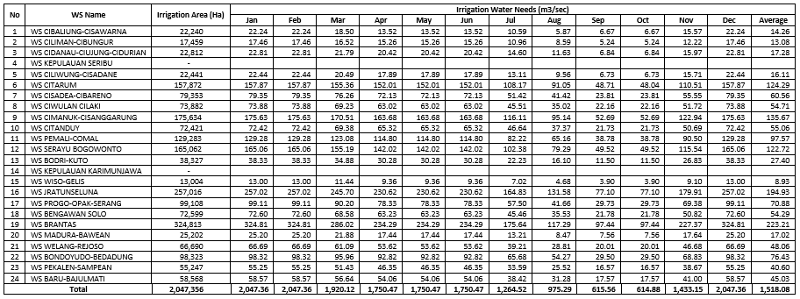

**5.4 Water Balance in Java**

The water balance in Java is still a surplus. The conclusion is in line with previous result from Radhika et al. (2013). Based on that research, there were no WS with a deficit status in Java in 2010. In this research, however, there were deficits in several river basins, namely in WS Kepulauan Seribu, WS Wiso-Gelis, and WS Welang-Rejoso (Table 11). Compared to water scarcity status in the world, in which approximately 40% rural people live in water-scarcity river basins, including regions like Middle East, Indian sub-continent and northeastern China (FAO, 2011), Java is still in the safe water balance status. Likely, Sub-Saharan Africa and Americas are also still in a low water stress status.

In 40 years from now, the water surplus in Java is projected to be 2368.69 m3/s compared to 1459.97 m3/s. This is largely due to the decrease in paddy field area (Asian Development Bank, 2016). Based on this scenario, the water surplus needs to be focused on the water use for DMI in the future.

On the other side, according to global trend, the water needs for irrigation will increase due to the needs for increasing food production. The irrigation in Java can be expanded further because the water is still in a surplus. The irrigation area sould be expanded in the WS with the most abundant water resources, namely in WS that have large areas.

**Table 11**. Java Island Water Balance

|  |  |  |  |  |  |  |
| --- | --- | --- | --- | --- | --- | --- |
| **No** | **River Basin** | **Water Availability (m3/s)** | **Water Demand (m3/s)** | | | **Water Balance (m3/s)** |
| **DUI** | **Irrigation** | **Total** |
| 1 | WS CIBALIUNG-CISAWARNA | 101.49 | 10.97 | 14.27 | 25.24 | 76.25 |
| 2 | WS CILIMAN-CIBUNGUR | 52.53 | 7.42 | 13.07 | 20.48 | 32.05 |
| 3 | WS CIDANAU-CIUJUNG-CIDURIAN | 149.48 | 18.39 | 41.69 | 60.07 | 89.41 |
| 4 | WS KEPULAUAN SERIBU | 0.07 | 0.51 | - | 0.51 | -0.44 |
| 5 | WS CILIWUNG-CISADANE | 131.55 | 51.51 | 58.53 | 110.04 | 21.51 |
| 6 | WS CITARUM | 304.44 | 46.81 | 232.71 | 279.53 | 24.91 |
| 7 | WS CISADEA-CIBARENO | 291.03 | 28.14 | 60.57 | 88.71 | 202.32 |
| 8 | WS CIWULAN CILAKI | 177.26 | 22.24 | 54.67 | 76.91 | 100.35 |
| 9 | WS CIMANUK-CISANGGARUNG | 380.32 | 31.10 | 164.80 | 195.90 | 184.42 |
| 10 | WS CITANDUY | 179.29 | 16.91 | 57.31 | 74.22 | 105.07 |
| 11 | WS PEMALI-COMAL | 167.50 | 15.31 | 97.61 | 112.91 | 54.59 |
| 12 | WS PEMALI-COMAL | 290.04 | 15.31 | 97.61 | 112.91 | 177.13 |
| 13 | WS BODRI-KUTO | 44.90 | 5.21 | 27.40 | 32.61 | 12.29 |
| 14 | WS KEPULAUAN KARIMUNJAWA | 0.83 | 0.15 | - | 0.15 | 0.68 |
| 15 | WS WISO-GELIS | 11.24 | 2.88 | 8.93 | 11.81 | -0.57 |
| 16 | WS JRATUNSELUNA | 152.64 | 28.05 | 116.70 | 144.75 | 7.89 |
| 17 | WS PROGO-OPAK-SERANG | 143.01 | 17.23 | 66.45 | 83.68 | 59.33 |
| 18 | WS BENGAWAN SOLO | 455.71 | 55.27 | 290.04 | 345.31 | 110.40 |
| 19 | WS BRANTAS | 375.19 | 37.06 | 211.14 | 248.20 | 126.99 |
| 20 | WS MADURA-BAWEAN | 52.21 | 14.61 | 17.01 | 31.62 | 20.59 |
| 21 | WS WELANG-REJOSO | 47.42 | 5.69 | 48.02 | 53.71 | -6.29 |
| 22 | WS BONDOYUDO-BEDADUNG | 126.35 | 13.88 | 76.36 | 90.24 | 36.11 |
| 23 | WS PEKALEN-SAMPEAN | 65.96 | 10.21 | 40.61 | 50.82 | 15.14 |
| 24 | WS BARU-BAJULMATI | 64.43 | 9.59 | 45.00 | 54.59 | 9.84 |
| **JAVA ISLAND** | | **3,764.89** | **464.43** | **1,840.49** | **2,304.92** | **1,459.97** |

The afore-mentioned result is quite different from arid regions, which have low rainfall (Li et al., 2020). Countries in arid regions focus on the efficiency of water use for irrigation, either by using technology or planting pattern optimization (Seckler et al., 1998; Wang et al., 2019) and water resource optimization by recycling the water (Huang & Yin, 2017). In Java, however, the water resource problems are solved by focusing on the water resource optimization by improving the planning to expand the irrigation field area. (Li et al., 2020) suggest inter-basins water subsidy as a solution to solve uneven water distribution.

**6. Conclusion**

The average water availability in Java is 5.6 thousand m3/s or equivalent to 175.7 billion m3/y. Q80% dependable flow is 3.8 thousand m3/s or equivalent to 118.7 billion m3/year. Java Island household demand is 260 m3/s while urban water demand is 77.9 m3/s, and industrial water demand is 135 m3/s. Java Island has an irrigation area of 2,468,515 ha with an irrigation water requirement of 1838.4 m3/ s. The highest water demand is in WS Brantas with an area of 325 thousand hectares of irrigation and an average water requirement of 223 m3/s. Overall, there is a surplus of water in Java even though there are several river basins with a water deficit, *namely in the WS Kepulauan Seribu, WS Wiso Gelis, and WS Welang Rejoso*. The WSs with the most abundant water resources are WSs with large areas whereas WSs which have the largest amount of water use are WSs with high population density. The water in Java is projected to have a larger surplus in the future due to the land change from the paddy field into buildings Asian Development Bank, (2016). The water surplus needs to be focused on the water use for DMI, which will increase due to population growth. Beside that, if the irrigation area were to be developed, the development should take place in WSs with large area to make sure that it has sufficient water resources.

# **Acknowledgement**

The authors would like to thank Directorate-General of Water Resources for the research permission and Research Center for Water Resources for data supporting. The authors would like also to thank the reviewers for the contribution in improving this manuscript.

# **References**

Asian Development Bank, 2016: *Indonesia: Country Water Assessment*. Philippines: Asian Development Bank, 38-39.

Badan Pusat Statistik , 2018: *Statistik Indonesia dalam Infografis 2018.* [*Http://bps.go.id*](Http://bps.go.id)*.* Accessed 6th September 2020, 02.05 PM*.*

Badan Pusat Statistik, 2019: *Statistik Indonesia 2019.* [*Http://bps.go.id*](Http://bps.go.id)*.* Accessed 6th September 2020, 02.45 PM*.*

Badan Standardisasi Nasional, 2015: *Standar Nasional Indonesia (SNI) 6728.1-2015: Penyusunan neraca spasial sumber daya alam-Bagian 1: Sumber Daya Air* (in Indonesian). Jakarta: Badan Standardisasi Nasional.

Bakosurtanal, 2007: *Peta Tata Guna Lahan Indonesia. https://bnpb.go.id/.* Accessed 7th August 2020, 10.45 AM.

Curk, Barbara & Rožič, Petra & Silvoni, R. & Franco, Cucchi & Calligaris, Chiara & Nistor, Mărgărit & Vrhovnik, Petra & Verbovšek, Timotej & Kostelic, B. & Babic, D. & Karleuša, Barbara & Radman, I. & Matic, Branislava B. & Dimkić, Dejan & Lukic, V. & Ibrahimllari, A. & Aliaj, A. & Lukovac, N. & Džajic-Valjevac, M. & Tsitsifli, Stavroula, 2016: Regional water resources availability and vulnerability. Ljubljanan.

Dieter, C.A., Maupin, M.A., Caldwell, R.R., Harris, M.A., Ivahnenko, T.I., Lovelace, J.K., Barber, N.L. & Linsey, K.S. (2018) Estimated use of water in the United States in 2015: U.S. Geological Survey Circular 1441, 65 p.. <https://doi.org/10.3133/cir1441>.

EurEau, 2017: Europe's water in figures: An overview of the European drinking water and waste water sectores.The European Federation of National Associations of Water Services, 2017 edition.

Faishal, A., Suyono, M.S., 2013, Evaluasi Ketersediaan Dan Kebutuhan Air Untuk Pertanian

Daerah Irigasi Boro Kabupaten Purworejo Provinsi Jawa Tengah, Jurnal Bumi Indonesia 2 (4) 2013.

FAO (2007). *Digital Soil Map of the World.* <http://www.fao.org/>. Accessed 15th August 2020, 10.00 AM.

FAO. (2011). *The State of the World's Land and Water Resources for Food and Agriculture: Managing Systems at risk*. New York: The Food and Agriculture Organization of the United Nations and Earthscan. <http://www.fao.org/>. Accessed 15th August 2020, 10.15 AM.

Gleick, P. (2003). Global freshwater resources: soft-path solutions for the 21st century. *Science* *302 (5650):* 1524-1528.

Google Earth. (2020). Accessed 8th August 2020, 09.00 AM.

Gunawan, B. (2008). Kenaikan muka air laut dan adaptasi masyarakat (in Indonesian). *Walhi*.

Hanjra, M.A. & Qureshi, M.E. (2010). Global water crisis and future food security in an era of climate change,. *Food Policy 35 (5):* 365-377.

Hidayat, N.M., Mulyo, A.P., Azani, A.A., Aofany, D.R., Nadiansyah, R., Rejeki, H.A., 2018, Evaluasi Ketersediaan Sumber Daya Air Berbasis Metode Neraca Air Thornthwaite Mather Untuk Pendugaan Surplus dan Defisit Air Di Pulau Jawa. DOI: [10.20961/prosidingsnfa.v3i0.28506](https://www.researchgate.net/deref/http%3A%2F%2Fdx.doi.org%2F10.20961%2Fprosidingsnfa.v3i0.28506).

Huang, LiGuo & Yin, Li. (2017). Supply and Demand Analysis of Water Resources based on System Dynamics Model. Journal of Engineering and Technological Sciences. 49 (6) 2017, 705-720. DOI: [10.5614/j.eng.technol.sci.2017.49.6.1](https://dx.doi.org/10.5614/j.eng.technol.sci.2017.49.6.1).

Indonesian Government. (2008). Indonesian Government Decree no. 26/2008 about National Urban Planning. <https://peraturan.bpk.go.id/>. Accessed 8th September 2020, 09.00 AM.

Indonesian Government. (2012). Indonesian Presidential Decree no. 12/2012 regarding River Basins determination. <https://peraturan.bpk.go.id/>. Accessed 8th September 2020, 09.30 AM.

KLHK. (2019). WEBGIS Kementerian Lingkungan Hidup dan Kehutanan. URL: <http://webgis.menlhk.go.id:8080/kemenhut/index.php/id/peta/peta-interaktif>. Accessed 6th August 2020, 10.05 AM.

Komariah, I. & Matsumoto T. (2019). Application of Hydrological Method for Sustainable Water Management in the Upper-Middle Ciliwung (UMC) River Basin, Indonesia. *Journal of Water and Environment Technology* *17 (4)*: 2013-217.

Li Y, Wang H, Chen Y, Deng M, Li Q, Wufu A, Wang D, Ma L. Estimation of regional irrigation water requirements and water balance in Xinjiang, China during 1995-2017. PeerJ. 2020 Jan 3;8:e8243. doi: 10.7717/peerj.8243. PMID: 31915574; PMCID: PMC6944122.

Ministry of Publik Work and Housing (2013). *Irrigation Planning Guidelines: Planning Criteria, Part Irrigation System Planning KP-01* (in Indonesian). <http://sibima.pu.go.id/>. Accessed 25th August 2020, 03.05 PM.

Ministry of Publik Work and Housing (2015). *Ministry of Public Work and Housing Regulation no. 4/PRT/M/2015 regarding River Basin Criteria and Determination* (in Indonesian)*.* <http://sibima.pu.go.id/>. Accessed 25th August 2020, 03.05 PM.

Minzhong Zou, Shaozhong Kang, Jun Niu, Hongna Lu, (2018), A new technique to estimate regional irrigation water demand and driving factor effects using an improved SWAT model with LMDI factor decomposition in an arid basin, Journal of Cleaner Production, Volume 185, 2018, Pages 814-828,

Mock, F.J. (1973). *Land Capability Appraisal Indonesia: Water Availability Appraisal, Basic study prepared for the FAO/UNDP Land*. Bogor: FAO.

Molden, D. (2007). Water for food water for life: A comprehensive assessment of water in agriculture. *Proc. R. Soc. Lond. Ser. A. 193*

Mulyani, A., Kuncoro, D., Nursyamsi, D., Agus, F. (2015). Analisis Konversi Lahan Sawah: Penggunaan Data Spasial Resolusi Tinggi Memperlihatkan Laju Konversi yang Mengkhawatirkan, Jurnal Tanah dan Iklim Vol. 40, No.2, Hal 121 - 133.

Neitsch, S.L., Arnold, J.G., Kiniry, J.R. & Williams, J.R. (2011).. *Soil and water assessment tool theoretical documentation version 2009.* Texas Water Resources Institute Technical Report no. 406

Ricky Nadiansyah, Hasti Amrih Rejeki, 2018, Evaluasi Ketersediaan Sumber Daya Air Berbasis Metode Neraca Air Thornthwaite Mather Untuk Pendugaan Surplus Dan Defisit Air Di Pulau Jawa, Prosiding SNFA (Seminar Nasional Fisika dan Aplikasinya) 2018. DOI: 10.20961/prosidingsnfa.v3i0.28506

Radhika, Fauzi, M., Rahmawati, Firmansyah, R., Fathoni, A. & Hatmoko, W. (2013). *Neraca Ketersediaan Air Permukaan dan Kebutuhan Air pada Wilayah Sungai di Indonesia (in Indonesian)*. Conference paper.

Radhika, Firmansyah, R. & Hatmoko, W. (2017) Perhitungan Ketersediaan Air Permukaan di Indonesia berdasarkan Data Satelit (in Indonesian). *Jurnal Sumber Daya Air 13 (2)*: 115-130.

Rahmawan, K., Makrup, L., 2016, Evaluasi Ketersediaan dan Kebutuhan Air Untuk Daerah Irigasi Soropan Di DAS Hulu Sungai Elo, Prosiding Kolokium Program Studi Teknik Sipil (KPSTS) FTSP UII 2016,

Schellekens, J. (2019). *wflow Documentation*. https://wflow.readthedocs.io/. Accesed 20 August 2020, 03.40 PM.

Seckler, D.; Amarasinghe, U.; Molden, D.; de Silva, R.; Barker, R. 1998. World water demand and supply, 1990 to 2025: scenarios and issues. Colombo, Sri Lanka: International Irrigation Management Institute (IIMI). vi, 40p. (IWMI Research Report 019 / IIMI Research Report 019) doi: http://dx.doi.org/10.3910/2009.019

Senent-Aparicio, J., Liu, S., Pérez-Sánchez, J., López-Ballesteros, A. & Jimeno-Saéz, P. (2018). Assessing impacts of climate variability and reforestation activities on water resources in the headwaters of the Segura River Basin (SE Spain). *Sustainability 10(9):* 3277.

Tampubolon, S.B., Suprayogi, S., 2017, Analisis Kebutuhan Air Untuk Pertanian Di Daerah Irigasi Karangloso Kabupaten Bantul, Jurnal Bumi Indonesia. 6 (4) Tahun 2017.

Taufik, I., Yanuar J. M., Purwanto, Pramudya, B., Saptomo, S., 2019, Analisis Neraca Air Permukaan DAS Ciliman, Jurnal Ilmu Lingkungan, Volume 17 Issue 3(2019) :452-464

Vernimmen, R., Hooijer, A. & Mamenun, N.K. (2012). Evaluation and bias correction of satellite rainfall data for drought monitoring in Indonesia. *Hydrology and Earth System Sciences Discussions 8(8):* 5969-5997.

Wang, Fei & Yaning, Chen & Li, Zhi & Fang, Gonghuan & Peng, Li & Xia, Zhenhua. (2019). Assessment of the Irrigation Water Requirement and Water Supply Risk in the Tarim River Basin, Northwest China. Sustainability. 11. 4941. 10.3390/su11184941.

Wurbs, R.A. (2005). Modeling river/reservoir system management, water allocation, and supply reliability. *Journal of Hydrology 300 (1-4):* 100-113.

York, R. & Longo, S.B. (2009). Structural influences on water withdrawals: an exploratory macro-comparative analysis,. *Human Ecology Review 16 (1):* 75-83.