The Spatial Transformation and Sustainability of Development in New Metropolitan Areas of Metro Tanjung Bunga, Makassar City

Batara Surya¹
City and Regional Planning, Bosowa University, Makassar, Indonesia
E-mail: bataraciptaperdana@yahoo.co.id
Syafri²
Urban Ecology, Bosowa University Makassar, Indonesia
E-mail: syafri@universitasbosowa.ac.id
Haeruddin Saleh³
Regional Economy, Bosowa University Makassar, Indonesia
E-mail: haeruddin@universitasbosowa.ac.id

ABSTRACT

Spatial transformation in a new metropolitan areas is indicated by functional change from farming land-use to urban industries, leading to changes in spatial structure and pattern, reduction in quality environment, and change in social-economic systems. The purpose of this study therefore was to analyze the spatial transformation and sustainability of development in new metropolitan areas in Metro Tanjung Bunga, Makassar City. The methodology used in this research was a combination of qualitative-quantitative approaches. The qualitative technique was implementable through observation, survey, and documentation while the quantitative approach used was statistical-descriptive analysis. The results indicated the development in new metropolitan areas is oriented to commercial activities, service, tourism, and large-scale residence as well as support of transport infrastructure development. This has impact on urban sprawl, morphological variety, segregations, and hierarchical difference of the local community need fulfillment. The change in urban systems of Mamminasaya Metropolitan, as result of reinvestment characterized by suburbanization, caused changes from local community status to plural roles. Therefore, development of new metropolitan areas should be oriented to sustainability of development of environment, economic, social, and reinforcement of government institution in future.

Keywords: spatial transformation, new metropolitan areas, transformation of land-use, sustainability of development.

INTRODUCTION

The economic globalization in urban development perspective was identified as a factor causing suburbanization and gentrification in metropolitan suburbs. The process was indicated by land-use allocation to various social-economic activities and the increase in population (Giyarsih, 2011; Surya, 2014^{b}). Global economic activity is not only formed in urban centres but also extends, and ultimately has an impact, to the area surrounding. The global economic restructuring has a profound effect on the socioeconomic population composition of major cities (Sassen, 1991; Utami, 2015; Surya, et al., 2018ª). The vigorousness of Makassar City development as a core conurbation in metropolitan area systems of Mamminasata was characterized by relationship pattern of spatial transformation, city infrastructure, spatial structure, and pattern in suburb of Mamminasata Metropolitan (Surya, 2018). Development of new metropolitan areas located in suburb which tends to develop into pole direction of economic growth was indicated by the increased trade activities, services, recreational media, transporting movement system, sub-urbanization, and increase in public’s living standard. Urban growth occur in peri-urban areas which are complex to manage and have significant impact on the liveability of cities. The local positive and negative correlation exist simultaneously between the spatial distribution density and the allocation of land-use scale (Giyarsih, 2001; Basant Maheshwari et al., 2016; Qu Yanbo et al., 2018). The density, continuity, cluster degree, centralization and development of the core of the city, are indicators of good land allocation. The urban areas changed from a compact city to “more dispersed patterns, or expanded in a compact, a condition which caused changes in spatial structure due to inter-urban connectivity in the periphery (Chang, et al., 2013; Gradinaru et al., 2015).

Dynamic of construction and development of new metropolitan areas was indicated by transformation from very intensive farming land-use to urban industries, becoming determinative factor of spatial transformation with variety of developing morphologies. The three elements affecting city morphology are land-use, road patterns, and characteristics of buildings (Hanief, 2014; Surya, et.al, 2018^{c}). The new municipal growth manifest itself in the urban forms and spatial structures, and the kind of ecological impacts the new growth brings. It is positively associated with changes in the social system and economic system of local communities in the urban suburbs (Sui, et al., 2001; Surya, 2015^{c}). According to the concept of interconnectivity in tipology, landscape connectivity is defined as the continuity of corridors, networks, or matrices in space which characterize the relationship between ecological systems, such as the overall complexity (Schreiber & Kelton, 2005), accessibility (Janssens, Bruneau, & Lebrun, 2006), interdependency (Haber, 2008), and agglomeration (Wei, Taubenbock, & Blaschke, 2017). Incontrovertibly, maintaining high connectivity is a key factor for protecting biodiversity and maintaining ecosystem stability and integrity (Taylor et al., 1993).

Spatial transformation in new metropolitan areas through the allocation of social-economic activity land and connectivity to inter-urban of Mamminasata Metropolitan cause changes in structure and the dimensional pattern. The process was indicated by wider areas of large-scale residence development occupying 1,145.82 Ha, shopping centres of 216.43 Ha, shops of 25.69 Ha, tourism services of 40.65 Ha, hotels of 10.12 Ha, and road construction of 5.07 Km. Facts indicate the addition of linearly and concentrically developing urban centres in the new metropolitan areas has impacts on urban sprawl and conurbation as well as a very significant effect on transporting movement systems on hinterland areas. Urban sprawl and associated workplace home distanciation may lead to more intensive use public transportation system, reducing the depedence on private vehicle travel (Andong and Sajor, 2017). The process of urban rural element ilfiltration in transtitional area experiencing intensive change cause urban sprawl (Bryant, et al., 1982; Soussan, 1981; Kustiwan and Pontoh, 2010; Surya, et al., 2018^{b}). A peri-urban area is described as the effect of land use change under high anthropic and demographic pressures, and mining operations (Cocheci et al., 2015).

The works relevant to this study include: (a) a research by Hakim and Parolin (2008) which established rapid urban expansion during the pre-crisis period, mainly in the manufacturing and housing development were converted from significant proportions of agricultural land; (b) a study by Gradinaru et al., (2015) which asserted that the shape of the urban areas changed from being compact to the city with “more dispersed patterns. However, specific processes of urban expansion, such as sub-urbanization or peri-urbanization, affect the vast majority of the analysed cities influenced by the development level of the urban area; (c) In Indonesia, a study by Winarso et al., (2015) indicated suburb transportation in metropolitan areas increased migrant proportion, change in job structure, number of formal and informal economic activities, and income. This process resulted in transformation of social-economic structure from agrarian characteristics to urban industries and created job orientation difference and spatial segregation. The three results of the studies are associated with spatial transformation in development of suburb of Mamminasata Metropolitan located in intersection. This confirms the change in suburb land-use due core city expansion and spatial transformation process caused differences in economic interest and spatial segregation in suburb of Mamminasata Metropolitan.

This study widely contributes to the development of New Metropolitan Areas which is oriented to future balanced development. It means that development and construction of new metropolitan areas, dynamically cause spatial transformation and change in use due to productivity improvement of trade activities, services and other social-economic activities. There is also some direct effects on social-economic condition of local community.

The purpose of this study therefore was to analyze the spatial transformation of the New Metropolitan Areas its impact on social-economic systems of local community, and change in physical condition of the environment.

Approach to case study and research methodology

Spatial transformation in the New Metropolitan Areas is determinant area expansion from Makassar City to the suburb of Mamminasata Metropolitan. The intensity of development is indicated by environmental degradation, change in spatial structure, pattern, and social-economic systems of the local community. In this paper, a case study was chosen to analyze and describe the spatial transformation, its impact and conceptual idea of sustainable development in the New Metropolitan Areas. According to the focus of the exercise, this is was a naturalistic, holistic and phenomenological study (Densin and Lincon, 2009; Creswell, 2016; Sugiyono, 2016).

In this work, case study was utilized to examine the conditions and characteristics of spatial transformation, occurring impact, and sustainability of development in the New Metropolitan Areas. The case study was chosen considering that (a) pattern of spatial transformation in the new metropolitan areas is specific. (b) a case study has prominent consistence and sequence. (c) It is sufficiently complex. (d) It is intended to help understand the background of event occurring in process of development of the new metropolitan areas. The research was conducted from January to November of 2017 in the New Metropolitan Areas (Figure 1). It used a combination of qualitative-quantitative approaches. Philosophically, the reasons for combining the approaches are (1) logics of triangulation, in which the results of qualitative study were rechecked in quantitative study vice versa; (2) quantitative and qualitative studies were combined to give general description; (3) quantitative technique was utilized in structural properties of social life, while qualitative approach took quality of subjects as a starting point so that both approaches were presented together in conducting the study; (4) quantitative approach was utilized to analyze the correlation between changes while qualitative approach helped to harmonize factors underlying the correlation; (5) quantitative method was utilized to express structural characteristics of social life in large scale, while qualitative approach was utilized to examine behavior in small scale. When pursued to express both levels, quantitative-qualitative approaches were utilized together; and (6) data collection of two different realities needed combination of both approaches.

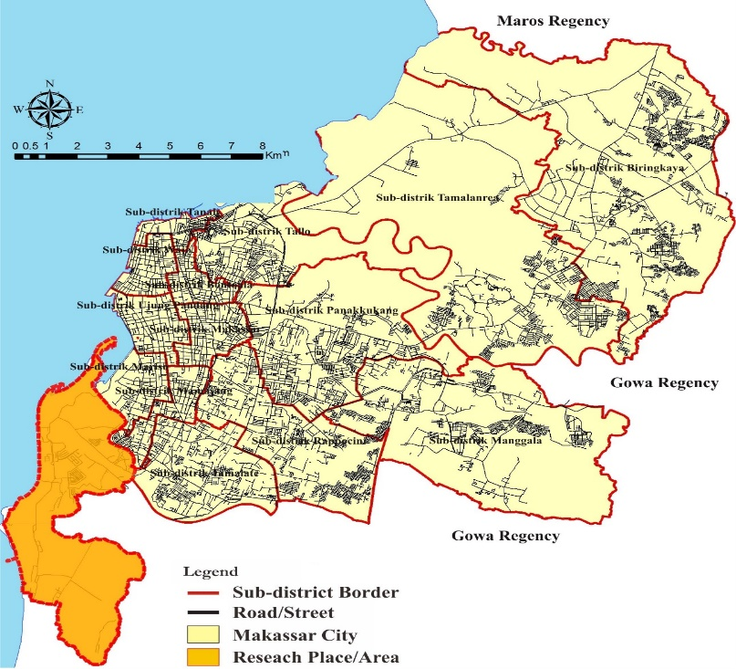

Figure 1. New metropolitan areas of Metro Tanjung Bunga, Makassar City as Study Object. Source: Bappeda of Makassar City, 2017

In this study, data collection methods included (a) observation to note spatial transformation, change in land use, spatial structure and pattern, and impact on change in environmental ecosystem; (b) survey to understand and assess respondents’ perception associated with changes in social, economic and hierarchical systems in order to fulfill the needs of local community; and (c) documentation to collect data associated with study conducted in the New Metropolitan Areas. The data were analyzed through the following methods: (i) qualitative data were categorized while quantitative information were examined by statistical-descriptive analysis; (ii) both data were interpreted by triangulation or between methods. The analysis was carried out interactively and continuously until the data saturated and complete. The data were analyzed during and after collection of data to obtain similar responses to the respondents’ view associated with condition developing in the New Metropolitan Areas. When interviewing, the responses of respondents up to certain stage were analyzed to enhance data credibility. Generally, the analysis involved data reduction, display, and conclusion drawing/verifying.

Process of combined qualitative-quantitative approaches was as shown in Figure 2.

Data collection

Deep interview

Observation

Documentation

Field Notes

Qualitative Approach

Researcher
Description of Spatial Transformation & Changes in Utilization of the Space Area of ​​Kota Baru Metro Bunga

Respondents

Quantitative Approach

Survey

Enumerator

Questionnaire

Data tabulation

Categorization

Data Interpertation

Percentage Analysis

Figure 2. The Process of Combined Qualitative and Quantitative Approaches
Source: Adapted from (Saefullah, 1993), with Modification

RESULTS AND DISCUSSION

Spatial transformation in New Metropolitan Areas of Metro Tanjung Bunga

In 2017, the built areas in the New Metropolitan Areas occupied 1,716.94 Ha of land and commercial-economic activities dominated the region. Evidence indicate the basic farm production had decreased sharply and it is no longer among the main activities of the local community. Noted how agriculture in these areas could contribute key services emanating from environmental, social and economic functions in response to the consumption-oriented need of urban society (Vizzari, et al., 2015). Spatial transformation in the New Municipal Areas has impacts on change in attributes in the suburb of Mamminasata Metropolitan. The spatial attributes of city changing in industrial model encourage formation cultural and creativity centers reflecting vitality for various social-economic opportunities (Inoguchi et.al, 2015; Surya, 2018). Change in spatial use relative to the adjustment in land use in the New Metropolitan Areas created suburbanization and gentrification in the suburban areas. The process was indicated by capital flow and investment of residential development, tourism, trade, infrastructure and other commercial economic activities. Increase in activities create very intensive spatial interaction with the urban system being a driving force to mobilize immigrants from near areas. The spatial interaction physically, economically and socially changes into urban conurbation, integrating the infrastructure systems in small surrounding cities. Interregional is influenced by transportation facilities and flow of people, goods and services (Hurst, 1974; Surya, 2015^{d}). Therefore, the allocation of land change in spatial use, in which large scale-commercial and residential functions dominate, transforms the New Metropolitan Areas to polar direction of economic growth and urban agglomeration. This process forms new service centers supporting functions and roles of Makassar City as a cornerstone in the urban systems of metropolitan of Mamminasata.

Table 1. Change in land-use in new metropolitan areas of Metro Tanjung Bunga,
from 2010 to 2017

No | Land-use |  |  |  |  |  | Description
No | 2010 | Land area (Ha) | % | 2017 | Land area (Ha) | % | Description
1 | Trade/commerce | 7.56 | 0.80 | Trade/commerce | 242.12 | 14.10 | Increasing
2 | Education | 1.50 | 0.16 | Education | 15.89 | 0.93 | Increasing
3 | Residence | 122.51 | 12.93 | Residence | 1145.82 | 66.74 | Increasing
4 | Health | 1.50 | 0.16 | Health | 1.5 | 0.09 | Static
5 | Tourism | 11.62 | 1.23 | Tourism | 40.65 | 2.37 | Increasing
6 | Office | 1.16 | 0.12 | Office | 9.56 | 0.56 | Increasing
7 | Sport media | 3.20 | 0.34 | Sport media | 14.56 | 0.85 | Static
8 | Social facility | 11.00 | 1.16 | Social facility | 30.39 | 1.77 | Increasing
9 | Hotel | - | - | Hotel | 10.12 | 0.59 | Increasing
10 | Mixed wet field & garden | 160.00 | 16.88 | Mixed wet field & garden | 25.15 | 1.46 | Decreasing
11 | Pond | 108.00 | 11.39 | Pond | 79.14 | 4.61 | Decreasing
12 | Empty land | 519.76 | 54.84 | Empty land | 102.04 | 5.94 | Decreasing
Source: Satellite Image and Survey Results, 2017

Dynamics of spatial transformation (see Table 1) are caused by the following two factors: (a) process of spatial-physical development occurring centrifugally and (b) spatial-physical growth happening centripetally. Centrifugal spatial development is the determinative factor of population mobilization and widening new urban centers to suburban areas surrounding, to esure control is required in one compact, safe and efficient urban system unit. Land transformation into urban residences, industries, trade, and growth of population causes land price to raise, and this has impacts on the surrounding urban area characteristics (Yunus, 2005; Parasati, 2011; Sugiana, 2011; Singh et.al, 2016). Thus, development of the New Metropolitan Areas is an expansion process and spatial addition of Makassar City to suburban area of metropolitan of Mamminasata. The process directly decreases the quality of the environment, change in spatial structure, spatial pattern, and morphology of suburban areas. Dominant pattern changes in function spatially causes formal and informal economic activities to develop in the New Metropolitan Areas. The change in spatial function and suburban land use transformation is positively associated with adjustment from production to urban space reproduction (Lee, 1979; McGee, 1997; Yunus, 2008; Surya, 2014). This means the New Metropolitan Areas plays a strategic role in integrating systems of social-economic activities in wider urban scale relative to spatial polarization of Makasar City. The effective polarization between the city and countryside, and the existence of interdependence among demographic processes, socio-economic and residential development in the urban has a direct impact on the connectivity of the metropolitan transportation system. The population growth requires the continued search for residential space. The urbanization of natural lands is an inevitable process, but does not have to be accomplished without regard for environmental quality (Prados, 2009; Surya, 2016). Therefore, economic polarization in the New Metropolitan Areas has direct impact on residential development, changing local characteristics of the surrounding and developing into system integration of metropolitan urban activities in Mamminasata.

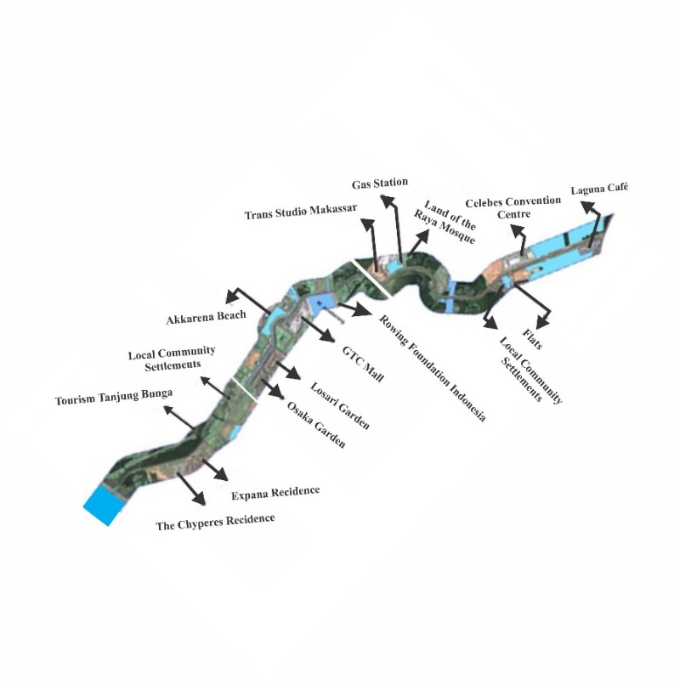
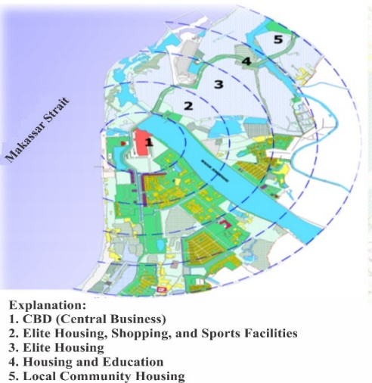

Figure 3. Spatial Linear and Concentric Physical Development
of new metropolitan areas of Metro Tanjung Bunga.
Source: the results of observation, 2017.

Linearly and concentrically spatial physical development (see Figure 3) in the New Metropolitan Areas is an urban area development in the built areas. It leads to integration through accumulation of commercial activities where the central point is indicated by Mall GTC. There are three established spatial zones (see Figure 4) including (1) the main zone in where people with high social-economic status occupy. It is indicated by complete social-economic services and dominated by new individuals consisting of ruling elite group, professionals, and “businessmen”. This group consists of expansively entering people, who are dominant investors with land, having political power, high income, and living in very luxurious residences in the New Metropolitan Areas, Makassar City; (2) the area between zones 1 and 3 is location which workers occupy, enter and commune with local community. The individuals here are of commercial economic businesses and have higher income than those in zone 3; and (3) the local community with low social-economic status occupies the outer zone (zone 3). Ordinarily, the residences include very simple stage houses, and their instruments tend to be slums. In consequence, the developing residential areas indicate difference of inter-zone spatial use aspects and mixing between formal and informal residences, and experiences rapid population growth. Besides, the core areas are experiencing population stagnation and reduction as a part of mega-urbanization process (Firman, 2004; Yunus, 2006; Setioko, 2009). The residential development tend to form new residential clusters due to economic classes, leading to stratification difference and social status between incoming individuals and local community (Surya, 2016). Suburbanization of poverty is caused not only by direct moves but also broader indirect and exclusionary processes attributable to the increasing unaffordability and inaccessibility of central city locations. This broader process reflects the changing topography of the urban regions marked by shifting socioeconomic divides (Hochstenbach and Musterd, 2018).

The increasing capital flow and investment relative to gentrification in the New Metropolitan reposition role of land economic value is not based on the potential farming products and land width. The evidence indicates land price/m2 before developing the New Metropolitan Areas ranged from Rp.50,000,- to Rp.100,000,- with valuation based on farming land productivity and width. Furthermore, change based on economic land productivity and price/m2 ranged from Rp.3,500,000,- to Rp.5,000,000,-. This condition indicates land and space experienced changes from local community ownership to investors, ruling elites, and capitalist classes. This means the current space and land are considered as commodities which may be reproduced and traded, and domination is determined by income and capital ownership (Harvey, 2009; Surya, 2015ª). Thus, the nearer residential location distance to main central and economic activities, the higher the value and price of land and vice versa. Therefore, land productivity will be determined mainly by locational site based on the economic spatial functions. The intensity of development increases dominantly in economic activities and large scale residences are positively associated with spatial domination inequality, stratification difference and social classes between the comers and the local community.

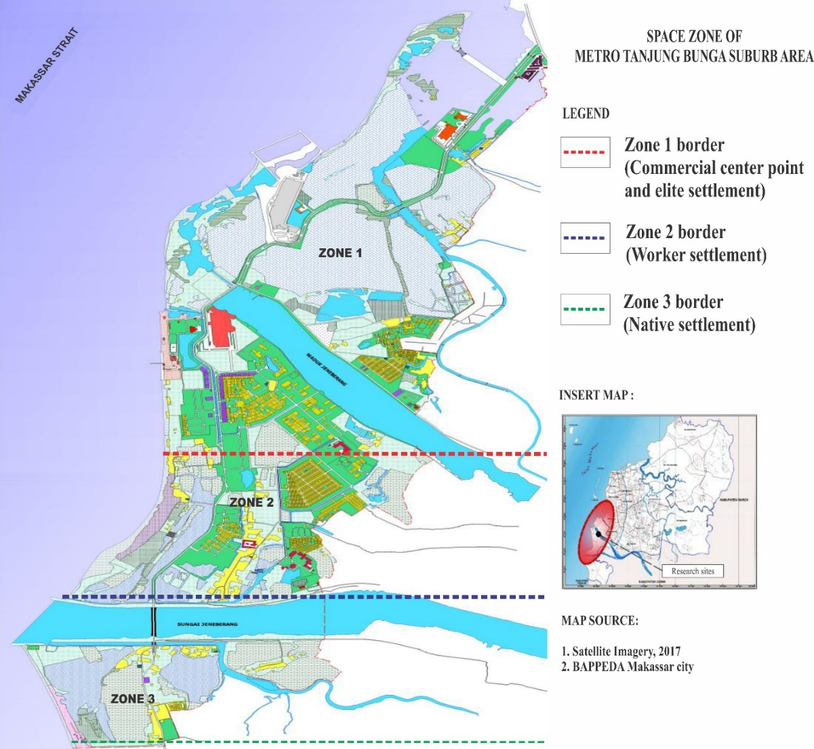

Figure 4. Spatial Zone of new metropolitan areas of Metro Tanjung Bunga
Source: Results of analysis, 2017

There are six issues associated with spatial zone division and functions developing in the New Metropolitan Areas. These are: (1) transformation of spatial use; (2) change in residential building characteristics; (3) adjustment in residential pattern; (4) social interaction and adaptation between the comers and local community; (5) gentrification and suburbanization in suburban areas; and (6) physical, economic and social segregation. These indicate the allocation of built spaces based on spatial zone has positive impact on changes in accessibility, population mobility and it is a driving factor for entrance of comers expansively. Information from the field indicates the large scale residences are dominantly occupied by middle and high individuals with luxury residential types in one hand. In contrast, the local community occupies slums with stage-house model which appear to be changing into slums. The parameters use to evaluate slums include (1) residential condition and building esthetic do not comply with requirements of health and low income people occupy these residences; (2) inability to access the resources in urban space; (3) scarce instruments and infrastructures of residences; flood vulnerability relative to insufficient drainage network infrastructures; (5) vulnerability to fire threat relative to poor roads; and (6) low accessibility relative to non-patterned and very limited road systems. The growth of slums was not a wholly organic development that occurred within the domestic conditions of a country, rather it is one of the results of globalized, neoliberal capitalism (Almeida, 2013). As a result, the spatial transformation and change in its use results in physical, economic and social segregation.

Figure 5. Slum Residence in new metropolitan areas of Metro Tanjung Bunga
Source: Results of Field Observation, 2017

Spatial change and inability to reproduce urban space makes it hard for the weak local community to access economic and land resources, triggering development of slums (See Figure 5). The development of slums is triggered by internal factors such as culture, religion, workplace, birthplace, length to reside, house investment, type of home building. It is also influenced by external factors such as land ownership and governmental policy (Srinivas, 2012). The institutional discrimination of community groups associated with land ownership is the main reason for the development of informal residences or Squatters (Zhao, 2015). There are three types of expressions associated with spatial transformation in the New Metropolitan Areas. These are: (a) social rank shown by change in economic status of the community to be societal positions with order based on specialization and collective prestige; (b) urbanization evidenced by change in family economic status, increasing from traditional lifestyle to urban way of life; and (c) segregation, having tendency to change in ethnic status of certain groups characterized by difference in wealth and residence instrument ownership. The change in occupational relationship pattern of traditional agrarian people moves to work-related relationship pattern of contractual-urban industrial society (Yunus, 2006; Surya, 2016). The direct impact is change in social solidarity, from mechanistic to organic cohesion (Kolip and Setiadi, 2011; Martono, 2014; Surya, 2014^{b}). The field observations show the inability of local community to adapt to environmental change stimulus relative to spatial change in development causes local community to exist in marginal position. This conclusion was made based on the indicators of residential instrument ownerships and difficulties in getting a proper job, and therefore categorized as urban poor society. Other information gathered from the field indicate job orientation which the local community achieves are categorized into two main classes, (a) urban formal activities, as security in luxury residences developed, office boy in commercial economic activities, and parking workers in advanced commercial economic activities; (b) urban informal activities such as house-helping in elite households; street peddlers, vegetable suppliers and construction workers. The hierarchy of human need levels is measured using the five indicators, (1) physiology consisting of clothing, food, residence, sex, and individual prosperity; (2) safety comprising job security; (3) social, entailing the need to be accepted by others, respect, achievement, and participation in an activity; (4) self-esteem, which include internal appreciations such as autonomy and achievement, and external factors such as status, acknowledgement, and care; and (5) self-actualization, consisting of motivation to be an individual based on capability, one’s growth achievement and self-sufficiency (Maslow, 1994; Hariyono, 2010). To support these facts, hierarchy of need fulfillment is measured based on perception of local community.
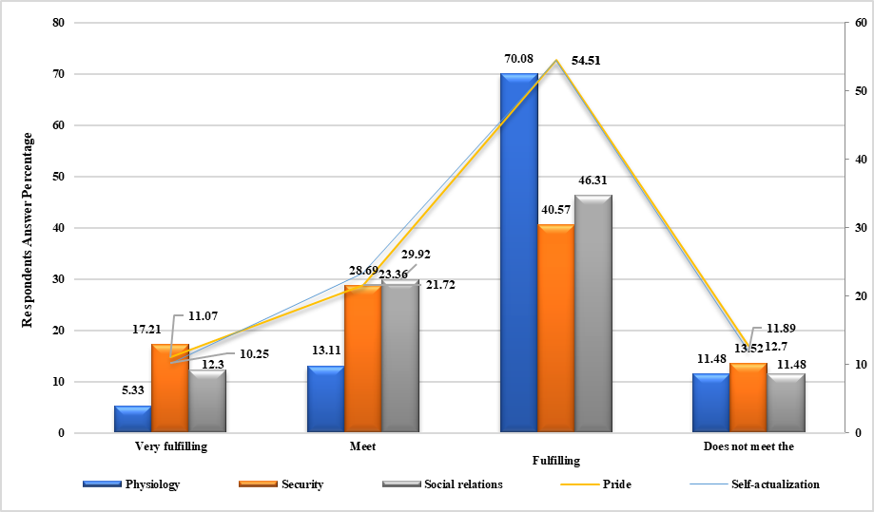

Figure 6. Hierarchical Graph of Fulfilling the Needs of Local Communities
In new metropolitan areas of Metro Tanjung Bunga.
Source: Primary Data, 2017

Proposed interpretations are seen in Figure 6 and include (i) relation between spatial transformation and change in its use against physiological fulfillment of local community indicates that 5.33% of them responded “very satisfactory”, 13.11% “satisfactory”, 70.08% “less satisfactory” and 11.48% responded “unsatisfactory”. Thus, spatial transformation and very rapid change in spatial use indicate a difference in physiological need fulfillment of local community. (ii) The relation between spatial transformation and change in spatial use to safety fulfillment for local community indicates 40.57% answered “less satisfactory” while 13.52% answered “unsatisfactory”. Therefore, spatial transformation and change in spatial use indicate the difference from safety fulfillment of local community. After this fact was confirmed, it was evident safety was only felt by local community whose members were involved in social-economic activities. (iii) In spatial transformation and change in spatial use for social relation fulfillment 12.3% “very satisfactory”; in this case, social relation is built between the comers and the local community and worked well. In the same regard, 29.92% “satisfactory”; in this case, social relation is built if necessary; 46.31% opted for “less satisfactory”; while 11.48% chose “unsatisfactory” option. These information indicate social relation work well only place in the residential environment of local community and especially in infiltrative comers.

Positive relation pattern between communities help in developing mutually advantageous social relation to improve prosperity and residences in one environmental unit. Space is a very important prerequisite in developing cultural and spatial identities as media to implement hierarchical process. Furthermore, social capital is a collection of sources binding to family relation and social organization of community which is useful for cognitive and social development of children and youths (Ahmed, 2011; Coleman, 2011) (iv) Spatial transformation and change in spatial use for self-esteem need fulfillment in local community. In this regard, 11.07% of the respondents chose “very satisfactory”, 21.72% “satisfactory” and were proud residents. On the same basis, 54.51% of the respondents opted for “less satisfactory” while 11.89% of them chose “unsatisfactory”. This implies the pride as residents in the New Metropolitan Areas was only felt by few of members of the local community. (v). Spatial transformation and change in spatial use needs of self-actualization of local community indicate 10.25% of the respondents chose “very satisfactory”; 23.36% of “satisfactory”; 54.51% “less satisfactory”; and 12.70% of them “unsatisfactory”. Therefore, spatial transformation and change in spatial use do not have direct effect on the development of economic business improved as form of self-actualization of local community. The five analyzed aspects indicate the spatial transformation and change in spatial use do not have direct effect on existence of local community in the New Metropolitan Areas. A positive contribution was only given to social relation between the local communities and the infiltrative comers while the other four aspects tended to weaken in fulfilling the needs of local community. The community’s ability to stay in the urban environment is associated with their capacity to adapt or modify their behavior in dealing with the availability and distribution of resources since decision making is required (M.J. Weaving, et.al 2014). The relationship between decision making and strategic group should integrate in organizations various needs and demands of community (Salusu, 2014). For this reason, spatial transformation and change in spatial use are positively associated with marginalization and poverty in the local community. The two emanate from the impact of the development in the New Metropolitan Areas.

Spatial transformation and change in spatial use indicate a certain portion of land has the potential to affect others near it and expand to the surrounding areas in urban systems of metropolitan of Mamminasata. There are two stages in dynamics of development in the new urban areas, (a) dominance of economic activities to small cities and surrounding rural areas; and (b) combination of activity pattern in the urban system of Mamminasata Metropolitan. These two factors cause morphological adjustment indicated by change in urban structure and city form in metropolitan spatial scale (Friedman, 1975; Yunus, 2006; Surya, 2018). Moreover, further evidence from the field indicate large scale residence development and regional scale economic activity functions have an impact on integration of surrounding urban areas and are positively associated with poverty in the local community. Poverty facing people is not only caused by process of urban involution and inability to access economic resources, but also by land dominance by capitalists (Berger, P.L., 1984; Armstrong, W.R. and McGee, 2002; Hariyono, 2010). Friedman (1988) called the facts as collective, eternality or spill-over effect phenomena (Briant et.al, 1982; Yunus, 2008) while McGee (1997), referred to it as transboundary effect phenomena. Schematically, the process of spatial transformation in the New Metropolitan Areas, is as shown in Figure 7.

Polarization of the Function of Makassar Socio-Economic Activities

Centrifugal Factor

Sentripetal factor

Transfer of Land Use Function

Change in Allocation of Land Allocation

Changes in Space Structure, Space Patterns & Transportation Systems

Decreasing Environmental Quality

Space Capacity

Environmental Support Capacity

Morphological diversity

Urban Sprawl and Konurbation Metropolitan Maminasata Urban System

Figure 7. Spatial Transformation Process of the new metropolitan areas of Metro Tanjung Bunga. Source: Results of Analysis, 2017.

The impact of spatial transformation in the New Metropolitan Areas of Metro Tanjung Bunga, Makassar City

Spatial transformation and change in spatial use is a determinative factor for expansion from urban areas in Makassar City to suburban areas of Metropolitan Mamminasata. Direct impacts of the process results include (1) increasing amount and density of population; (2) development of urban activities surrounding the new city areas; (3) urban sprawl and urban conurbation; (4) integration of activity systems and regional infrastructures. The four factors are positively associated with increasing agility of product and service transportation as well as the mobility of population physically, economically and socially. Facts from the field indicate long road lines developing lengthwise are the built areas dominated by commercial activity functions. The urban lengthwise lines have controlled growth of residences and non-residential buildings (Yunus, 2008; Surya, B., 2015^{b}). Transportation flow is indicated by sufficiently high volume of motorized vehicles from and to Makassar City, affecting the growth of surrounding urban areas and development of regions physically. This is because one urban system unit often led to single, dispersed, spatial use pattern, urban sprawl, and degradation of the surrounding environment. Generally, urban sprawl is associated with policy of investment, speculation, rule of land use, and facility pricing (Kustiwan, 2011). Therefore, the development of New Metropolitan Areas indicates spatial transformation and change in spatial use recur in the urban area systems of Metropolitan Mamminasata.

Table 2. Impact of Spatial Transformation in new metropolitan areas of Metro Tanjung Bunga to the Mamminasata Metropolitan Urban System

No | Impact | Parameter | Interpretation
1 | Urban system | Spatial structure | - Changes in the structure of urban services are characterized by economic growth poles.  - Accumulation of urban activity centres towards the suburbs of Mamminasata Metropolitan
1 | Urban system | Spatial pattern | - Changes in agricultural cultivation activities towards industrial areas on the outskirts of Mamminasata Metropolitan  - Physical changes to the Mamminasata Metropolitan area due to the allocation of new space functions (houses, works, clans, likes and facilities and infrastructure).
1 | Urban system | Transport movement system | - Increased mobility of goods and passenger transportation.  - Increased volume of motor vehicles and traffic congestion.
2 | Environmental system | Ecosystem condition | - Environmental degradation and decreasing Green region coefficient (KDH) in the Mamminasata Metropolitan urban area.  - Environmental damage due to pollution of soil, water and air.
2 | Environmental system | Land-use system | - Removal of productive agricultural land-use function.  - Environmental damage due to pollution of soil, water and air.
3 | Economic system | Economic activities | - Inequality in mastery of space reproduction and urban dualistic (formal and informant) economic systems.  - Changes in work relations from traditional economic systems towards urban modern economic systems.
3 | Economic system | Land value | - Changes in land sale value based on urban space functions.  - The economic value of the land is oriented to the function of space and the market economy.
4 | Social system | Social structure | - Changes in social relations towards differences in modes of production and sharpening of socio-economic strata.  - Changes in social status based on educational background, expertise, and skills.
4 | Social system | Social mobility | - Differences in vertical and horizontal social mobility between immigrants and local residents.  - Social mobility is characterized by the ability of capital, wealth, and develops towards segregation.
4 | Social system | Social dynamic | - Social dynamics are very dynamic characterized by changes in the orientation of agricultural work to urban industry.  - The social dynamics of immigrants and local residents develop in the direction of urban inter-ethnic segmentation.
Source: results of analysis

Explainable interpretations associated with spatial transformation (see Table 2) are: (a) change in urban systems; in this case, improvement of service structure is characterized by accumulation of social-economic activities, tending to develop in urban agglomeration through creation of market and spatial interaction process in the urban areas of Metropolitan Mamminasata. Agglomeration appears as the outcome of the interaction of increasing returns, trade costs, and factor price differences market area due to the meeting of two or more different economic activities (Dahuri dan Nugroho, 2012; Tarigan, 2014; Lincaru et al., 2016). Spatial interaction and agglomeration work parallel to connectivity to trade systems, large scale settlements, tourism, and other urban activities increases transportation of goods and passengers. Interregional interaction is reflected in transportation facilities and flow of people, goods, and services (Hurst, 1974; Surya, 2015^{b}). (b) Degradation of urban environment quality characterized by high pollution burden is associated with various social-economic activities such as beach habitat damage, coastal area ecosystem caused by spatial addition (coast reclamation) in development of the New Metropolitan Areas and the problem of water absorption. (c) Developing economic systems have positive contribution to land value of urban areas of Metropolitan Mamminasata by increasing economic productivity, trade, service and tourism. Formal trade results in new buildings in an area which not only have visual effect, but also affects patterns and activities surrounding the structures (Purnamasari, 2013). Besides, economic systems developing in the New Metropolitan Areas have tend to follow dualistic models and coexisting formal and informal financial structures, though not existing in hierarchical position. The dynamics leads to inequality in dominance of urban space, characterized by domination of capitalism to pre-capitalism production mode, leading to the new social formation (Surya, 2014). (d) Built social systems have tendency to change in social structure, mobility, and dynamics in the comers and the local community. The developing social relation is difference from collective adaptation and interaction aspects. The real impact on life of local community is repositioning the role and status to plural functions characterized by urban community. For this reason, the development of New Metropolitan Areas has dualistic characteristics, mixing between planned and traditional residences, and social systems exist as reproduced practices (Setioko, 2009; Giddens, 2010). It means that social spaces in gradually expect changes along with modification in spatial order and mental structures between the comers and the local community. Social space is one of dominant places and production factor is fundamental element of social structure decreasing behavior, action and civilization (Bourdieu, 1997; Kristeva, 2013; Schumpeter, 2013). The results of the study show behavior, action and civilization between comers and the local community show basic differences based on residence characteristics developing in the New Metropolitan Areas. There are two main categories indicating the difference associated with the behavior, action and civilization; (a) existence of residences developed has tendency to appear as a well arranged residence pattern and forms luxury habitation clusters based on economic classes of the comers; (b) residential patterns of the local community early existing in main road lines in tend to develop in slums. These two conditions indicate the difference in lifestyle, consumption pattern, and action rationality. In consequence, spatial transformation and change in spatial use leads to social adjustment and its intensity is affected by dynamics of the development.

Sustainability of Development in the New Metropolitan Areas of Metro Tanjung Bunga

The sustainable development in the New Metropolitan Areas will be improved in the following main dimensions; (a) environmental sustainability oriented to safety. Sustainability of environment refers to controlling of spatial use and optimization of land use, water and ecosystem service resources, and minimization of environmental pollution. The local improvement of ecosystem services is facilitated by constructing green infrastructure, or the rigid spatial restraint created by urban growth boundary (Jian Peng, et.al, 2018). The efforts are made by preparing and developing green infrastructure based on natural disaster mitigation and conservation considering is located in coastal area. (b) Economic sustainability is oriented to development of local economic potential through economic empowerment of local community still existing in the New Metropolitan Areas. The idea is implemented by economic balance principle between the comers and the local community. (c) Social sustainability is oriented to social capital reinforcement through development capital, which can be human, produced economic, or natural in order to avoid social conflict. The principle is implemented by developing economic assets of marginal community in terms of access to land resources, business capital, improving mutual reliance, collaborating, reinforcing collective identity, equality and constructing a shared future. The three factors should be implemented consistently in the development and construction. The urbanization course improves the quality and reduce the resources and environmental costs of urbanization along with the environment, energy resources. However, this infrastructure requires holistic comprehension and actionable approaches to the city as the nexus of environmental context, built set-up, and human communities (Xingliang Guan, at al., 2018; Nan Li, at al., 2018).

Figure 8. Sustainability of Development in new metropolitan areas
of Metro Tanjung Bunga, Makassar City.
Source: Results of Analysis, 2017

The four explainable issues (see Figure 8) are (1) management of environment oriented to green city development based on development of renewable energy resources, wise management of natural resources and management of ecosystem service based on information technology. (2) Economic systems are developed to create job opportunities, coaching of people’ productive economic business, and the development of human resources as well as incorporation of economic assets and land to the local community. (3) Social systems are directed to two following main issues; (a) development of human resources potential consisting of education and development of social-cultural character of community, (b) giving easy access to education, healthcare, and safety insurance services to residents of the local community in the new urban area. (4) Improvement of functions and roles of government through strengthening of institutional capacity, strengthening of planning systems and role of people in development. Governments are likely to have a key roles as promoters or in legitimation (or both), but other actors are also likely to contribute significantly, especially social movements and civil society groups (James, J. Patterson, et al., 2017). The four pillars of development in the new urban area include inclusive principle, effectiveness, economic efficiency and creation of sustainable social cohesion.

Conclusions

From the above discussion, the following conclusions can be made:

Spatial transformation followed by change in land use causes change in spatial structure and pattern. Besides, it also leads to degradation of the ecosystem having impact on complex morphological variety, decreasing in farming land productivity, and environmental pollution. Additionally, it causes physical, economic and social segregation characterized by urban formal and informal activities, planned residential areas and slums. Urban addition to the New Metropolitan Areas through polarization of activity functions and allocation to land use gives positive contribution to integration of urban systems of Mamminasata Metropolitan characterized by economic growth and formation of service centers.

Spatial transformation and change in land use have a tendency to change in social structure, mobility and dynamics. Suburbanization and gentrification characterized by capital flow and investment leads to inequality of spatial reproduction dominance between expansive comers and local community. For this reason, sustainability of development should be oriented to inclusive principles, effectiveness, economic efficiency and creation of sustainable social cohesion. Since this study was carried out in limited scope, further researches are recommended, especially on the model of new urban area development in perspective of suburban area of Mamminasata Metropolitan.

References

Andong, R.F, and Sajor, E., (2017). Urban Sprawl, Public Transport, and Increasing C02 Emission: the case of Metro Manila, Philippines. Journal Environment, Development and Sustainability. Springer. Vol 19. Issue 1. pp. 99-123. https://doi.org/10.1007/s10668-015-9729-8

Armstrong, W.R. dan Terry McGee., (2002). “A Theory of Urban Involution.” Hlm 220-234 dalam Hans-Dieter Ever (ed.), Sociologi of South-Eats Asia: Reading on Social Change and Development. Kuala Lumpur: Oxford University Press.

Almeida, T., (2013). Neoliberal Policy and the Growth of Slums. Publisher Prospect Journal of International Affairs at UCSD. https://prospectjournal.org/2012/05/21/neoliberal-policy-and-the-growth-of-slums/

Basant, Maheshwari et al., (eds.). (2016). Balanced Urban Development: Is It a Myth or Reality?. Springer Open. https://link.springer.com/chapter/10.1007/978-3-319-28112-4_1

Briant, C.R. et al., (1982). The City’s Countrysides: Land and its Management in Rural Urban Fringe. Longman Inc. New York. https://www.researchgate.net/publication/266138394_The_City%27s_Countryside_Land_and_Its_Management_in_the_Rural-Urban_Fringe

Bourdieu, P. (Coord.)., (1997). A Miséria do Mundo. Petrópolis: Editora Vozes. http://www.netmundi.org/home/wp-content/uploads/2018/01/BOURDIEU-Pierre-org..-A-mis%C3%A9ria-do-mundo.pdf

Berger, Peter L., (1984). Revolusi Kapitalis. Jakarta. Penerbit LP3ES.

____Bappeda Kota Makassar (2017). Rencana Tata Ruang Kota Makassar 2015-2035.

Cocheci R.M. et al., (2015). Environmental Degradation In Rural Areas With High Anthropic Pressure-Impact And Planning Models. Carpathian Journal of Earth and Environmental Sciences, August 2015, Vol. 10, No 3, pp. 25-36. https://www.researchgate.net/publication/285229782_Environmental_degradation_in_rural_areas_with_high_anthropic_pressure_-_Impact_and_planning_models

Chang, S. et al., (2013). Discussion on sustainable land use allocation toward the sustainable city A practice on Linco New Town. ELSEVIER. Procedia Environmental Sciences 17 (2013) 408-417. https://doi.org/10.1016/j.proenv.2013.02.054

Creswell, J.W., (2016). Research Design. Pendekatan Metode Kualitatif, Kuantitatif, dan Campuran. Edisi 4. Penerbit. Pustaka Pelajar.

Denzin and Lincoln., (2009). Hand Book Of Qualitative Research. Penerbit. Pustaka Pelajar.

Dahuri, R. dan Nugroho, I., (2012). Pembangunan Wilayah: Perspektif Ekonomi, Sosial dan Lingkungan. Penerbit. LP3ES.

Firman T., (2004). New town development in Jakarta Metropolitan Region: a perspective of spatial segregation. Pergamon. Habitat International Vol. 28 (2004) pp. 349–368. https://doi.org/10.1016/S0197-3975(03)00037-7

Friedman, J, and Alonso, W., (1975). Regional Policy. Reading in Theory and Apllication. Massachusetts. MIT Press.

Friedman, J., (1988). Editorial; Life Space and Economic Space, Essay in Third Word Planning.

Gradinaru S.R. et al., (2015). Do Post-Socialist Urban Areas Maintain their Sustainable Compact Form? Romanian Urban Areas as Case Study. Journal of Urban and Regional Analysis. Vol. VII, 2, 2015a, pp. 129-144.

Giddens, A., (2010). Teori Strukturasi: Dasar-Dasar Pembentukan Manusia (terjemahan oleh: Maufur dan Daryatno, Judul Asli: The Constitusion of Society: Online of the Theory of Structuration. University of California Press, USA, 1984.

Giyarsih, S.R., (2001). Gejala Urban Sprawl Sebagai Pemicu Proses Densifikasi Permukiman Di Daerah Pinggiran Kota (Urban Fringe Area). Jurnal Perencanaan Wilayah dan Kota (ITB). Vol:12. No:1-4. http://journals.itb.ac.id/index.php/jpwk/article/view/4312

Hakim, I. and Parolin, B., (2008). Spatial Structure and Spatial Impacts of the Jakarta Metropolitan Area: a Southeast Asian EMR Perspective. International Journal of Civil, Environmental, Structural, Construction and Architectural Engineering. Vol.2, No.10. pp. 227-235. https://www.researchgate.net/publication/242714764_Spatial_Structure_and_Spatial_Impacts_of_the_Jakarta_Metropolitan_Area_a_Southeast_Asian_EMR_Perspective

Harvey, D., (2009). Neoliberalisme Dan Restorasi Kelas Kapitalis. Penerbit. Resist Book.

Hariyono, P., (2010). Perencanaan Pembangunan Kota Dan Perubahan Paradigma. Penerbit. Pustaka Pelajar.

Hanief, F., (2014). Pengaruh Urban Sprawl Terhadap Perubahan Bentuk Kota Semarang Ditinjau Dari Perubahan Kondisi Fisik Kelurahan Meteseh Kecamatan Tembalang. Jurnal Ruang. Vol. 2. No. 1 Hlm: 341-350.

Hochstenbach, C and Musterd, S., (2018). Gentrification and the suburbanization of poverty: changing urban geographies through boom and bust periods. Urban geography, 2018. Vol.39. No.1. pp. 26–53. https://doi.org/10.1080/02723638.2016.1276718

Hurst, E., (1974). Transportation Geography: Comments and Readings. New York, United States. McGraw-Hill, Inc.

Haber, W., (2008). Biological diversity–A concept going astray? Gaia-Ecological. Perspectives for Science and Society. Vol. 17(1). pp. 91–96. https://doi.org/10.14512/gaia.17.S1.4

James, J. Patterson, et al., (2017). Political feasibility of 1.5°C societal transformations: the role of social justice. Environmental Sustainability. ELSEVIER. Vol.31.pp.1-9. https://doi.org/10.1016/j.cosust.2017.11.002

Janssens, X., Bruneau, E., & Lebrun, P., (2006). Prediction of the potential honey production at the apiary scale using a Geographical Information System (GIS). Apidologie. Vol. 37 (3). Pp. 351–365. https://doi.org/10.1155/2012/951215

Jian Peng, et al., (2018). Linking ecological degradation risk to identify ecological security patterns in a rapidly urbanizing landscape. Habitat International. ELSEVIER. Vol.71. (2018).pp.110-124. https://doi.org/10.1016/j.habitatint.2017.11.010

Inoguchi, Takashi et al., (2015). Kota Dan Lingkungan. Pendekatan Baru Masyarakat Berwawasan Ekologi. Penerbit. LP3ES.

Kristeva, N.S., (2013). Kapitalisme Negara Dan Masyarakat. Penerbit. Pustaka Pelajar.

Kustiwan, I., (2011). Pengendalian Perkembangan Fisik Kota: Penanganan Urban Sprawl. Dalam Bunga Rampai Pembangunan Kota Indonesia Dalam Abad 21. Konsep Dan Pendekatan Pembangunan di Indonesia. Hlm 421-437: Edisi 2. Penerbit URDI.

Kustiwan, I dan Pontoh, N.K., (2010). Pengantar Perencanaan Perkotaan. Penerbit. ITB.

Kolip, U. dan Setiadi Elly, M., (2011). Pengatar Sosiologi Pemahaman Fakta Dan Gejala Permasalahan Sosial: Teori, Aplikasi, Dan Pemecahannya. Penerbit. Kencana Prenadamedia Group.

Lee, L., (1979). Factors Affecting Land Use Change in the Rural-Urban Fringe in Grow and Change: A Journal of Regional Development, Vol.10. https://doi.org/10.1111/j.1468-2257.1979.tb00861.x

Lincaru. et al., (2016). Peri-urban Areas and Land Use Structure in Romania at LAU2 Level: An Exploratory Spatial Data Analysis. ELSEVIER. Procedia Environmental Sciences 32 (2016) pp. 124 – 137. https://doi.org/10.1016/j.proenv.2016.03.017

Martono, N., (2014). Sosiologi Perubahan Sosial: Perspektif Klasik, Modern, Posmodern, dan Poskolonial. Penerbit. RajaGrafindo Persada.

McGee, T.G., (1997). The Emergence of Desa-Kota Region in Asia: Expanding a Hypothesis, in Notton Ginsburg, Bruce Koppel, T.G. McGee (eds). The Extended Mtropolis and Setlement Transition in Asia. Honolulu: The University of Hawai Fress.

Maslow, A.H., (1994). Motivasi dan Kepribadian (Teori Motivasi dengan Pendekatan hierarki Kebutuhan Manusia). Penerbit. PT PBP, Jakarta.

M.J. Weaving, et al., (2014). Sex-biased space-use response to urbanization in an endemic urban adapter. Landscape and Urban Planning. Vol. 130. pp.73–80. https://doi.org/10.1016/j.landurbplan.2014.06.011

Nan Li, et al., (2018). Urban sustainability education: Challenges and pedagogical experiments. Habitat International. ELSEVIER. Vol.71. pp. 70-80. https://doi.org/10.1016/j.habitatint.2017.11.012

Parasati, H. (2011). Kebijakan Pembangunan Perkotaan Dalam Kurun Waktu RPJPN 2005-2025. Dalam Bunga Rampai Pembangunan Kota Indonesia, Dalam Abad 21. Konsep Dan Pendekatan Pembangunan di Indonesia. Hlm 3-20: Edisi 2. Penerbit URDI.

Prados, M. J., (2009). Naturbanization: New Identities and Processes for Rural-Natural Areas. London: Taylor and Francis Group. https://doi.org/10.1201/9780203881149

Purnamasari, D. W., (2013). Model Konseptual Adaptasi Ruang Kampung Kota Sebagai Akibat Keberadaan Sektor Perdagangan Formal (Kampung Sekayu Kota Semarang). TATA LOKA. Vol. 15 No. 2, Hlm.140-159. https://doi.org/10.14710/tataloka.15.2.140-159

Sui Z, et. al., (2001). Modeling the dynamics of landscape structure in Asia's emerging desa kota regions: a case study in Shenzhen. ELSEVIER. Landscape and Urban Planning 53 (2001).pp. 37-52. https://doi.org/10.1016/S0169-2046(00)00136-5

Surya, B., (2010). Urbanisasi dan Pertumbuhan Kota. Penerbit. Fahmis Pustaka

Surya, B., (2014ª). Penetrasi Kapitalisme Memarginalkan Komunitas Lokal. Penerbit Fahmis Pustaka.

Surya, B., (2014^{b}). Social Change, Spatial Articulation in the Dynamics of Boomtown Construction and Development (Case Satudy of Metro Tanjung Bunga Boomtown, Makassar). Modern Applied Science; Vol. 8. No. 4. pp.238-245. https://doi.org/10.5539/mas.v8n4p238

Surya, B. (2015ª). Sosiologi Spasial Perkotaan. Gagasan dan Pengalaman Empiris. Penerbit Fahmis Pustaka.

Surya, B., (2015^{b}). The Dynamics of Spatial Structure and Spatial Pattern Changes at the Fringe Area of Makassar City. Indonesian Journal of Geography. Vol. 47 No.1. pp.11-19. https://doi.org/10.22146/ijg.6926

Surya, B., (2015^{c}). Spatial Articulation and Co-Existence of Mode of Production in the Dynamics of Development at the Urban Fringe of Makassar City. Medwell Journal. Journal of Engineering and Applied Science. Vo.10. Issue 8.pp.214-222. https://doi.org/10.3923/jeasci.2015.214.222

Surya, B., (2015^{d}). Spatial Interaction Pattern and the Process of City Activity Formation System (Case study, Ternate City, Tidore Archipelago City and Sofifi City of North Maluku, Indonesia). Medwell Journal. Research Journal of Applied Sciences. Volume 10. Issue 12. pp.880-892. https://doi.org/10.3923/rjasci.2015.880.892

Surya, B., (2016). Change Phenomena of Spatial Physical in the Dynamics of Development in Urban Fringe Area. Indonesian Journal of Geography. Vol. 48 No.2. pp.118-134. https://doi.org/10.22146/ijg.17631

Sugiyono., (2016). Metode Penelitian dan Pengembangan. Untuk Bidang: Pendidikan, Manajemen, Sosial dan Teknik. Penerbit. Alfabeta. Bandung.

Surya, B, et al., (2018ª). Economic Gentrification and Socio-Cultural Transformation Metropolitan Suburban of Mamminasata. Medwell Journal. Journal of Engineering and Applied Science. Vol.13. Issue 15.pp.6072-6084. https://doi.org/10.3923/jeasci.2018.6072.6084

Surya, B., (2018). Transformasi Spasial Dan Kota Berkelanjutan (Perspektif Sosiokultural, Ekonomi, dan Fisik Lingkungan). Penerbit. PT. RajaGrafindo Persada. Jakarta.

Surya, B., et al., (2018^{b}). Transformation of metropolitan suburban area (a study on new town development in Moncongloe-Pattalassang Metropolitan Maminasata). IOP Conf. Series: Earth and Environmental Science 202 (2018) 012027. pp. 1-10. https://doi.org/10.1088/1755-1315/202/1/012027

Surya, B, et al., (2018^{c}). Inequility of Space Reproduction Control and Urban Slum Area Management Sustainability (Case Study: Slum Area of Buloa Urban Village in Makassar City) Medwell Journal. Journal of Engineering and Applied Science. Vol.13. Issue 15.pp.6033-6042. https://doi.org/10.3923/jeasci.2018.6033.6042

Soussan, John., (1981). The Urban Fringe in The Third Wrold. Working Paper 316. School of Geography University of Leeds. London.

Sassen, Saskia., (1991). The global city: New York, London, Tokyo. Princeton: Princeton University Press.

Sugiana, K., (2011). Pengembangan Wilayah Melalui Keterkaitan Desa-Kota: Dalam Bunga Rampai Pembangunan Kota Indonesia Dalam Abad 21. Konsep Dan Pendekatan Pembangunan di Indonesia. Hlm 147-167: Edisi 2. Penerbit URDI.

Setioko, et al., (2012). Towards sustainable urban growth: The unaffected fisherman settlement setting (with case study Semarang coastal area). Elsevier B.V. Procedia Environmental Sciences. Vol. 17. pp.401 – 407. https://doi.org/10.1016/j.proenv.2013.02.053

Srinivas, H., (2012). Defining Squatter Settlement. http://www.gdrc.org/uem/definesquatter. Diakses tanggal 30 Agustus, 2017.

Schumpeter, Joseph, A., (2013). Capitalism, Socialism Dan Democracy. Penerbit. Pustaka Pelajar.

Schreiber, S. J., & Kelton, M., (2005). Sink habitats can alter ecological outcomes for competing species. Journal of Animal Ecology. Vol. 74 (6). pp. 995-1004. https://doi.org/10.1111/j.1365-2656.2005.00996.x

Salusu., (2015). Pengambilan Keputusan Stratejik: Untuk Organisasi Publik Dan Organisasi Nonprofit. Penerbit. PT. Gramedia, Jakarta.

Saefullah, Asep Djaja., 1993. Pendekatan Kualitatif dan Kuantitatif Lapangan: Khususnya Dalam Studi Kependudukan. Penerbit Media Bandung.

Taylor, P. D., Fahrig, L., Henein, K., & Merriam, G., (1993). Connectivity is a vital element of landscape structure. Oikos. Vo. 68 (3). pp. 571–573. https://doi.org/10.2307/3544927

Tarigan, R., (2014). Ekonomi Regional: Teori dan Aplikasi. Penerbit. PT. Bumi Aksara.

Utami, S.D., (2015). Foreign Direct Investment and Regional Develompment in Jakarta Metropolitan Area. Sustainable Megacities: vulnerability, diversity, and livability. The 5th International Conference of Jabodetabek Studi Forum. IPB International Convention Center. Hlm.495-505.March.2015.https://www.academia.edu/23707098/SUSTAINABLE_MEGACITIES_vulnerability_diversity_and_livability

V.P. Singh, et al., (2016). Options and Strategies for Balanced Development for Liveable Cities: An Epilogue. Springer Open. https://doi.org/10.1007/978-3-319-28112-4_35

Vizzari, et al., (2015). Landscape sequences along the urban–rural–natural gradient: A novel geospatial approach for identification and analysis. ELSEVIER. Landscape and Urban Planning 140 (2015).pp. 42–55. https://doi.org/10.1016/j.landurbplan.2015.04.001

Qu Yanbo et al., (2018). Multi-scale analysis on spatial morphology differentiation and formation mechanism of rural residential land: A case study in Shandong Province, China. ELSEVIER. Habitat International Vol. 71. (2018). pp. 135-146. https://doi.org/10.1016/j.habitatint.2017.11.011

Winarso, H. et al., (2015). Peri-urban transformation in the Jakarta metropolitan area. ELSEVIER. Habitat International Vol. 49. (2015). pp. 221-229. https://doi.org/10.1016/j.habitatint.2015.05.024

Wei, C., Taubenbock, H., & Blaschke, T., (2017). Measuring urban agglomeration using a city-scale dasymetric population map: A study in the pearl river delta, China. Habitat International. ELSEVIER. Vol. 59. pp. 32–43. https://doi.org/10.1016/j.habitatint.2016.11.007

Winarso, H., et al., (2015). Peri-urban transformation in the Jakarta metropolitan area. ELSEVIER. Habitat International 49 (2015).pp. 221-229. https://doi.org/10.1016/j.habitatint.2015.05.024

Xingliang Guan, et al,. (2018). Assessment on the urbanization strategy in China: Achievements, challenges and reflections. Habitat International. ELSEVIER. Vol. 71.pp. 97-109. https://doi.org/10.1016/j.habitatint.2017.11.009

Yunus, S.H., 2005. Manajemen Kota Prespektif Spasial. Penerbit. Pustaka Pelajar.

Yunus, S.H., 2006. Megapolitan: Konsep, Problematika dan Prospek. Penerbit Pustaka Pelajar.

Yunus, S.H., 2008. Dinamika Wilayah Peri-Urban Diterminan Masa Depan Kota. Penerbit. Pustaka Pelajar.

Zhao., (2016). An ‘unceasing war’ on land development on the urban fringe of Beijing: A case study of gated informal housing communities. ELSEVIER. Cities Vol. 60 pp. 139-146. https://doi.org/10.1016/j.cities.2016.07.004

