**Supplementary Data**

|  |
| --- |
| **Phenolic Compounds from the Stem Bark of *Sonneratia caseolaris* (Lythraceae) and Their Antibacterial Activity**  **Harizon1,Dikdik Kurnia2, Dadan Sumiarsa2, Tati Herlina2, Siska Elisahbet Sinaga3,Yoshihito Shiono4,Mohamad Nurul Azmi5, Unang Supratman2,3\***  *1Faculty of Teacher Training and Education, Universitas Jambi, Mendalo Indah,*  *Jambi 36361, Indonesia.*  *2Department of Chemistry, Faculty of Mathematics and Natural Sciences,*  *Universitas Padjadjaran, Jl. Raya Bandung-Sumedang Km. 21, Jatinangor,*  *Sumedang 45363, Indonesia*  *3Central Laboratory of Universitas Padjadjaran, Jl. Raya Bandung-Sumedang Km. 21, Jatinangor, Sumedang 45363, Indonesia*  *4Department of Food, Life, and Environmental Science, Faculty of Agriculture,*  *Yamagata University, Tsuruoka, Yamagata 997-8555, Japan.*  *5School of Chemical Sciences, Universiti Sains Malaysia, 11800 Minden,*  *Penang, Malaysia*  *Corresponding author Tel./Fax: +62-22-7794391  E-mail: unang.supratman@unpad.ac.id  **Table of Contents** |
| Fig S1. FT-IR spectrum of (**1**)  Fig S2. 1H-NMR spectra of (**1**) (500 MHz in acetone-d6)  Fig S3. 13C-NMR spectrum of (**1**) (125 MHz in acetone-d6)  Fig S4. HMQC spectrum of (**1**)  Fig S5. 1H-1H-COSY spectra of (**1**)  Fig S6. HMBC spectrum of (**1**)  Fig S7. FT-IR spectrum of (**2**)  Fig S8. 1H-NMR spectra of (**2**) (500 MHz in acetone-d6)  Fig S9. 13C-NMR spectrum of (**2**) (125 MHz in acetone-d6)  Fig S10. HR-ESI-TOF-MS spectrum of (**3**)  Fig S11. FT-IR spectrum of (**3**)  Fig S12. 1H-NMR spectra of (**3**) (500 MHz in CD3OD)  Fig S13. 13C-NMR spectrum of (**3**) (125 MHz in CD3OD) |
|  |
|  |
|  |

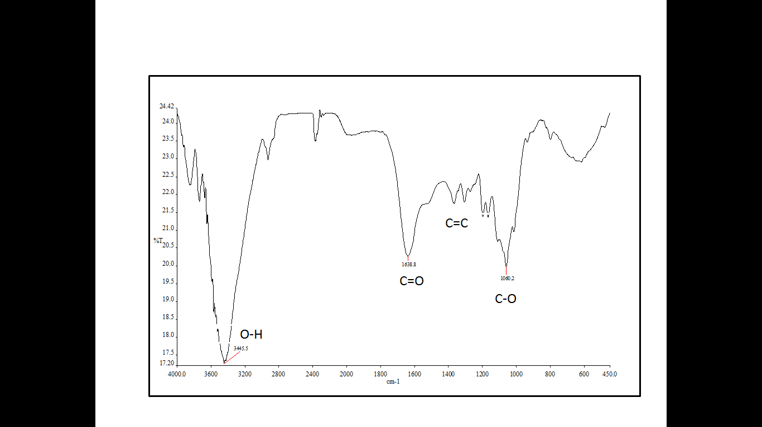

Fig S1. FT-IR spectrum of (**1**)



Fig S2. 1H-NMR spectra of (**1**) (500 MHz in acetone-d6)

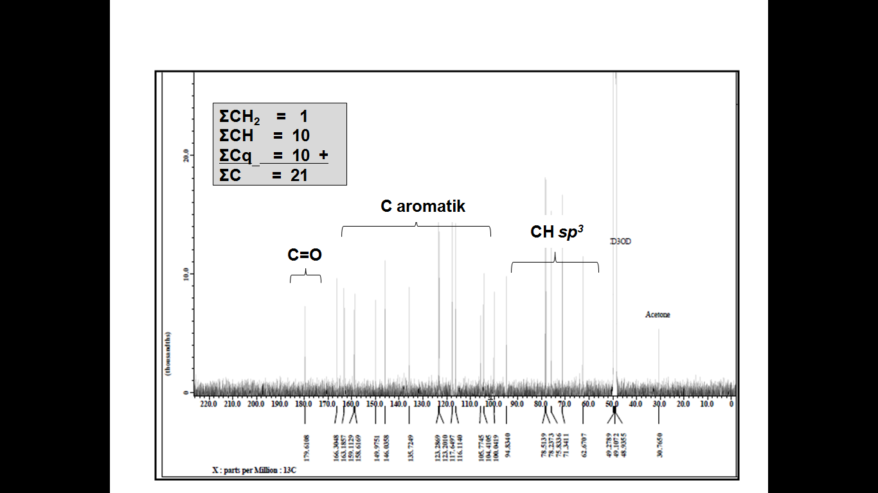

Fig S3. 13C-NMR spectrum of (**1**) (125 MHz in acetone-d6)

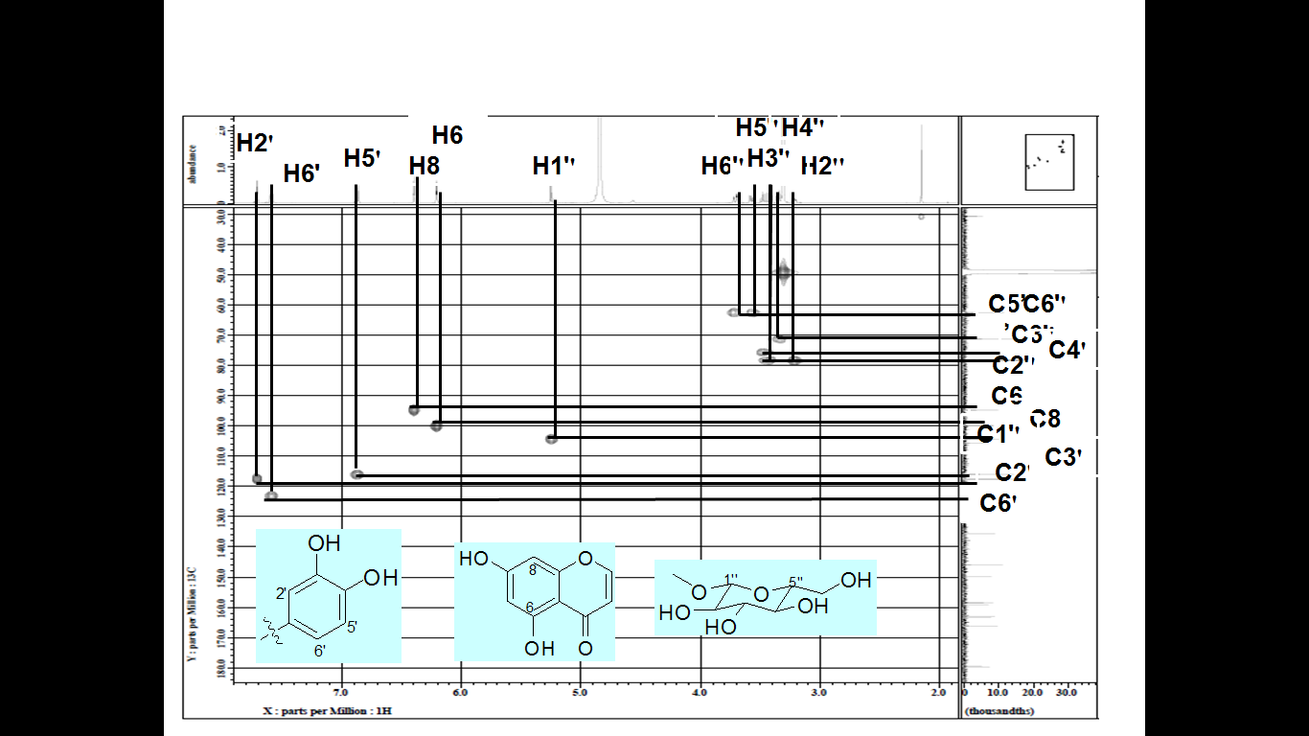

Fig S4. HMQC spectrum of (**1**)

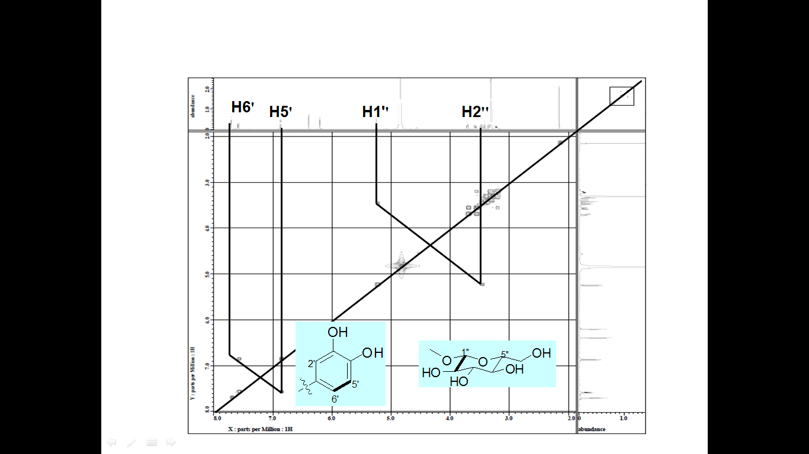

Fig S5. 1H-1H-COSY spectra of (**1**)

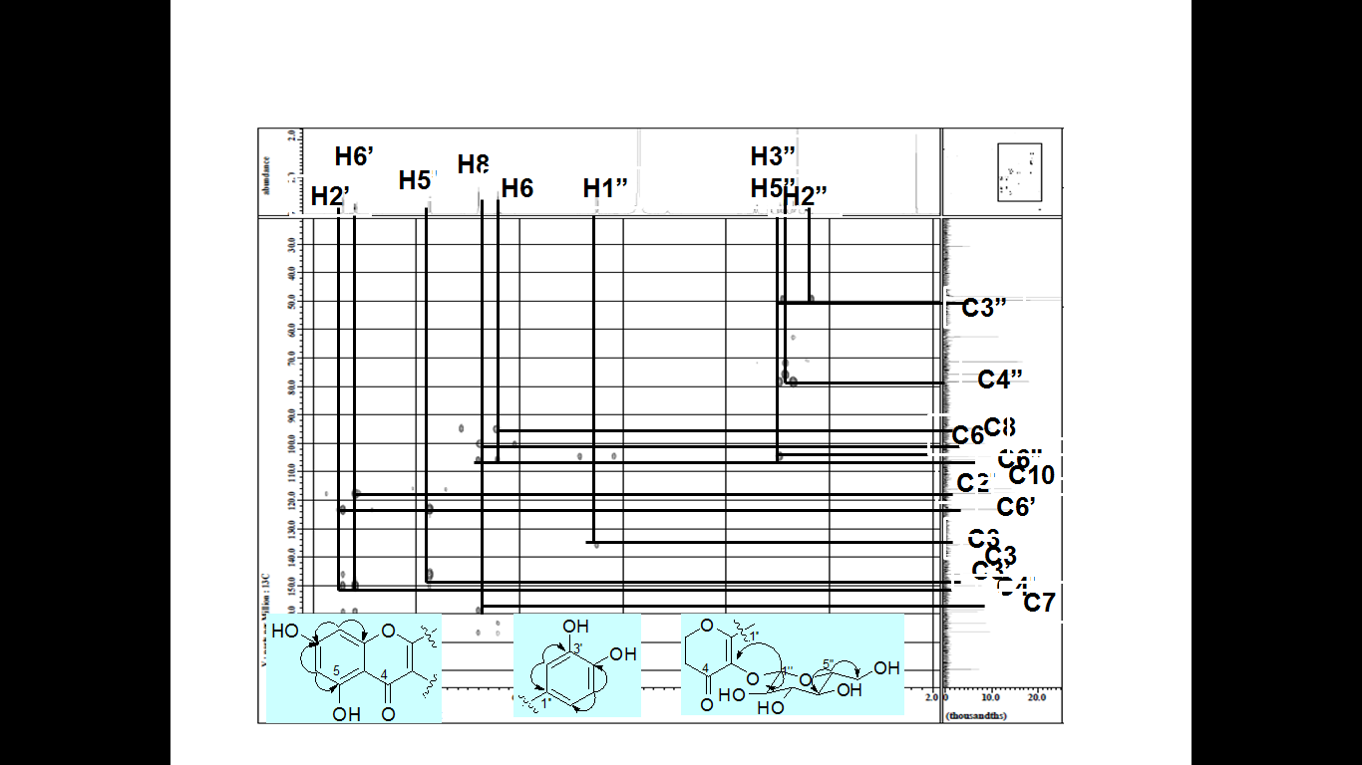

Fig S6. HMBC spectrum of (**1**)

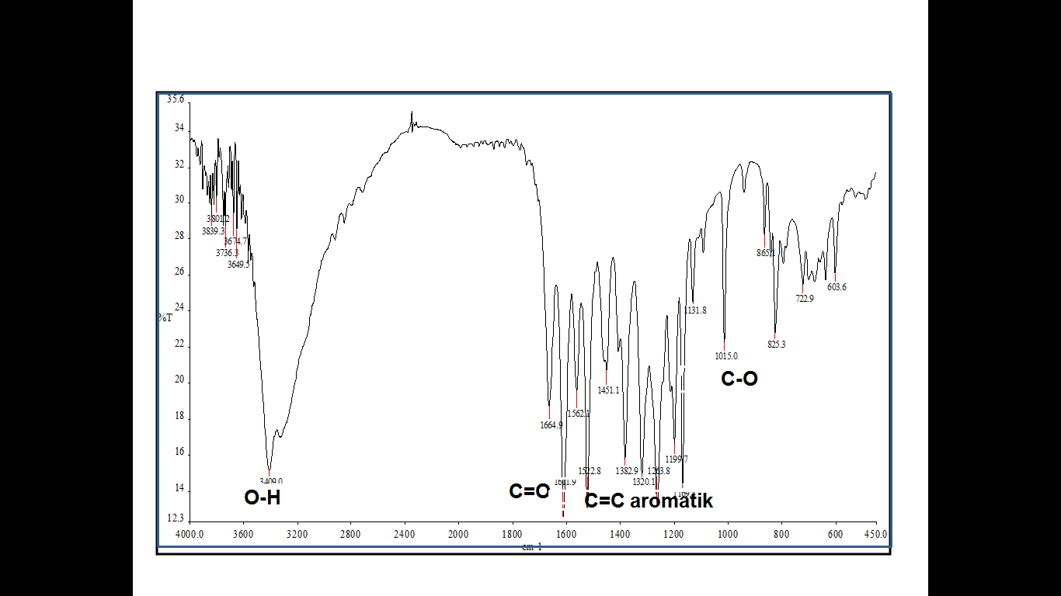

Fig S7. FT-IR spectrum of (**2**)

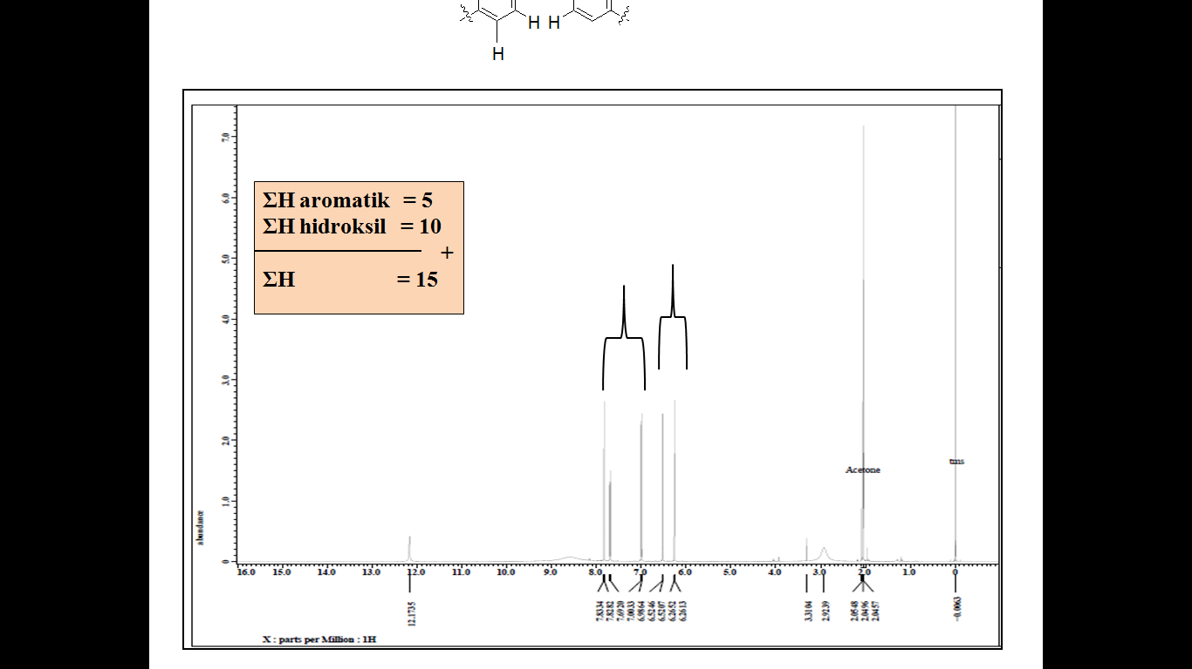

Fig S8. 1H-NMR spectra of (**2**) (500 MHz in acetone-d6)

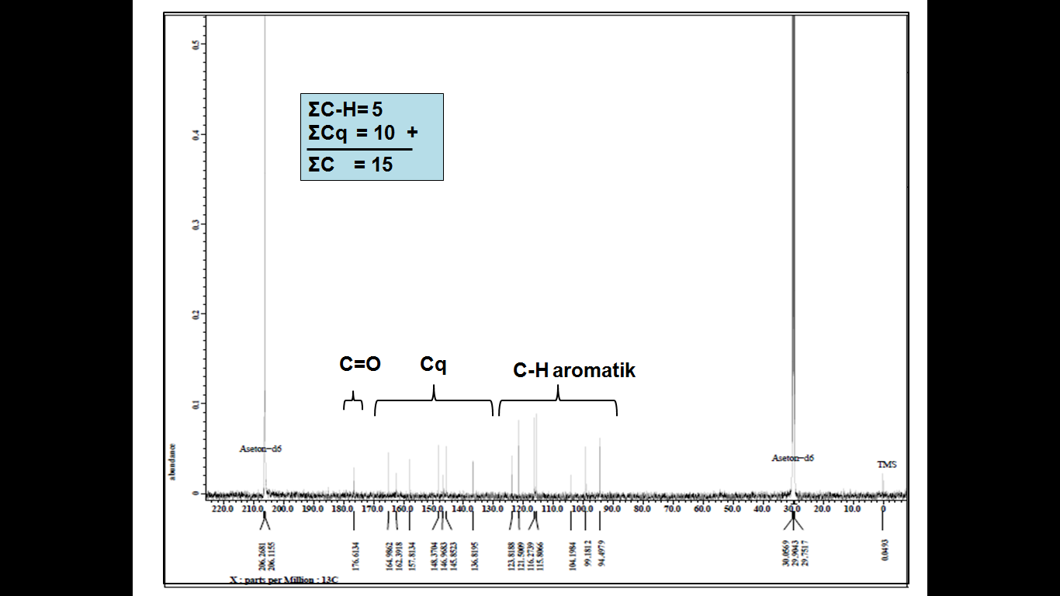

Fig S9. 13C-NMR spectrum of (**2**) (125 MHz in acetone-d6)

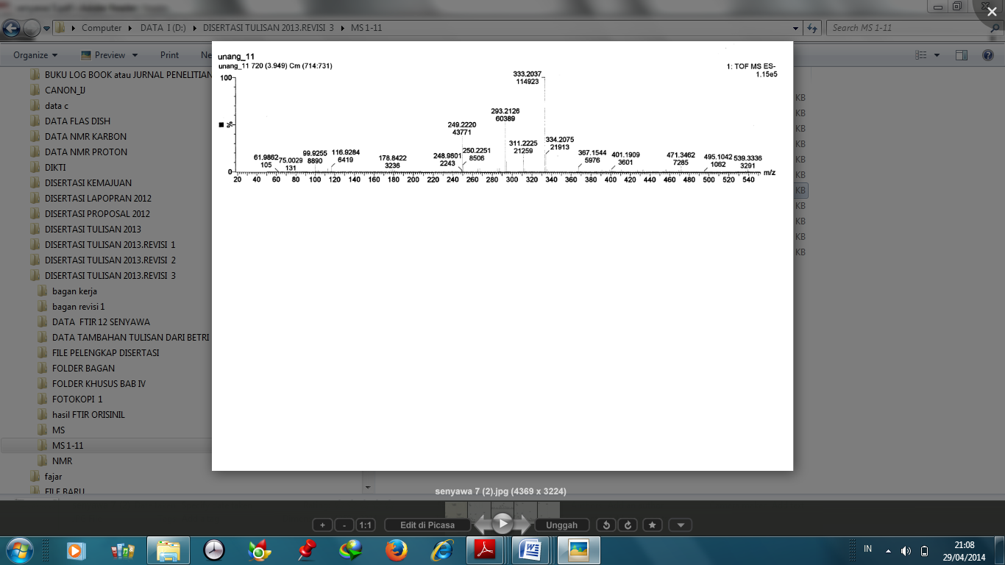

Fig S10. HR-ESI-TOF-MS spectrum of (**3**)

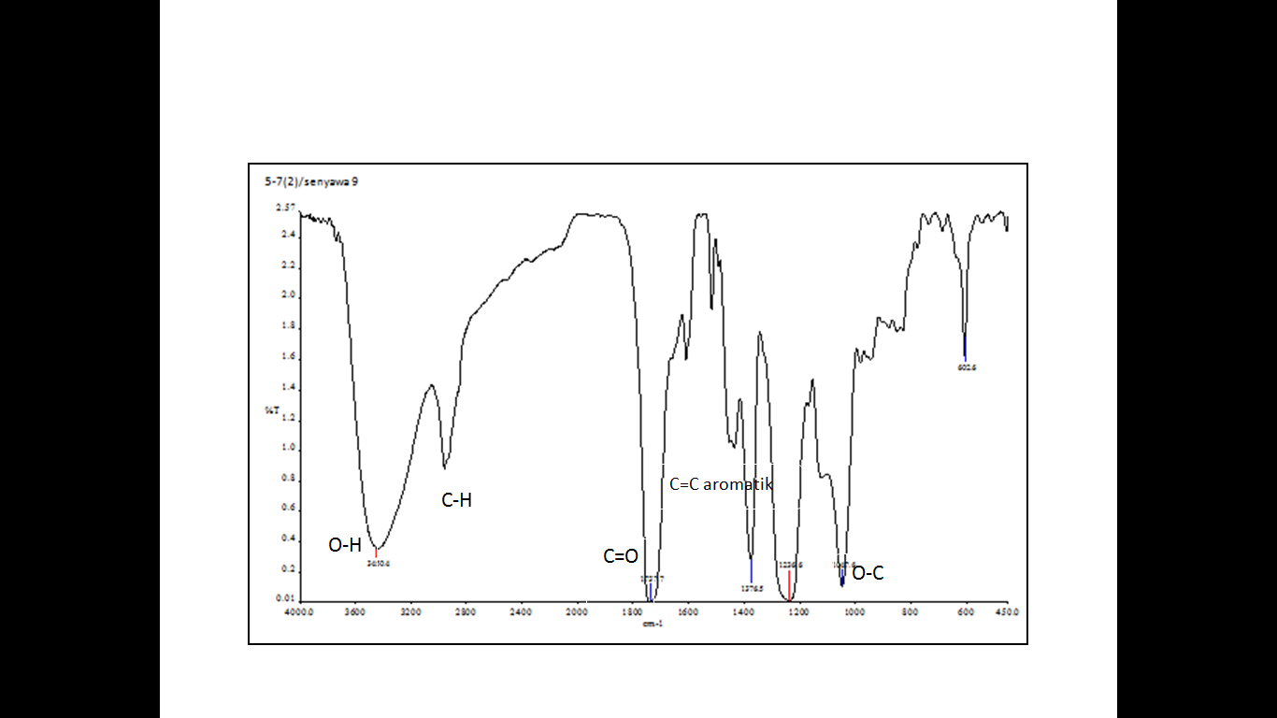

Fig S11. FT-IR spectrum of (**3**)

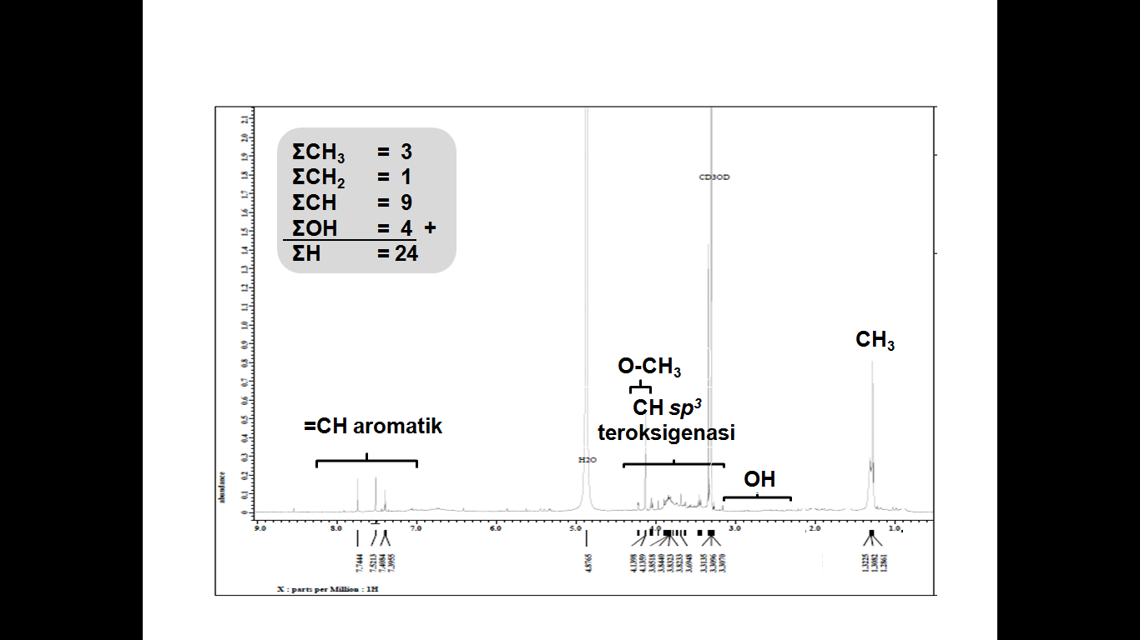

Fig S12. 1H-NMR spectra of (**3**) (500 MHz in CD3OD)

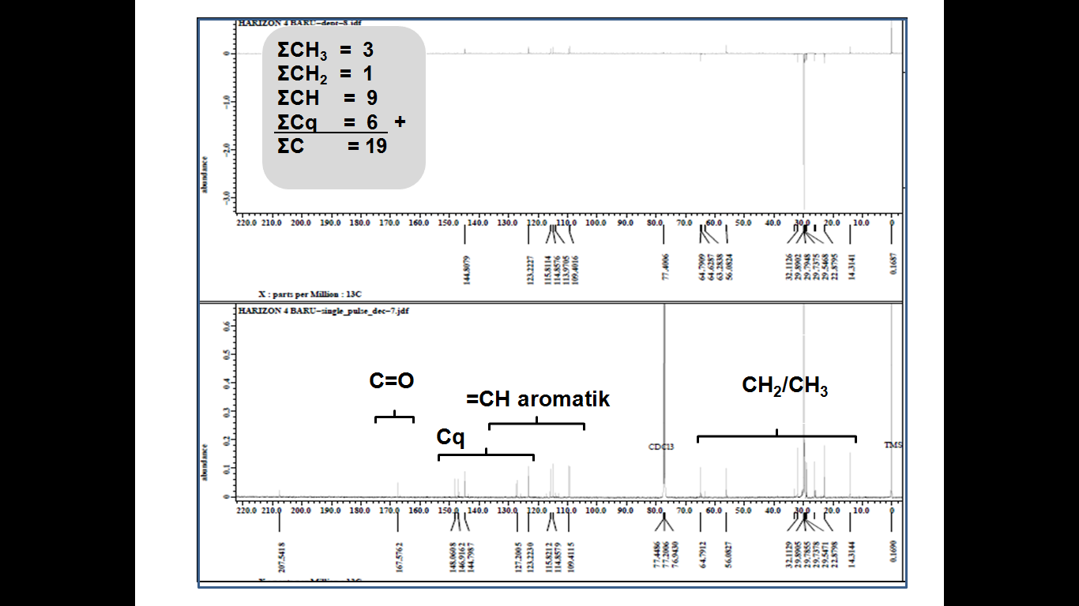

Fig S13. 13C-NMR spectrum of (**3**) (125 MHz in CD3OD)