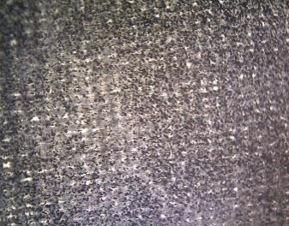 | 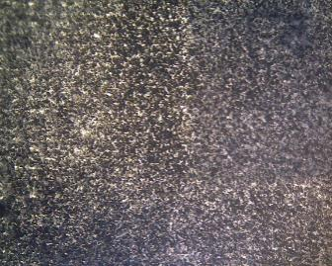
(a) | (b)
 | 
(c) | (d)
Fig. 4. ACC surfaces prepared with various concentrations of adhesive: (a) 50 wt%, (b) 60 wt%, (c) 70 wt%, and (d) 80 wt%.

