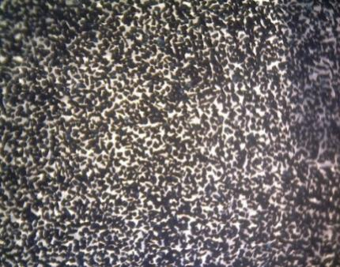 | 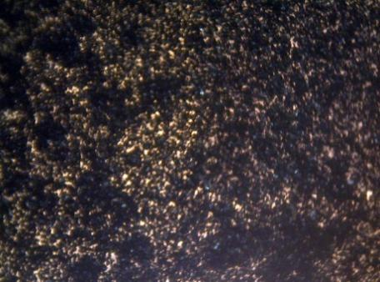
(a) | (b)
 | Fig. 3. Light microscope images of ACC surfaces prepared with several carbon particle sizes using 80 wt% adhesive: (a) 60 mesh, (b) 80 mesh, and (c) 100 mesh.
(c)

