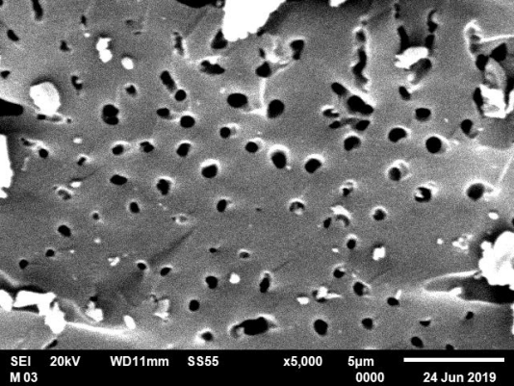 | 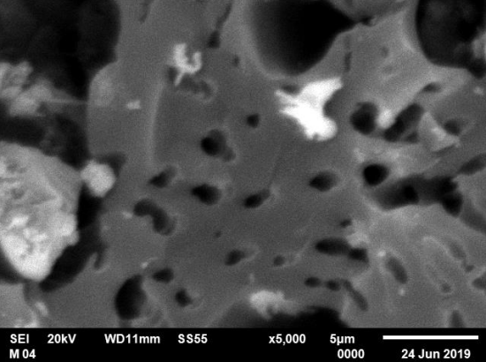
(a) | (b)
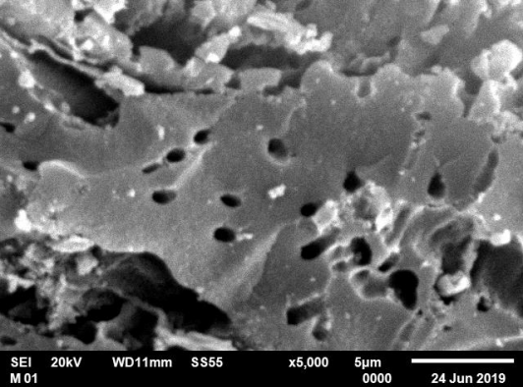 | 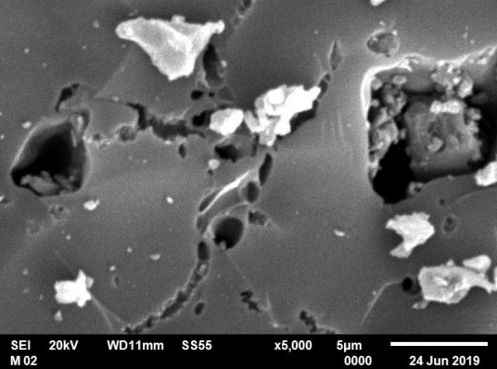
(c) | (d)
Fig. 2 SEM images of the ACC (a) Palm-carb-prior act-C,
(b) Palm-act-prior carb-C. (c) water filtration carbon (WF-C),
(d) regenerated filtration regeneration (RWF-C)

