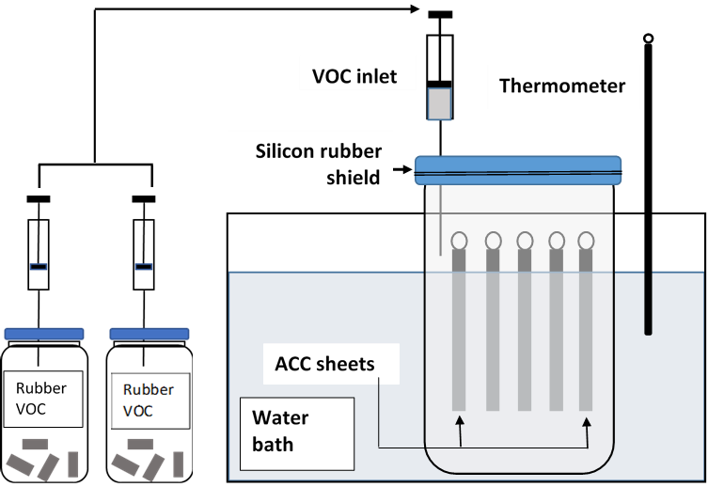

**Fig. 1** Vapor adsorption experiment;

skim latex voc source (left) and vapor adsorption reactor equipped with ACC sheets (right)