Development of Voltammetry Analysis Method
of Copper Metal Ions by Solid State Membrane
with Nanotube Carbon

Suyanta^{1,*}, Sunarto¹, Regina Tutik Padmaningrum¹, Karlinda¹, and Illyas Md.Isa², Rahadian³

¹ Jurusan Pendidikan Kimia, FMIPA Universitas Negeri Yogyakarta
² Nanotechnology Research Centre, Faculty of Science and Mathematics, Universiti Pendidikan Sultan Idris, 35900 Tanjong Malim, Perak, Malaysia
³Jurusan Kimia, FMIPA Universitas Negeri Padang
*E-mail: suyanta@uny.ac.id

This study was aimed at developing a method of metal analysis in continuous integration using voltammetry techniques. The research subject was copper (II) ions. The objects of research were linearity, scan rate, repeatability of readings, and the presence of Cu (II) levels in well water samples. In this study, a selective electrode was developed with a solid membrane voltammetry system using differential pulse voltammetry measurement. The results showed the regression line of voltammetry method Y= 10.265ln (x) + 330.47 with a correlation value of 0.9321, the optimum scan rate is 10 mV/s, and the five repetitions of each measurement for one electrode shows good repeatability. The result of regression with UV-Vis spectrophotometric method Cu (II) Y= 0.12386x + 0.00879 with a correlation value of 0.994305. The voltammetry method was better than the UV-Vis method because it can be used for analysis up to a concentration of 1x10⁻¹¹ M, while the UV-Vis method was only up to 1.5 ppm or 2.36x10⁻⁵ M.

Keywords: copper, spectrophotometry, voltammetry

1. INTRODUCTION
Waste is unnecessary substance disposal from the production process both industrial and domestic, which if not processed properly can cause environmental pollution. Substances commonly found in chemical industrial wastes are Ag, Cd, Co, Fe, Cr, Cu, Ni, Zn [1].
Copper (Cu) is used extesively in the chemical industry in particular, electroplatig, textile, and metal industries. Sulfuric copper is usually used for chemical analysis reagent, organic compound synthesis, additives in NPK fertilizer, blue dyeing in the textile industry, etc. Copper is one of the heavy metals that includes toxic and dangerous substances [2].
Many techniques have been developed to detect copper using instruments such as UV-VIS spectrophotometers, AAS, ICP-MS and ICP-AES. The AAS method is less sensitive for the determination of copper and iron because of the high detection limit, which is 800 - 900 ppm [3]. The ICP-MS and ICP-AES methods require very expensive devices [3]. Because of the limitations of several methods, another method is needed for better iron determination.
Potentiometry method with the use of ion selective electrodes as working electrodes is a fairly inexpensive and practical analysis method, but can provide good sensitivity and selectivity. Based on the study [4], copper and iron electrodes were quite sensitive and the detection limit was reached to 10⁻⁶ M. Ganjali et all [5] have been synthesizing compound of 4-methyl-hidrazino benzothiazole hydrobromide and hydrazine hydrate. This compound has a complex set of copper and iron, so are pretty selectively react with copper and iron.
The development of analyzing metal ions including copper ions using voltammetry has been developed, both ionically and molecularly in compounds, especially with electrometry systems [6-8]. The development of voltammetry analysis techniques using carbon nanotubes has been developed. The determination of cadmium, iron and voltammetric lead has been carried out by Deswati et al. [9]. The determination of several heavy metal ions by means of differential anodic stripping voltammetry pulse has been done by Saryati [10] and the development of analysis of Cd, Cu, Pb and Zn ions in seawater as well has been carried out by Deswati et al [11].
The use of carbon nanotubes as an ion selective electrode is not only for the analysis of metal ions, but also for the analysis of non-metals, especially organic compounds. The analysis of phenols and their derivatives by voltammetry using carbon nanotubes has been developed by by Adekunle, et al. [12]. The determination of voltammetric tetracycline compounds with carbon nanotube electrodes has also been developed by Guo, et al. [13]. The characteristic of glutamate with biosensors of carbon nanotube electrodes has been studied by Norouzi et al. [14].
Copper determination using UV-VIS generally uses various complexing compounds. The complexes used are ferrocene [15]. Another compound which has similar structure is Na-diethyldithiocarbamate or Na-DDTK with molecular formula is (C2H5)2NCS2Na. Therefore, in this study the copper ion selective electrode developed by Na-diethyldithiocarbamate as an active ingredient of the membrane and the basic matrix of carbon nanotubes that then be analyzed by means of differential pulse voltammetry.

2. RESEARCH METHODS
The subject of this study was copper (II) ions in well water and the objects were linearity, scanrate, repeatability of readings, and the presence of Cu (II) levels in well water samples.

2.1. Reagents and Chemicals
All reagents used in this study were analytical reagent grade. Carbon nanotube powder (Timesnano) and paraffin (Uvasol, Merck), copper (II) sulfate (Sigma-Aldrich), Na- diethyldithiocarbamate (Merck), potassium chloride (Merck), and potassium nitrate (Merck) were used as received. Stock solutions of copper ion were freshly prepared by dissolving appropriate amount of copper (II) sulfate in distilled deionized water. The sample of well water were collected from some area in Yogyakarta State University, Indonesia.

2.2. Equipments
The differential pulse voltammetry was performed with EDAQ Potentiostat, (Australia). All experiments were carried out in a single compartment electrochemical cell with a carbon-paste working electrode, saturated Ag/AgCl reference electrode and Pt wire counter electrode. These electrodes were immersed in 40 mL buffer solution (also as supporting electrolytes) at various pH and amount of Cu (II) solution. The pH value was determined using glass electrode Orion 915600, USA. Spectroscopy method using Spectrophotometer UV-VIS Shimadzu, 2450 Series was used to analyze the copper (II).

2.3. Electrode Preparation
The modified carbon paste electrodes were a homogenized mixture of Na- diethyldithiocarbamate, carbon nanotube, and solid paraffin with comparison 4:3:3 in mass composition in paste form. The modified carbon paste electrodes were packed firmly into teflon tubing (id= 4 mm). Electrical contact to paste was established via a copper wire at one end of tubing, while the other end acted as disc electrode. Before the measurement, the disc electrode was smoothened on a piece of weighing paper. The method refers to Suyanta research [16].

2.4. Voltammetry Analysis
The copper (II) ion analysis was developed using differential pulse voltammetry. This technique was usefull in analyzing metals ion in voltammetry. This techniques was develop by some reseachers [17-18]. Voltammetry data in the form of peak adsorption currents were changed because of the scan rate variable, repeatability and concentration variables studied in this study.

2.5. Data Analysis
The results of the study on solutions of various concentrations then were determined by the linear concentration region and a calibration curve between the high currents of peak versus the concentration. This analysis was done to determine the linearity and the correlation between the standard solution calibration curve test and its the samples. The analysis technique are used for voltammetry and spectroscopy methods.

3. RESULTS AND DISCUSSION
3.1. Characterization of Copper (II) Electrode System Carbon Paste in Differential Pulse Voltammetry.
The active ingredient sodium diethyldithiocarbamate membrane as a modifier of carbon paste electrode influences the copper (II) voltammogram. The results of the voltammogram of copper ion measurements are shown in Figure 1.

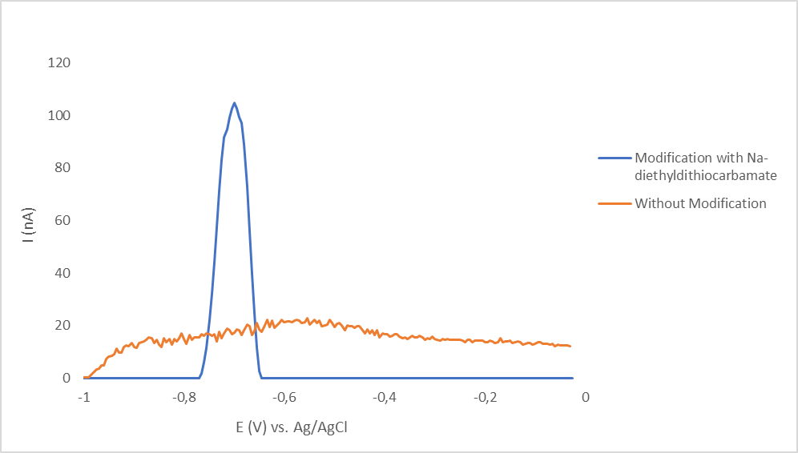

Figure 1. Difference in voltammogram curve at work electrode modified with Na-diethyldithiocarbamate and without modification.

Figure 1 shows that the modified electrode of Na-diethyldithiocarbamate carbon paste gave a peak current response to copper (II) solution, at a potential of -0.695 V vs. Ag / AgCl with a current value of 102.636 nA, while an electrode without modification did not give any rise to a peak. Thus the electrode can censor the presence of copper (II) ions properly.

3.2. Linearity
The linear concentration area of the modified carbon paste electrode was studied to determine the area (range) of concentration which provided a linear relationship between the height of the peak current and the concentration of copper (II) (10⁻⁶ – 10⁻¹⁰ M).

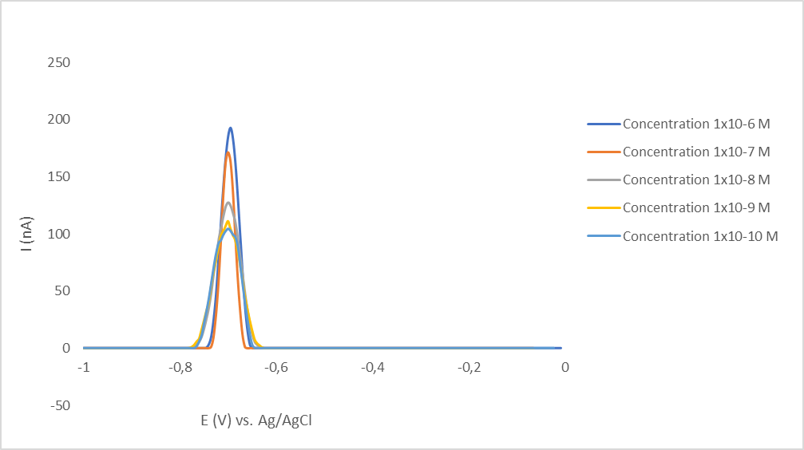

Figure 2. The Cu (II) voltammogram curve of the working electrode has been modified, at various concentrations.

Based on Figure 2, it appears that the presence of copper (II) ions at various concentrations can be censored by the electrode properly. The greater the concentration of copper (II) ion, the higher the voltammogram.
If the voltamogram in Figure 2 created a relationship between the concentration and the measurement current value, a linear graph would formed. The relationship between concentration and current is seen in table 1.

Table 1. The results of measuring the current of copper (II) voltammograms at various concentrations.

Concentration (M) | Current (nA)
1.0 x 10⁻⁶ | 192.59
1.0 x 10⁻⁷ | 171.37
1.0 x 10⁻⁸ | 127.37
1.0 x 10⁻⁹ | 111.04
1.0 x 10⁻¹⁰ | 104.58

Based on Table 1, then a curve was made between the concentration of copper (II) solution and the height of the peak current produced. It shows in Figure 3.

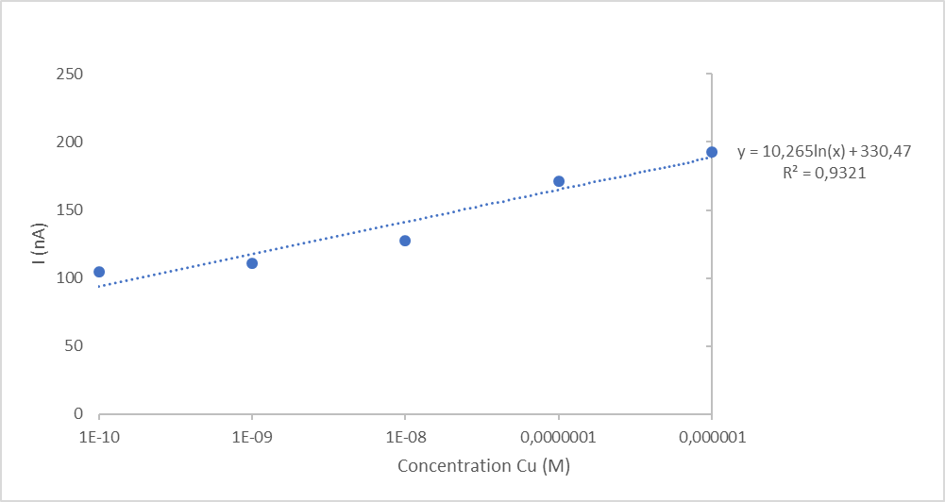

Figure 3. The relationship between the concentration of copper (II) solution and the high current.

Based on the results of this study, it can be seen that the current is comparable with concentration. This relationship is mathematically expressed through the regression line equation which is calculated with the value Y = 10.265 ln (X) + 330.47 and the value of R² = 0.9321. The comparison between this values and the results of linearity using the UV-Vis spectroscopy method obtains the line equation Y= 0.12386X + 0.00879 with the value r= 0.994305 for analysis, as in the calibration curve shown in Figure 4 [19].

Figure 4. Copper (II)- diethyldithiocarbamate Calibration curve.
With the results of the study that the value of r ≥ of 0.95 indicates a linear criterion, then both methods are good methods of analysis.

3.3. Scan Rate
In differential pulse voltammetry, the height current and width of the peak are affected by the speed of reading. The measurement results are shown in Figure 5.

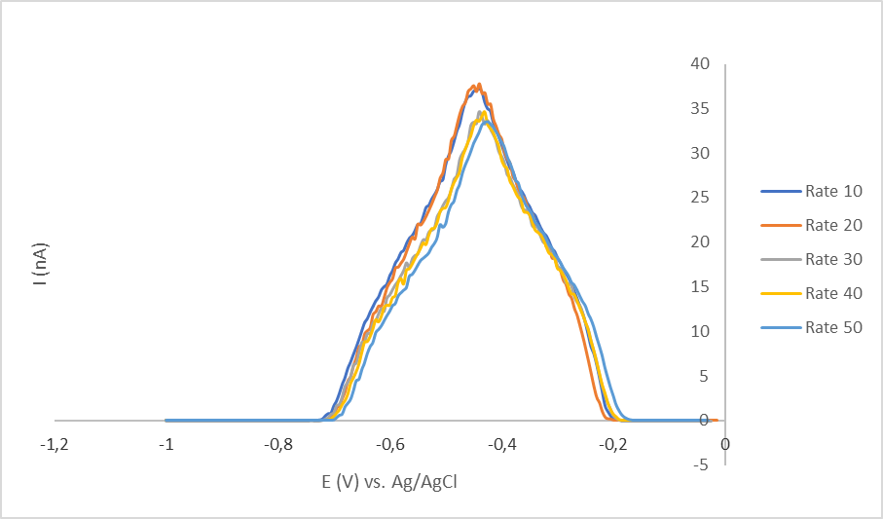
Figure 5. The effect of the difference in the adsorption rate of copper (II) from the modified work electrode at a concentration of 1x10⁻¹⁰ M and a maximum current of 50 nA.

The results of current measurements with differences in scan rate can be seen in Table 2.

Table 2. The copper (II) flowmeasurement results

Scan Rate (mV/S) | Curret (nA)
10 | 37.02
20 | 36.90
30 | 34.67
40 | 34.10
50 | 33.52

Based on Table 2, as the results, it can be concluded that the higher scan rate, the smaller the current value obtained. In this study, the optimum reading scan rate was 10 mV/s because the peak obtained was higher and not wider.

3.4. Repeatability Results of Elektrode
The repeatability of modified carbon paste electrodes was studied by comparing the peak current of the measurement results at optimum conditions. The measurements were carried out 5 times with one electrode under solution conditions and fixed measurements. The measurement results are shown in Figure 7.

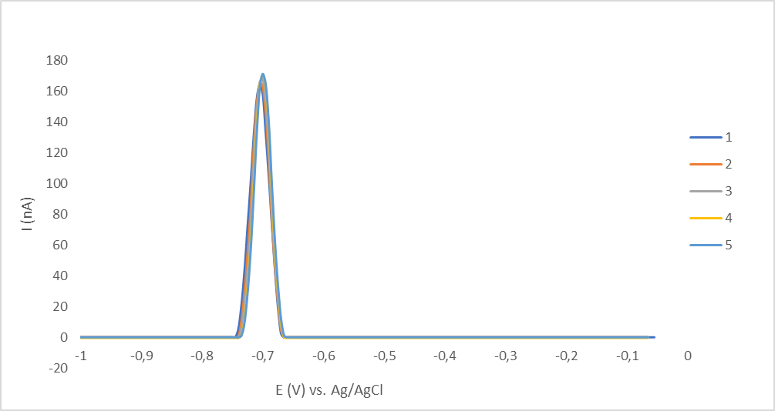

Figure 7. The measurement curve were done in 5 times. The adsorption of copper (II) from the modified work electrode was done at a concentration of 1x10⁻⁷ M and a rate of 50 mV / s.

The results of repeated measurements in 5 times indicated that the peak current was stable (constant). So that the modified Na-diethyldithiocarbamate carbon paste electrode has reproducible repetition.
3.5. The Measurement Result of Cu (II) in Well Water
The Na-diethyldithiocarbamate modified electrode then was applied to determine the content of copper (II) in well water. The results of measuring well water are shown in Figure 8.

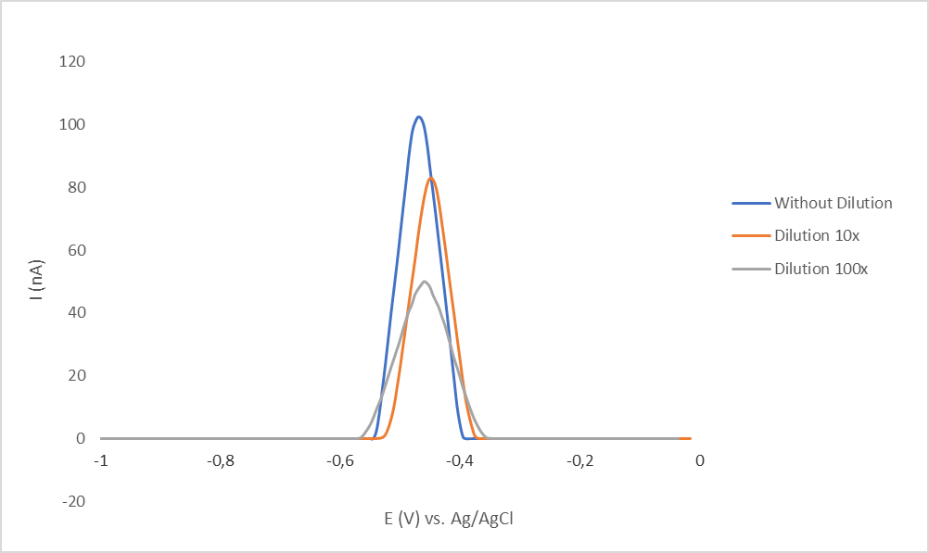

Figure 8. Voltammogram of copper (II) content in well water

Based on the results of measurements on well water samples, it shows that the copper content in well water is very small. The copper voltammogram, current which obtained from the analysis results above 100 nA.

3.6. Comparison of Validation Results
The comparison of the validation result was aimed to determine the method of determining copper (II) better, UV-Vis or Voltammetry spectrophotometry method. Comparison of the correlation coefficient and analytical ability of copper (II) with the UV-Vis Spectrophotometry method and the Voltammetry method can be seen in Table 3.

Table 3. Comparison among the value of correlation coefficients and the ability of analysis of copper with UV-Vis Spectrophotometry Method and Voltammetry Method

Metal Ion | Correlation Coefficient Value |  | Ability of Analysis
Metal Ion | Voltammetry Method | Spectrophotometry Method | Voltammetry Method | Spectrophotometry Method
Copper (II) | 0.9321 | 0.994305 | until concentration 1x10⁻¹¹ M | until  concentration 2.36x10⁻⁵ M

Based on the results of the study, it shows that the voltammetry method is better at measuring the content of copper (II) in solution and also in well water than the UV-Vis Spectrophotometry method.

4. CONCLUSION
Based on the research, it can be concluded that:
1. The making of Na-diethyldithiocarbamate modified thin layer electrode shows a very good peak current response to copper (II) solution.
2. The regression line equation copper (II) ion voltammetry method Y= 10.265 ln (x) + 330.57 with a r value of 0.9321; Optimum rate of 10 mV/s, stable repeatability (reproducible).
3. The Voltammetry method is better than the UV-Vis spectrovotometry method for analysis of copper (II) in solution or in well water.

References

[1] Pratiwi, Agustin., Bohari Yusuf., dan Rahmat Gunawan. (2015).Jurnal Kimia Mulawarman, 13(1)
[2] Soemitrat S, J. (2009). Kesehatan Lingkungan. Yogyakarta: Gadjah Mada University Press.
[3] Shibata, N., Fudagawa, N., and Kubota, M., (1991), Analytical Chemistry, 63, 636-640.
[4] Suyanta, (2010), Laporan Penelitian, UNY: Yogyakarta
[5] Ganjali M.R., Norouzi P., Shamsolahrari L., and Ahmadi A., (2006). Sensors and Actuators B: Chemical, 114(2), 713-719
[6] M. Pandurangachar, B. E. Kumara Swamy, B. N.Chandrashekar, Ongera Gilbert, Sathish Reddy, and B.S. Sherigara, Int.J. Electrochem. Sci., 5 (2010), 1187-120.

[7] Ali A. Ensafiand Hassan Karimi-Maleh, Int. J. Electrochem. Sci., 5, (2010) 392 – 406.

[8] Abolanle S. Adekunle and Kenneth I. Ozoemen, Int. J. Electrochem. Sci., 5 (2010) 1726 – 1742.

[9] Deswati, Hamzar Suyani, Safni, Umiati Loekman, and Hilfi Pardi, Indo. J. Chem.,2013, 13 (3), 236 – 241.

[10] Saryati, Indo. J. Chem., 2009, 9 (2), 243 – 246.

[11] Deswati, Hamzar Suyani, and Safni, Indo. J. Chem., 2012, 12 (1), 20 - 27

[12] Abolanle S. Adekunle, Omotayo A. Arotiba, Bolade O. Agboola, Nobanathi W. Maxakato and Bhekie B. Mamba, Int. J. Electrochem. Sci., 7 (2012) 8035 - 8051

[13] Gaiping Guo, Faqiong Zha, Fei Xiao, and Baizhao Zeng, Int. J. Electrochem. Sci., 4 (2009) 1365 – 1372

[14] P. Norouzi, F. Faridbod, H. Rashedi, and M. R. Ganjali, Int. J. Electrochem. Sci., 5 (2010) 1713 - 1725

[15] Douglas A. Skoog, F. James Holler, and Stanley R. Crouth, 2007, Textbook of Instrumental Analysis. Thomson Brook/Cole, Canada.

[16] Suyanta, Sunarto, Lis Permana Sari, Nur Indah Wardani,and Illyas Md Isa, Int. J. Electrochem. Sci., 9 (2014), 7763-7772.

[17] Alireza Mohadesi, Elham Teimoori, Mohammad Ali Taher, and Hadis Beitolla, Int. J. Electrochem. Sci., 6 (2011) 301 - 308

[18] Verónica Arancibi, Edgar Nagles, Olimpo García-Beltrán, and John Hurtad, Int. J. Electrochem. Sci., 13 (2018) 8711 – 8722.

[19] Sari Rosiati Nur Khasanah dan Sunarto, Skripsi, Kimia UNY, 2018.

© 2019 The Authors. Published by ESG (www.electrochemsci.org). This article is an open access article distributed under the terms and conditions of the Creative Commons Attribution license (http://creativecommons.org/licenses/by/4.0/).

