SUPPLEMENTARY MATERIAL

Purification and characterization of thermostable alpha-amylase from Geobacillus sp. DE3

Lucia Dhiantika Witasari*, Dea Rizki Widiana, Sotharith Phon, Andriati Ningrum

Department of Food and Agricultural Products Technology, Faculty of Agricultural Technology, Gadjah Mada University, St. Flora No. 1, Yogyakarta, 55281, Indonesia
*Corresponding author: dhiantea_k@ugm.ac.id

Supplementary figure 1. Alpha amylase’s clear zone at 50°C for 24 h of incubation.

Supplementary figure 2. Effect of ammonium sulfate presipitation on partial purification on enzyme activity. Note: F1: fraction 0-20% of ammonium sulfate, F2: fraction 20-40% of ammonium sulfate, F3: fraction 40-60% of ammonium sulfate, F4: fraction 60-80% of ammonium sulfate, F5: fraction 80-100% of ammonium slfate.

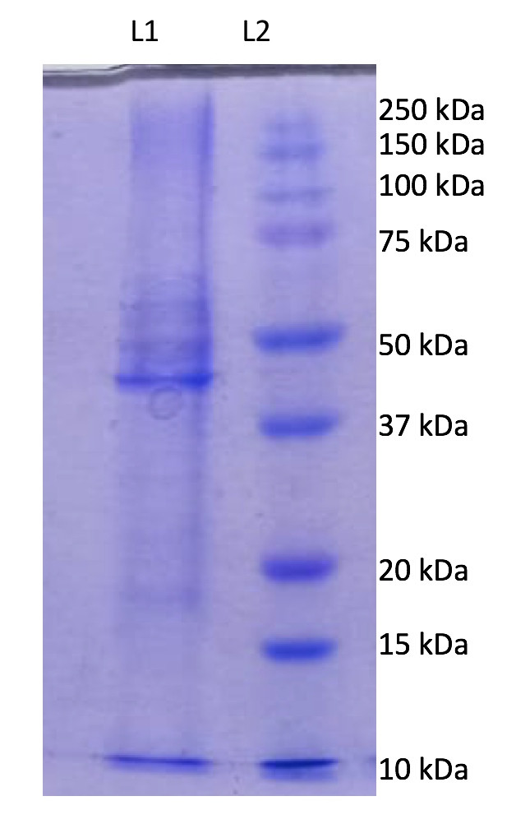

Supplementary figure 3. SDS-PAGE for molecular weight . Determination of alpha-amylase, L1: ammonium sulfate 40-60% enzyme, L2: protein marker

Supplementary figure 4. Absorbance of DEAE Sephadex fractions at 280 nm
Fraction 1-25: Unbound (phosphate buffer ), Fraction 26-45: Bound (phosphate buffer + NaCl 0.1M), Fraction 46-65: Bound (phosphate buffer + NaCl 0.25 M), Fraction 66-85: Bound (phosphate buffer + NaCl 0.5 M)
Fraction 4,5,6,7 as Peak 1, fraction 33,34,35 as Peak 2, Fraction 41 as Peak 3, fraction 44 as Peak 4, fraction 53,54,55 as Peak 5, and fraction 79,80,81 as Peak 6.

Supplementary figure 5. Alpha-amylase activity at peaks from DEAE Sephadex.

