Protein-Protein Interaction Analysis in Parkinson’s Disease using Top-k Skyline Query revealed Alpha synuclein as the most important proteins in Parkinson Disease.

Abstract
Parkinson's Disease is the second most common neurodegenerative disorder that can reduce a patient’s quality of life. The disease may caused by several abnormalities in dopaminergic neurons, such as Reactive Oxygen Species (ROS) imbalance that leading to programmed cell death, proteins misfolding, , and vesicle trafficking. The protein-protein interaction (PPI) analysis has been demonstrated provides a better understanding of candidates of important proteins that might contribute to multifactorial neurodegenerative diseases, in particular Parkinson's diseases. The PPIs can be obtained from experiments and computational predictions. However,the experiment data were often limited in interactome coverage. Therefore, additional computational prediction methods are required to improve more comprehensive PPI. The PPI can be represented into protein-protein networks and can be analyzed based on their centrality measures. Previous study shown that Top-k Skyline Query, a method that using dominance rule-based centrality measures to reveal important proteins candidates in PD. In this study, Top-k Skyline Query is applied to the PPI data that contain experiment and prediction data to find significant protein for Parkinson's disease. The result shown that Alpha Synuclein (SNCA) was the most significant protein and expected to be a potential biomarker candidate for Parkinson's disease.

Keywords: centrality measures; Parkinson’s disease; significant protein, top-k skyline query.

Introduction
Parkinson’s disease (PD) is a disease that can be recognized by several symptomps which may appear such as decrease of motor functions, autonomic dysfunction, hallucinations, and depression (DeMaagd and Philip 2015). As the disease may worsening and cause pneumonia, which can threaten the patient’s life. Furthermore, The disease not only can lower patient’s quality of life, but also may impact their family and society (DeMaagd and Philip 2015). The disease burden was estimated will arise from 4.1 to 4.6 million in 2005 to 8.3 to 9.3 million in 2030 (Dorsey et al. 2007), which may largely impact crowded nations in particular several asian countries such as China, India, and Indonesia. Currently, PD’s has been known as one of most common neurodegenerative disorders with incidence ranging from 16 to 19 per 100,000 people per year (Twelves et al. 2003; Lebouvier et al. 2009; World Health Organization 2004) and expected to overcome cancer as the second most common cause of death in 2040. Furthermore, economical burden of PD direct and indirect cost of treatment reached US$ 1100 million worldwide (Twelves et al. 2003; World Health Organization 2004).

Parkinson disease,
the disease which known as neurons dysfunctions which mostly impact dopaminergic receptors due to several factors such as ROS induced cell death (Dias et al. 2013), protein misfolding (Tan et al. 2009), or changes of proteins that responsible for vesicle trafficking (Clara and Verstreken 2012), Gprotein activations (Odagaki and Toyoshima 2006), and many proteins which should noticed carefully. Proteins interact with each other in carrying out its function and often called as protein-protein interaction (Chang et al. 2016). Protein-protein interaction (PPI) is a good representation for unravelling protein functions, disease-disease and disease-gene associations (Liu et al. 2015; Chang et al. 2016). Therefore, the protein-protein interaction (PPI) analysis to predict significant protein candidates that play a role during the disease progresion, provides a better understanding of multifactorial degenerative diseases including Parkinson’s Disease.

Currently, there are many databases that stores PPI information, such as STRING. STRING database (string-db.org) is a PPI database with the largest number of organism and proteins (Szklarczyk et al. 2018). The database provides two types of interaction, the first one is experimental data obtained from experiments. The second type is prediction interaction data obtained from many methods, including co-expression analysis, detection of shared selective signal across genomes, text-mining and computational transfer knowledge based on gene ontology (Szklarczyk et al. 2018). Experimental proteins interaction information in STRING collected from other databases such as BIND, DIP, GRID, HPRD,IntAct, MINT,and PID.

PPI analysis often limited by interactome coverage, where interactome is a set of PPI that can occur inside a cell (Yu and Fotouhi 2006). The interactome coverage is a ratio between PPI that occurred inside the cell and interactome often stated in percentage (%). Human is predicted to have 650,000 PPI (Stumpf et al. 2008). However, Human Protein Reference Database (HPRD), accessed on December 2019, only has 41,327 PPI information which was only covering 6.3% interactome. To improve interactome coverage, experimental data can be combined with prediction data (Jansen et al. 2002; Liu et al. 2015).

PPI network can be represented as a graph, which proteins as nodes and interactions as edges. As a network, the measure of centrality can be applied for finding the subnetwork, even the importance of a node in a network. So that data transformation can be done from a graph to an object with centrality measures as attributes. However, there were many centrality measures with different characteristics, which leading to debate among the researchers to determine which centrality measures are better (Raman et al. 2014).

In PPI analysis, clustering is frequently used to predict proteins function (Hao et al. 2016). Previously, several studies that focused on centrality measures and machine learning was conducted for revealing PPIs subnetworks that have an important role in certain diseases such as Diabetes (Usman et al. 2019). In this study we try to reach a better understanding to predicts of which proteins that play significant role in PD. Previously, Diansyah et al. performed Skyline Query to predict PPI in PD’s. (Diansyah et al. 2019). In this study, we performed the Skyline Query, an algorithm for finding non-dominated data, along with centrality measure to find significant proteins of Parkinson’s disease.

Skyline Query (SQ) is an algorithm that shows the optimal solution for the problem with various criteria based on dominance rules (Borzsony et al. 2001). This algorithm is developed based on the maxima point problem in mathematics. The result of SQ, namely object, dominates another object only if it has the same score or a better score in all attributes and better at least in one attribute (Borzsony et al. 2001). Commonly, SQ is used to find the optimal object, for instance hotel or restaurant, that meet multiple criteria determined by the user.

In this study, we employed SQ to find the significant proteins that have significant roles in the regulation of Parkinson diseases. The logic of finding the maxima point is in line with the idea of ​​finding significant proteins, which attribute values ​​are not less than that of any other protein and which has at least one attribute which value is greater than that of any other protein. We employed Top-k SQ, one of the variants of SQ, which overcomes the weakness of SQ which is not robust against increasing the number of attributes. We used seven centrality measures, namely degree, betweenness, closeness, eigenvector, eccentricity, radiality and bridging as attributes. To improve interactome coverage, we combined experiment data and prediction data (Jansen et al. 2002; Lu et al. 2005).

Materials and Methods
This research was conducted in four stages. First, we collected the necessary data for this research. Second, we performed data pre-processing, this step included the removal of duplicate data, the deletion of unconnected networks and the transformation of the network into centrality measures. Third, we applied the Top-k Skyline Query to find the significant proteins. Finally, we analyzed the results by conducting a literature review to determine whether the Top-k Skyline Query could be used to find the significant proteins. The flow chart of this research can be seen in Figure 1..
Figure 1 Flow chart of study.

Dataset
We collected dataset from OMIM and STRING database on March 11th 2020. OMIM database was used to find protein associated with PD. Moreover, STRING database was used to find the protein interaction of protein associated with PD. The first step was to find protein associated with PD from OMIM. Query at OMIM was conducted using “+” as a prefix for every word. The prefix was used to get the precise result. Query for this study in OMIM is “+Parkinson +Disease”.
Second step is to find the PPI in STRING for protein that we get from OMIM. For each protein associated with PD, there was a separate interaction file so that we need to combine the data into 1 file. In this study, this process was done by developing a program or scraper in Python 3.7 to automate this step. Pseudo code of data scraping can be seen in Figure 2. Moreover, in this study, we used the combination of experimental dataset and prediction dataset from STRING .
Figure 2 Pseudocode of data scraping

Data pre-process
We used Cytoscape for conducting pre-processing data. There are two main steps in this study include data cleaning and data transformation. We visualized the PPI data to find whether there was any unconnected network. A Network that was not connected to the main (biggest) network would be removed. We assumed that the significant proteins are located in the back bound network, a collection of nodes that has a high number of members and a high density. Thus the unconnected networks to the back bound were removed. Next, we omitted the duplicate interaction data. The last step for this part was to transform the data from the protein network into centrality measures. This process was done by using CentiScaPe 2.2 in the Cytoscape application (Scardoni et al. 2009; Scardoni and Laudanna 2012). After data transformation completed, proteins with seven centrality measures were exported into a comma separated value file (csv). The output for this process was processed in further steps.

Centrality Measures
Centrality measures are a unit of measure to measure the important node in a network interaction and have been widely used for analysis in biological networks. Currently, there are many centrality measures that can be used to measure the importance of a node. In this study, there were seven values of centrality measures used, namely degree centrality, betweenness centrality, closeness centrality, eigenvector centrality, radiality, eccentricity and bridging centrality.
Degree centrality is the simple calculation of centrality. Degree centrality is obtained by counting the number of edges connected to the node. The probability of a protein becoming the center of regulation is directly proportional to the greater the degree of centrality (Scardoni and Laudanna 2012) .
Betweenness centrality can be obtained by calculating the shortest path, by adding the shortest path through the node divided by the total number of shortest paths in the graph. The greater the betweenness centrality value, the more likely the node is often bypassed for communication between proteins so that the more relevant it is to become a regulatory regulatory protein (Scardoni and Laudanna 2012)
The calculation for closeness centrality is based on the number of shortest paths from one node to another node. The value of the number of shortest paths is used as a divisor of 1. Thus, the greater the value of closeness centrality, the more central the position of the protein is, so that it can become a regulatory protein for other proteins in the network (Scardoni and Laudanna 2012)
Eigenvector centrality is calculated based on the concept that if a node-i is connected to another node with a high score, then node i will also have a high score (Scardoni et al. 2009). The initial step in finding eigenvector centrality is to find the largest eigenvalue first, then using the largest eigenvalue, the eigenvector matrix will be obtained. The eigenvector centrality value was obtained by dividing the eigenvector matrix of a node by the determinant value of the eigenvector matrix. The greater the eigenvector centrality value indicates if the node interacts with other important proteins so that it can become a regulatory center for other important proteins (Scardoni et al. 2009)
Radiality is based on the shortest path from one node to another node in the network. Before adding up, the shortest path value is used to reduce (∆_{G} + 1) where ∆_{G} is the largest shortest path, after which it is added. The higher the radiality value of a node is functionally relevant to other nodes. The high values of radiality, eccentricity and closeness centrality indicate the consistency of a node to become the center of the network (Scardoni and Laudanna 2012)
Eccentricity is calculated by finding the largest, the shortest path from one node to another node. In biological terminology according to Scardoni (2012) (Scardoni and Laudanna 2012), eccentricity can indicate the convenience a protein reached by other proteins in the network, so that the greater the eccentricity value indicates that it is easy to influence other proteins in the network.
Bridging centrality is the result of the development of betweenness centrality. The bridging centrality value is obtained from the multiplication of the betweenness centrality and the bridging coefficient. According to Scardoni 2009 (Scardoni et al. 2009) a node with a high value of bridging centrality indicates if the node connects a node with a high degree, so that the node can connect between clusters in the interaction network.
All values of centrality measures that have been described will be used as attributes for each protein. Furthermore, this data will be used for the next process to select interesting objects based on seven criteria of centrality measures by using Skyline Query.

Skyline Query
Skyline Query is a method to find the non dominated object, this algorithm chooses an interesting object from a dataset. An object will later categorize as an interesting object only if it is not dominated by another object, at least in one attribute (Borzsony et al. 2001). Object A is dominated by object B if object A didn’t have a better score in every attributes compared to object B. The rule in Skyline Query is called dominance rule. Dominance rule a domination rule of an object to another object.
Table 1 Dataset example with two centrality measures.

In this study, for every centrality measures, the higher score in centrality measures means a higher chance of the protein to be an important protein. So, the dominance rule for Table 1 is the highest score in degree centrality and closeness centrality means better. If we implement Skyline Query in Table 1, the results will be object A and C. Object B has a same score with object A in degree centrality, however, it has a lower score in closeness centrality that makes object A dominates object B. For object D, it’s dominated by A because it has the lowest score in every attributes compared to object A. Since there were no other object that can dominates object A and C, object A and C became the skyline object for Table 1.
However, the SQ has weakness involve attributes used, more attributes use cause the skyline objects to increase so that the result is not relevant again (Kontaki et al. 2008). This study used a developed SQ called Top-k Skyline Query. Top-k SQ rank skyline results to find the most important data in skyline objects. The ranking is done by searched the most dominant data. This method finds data that dominates other data and the most dominant data will be in the top result. This study used centrality measure as attributes along with Top-k Skyline Query for analysing PPI.
Based on the concept of Top-k Skyline Query, an protein is a protein that is not dominated by another protein with the order by how many proteins it dominated. The most important result of Top-k Skyline Query is a candidate for important proteins related to disease were later further cross checked . Since there are many centrality measures, this study only used basic centrality measures with the addition of other two centrality measure. The basic centrality measures in the graph theory are degree, betweenness, closeness, eigenvector and eccentricity (Sharma et al. 2016). Beside the basic centrality measures, in this study, we used radiality and bridging centrality.
In this study, we used Top-k Skyline Query to find an important protein of PD using 7 centrality measures (degree, betweenness, closeness, eigenvector, eccentricity, radiality and bridging). There are 2 interaction data types based on their resources, experiment data and experiment+prediction data. We used experimental data to determine whether interactome coverage in PD good enough to do a PPI analysis. This study used Skyline Query, an algorithm for finding non-dominated data, along with centrality measure to find important proteins of Parkinson disease.

Top-k Skyline Query
Top-k Representative Skyline Query (Top-k RSP) is Top-k SQ algorithm used to maximize data dominated by k skyline object (Lin et al. 2007). The complexity for Top-k RSP is O(kn²+kn) where n in the total data number. This study chose a basic Top-k Skyline Query because the data itself is quite small and the process done only once. Pseudocode for Top-k RSP can be seen in Figure 3.
Figure 3 Top-k RSP pseudocode.

Using Skyline Query, skyline objects from Table 1 are object A and object C. Object D dominated by object A because A have better score in all dimensions compared to Object D. Object B is dominated by Object A because it has a lower score in closeness centrality although it has the same score in degree centrality. Object C dominates object B because it has the same score in closeness with a better score in degree. Object A and object C is incomparable because A better for closeness score and C better at degree centrality. There were no other data that can dominates object A and C, so object A and C is the skyline object from Table 1.
Figure 4 Visualization for Top-k Skyline Query.

Top-k Skyline Query rank the skyline objects by how much data were dominates by the skyline objects. As we can see from Figure 3, object A dominates 2 data (D and B) meanwhile object C only dominates 1 data (B). Object A is the highest rank for Top-k Skyline Query because it dominates the most. Top-1 Skyline Query for Table 1 is object A and Top-2 Skyline Query for Table 1 are object A and C.

Data Analysis
The objective of this step is to analyze the result of Top-k Skyline Query. The proteins relations to PD’s was cross checked with experimental data, in particular the highest rank skyline object we get from Top-k Skyline Query. There would be further analysis to define whether experiment and experiment+prediction data can be used in the PD PPI analysis. Our expection is to be able to see the effect of interactome coverage.

Results and discussion
There were 271 proteins data related to PD obtained from OMIM, but only 252 proteins have interaction information in STRING. Proteins associated with PD which are not found in STRING were excluded from this study. 252 proteins interaction file was merged into one file for each interaction source. The results from STRING after interaction file merge can be seen in Table 2.
Table 2 Results from STRING after merged.

From Table 2, there are 1553 proteins with 4868 interaction data with interaction source only from experiment, meanwhile there are 1848 proteins with interactions as much as 8577 for interaction sources from experiment and prediction. Visualization of experimental data can be seen in Figure 5. We can see in Figure there are many unconnected networks. Networks that are not connected to the main graph will be deleted. After the deletion of unconnected graph, data duplicate will be removed as well. Visualization for experiment data after data cleaning can be seen in Figure 5. In Figure 5 and Figure 6, the red nodes represent proteins associated with PD that we obtained from OMIM. Meanwhile the green nodes represent protein without direct association with PD (interaction protein from STRING).
Figure 5 Experiment data visualization before data cleaning.

Figure 6 Experiment data visualization after data cleaning.

However, deletion in duplicate data and unconnected networks will make the number of protein and interaction decreased. The number of protein and interaction before the protein networks transformed into centrality measures can be seen in Table 3. From Table 3 we can see that there are only 1,269 proteins and 4,198 interactions for experiment data interaction source. There are 1 682 proteins with 7 894 interactions left for the experiment+prediction data source.
Table 3 Results from STRING after data cleaning.

After data cleaning, PPI networks will be transformed into centrality measures. CentiScaPe 2.2 used for this process. There are 2 default output such as name and shared name, since both of them contain the same protein name, shared name deleted. The result from transformation data are proteins with 7 centrality measures as attributes with 1 protein name as the attribute (name, degree centrality, betweenness centrality, closeness centrality, eccentricity, eigenvector centrality, bridging centrality, and radiality). The data transformed, then exported into comma separated value (CSV) as the input for Top-k Skyline Query.

Data with interaction source experiment is processed first. The maximum k for Top-k Skyline Query is 21 since there are only 23 skyline objects as a result of Skyline Query. Protein included in the Top-21 Skyline Query were SNCA (Alpha-synuclein), PARK2 (parkin RBR E3 ubiquitin protein ligase), TRAF2 (TNF Receptor Associated Factor 2), FN1 (Fibronectin 1), HSPA8 (Heat Shock Protein Family A (Hsp70) Member 8), GPR37 (G-Protein Coupled Receptor 37), TRAPPC1 (Trafficking Protein Particle Complex Subunit 1), LRRFIP1 (LRR binding FLII interacting protein 1), TH (Tyrosine Hydroxylase), GLB1 (Galactosidase beta 1), CTSA (Cathepsin A), PTPRC (Protein Tyrosine Phosphatase Receptor Type C), GSR (Glutathione-Disulfide Reductase), TNF (Tumor Necrosis Factor), C4BPA (Complement Component 4 Binding Protein Alpha), PRNP (prion protein), TP53 (Tumor Protein 53), MAPK8 (Mitogen-Activated Protein Kinase 8), SOD1 (superoxide dismutase 1), HSP90AA1 (Heat Shock Protein 90 Alpha Family Class A Member 1) and GNAI2 (G Protein Subunit Alpha I2). The genes biologically and experimental relation to PD’s shown in Table 4 below.

However, the Top-1 Skyline Query is SNCA since SNCA dominates most data. The result for Top-3 Skyline Query for experimental data can be seen in Table 5. SNCA is the important protein because it dominates another protein the most (1217 proteins). Meanwhile, the other protein dominates only vary from 0-14 proteins.
Table 5 Result of Top-3 Skyline Query for experiment data.

The next process used data interaction sources were experiment and prediction. Maximum k for Top-k Skyline Query for experiment+prediction data is 10 since there were only 10 skyline objects. The results were SNCA, TP53, KNG1 (Kininogen-1), PRDX5 (Peroxiredoxin-5), GTPBP4 (GTP Binding Protein 4), PABPC1 (Polyadenylate-binding protein 1), ANXA1 (Annexin A1), AKT1 (RAC-alpha serine/threonine-protein kinase), PARK2 and APP (Amyloid Beta Precursor Protein). Aside to SNCA, TP53, and PARK2 relations to Parkinson disease was shown in Table 6. In this table, we added further information of other genes that not mentioned in previous table.

Among 10 skyline objects the most important protein is SNCA. SNCA is the result of a Top-1 Skyline Query, it means that SNCA dominates another protein the most. Result for Top-3 Skyline Query with experiment+prediction data as the interaction source can be seen in Table 7. Based on Table 5, SNCA dominates 1663 another protein so that it becomes the most important skyline object based on Top-k Skyline Query.
Table 7 Result of Top-3 Skyline Query for experiment+prediction data.

The execution time for the Python program are 0.2532 seconds for experimental data and 0.1508 seconds for experiment+prediction interaction data. Since both of the data types return the same protein that is SNCA as the important protein, there is only one candidate for important protein. From among those proteins, at least five proteins were foundly related to the Parkinson disease (PD). One of the most important proteins was Alpha synuclein. Biologically, alpha synuclein was responsible was located in presynaptic terminals and critical to regulate neurotransmiter release and vesicle trafficking. (Mata et al. 2010) in Alpha synuclein was known was commonly detected in Lewy bodies, which known as pathologic features of parkinson disease. (Siddiqui et al. 2016)
Besides alpha synuclein, some several proteins important in disease progressions For instance, Parkin2, controls program cell death and apoptosis.(5) Park2 germline mutations leading cause neurons dysfunctions (6). PARK2 mutations caused an imbalance of programmed cell death and increase apoptosis.(Konovalova et al. 2015: 2) In GPCR classes, the gene : GRP37 was highly expressed in neuronal progenitor cells, in particular Wnt-dependent neurogenesis. (Berger et al. 2017) GNAI expression was increased during stress and plays an important role to inhibit adenylate cyclase, to modulate cAMP mediated responses beta adrenergic stimuli.(Tsolakidou et al. 2010) Lastly, Tyrosine Hydroxilase was an enzyme in dopamine biosynthesis, and since the Parkinson disease was related to dopaminergic neurons, TH expression was foundly related to occurence of PD. (Chen et al. 2017)

SNCA is the first gene linked to PD, SNCA itself being thought to have an essential role in synaptic transmission (Mata et al. 2010). This protein has been given an identification name to show that SNCA linked to PD and plays an important role, the identification name is PARK1 (Klein and Westenberger 2012). SNCA considered involved in early onset of familial Parkinson’s disease (FPD) as a major causative gene, it has been identified 5 mutations point in SNCA that cause autosomal dominant Parkinson’s (Siddiqui et al. 2016). Study in Diansyah et al.(Diansyah et al. 2019) found 14 proteins as the result of a Skyline Query in PD, SNCA is one of the results. However, it’s still lacking the information about the most important protein to PD. This study shows that SNCA is the most important protein for PD.

Experiment and experiment+prediction data give the same result that has been proven its significance. It shows that experimental data can be used in the PPI analysis for PD using this method. Also, it can be an indication that interactome coverage in PD is good enough for PPI analysis since experiment data give an important protein as the result of this method. However, we need to do another research to prove that interactome coverage in PD was sufficient.

Conclusions
Based on the result of this study, it can be concluded that Top-k Skyline Query can be used to find important proteins in Parkinson’s disease. Experiment and experiment+prediction interaction data sources for Parkinson’s disease can be used in PPI Analysis using this method. The important protein for Parkinson’s disease based on this study is SNCA that has been proven to have a significant role in PD.

Acknowledgments
This research is supported by Ministry of Research, Technology and Higher Education, Indonesia, under Master’s Thesis Research Grant from Directorate of Higher Education, Indonesia, 2020. We thank Aryo Tedjo from Department of Medical Chemistry, Faculty of Medicine Universitas Indonesia and Dimas Ramadhian from Human Cancer Research Center, Indonesia Medical Education and Research Institute, Faculty of Medicine Universitas Indonesia for added proteins information.

Competing Interests

The authors declare there is no conflict of interest.

References
Berger B, Pérez-Acebrón S, Herbst J, Koch S, Niehrs C. 2017. Parkinson’s disease‐associated receptor GPR37 is an ER chaperone for LRP6. EMBO Rep. 18:e201643585. doi:10.15252/embr.201643585.
Borzsony S, Kossmann D, Stocker K. 2001. The Skyline Operator.
Bottero V, Santiago JA, Potashkin JA. 2018. PTPRC Expression in Blood is Downregulated in Parkinson’s and Progressive Supranuclear Palsy Disorders. J Park Dis. 8(4):529–537. doi:10.3233/JPD-181391.
Chang J-W, Zhou Y-Q, Ul Qamar MT, Chen L-L, Ding Y-D. 2016. Prediction of Protein-Protein Interactions by Evidence Combining Methods. Int J Mol Sci. 17(11). doi:10.3390/ijms17111946.
Chen Y, Lian Y, Ma Y, Wu C, Zheng Y, Xie N. 2017. The expression and significance of tyrosine hydroxylase in the brain tissue of Parkinson’s disease rats. Exp Ther Med. 14(5):4813–4816. doi:10.3892/etm.2017.5124.
Chi J, Xie Q, Jia J, Liu X, Sun J, Deng Y, Yi L. 2018. Integrated Analysis and Identification of Novel Biomarkers in Parkinson’s Disease. Front Aging Neurosci. 10:178. doi:10.3389/fnagi.2018.00178.
Chung J-Y, Park HR, Lee S-J, Lee S-H, Kim JS, Jung Y-S, Hwang SH, Ha N-C, Seol W-G, Lee J, et al. 2013. Elevated TRAF2/6 expression in Parkinson’s disease is caused by the loss of Parkin E3 ligase activity. Lab Investig J Tech Methods Pathol. 93(6):663–676. doi:10.1038/labinvest.2013.60.
Clara F, Verstreken P. 2012. Synaptic vesicle trafficking and Parkinson’s disease. Dev Neurobiol. 72:134–44. doi:10.1002/dneu.20916.
DeMaagd G, Philip A. 2015. Parkinson’s Disease and Its Management: Part 1: Disease Entity, Risk Factors, Pathophysiology, Clinical Presentation, and Diagnosis. P T Peer-Rev J Formul Manag. 40(8):504–532.
Diansyah R, Kusuma W, Annisa A. 2019. Analysis of Protein-Protein Interaction Using Skyline Query on Parkinson Disease.
Dias V, Junn E, Mouradian MM. 2013. The role of oxidative stress in Parkinson’s disease. J Park Dis. 3(4):461–491. doi:10.3233/JPD-130230.
Dorsey ER, Constantinescu R, Thompson JP, Biglan KM, Holloway RG, Kieburtz K, Marshall FJ, Ravina BM, Schifitto G, Siderowf A, et al. 2007. Projected number of people with Parkinson disease in the most populous nations, 2005 through 2030. Neurology. 68(5):384–386. doi:10.1212/01.wnl.0000247740.47667.03.
Hao T, Peng W, Wang Q, Wang B, Sun J. 2016. Reconstruction and Application of Protein-Protein Interaction Network. Int J Mol Sci. 17(6). doi:10.3390/ijms17060907.
Jansen R, Lan N, Qian J, Gerstein M. 2002. Integration of genomic datasets to predict protein complexes in yeast. J Struct Funct Genomics. 2(2):71–81. doi:10.1023/a:1020495201615.
Klein C, Westenberger A. 2012. Genetics of Parkinson’s disease. Cold Spring Harb Perspect Med. 2(1):a008888. doi:10.1101/cshperspect.a008888.
Konovalova EV, Lopacheva OM, Grivennikov IA, Lebedeva OS, Dashinimaev EB, Khaspekov LG, Fedotova EY, Illarioshkin SN. 2015. Mutations in the Parkinson’s Disease-Associated PARK2 Gene Are Accompanied by Imbalance in Programmed Cell Death Systems. Acta Naturae. 7(4):146–149.
Kontaki M, Papadopoulos A, Manolopoulos Y. 2008. Y.: Continuous k-Dominant Skyline Computation on Multidimensional Data Streams.
Lebouvier T, Chaumette T, Paillusson S, Duyckaerts C, Bruley des Varannes S, Neunlist M, Derkinderen P. 2009. The second brain and Parkinson’s disease. Eur J Neurosci. 30(5):735–741. doi:10.1111/j.1460-9568.2009.06873.x.
Lin X, Yuan Y, Zhang Q, Zhang Y. 2007. Selecting Stars: The k Most Representative Skyline Operator. In: 2007 IEEE 23rd International Conference on Data Engineering. p. 86–95.
Liu W, Wu A, Pellegrini M, Wang X. 2015. Integrative analysis of human protein, function and disease networks. Sci Rep. 5:14344. doi:10.1038/srep14344.
Loeffler DA, Klaver AC, Coffey MP, Aasly JO, LeWitt PA. 2016. Age-Related Decrease in Heat Shock 70-kDa Protein 8 in Cerebrospinal Fluid Is Associated with Increased Oxidative Stress. Front Aging Neurosci. 8:178. doi:10.3389/fnagi.2016.00178.
Markaki I, Bergström S, Tsitsi P, Remnestål J, Månberg A, Hertz E, Paslawski W, Sorjonen K, Uhlén M, Mangone G, et al. 2020. Cerebrospinal Fluid Levels of Kininogen-1 Indicate Early Cognitive Impairment in Parkinson’s Disease. Mov Disord. 35(11):2101–2106. doi:10.1002/mds.28192.
Mata IF, Shi M, Agarwal P, Chung KA, Edwards KL, Factor SA, Galasko DR, Ginghina C, Griffith A, Higgins DS, et al. 2010. SNCA Variant Associated With Parkinson Disease and Plasma α-Synuclein Level. Arch Neurol. 67(11):1350–1356. doi:10.1001/archneurol.2010.279.
Odagaki Y, Toyoshima R. 2006. Dopamine D2 receptor-mediated G protein activation assessed by agonist-stimulated [35S]guanosine 5’-O-(gamma-thiotriphosphate) binding in rat striatal membranes. Prog Neuropsychopharmacol Biol Psychiatry. 30(7):1304–1312. doi:10.1016/j.pnpbp.2006.05.007.
Scardoni G, Laudanna C. 2012. Centralities Based Analysis of Complex Networks.
Scardoni G, Petterlini M, Laudanna C. 2009. Analyzing biological network parameters with CentiScaPe. Bioinforma Oxf Engl. 25:2857–9. doi:10.1093/bioinformatics/btp517.
Sharma P, Bhattacharyya DK, Kalita JK. 2016. Centrality analysis in PPI networks. In: 2016 International Conference on Accessibility to Digital World (ICADW). p. 135–140.
Siddiqui IJ, Pervaiz N, Abbasi AA. 2016. The Parkinson Disease gene SNCA: Evolutionary and structural insights with pathological implication. Sci Rep. 6:24475–24475. doi:10.1038/srep24475.
Szklarczyk D, Gable A, Lyon D, Junge A, Wyder S, Huerta-Cepas J, Simonovic M, Doncheva N, Morris J, Bork P, et al. 2018. STRING v11: protein-protein association networks with increased coverage, supporting functional discovery in genome-wide experimental datasets. Nucleic Acids Res. 47. doi:10.1093/nar/gky1131.
Szybińska A, Leśniak W. 2017. P53 Dysfunction in Neurodegenerative Diseases - The Cause or Effect of Pathological Changes? Aging Dis. 8(4):506–518. doi:10.14336/AD.2016.1120.
Tan JMM, Wong ESP, Lim K-L. 2009. Protein misfolding and aggregation in Parkinson’s disease. Antioxid Redox Signal. 11(9):2119–2134. doi:10.1089/ars.2009.2490.
Trist BG, Hare DJ, Double KL. 2018. A Proposed Mechanism for Neurodegeneration in Movement Disorders Characterized by Metal Dyshomeostasis and Oxidative Stress. Cell Chem Biol. 25(7):807–816. doi:10.1016/j.chembiol.2018.05.004.
Tsolakidou A, Czibere L, Pütz B, Trümbach D, Panhuysen M, Deussing JM, Wurst W, Sillaber I, Landgraf R, Holsboer F, et al. 2010. Gene expression profiling in the stress control brain region hypothalamic paraventricular nucleus reveals a novel gene network including Amyloid beta Precursor Protein. BMC Genomics. 11(1):546. doi:10.1186/1471-2164-11-546.
Twelves D, Perkins KSM, Counsell C. 2003. Systematic review of incidence studies of Parkinson’s disease. Mov Disord Off J Mov Disord Soc. 18(1):19–31. doi:10.1002/mds.10305.
Usman M, Kusuma W, Afendi F, Heryanto R. 2019. Identification of Significant Proteins Associated with Diabetes Mellitus Using Network Analysis of Protein-Protein Interactions. Comput Eng Appl J. 8:41–52. doi:10.18495/comengapp.v8i1.283.
Veeriah S, Taylor BS, Meng S, Fang F, Yilmaz E, Vivanco I, Janakiraman M, Schultz N, Hanrahan AJ, Pao W, et al. 2010. Somatic mutations of the Parkinson’s disease–associated gene PARK2 in glioblastoma and other human malignancies. Nat Genet. 42(1):77–82. doi:10.1038/ng.491.
World Health Organization. 2004. Atlas : country resources for neurological disorders 2004 : results of a collaborative study of the World Health Organization and the World Federation of Neurology. https://apps.who.int/iris/handle/10665/43075.
Xiromerisiou G, Hadjigeorgiou GM, Papadimitriou A, Katsarogiannis E, Gourbali V, Singleton AB. 2008. Association between AKT1 gene and Parkinson’s disease: a protective haplotype. Neurosci Lett. 436(2):232–234. doi:10.1016/j.neulet.2008.03.026.

Figures
Figure 1
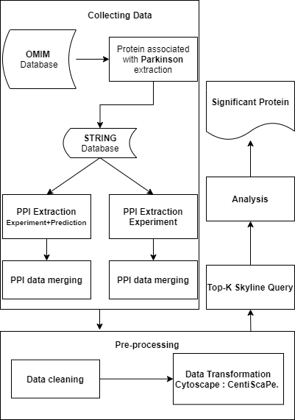

Figure 2
Request Stringdb API (protein, string method)
Get interacction of proteins
Sort node according to alphabet
Remove redudant node //remove redudant protein
Remove duplicate interaction
Sort interaction
Remove duplicate
Get PPI

Figure 3
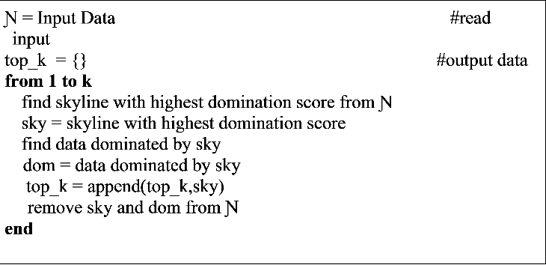

Figure 4
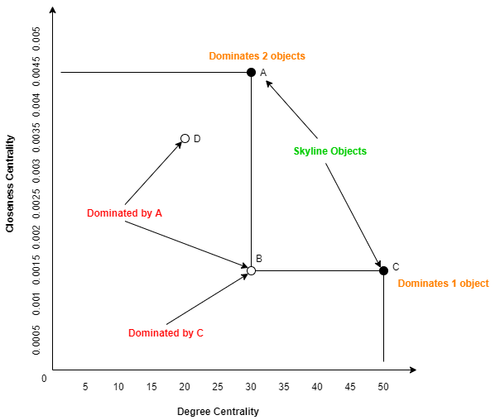

Figure 5
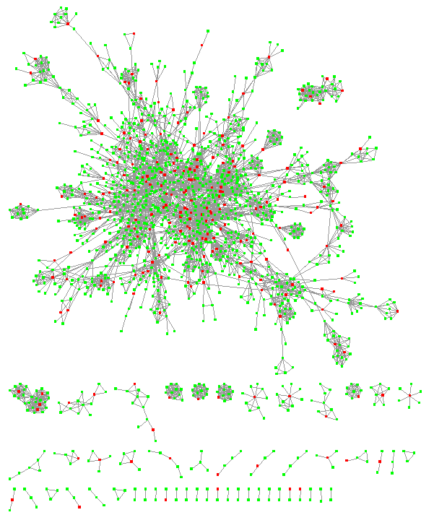

Figure 6
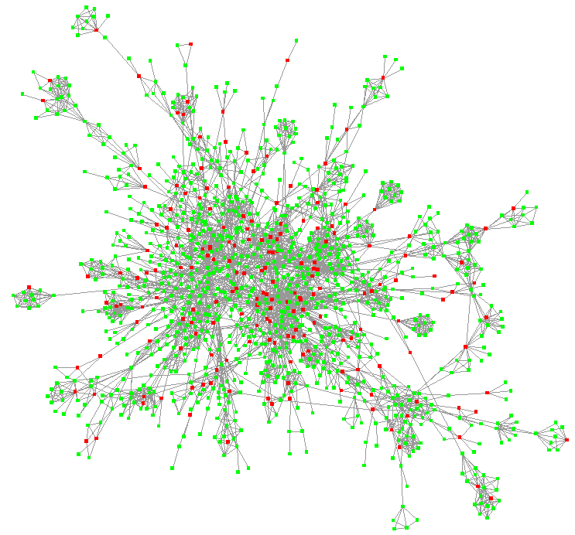

Tables
Table 1 Dataset example with two centrality measures.
Object | Degree | Closeness
A | 30 | 0.0045
B | 30 | 0.0015
C | 50 | 0.0015
D | 20 | 0.0035

Table 2 Results from STRING after merged.
Interaction Source(s) | Number of Proteins | Number of Interaction
Experiment | 1 553 | 4 868
Experiment+Prediction | 1 848 | 8 577

Table 3 Results from STRING after data cleaning.
Interaction Source(s) | Number of Proteins | Number of Interaction
Experiment | 1 269 | 4 198
Experiment+Prediction | 1 682 | 7 894

Table 4. List of Proteins that related to Parkinson Disease’s.
Proteins |  |  | Associations to Parkinson Disease (PD)
GPR37 |  |  | GRP37 was highly expressed in neuronal progenitor cells, in particular Wnt-dependent neurogenesis.(Berger et al. 2017: 6)
GNAI2 |  |  | GNAI expression was increase during stress and plays important role to inhibits adenylate cyclase, to modulate cAMP mediated responsed beta adrenergic stimuli.(Tsolakidou et al. 2010)
SNCA |  |  | Alpha synuclein was responsible was located in presynaptic terminals and critical to regulates neurotramsiter release and vesicle trafficking.(Mata et al. 2010) in Alpha synuclein was known was commonly detected in Lewy bodies, which known as pathologic features of parkinson disease.(Siddiqui et al. 2016)
PARK2 |  |  | Parkin, controls program cell death and apotptosis.(Konovalova et al. 2015) Park2 germline mutations leading to cause neurons dysnfunctions (Veeriah et al. 2010). PARK2 mutations caused imbalance of program cell death and increase apoptosis. (Konovalova et al. 2015)
TH |  |  | Tyrosine Hydroxilase was an enzymes in dopamine biosynthesis, and since parkinson disease was related to dopaminergic neurons, TH expression was foundly related to occurence of PD.(Chen et al. 2017)
HSPA8 |  |  | HSPA8 in was foundly decreased to during aging and may postulated to PD’s, which may affect autophagy process due to response of ER stress by protein unfolding.(Loeffler et al. 2016)
TRAF2 |  |  | Overexpression of TRAF2/6 may induced by chronic inflammations and hypothized to be reason of occurence PD. (Chung et al. 2013)
Tp53 |  |  | TP53 is one of the disease hallmark(Szybińska and Leśniak 2017),
SoD1 |  |  | SOD1 proteinopathy known as neurotoxic superoxide dismutase 1 (SOD1) : SOD1-associated familial amyotrophic lateral  sclerosis (fALS) is recapitulated in idiopathic Parkinson disease (PD) (Trist et al. 2018)
TRAPPC1 |  |  | Not founded.
GLB1 |  |  | Not founded.
HSP90AA1 |  |  | Not founded.
FN1 |  |  | Not founded
MAPK8 |  |  | MAPK8 was downregulated and possible biomarker of PD’s. (Chi et al. 2018)
C4BPA |  |  | Not founded
PTPRC |  |  | PTPRC expression in blood was downregulated in PD. (Bottero et al. 2018)
CTSA |  |  | Not founded.
PRNP |  |  | Not founded.
LRRFIP1 |  |  | Not founded.

Table 5 Result of Top-3 Skyline Query for experiment data.
Protein | Dominates
SNCA | 1 217
PARK2 | 14
TRAF2 | 11

Table 6. List of Proteins that related to Parkinson Disease.
Proteins |  | Associations to Parkinson Disease (PD)
KNG1 |  | Level of KNG1 in cerebbrospinal was potential marker of cognitive impairment in PD.(Markaki et al. 2020)
PRDX5 |  | Not founded
GTPBP4 |  | Not founded
PABPC1 |  | Not founded
ANXA1 |  | Not founded.
AKT1 |  | AKT shown involved in protected against PD.(Xiromerisiou et al. 2008)
APP |  | Not founded.

Table 7 Result of Top-3 Skyline Query for experiment+prediction data.
Protein | Dominates
SNCA | 1 663
TP53 | 6
KNG1 | 3

