Figure 1: S. subarctica T7b’s growth as well as desulfurization activity in MSSF medium and n-tetradecane as a model oil containing the single substrate of DBT and its derivatives (100 mg/L), incubated at 27 ºC, and shaken at 273 rpm for 5 d.

Figure 2: Time course of DBT biodesulfurization and 2-HBP production by growing S. subarctica T7b cells in MSSF-TD medium.

Figure 3: Biodesulfurization of DBT and 4,6-dibutyl DBT (1:1) mixture in MSSF-TD medium by growing S. subarctica T7b cells.

Figure 4: Biodesulfurization of a DBT, 4-hexyl DBT, and 4,6-dibutyl DBT mixture by growing S. subarctica T7b cells in MSSF-TD medium. The data above represents the duplicate sample analyses mean results and the average relative standard deviation for all data points did not surpass 5%.

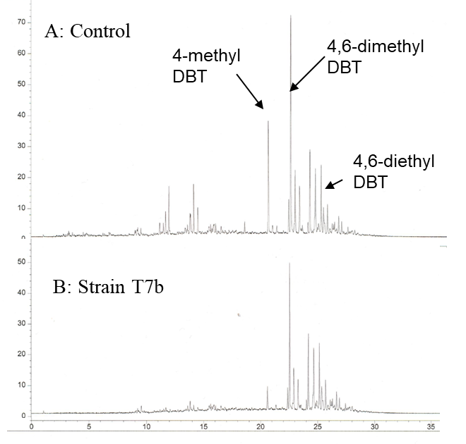
Figure 5: LGO GC-AED pattern for the degradation of an organosulfur compound mixture in light gas oil by growing S. subarctica T7b cells. A. Commercially hydrodesulfurized LGO (S=280 mg/L). B. After desulfurization by S. subarctica T7b, (S=164 mg/L). The strain was cultivated aerobically in an MSSF-LGO medium (5 mL MSSF medium containing 1 mL of LGO) at 27 ºC with shaking at 273 rpm for 132 h (5.5 d).

