Table 1
No. | Strains | Access. No. | Length (amino acids)
1 | B. safensis strain CFA06 | KEP29487.1 | 616
2 | B. safensis strain JG-B5T | RAU57979.1 | 616
3 | B. safensis strain RIT372 | KIZ56126.1 | 616
4 | B. safensis | WP_041109021.1 | 616
5 | B. safensis strain LK12 | KMN80921.1 | 616
6 | B. safensis strain LK32 | KML49660.1 | 616
7 | B. safensis strain LK21 | KML10526.1 | 616
8 | B. safensis strain Ingolstadt | OYN66870.1 | 616
9 | B. safensis strain JPL_MERTA8-2 | KKD42423.1 | 616
10 | B. safensis strain SCAL1 | KMK71141.1 | 616

Table 2
No. | Program | Function | Source
1 | BioEdit ver. 7.2.5 (Hall, 1999) | Editing of biological sequences and alignment. | www.mbio.ncsu.edu/BioEdit/bioedit.html
2 | BLAST (Altschul et al., 1990) | Comparing nucleotide or protein sequences to sequence databases and calculating the statistical significance of matches. | https://blast.ncbi.nlm.nih.gov/Blast.cgi
3 | ClustalX ver. 2.1 (Larkin et al., 2007) | Performing multiple sequence alignment (MSA) to find conserved/unconserved regions in the alignment. | www.clustal.org
4 | Clustal Omega (Sievers et al., 2011) | Performing MSA. Numbers indicating positions of bases/residues in the alignment are shown in this version. | www.ebi.ac.uk/Tools/msa/clustalo/
5 | MEGA ver. 7.0.18 (Kumar et al., 2016) | Inferring phylogenetic trees. | www.megasoftware.net
6 | SnapGene ver. 2.3.2 | Planning, visualizing, and simulating restriction-ligation cloning, PCR, and gel electrophoresis. | SnapGene software (from GSL Biotech; available at snapgene.com)
7 | GC Content Calculator (McGowan, 2015) | Calculating %GC of a given nucleotide sequence. | www.jamiemcg. github.io/bioinf/index.html
8 | EMBOSS Transeq (Rice et al., 2000) | Translating nucleotide sequences to their corresponding peptide sequences. | www.ebi.ac.uk/Tools/st/emboss_ transeq/
9 | InterProScan (Zdobnov and Apweiler, 2001) | Scanning a sequence for matches against the InterPro protein signature databases. | www.ebi.ac.uk/interpro/search/sequence-search
10 | ScanProsite (De Castro et al., 2006) | Scanning protein sequences for the occurrence of patterns, profiles and motifs against the PROSITE database. | www.prosite.expasy.org/scanprosite/
11 | Compute pI/Mw (Gasteiger et al., 2005) | Predicting protein isoelectric point (pI) and molecular weight (MW). | web.expasy.org/compute_pi/
12 | ProtParam (Gasteiger et al., 2005) | Computing amino acid composition. | web.expasy.org/protparam/
13 | MyDomains (Hulo et al., 2007) | Creating custom domain figures. | www.prosite.expasy.org/mydomains/
14 | PredictProtein (Yachdav et al., 2014) | Predicting protein secondary structures composition. | www.predictprotein.org
15 | Sequence Annotated by Structure (SAS) (Milburn et al., 1998) | Predicting secondary structures positions in a given protein sequence. | www.ebi.ac.uk/thornton-srv/databases/sas/
16 | SWISS-MODEL (Waterhouse et al., 2018) | Modeling of 3D protein structures based on homology. | www.swissmodel.expasy.org/interactive

Table 3
Clear zones around the bacterial colonies in Congo-red dyed media | 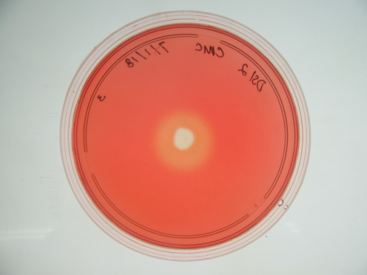 |  |  | 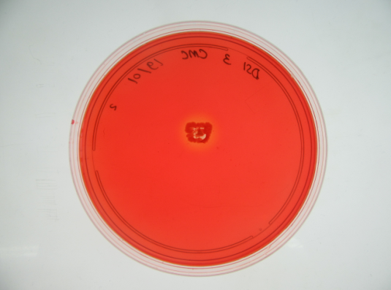 |  |  | 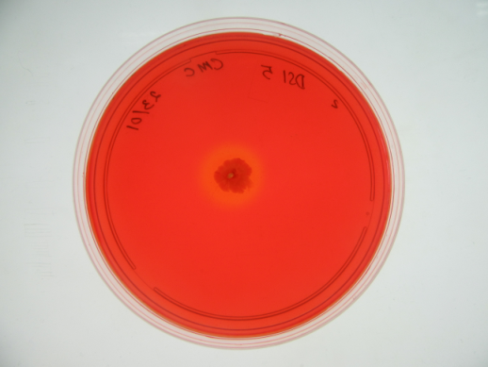
Isolate | DSI 2 |  |  | DSI 3 |  |  | DSI 5
Repetition | I | II | III | I | II | III | I | II | III
Clear zone diameter (A) (cm) | 1.6 | 1.7 | 1.9 | 0.9 | 0.95 | 0.9 | 0.9 | 1.4 | 0.8
Colony diameter (B) (cm) | 0.7 | 0.75 | 0.7 | 0.9 | 0.8 | 0.8 | 0.8 | 0.8 | 0.75
Ratio A/B | 2.29 | 2.27 | 2.71 | 1.00 | 1.19 | 1.13 | 1.13 | 1.75 | 1.07
Mean | 2.42 |  |  | 1.11 |  |  | 1.32

Table 4
DSI 2 | B. safensis SCAL1 | Bacillus sp.  WP8 | B. safensis U17-1 | B. safensis U41 | B. pumilus BY-1 | B. xiamenensis VV3
 | Nucleotide Sequence
 | 99.3% | 99.19% | 97.73% | 97.73% | 95.30% | 87.26%
 | Amino Acid Sequence
 | 99.35% | 99.2% | 98.2% | 98.2% | 97.2% | 91.4%

Amino acid sequences of endoglucanase from: B. safensis SCAL1 (KMK71141.1); Bacillus sp. WP8 (WP_039178590.1); B. safensis U17-1 (APT54136.1); B. safensis U41 (APT49588.1); B. pumilus BY-1 (AEX68682.1); dan B. xiamenensis VV3 (AOZ87246.1).

Table 5

No | Amino Acid (AA) | AA Group | AA Percentage in
 |  |  | EG* DSI 2 | EG BS | EG BA | EG BL
1 | Arginine (Arg/R) | Charged (side chains may form salt bridge) | 3.4 | 3.0 | 2.6 | 1.7
2 | Lysine (Lys/K) |  | 5.0 | 8.8 | 3.3 | 6.0
3 | Aspartic acid (Asp/D) |  | 6.5 | 7.2 | 8.9 | 5.2
4 | Glutamic acid (Glu/E) |  | 6.2 | 4.0 | 8.3 | 2.2
5 | Histidine (His/H) |  | 2.4 | 1.4 | 2.6 | 1.7
Total |  |  | 23.5 | 24.4 | 25.7 | 16.8
6 | Glutamine (Gln/Q) | Polar / hydrophilic (form hydrogen bond) | 4.5 | 4.2 | 4.0 | 2.6
7 | Asparagine (Asn/N) |  | 5.7 | 7.6 | 6.9 | 9.9
8 | Glysine (Gly/G) |  | 7.1 | 9.0 | 8.3 | 9.1
9 | Serine (Ser/S) |  | 6.2 | 7.2 | 7.3 | 12.1
10 | Threonine (Thr/T) |  | 6.2 | 6.8 | 3.6 | 8.2
11 | Tyrosine (Tyr/Y) |  | 6.0 | 4.0 | 4.3 | 6.0
12 | Cysteine (Cys/C) |  | 0.3 | 0.6 | 0 | 0
Total |  |  | 36 | 39.4 | 34.4 | 47.9
13 | Alanine (Ala/A) | Nonpolar / hydrophobic (commonly present inside protein core) | 10.6 | 7.0 | 7.9 | 6.5
14 | Isoleusine (Ile/I) |  | 3.6 | 6.2 | 6.9 | 6.0
15 | Leusine (Leu/L) |  | 7.1 | 7.0 | 5.3 | 3.0
16 | Methionine (Met/M) |  | 1.8 | 1.6 | 2.3 | 0.9
17 | Phenilalanine (Phe/F) |  | 4.5 | 3.0 | 3.3 | 3.4
18 | Valine (Val/V) |  | 5.5 | 5.0 | 6.9 | 6.5
19 | Proline (Pro/P) |  | 4.2 | 3.4 | 3.6 | 2.6
20 | Tryptophan (Trp/W) |  | 3.1 | 2.8 | 3.6 | 6.5
Total |  |  | 40.4 | 36 | 39.8 | 35.4
*EG DSI 2 = thermostable endoglucanase from Bacillus safensis DSI 2
EG BS = thermostable endoglucanase from B. subtilis I15 (NCBI No. ACK38261.1)
EG BA = thermolabile endoglucanase from B. agaradhaerens (PDB No. 7A3H)
EG BL = thermolabile endoglucanase from B. licheniformis (PDB No. 2JEN)

