Heating for 5min till temp: 90 °C is reached
Addition of 10% Green tomato Juice
Preparation of sugar syrup (14 °Brix)

Pasteurization at 90 °C for 1 min
Homogenization in homogenizer
Addition of emulsifier (pectin) and citric acid

Addition of sodium benzoate with thorough continuous stirring
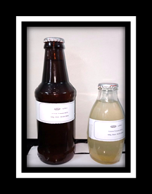
Hot filling in glass containers BB (brown glass container) (350 mL) and WB (white glass container) (200 mL)

Brown & White
Glass containers
Storage at refrigerated temperature (4±1 °C)

Quality monitoring of α-Tomatine rich RTS Beverage (microbiological, sensory, physiochemical, tomatine levels)

Fig 1: Flow chart showing the process of preparation of α-Tomatine rich RTS-beverage

Fig 2: A. Changes in total phenolic content and B. Changes in antioxidant property of α-Tomatine rich RTS stored in different containers at LT (4±2 °C) condition.

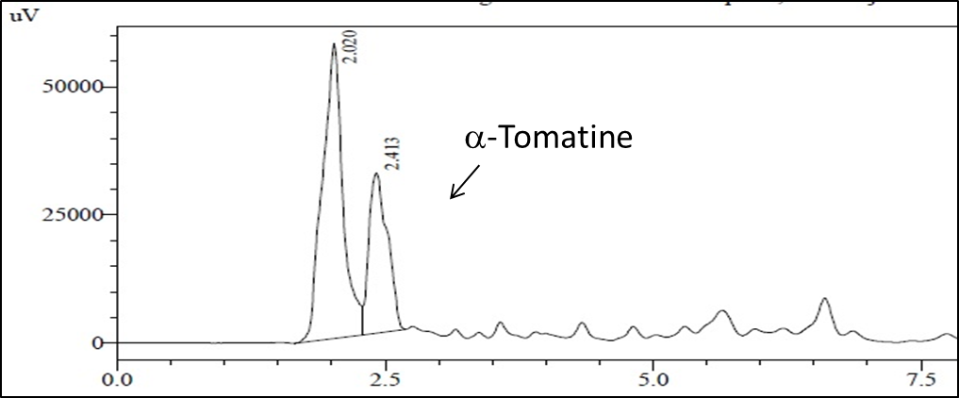
Fig 3A. Standard α-Tomatine chromatogram 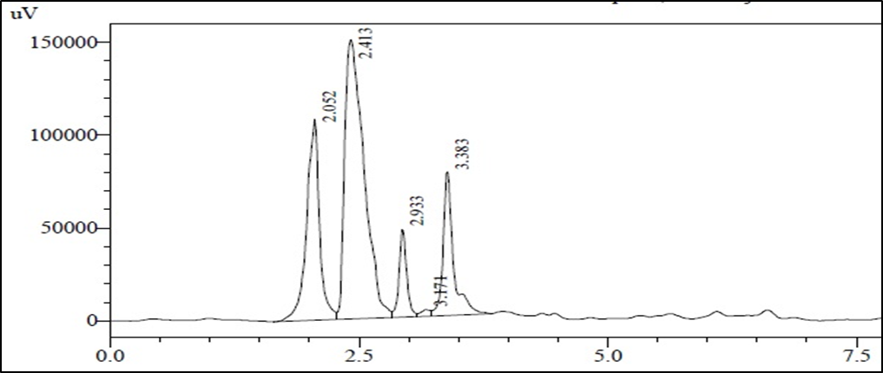
Fig 3B. The α-tomatine chromatogram of green tomato juice.
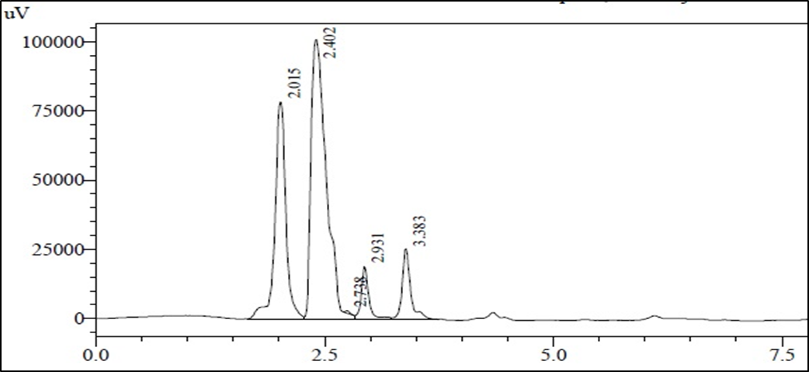
Fig 3C. Initial α-Tomatine chromatogram of RTS beverage (0 ^{th} day).

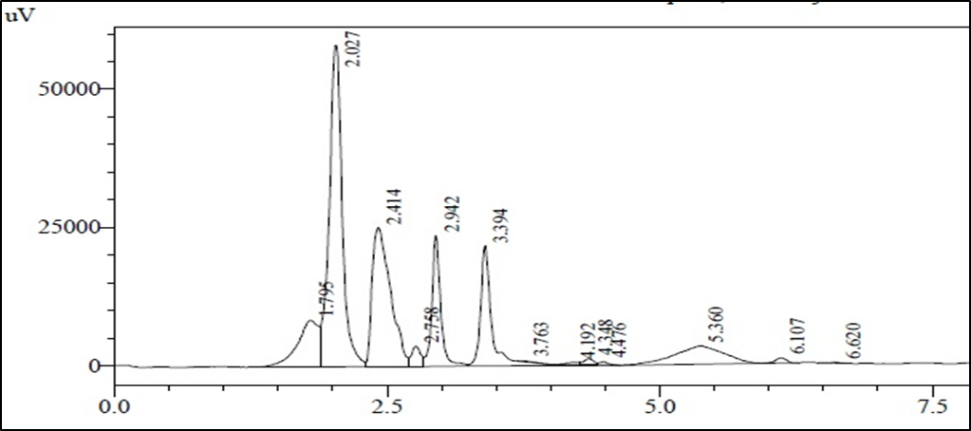
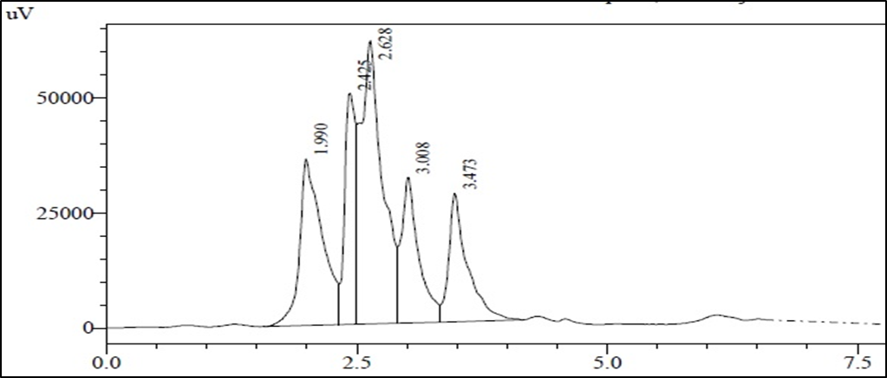
Fig 3D The α-Tomatine chromatogram of BB and WB stored RTS beverage (45th day)

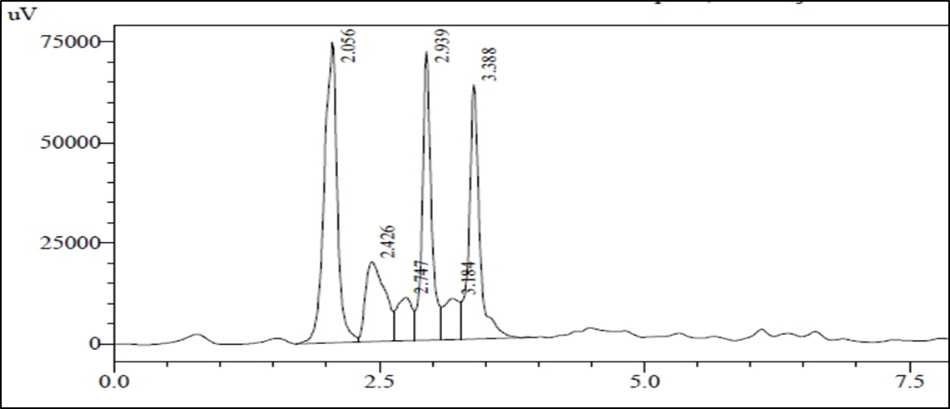
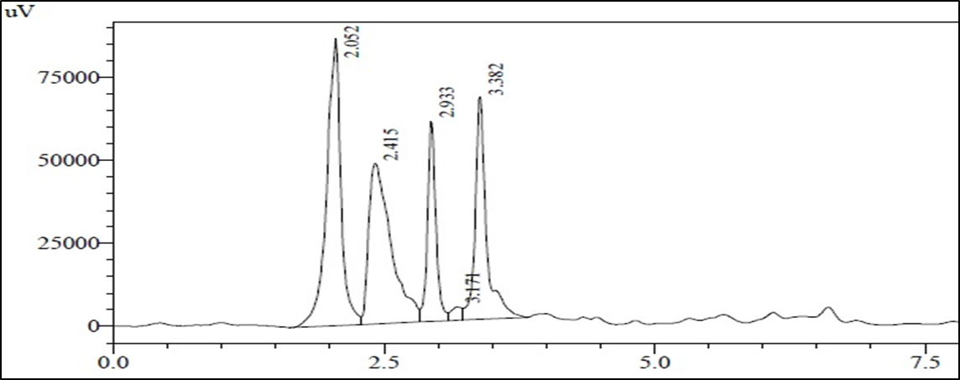

Fig 3E The α-Tomatine chromatogram of BB and WB stored RTS beverage (90th day)
Fig 3 : HPLC chromatogram for α-Tomatine estimation throughout the study

0
2
4
6
8
10
Color
Flavor
Texture
Sweetness
Sourness
Overall
Acceptability
bb
wb
0 Day
0
2
4
6
8
10
Color
Flavor
Texture
Sweetness
Sourness
Overall
Acceptability
bb
wb
15 Days
0
2
4
6
8
10
Color
Flavor
Texture
Sweetness
Sourness
Overall
Acceptability
bb
wb
30 Days
0
2
4
6
8
10
Color
Flavor
Texture
Sweetness
Sourness
Overall
Acceptability
bb
wb
45 Days
0
2
4
6
8
10
Color
Flavor
Texture
Sweetness
Sourness
Overall
Acceptability
bb
wb
60 Days
0
2
4
6
8
Color
Flavor
Texture
Sweetness
Sourness
Overall
Acceptability
bb
wb
75 Days
0
2
4
6
8
Color
Flavor
Texture
Sweetness
Sourness
Overall
acceptability
bb
wb
90 Days
Fig 4 :Sensory profile of BB and WB container packaged α-Tomatine rich RTS beverage during storage at LT (4±2 °C) condition.

