Revision Tracking
1st review by GAMA-IJB result per 18 Jan 2021
Revision by authors per 18 Jan 2021 @22:15

2nd review by GAMA-IJB result per 19 Jan 2021


Revision by authors per 20 Jan 2021 @08:51

3rd review by GAMA-IJB result per 20 Jan 2021
Revision by authors per 20 Jan 2021 @18:22, without references


Revision by authors per 20 Jan 2021 @18:22, with references


Checklist
AUTHOR GUIDELINE
- Each manuscript must include a reference list containing only the quoted work and using the Mendeley or Zotero tool. (Ok!)
- Author’s name and Affiliations
- The detailed information about the author will be placed on the ABOUT THE AUTHOR (short CV) page. (Ok!)
- Language - Spelling follows Webster’s International Dictionary. (Ok!)
- To ensure an anonymous review, the authors should not identify themselves directly or indirectly in their papers. (Ok!)
- The manuscript does not have errors of more than 250 and 5% of plagiarism indicators. (Ok!)
  - (Authors do not have access to Grammarly premium. Standard free Grammarly results are provided together with SmartEdit, ProWritingAid, and Plagiarism Checker results. Please see screenshots below.
  - Standard free Grammarly version shows error of 216 without and 229 with the references that needs premium version to correct. These are below 250 (Please see screenshot below).
  - The author uses terminology specific to their research such as endogenize, endogenization, etc. These are viewed and flagged as unclear by the software.
- Article length - should be between 4000 and 7000 words. The word count excludes tables, figures, and references. (Ok!) (Total 6,962 words excluding References)
- TITLE PAGE, Article Title - should be no more 20 words. (Ok!)
- An abstract - between 100-200 words (Ok!)
- Should be presented in English on a separate page (Ok!)
- Keyword - a maximum of five keywords (Ok!)
- JEL Classification Numbers - add a 1 - 3 JEL Classification Number (Ok!)
- References - use reference management tools (example: Mendeley, EndNote, or Zotero) (Ok!)
- Use the manuscript template (Ok!)
TEMPLATE OF JOURNAL
TEMPLATE OF ABOUT THE AUTHOR
- Artwork - provide high-quality artwork. (Ok!)
- Tables and Figures should be numbered separately. (Table 1, Table 2; Figure 1, Figure 2). (Ok!)
- Each table and each figure should be given a title and; (Ok!)
- should be presented on a separate page at the end of the manuscript. (Ok!)

Screenshots
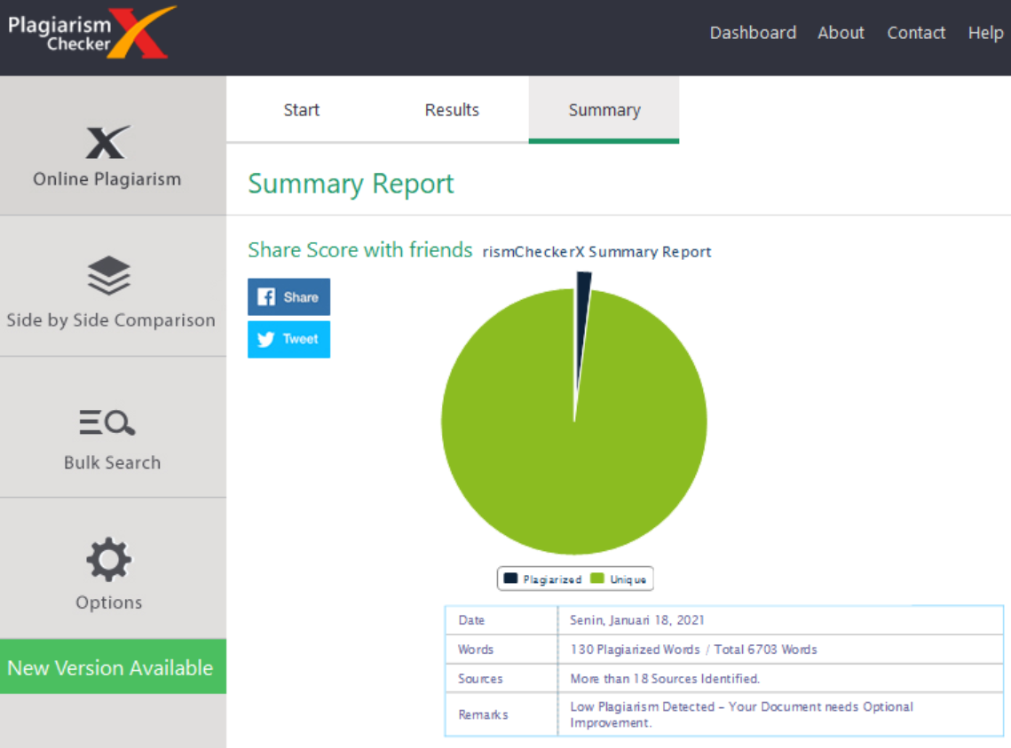
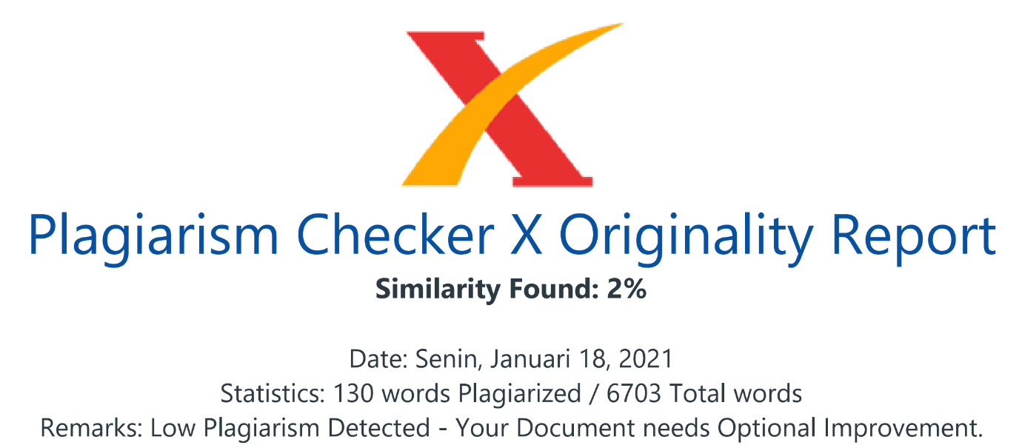

Rechecking – after receiving feedback from GAMA-IJB @15:00
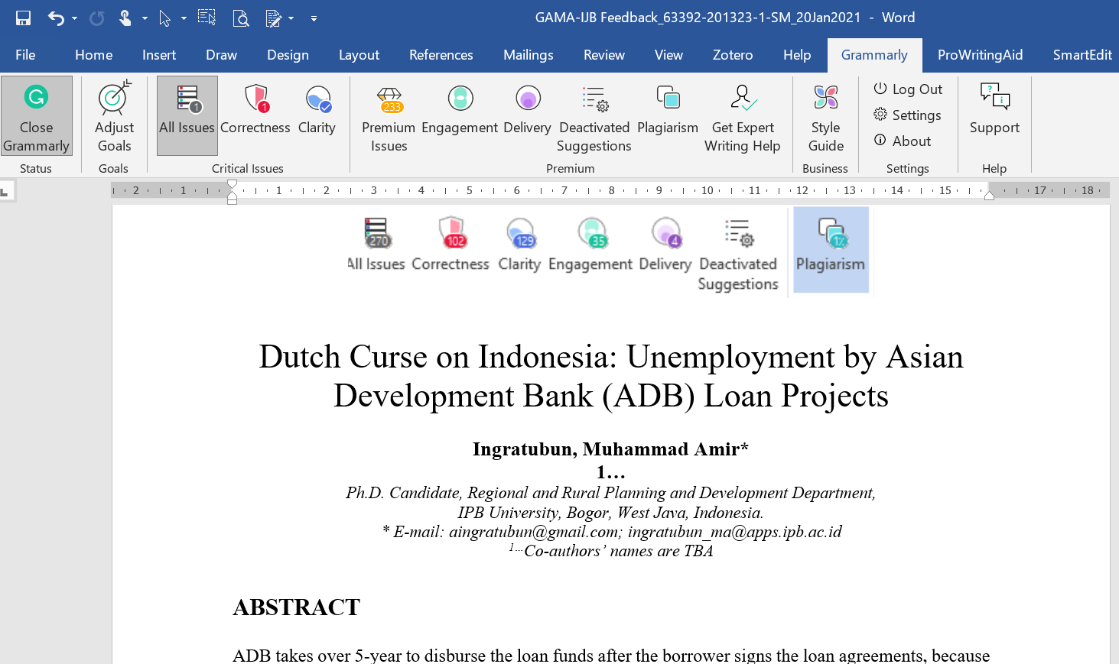
Difference 37

Revision by authors per 20 Jan 2021 @18:19, without references
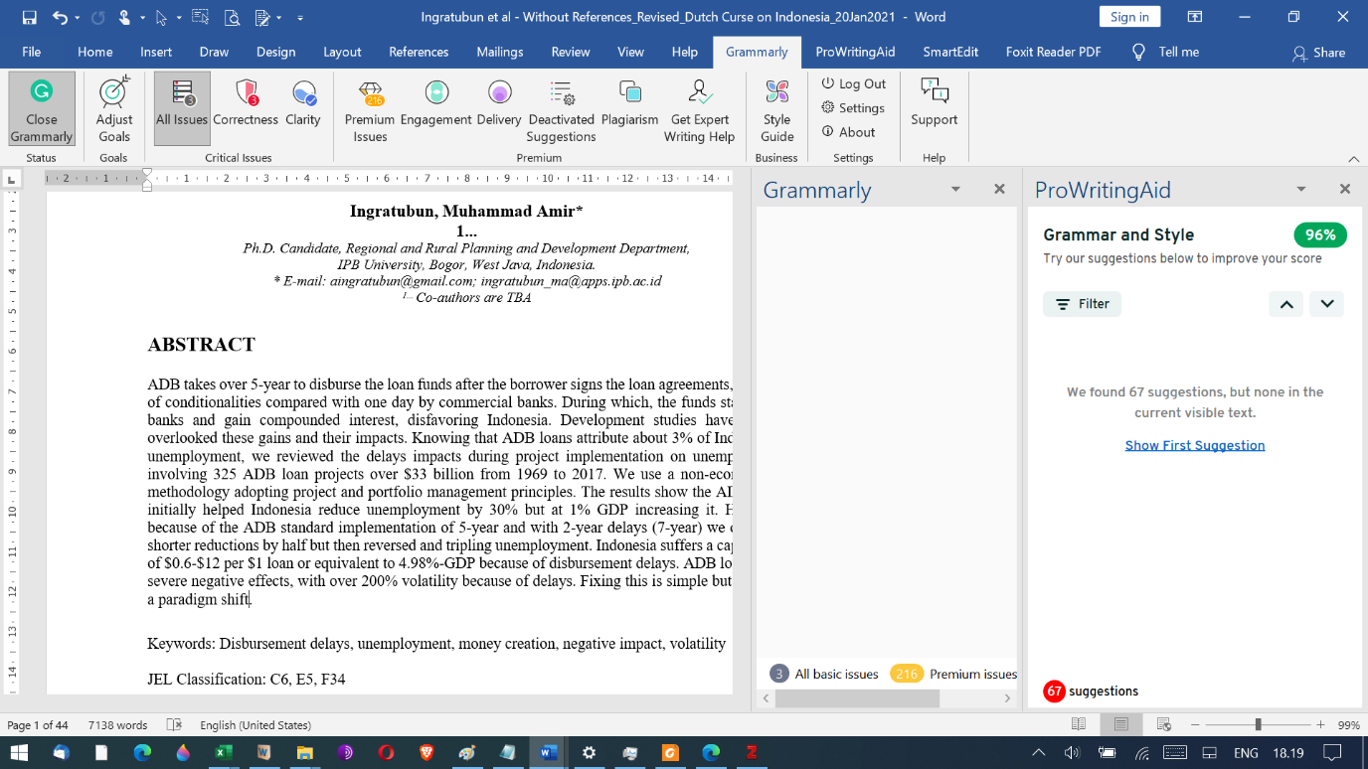

Revision by authors per 20 Jan 2021 @18:29, with references
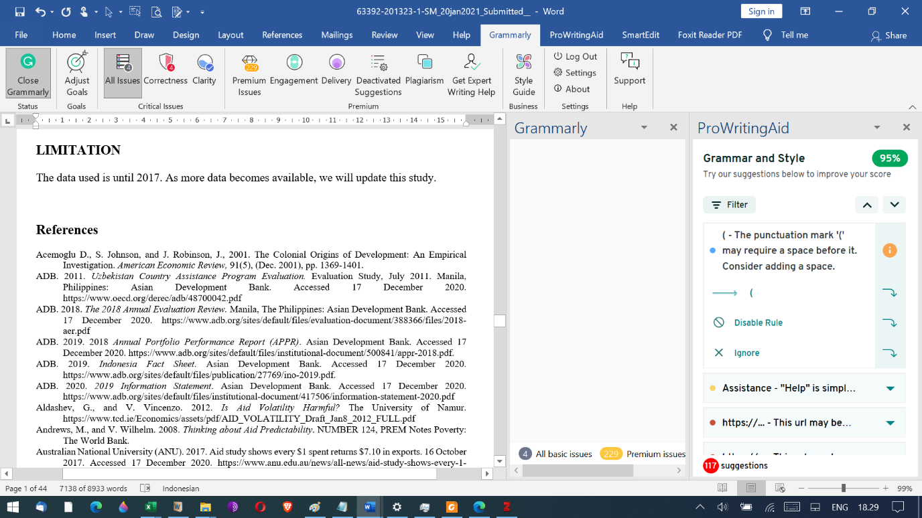

About the Author
Ingratubun, Muhammad Amir is a Ph.D. candidate in Regional and Rural Development Planning at IPB University, Bogor, Indonesia. He received his Insinyur (BSc) degree in Civil (Structural and Hydropower) engineering from Hasanuddin University, South Sulawesi, Indonesia; a Master (MSc) in Construction Management from The University of Reading, Reading, UK; and an MSc. Eng. in energy conversion technology from Bremerhaven University of Applied Sciences, Bremerhaven, Germany. He has worked as a portfolio manager for a development bank, managing over $1 billion in infrastructure loan projects. He is currently managing private capital for infrastructure development of over $1.5 billion. He has reviewed over 150 publications and has several publications, both solely and in a team.
Author contact details:
Sekretariat PS PWD, Gedung FEMA Wing 10 Level 4 Jawa Barat, Indonesia, Jl. Kamper, Kampus IPB Dramaga Bogor, Jawa Barat, Indonesia 16680
Telp / Fax: +62 251 8422143; email: pspwdipb@gmail.com. http://pwd.ipb.ac.id/
Email: aingratubun@gmail.com; ingratubun_ma@apps.ipb.ac.id

The co-authors are Ph.D. supervisors. I will inform their names subject to the reviewers’ committee approval.
Author contact details: I will inform you later.

Dutch Curse on Indonesia: Unemployment by Asian Development Bank (ADB) Loan Projects

Ingratubun, Muhammad Amir*
1...
Ph.D. Candidate, Regional and Rural Planning and Development Department,
IPB University, Bogor, West Java, Indonesia.
* E-mail: aingratubun@gmail.com; ingratubun_ma@apps.ipb.ac.id
^{1...}Co-authors are TBA

ABSTRACT
ADB takes over 5-year to disburse the loan funds after the borrower signs the loan agreements, because of conditionalities compared with one day by commercial banks. During which, the funds stay in the banks and gain compounded interest, disfavoring Indonesia. Development studies have mostly overlooked these gains and their impacts. Knowing that ADB loans attribute about 3% of Indonesia’s unemployment, we reviewed the delays impacts during project implementation on unemployment involving 325 ADB loan projects over $33 billion from 1969 to 2017. We use a non-econometric methodology adopting project and portfolio management principles. The results show the ADB loans initially helped Indonesia reduce unemployment by 30% but at 1% GDP increasing it. However, because of the ADB standard implementation of 5-year and with 2-year delays (7-year) we observed shorter reductions by half but then reversed and tripling unemployment. Indonesia suffers a capital loss of $0.6-$12 per $1 loan or equivalent to 4.98%-GDP because of disbursement delays. ADB loans have severe negative effects, with over 200% volatility because of delays. Fixing this is simple but requires a paradigm shift.

Keywords: Disbursement delays, unemployment, money creation, negative impact, volatility

JEL Classification: C6, E5, F34

INTRODUCTION
Indonesia was under the control of a Dutch multinational corporation of the Dutch East India Company or Vereenigde Oostindische Compagnie (VOC) from the early 17th into 20th century. The Dutch government nationalized it into a state asset because of bankruptcy. VOC nurtured the spread of—among other—disease, slavery, bureaucracy, globalization, destruction, and exploitation on an unfathomable scale (Shorto, 2013), modern banking, and planted the seed of multilateral cooperations bank to develop colonized lands. During this period, the Dutch generated billions of dollars of capital from Indonesia in various forms, including slave trading, and exported to the Netherlands.

Dutch disease, often associated with the natural resource curse, describes the causal relationship between economic development growth in one sector and a reduction in another. The putative theory is that as national revenues increase, including those gotten from debt capital, foreign aid inflows induce the strengthening of the national currency gauged from the stability of the exchange rate (Ebrahim-Zadeh, 2003). The theorized impacts would be, among others, increased growth, job creation, revenues, and poverty reduction.

Contrary to the description of Dutch disease, particularly with capital inflows and the creation of employment, Indonesia suffers from capital outflows, not only during Dutch colonialization but also from borrowing from the ADB (Fauzi and Ingratubun, 2020). This is because of its infamous disbursement delays that could take on average 7-years before disbursing the debt funds into the economy of Indonesia, which in most cases are not 100%. A study by the OECD (2003) discovered that disbursement delays are one of the five most burdensome donor practices that may cause aid ineffectiveness. Pallage and Robe (2001:10) found that many studies classified disbursement delay (lead and lag) as a minor issue. However, Diarra (2011: 7) has empirically identified that the “disbursement delays approach” by donors is one of the principal causes of aid volatility. Sogge (2017:36, citing Doucouliagos and Paldam (2015:325)) shows that many biased aids-related studies towards donors because of financial sponsorship. To date, notwithstanding all aid ineffectiveness studies have anchored on disbursements, yet there is almost no reference that shows unequivocally that disbursement delays alone are the primary cause of loan projects ineffectiveness in achieving the putative development rhetoric. Let alone from banking theories and practices. Hence, our paper is filling this gap.

We argue that 5-year disbursement delays under ADB standard loan projects implementation in Indonesia, as opposed to the full disbursement of 100% in year-1, reduces not only long-term job creation by about 70%. The remaining 30% enjoyed beyond year-5 but also increasing 1.7 times unemployment level because of loss of job creation opportunities. Delays beyond 5 years and incorporating compounded interest and fees likewise the financial costs of delays under the Loanable Fund (LF), severely affecting growth which triples unemployment negatively. Disbursement delays induce financial losses as capital out-flights over ten times the loan value (Fauzi and Ingratubun, 2020) under fractional reserve banking (FRB) theory. If we endogenized these losses in favor of Indonesia, the disbursement delays would hold back growth and increase unemployment. Thus, ADB loans with or without delays have zero impact on increasing growth and reducing unemployment. But worsen them, hence the Dutch disease going in reverse is inflicting Indonesia, which we term as Dutch Curse.

The following sections discuss aid volatility definitions, ADB implementation delays, and Indonesia’s capitals in ADB. The underlying theory of the negative impact of disbursement delays on growth and unemployment, a literature review on aid volatility and returns per U.S. dollar aid, a brief description of capital endogenization, and three banking theories and practices. Succeeding this, an elaboration on the novel methodology, discussion on the results, and followed by recommendations. Fauzi and Ingratubun (2020) provide Detailed discussions on ADB loan impacts on the economic growth of Indonesia, hence this paper briefly touches upon growth and is expounding on unemployment.
- Aid volatility and unemployment definition
Most authors infer aid volatility as the difference between commitment and disbursements (Pallage and Robe, 2001; Bulíř and Haman, 2006; Eifert and Gelb, 2005). Bulíř and Lane (2004) refer to aid conditionalities and shortfalls by Celasun and Walliser (2008). All of them harnessed disbursement as the main predictor and almost all are using econometrics approaches while the rest with contextual descriptions.

Our paper specifically deals with ADB loans to Indonesia and defines aid volatility because of disbursement delays. We measure this by the difference between 100% loan disbursement in year-1 upon loan agreement (LA) signing versus planned and/or actual disbursements. We did the analysis using a non-econometric yet empirical methodology aided by graphical and numerical explorations.

We use the unemployment definition by the World Bank that is “the share of the labor force that is without work but available for and seeking employment.” Definitions of the labor force and unemployment differ by country.
- ADB Disbursement Delays in Indonesia
Development banks, such as the ADB, operate in similar ways to traditional banks (Mazzi, 2013: xxvi). However, unlike borrowing from a commercial bank where the fund or bank credit disbursement in-full and deposited into the borrower’s controlled-account upon Loan Agreement (LA) signing, borrowing from ADB does not work like this (Figure-1).

The ADB ties its disbursements with certain conditionalities and controls the loan account. Kanbur (2000:pp.413-416), a former World Bank staffer, expresses that conditionality of whatever type has failed in Africa and they designed it to fail as a systemic imperative to ensure the aid keeps flowing. Conditionality incriminates the actual issue that is “one of an unhealthy interaction between donor and recipient processes which propagate aid dependence but are not so simple as to be characterized as the strength of the donors and the weakness of the recipients.” (Kanbur 2000:414) To date, as shown by Howarth (2017:33) that the infliction of conditionality is a nuisance, highly controversial, and ineffective.

Essentially ADB requires that upon signing, the borrowers must meet certain LA conditions before making the first disbursement, and only then will the loan becomes effective which signifies the availability of loan funds. This is still subject to the submission of withdrawal application (WA) by the borrower and the formal No-objection (NO) issued by the ADB before disbursing any funds. The process takes time and causes delays. Ensuant disbursements follow the same procedure. The Ministry of Finance of the Republic of Indonesia (MOF-RI, 2020) provided the first disbursements data for ADB loan projects (1969–2017, Project No.12–8327) with a total of $37 billion in U.S. Dollars (Figure-2). Indonesia signed the first ADB loan (No.12) on 2 July 1969 and took 3.7 years (year-4) for its first disbursement on 7 February 1973.

The average 1st disbursement time since 1969 is over 2 years (year-3). ADB-wide standard overall project implementation duration is 5 years (ADB 2018 APPR:21) that normally coincides with the grace period. On average, ADB-wide experiences 2.2 years of delays hence in their year-8 implementation (ADB 2018 APPR: iii). This is consistent with Indonesia project data. According to ADB President Nakao, about 90% of ADB loan projects are experiencing 2-year delays (Witular, 2016). Hence, in our analysis, we use standard 5-year with 2 years of delays (7-year).
- Indonesian Capitals in ADB
Established in 1966, the ADB as a quasi-government requires an establishment act, which each member countries have to ratify through their national law. Indonesia enacted the law No.4/1966 accordingly. This provides ADB with no competition to provide its services to Indonesia. Block (1988:3) expresses that when the government gives a legal status on an entity and passes a law that protects it from competitors, it creates unemployment. Block argues that “[i]n almost every case, government programs are the cause of joblessness” and the free market is better and more efficient in creating employment than by politicians and bureaucrats as with ADB loans.

Indonesia paid-in (in-cash) plus subscribed capitals (total about $8 billion) and guarantees (in-kind) to ADB which under banking practices are Promissory Notes (PNs) per Bill of Exchange 1882. Thus, they are tradable as securities, leveraged as deposits, or to create money. Each signed LA is a tradeable security and bank reserve (Nichols, 1992:11; Werner, 2016; and IMF, Gross and Siebenbrunner, 2019), and adding to Indonesia’s securities to ADB. These are leverage as 100% full loan-fund-disbursement collateral. Indonesia has a much larger disbursement capacity of 14%-GDP compares with average ADB loans of 0.415%-GDP or equivalent to 0.1%-GDP disbursement/year. Alternatively, if we use Appendix-A data on average ADB loans over Indonesia disbursement capacity, assuming ADB disburses 15%-20% per year, gives a ratio of 1:225 (1:169) being Indonesia having the much larger capacity (169-225 times per year) than ADB. Despite these, the ADB is asserting on controlling, thus delaying, the disbursement following its interpretation of its Charter, Article 14, and awkwardly Indonesia agrees. The Netherlands (or the Dutch) is one shareholder and a non-borrowing member of ADB.
- Theory and Hypothesis
Ibnu Khaldun, in the 14th century predating all Nobel prize winners, warned that when the ruler (government) is not spending money, it is causing a shortage of capital. “Now, if the ruler keeps it to himself [undisbursed], it is lost to the subjects.” (Khaldun, 1377:365) Similarly, ADB loans if disbursed into Indonesia, correlate to capitals, greens, and fertile soils (Khaldun, 1377). Hence, while the ADB loan funds remain undisbursed, it is a loss to Indonesia.

LITERATURE REVIEW
- Aid volatility, growth, and unemployment
The United Nations has expressed that unemployment and underemployment are the major causes of poverty (UN, 2012:3-4). However, there is worryingly scarce literature that deals with the aid nexus with unemployment. This is most probably because of the preferred linkages between aid and employment when the literature is discussing growth. In 2009, the IMF identified that the right type of development aid has a positive impact on long-running economic growth (Minoiu and Reddy, 2009:6) . However, their most recent study discovered that there is no robust evidence that aid increases growth (Dreher and Lohmann, 2015:5) and job creation. Despite development aid initiatives being established in the 1940s, the linkage between aid volatility, effectiveness, and growth was long neglected by scholars (Bulíř and Hamann, 2006:4; Diarra, 2011:1).

Over the past 40 years, significant evidence shows that aid volatility has had a severe negative impact on growth, but little knowledge about their primary sources (Desai and Kharas, 2010:1) and on their nexus with employment creation. Despite the mainstreamed putative aid theory of growth promotion, job creation, and poverty eradication. Desai and Kharas (2010) identified loan disbursement delays as a source of aid unpredictability, which impairs aid recipients through rising financial costs (see also ADB 2011:26 on cost increases). It slashes investments and reduces welfare, hence affects growth and employment levels. Kharas (2008:9) exhibits that disbursement volatility has massive negative shocks on growth and national income similar to those experienced by developed countries during the two World Wars and the Great Depression.

Fauzi and Ingratubun (2020) discover that ADB loans have very little to no positive impacts on the economic growth of Indonesia but cause negative growth (Figure-3) or act as a hand-brake for accelerating growth. They show that over 10 folds of Indonesia’s capital per one dollar loan fund being delayed are capital flights. These are benefiting the economic growth of the countries where ADB keeps Indonesia loan funds, hence decelerates Indonesia’s growth. We translate this as the Dutch curse at work in which despite the money (or capital) being present, Indonesia cannot use it—but others can—and even suffered capital flight.
- The impact of disbursement volatility
Aldashev and Verardi (2012:3-4) show that doubling aid volatility causes a fall in average GDP growth by two-thirds (67%). Using return per $1 aid invested and disbursed by donors as a measure of volatility, this shows a range of 15%-2400% (Jepma, 1991; Andrews and Wilhelm, 2008; GFI et al., 2015; ANU, 2017; Lotti and Presbitero, 2019; Hickel, 2019; and Fauzi and Ingratubun, 2020). The U.S. Congress (1968a:280) record relating to 1969 budget appropriation for the ADB registers that “we find that many of the members ... put in $1 and get out $7 [or 700%].” For paying interest alone it consumes 0.8%-GDP and total capital flights are 7.6%-GDP (Griffiths, 2014).
- Capital Endogenization
Interest earned on ADB undisbursed loan amounts and fees incurred are profits for the ADB and/or its private bank and not accounted for as Indonesia’s national income (Paradox of profits). For monetizing those gains for the benefit of Indonesia before endogenizing them, we are consistently treating them as a source of capital (Zezza, 2011:15) for Indonesia. Capital endogenization is common in assessing regional economic wealth leakages (Rustiadi et al., 2018) and development sustainability (Fauzi, 2019).
- Foundation: Banking Theories, Practices and Governance
Bourguignon and Sundberg (2007); and Edwards (2014) have voiced the need to go beyond econometrics to open a black box of development aid. This because a plethora of studies, including aid volatility, remains inconclusive. Since no cross-country financial transactions (GFI et al., 2015) can occur in the world without engaging banking systems hence, this paper builds its foundation on banking practices, rather than econometrics. As the black box opener, Galbraith (1975:5) expresses that the knowledge of how the banks work is essential. He says that “[t]he studies of money, above all other fields in economics, is the one in which complexity is used to disguise truth or to evade truth, not to reveal it. ... Money, in contrast, is equally important to those who have it and those who don’t. Both, accordingly, have a concern for understanding it.” Hence, the subsequent section opens the black box yet briefly, by expatiating on the three banking theories identified by Werner (2014, 2016).

Financial Intermediation Banking (or Loanable Funds) (LF)
First, LF is the most dominant theory which holds that banks are merely financial intermediaries. They gather deposits, mostly in cash, from patient savers and lend them out to customers or impatient spenders and charge interest. ADB appears to practice the LF as it continuously requests its member countries to replenish its ordinary capital resources.

Money Multiplier or Fractional Reserve Banking (FRB)
Second, the FRB theory adopts that banks create money via multiple deposit expansion by using a fraction of the money in their possession as the basis for credit generation. A bank with $10 cash in its entire holding able to lend out $100 (10 times) under the 10% reserve rule (Nichols, 1992 (1st ed., 1961:11)). At the time of ADB creation in 1966, the FED required all banks to maintain a reserve ratio of 4-6% (The Fed, 2020, Footnote 10-13). The Fed nullifies this requirement on 26 March 2020 (The Fed, 2020) which means any bank can lend out money with zero reserves (Nichols, 1992:3). Per its 2020 Information Statement (ADB, 2020:4), ADB lending operation appears to maintain between 4-8% reserve (FRB) ratio. We measured this from the paid-in capital (PIC) in cash ($$7,372 million) or Other Reserves (Table 12, Footnote c:24) over its maximum lending ceiling (MLC) of $192,547. This is 1.3 times over its Subscribed Capital (SC) of $147,120. With 4-8% reserve, ADB can lend out between 12.5-25 times of its PIC. Based on this evidence we assumed that ADB, through its banking governance, is adopting both the FRB and LF. This paper uses these two terms in the analysis.

Werner (2014, 2016), Keen (2014) and Moore (1983), and a growing number of central banks, for example, the Fed (Carpenter and Demiralp, 2010) and the Bank of England (McLeay, et al., 2014), have mathematically, empirically, and practically proven that both LF and FRB theories are untenable, factually incorrect and not reflecting reality hence are indefensible.

Credit Creation (CC)
Third, the CC is the most dominant theory and currently practiced around the world in which banks require neither deposit nor reserve. The Bank of England describes the money creation begins when a client signs the LA. They state that “The bank, therefore, creates its funding, deposits, in the act of lending, in a transaction that involves no intermediation whatsoever.” (Jakab & Kumhof, 2015: ii). All the banks need for credit money creation is a signed LA or promissory note. This is the oldest banking theory in a modern civilization based on 5000 years of practice (Werner, 2016; Hudson, 2018). Werner (2014:14) in the first-ever practical empirical test of 5000 years of modern banking, observed in real-time and in an actual bank environment. A BBC crew was filming the whole process of LA signing until he receives the credit money into his bank account. The entire process took 35 minutes in contrast with the fund outlaying by ADB that takes over 5 years or an average of 7-8 years (Figure-1).

- Banking Practice Illustrations
To illustrate the gains from money creation under the three banking theories, this online calculator helps view those gains. The calculator uses the compounded interest formula A=P(1+r)^{t}. We run two scenarios, namely borrow-to-invest (BTI) and borrow-to-project finance with a $10 annual withdrawal (BTPF) hence an 8-year investment. Annual interest (r) is using estimated average ADB loans to Indonesia of 4.727% and compounded annually. A hypothetical loan (P) of $100 under LF and 10% bank reserve hence, 100/10% = $1000 money creation under FRB or CC. For (t), we applied eight years under LF to reflect average ADB delays and five years for FRB/CC which coincides with the ADB grace period when loan repayment begins in year-6 and the beginning of FRB/CC money creation reduction. We did not calculate the loan principal repayment plus interest to mirror the implementation phase or grace period of ADB loans. The results show gains (A) of $44.70 (BTI) and $23.48 (BTPF) hence per $1 loan is between $0.24 and $12.60 ($2.60 + $10) or 30% and 1170% for LF and FRB, respectively. This includes the newly created money plus compounded interest which is not all in favor of Indonesia hence a capital flight or loss.

Hence, this means for every one-year delay in ADB loan funded project causing the borrower (i.e., Indonesia) to lose between $0.03 ($0.24/8year) and $2.52 ($12.60/5year) per $1 loan or $0.003-$0.21 per $1 loan/month under LF and FRB correspondingly. In brief, if ADB does not disburse the loan fund 100% in year-1 upon LA signing, it financially costs the borrower between $0.3-$21 per $100 loan/month under prevalent banking practices. The ADB (2018, footnote a:37) states that for every 2 months delay avoided in their project implementation might increase the net economic benefit by 1% of their loan portfolio, which is equivalent to $0.5 per $100 loan. Based on this, ADB is gaining interest through BTPF on undisbursed funds (See also U.S. Congress, 1968a:274).
- A case study with one country and one source of funding
As identified by the World Bank (Bourguignon and Sundberg, 2007:316), Aldashev and Verardi (2012:2); Edwards (2014) and Howarth (2017:pp.41-49) that lumping aids and countries in the analysis have fragile, fragmented, often ambiguous, spurious and gives inconclusive results. Hudson (2015:66) concludes that the most important predictor of aid volatility is debt-financed by loans. Dreher and Lohmann (2015:5) identify the gap in the literature on aid effectiveness because of the lack of empirical evidence at the country-level. Hence, this paper covers only one country (i.e., Indonesia), and one component of aid, which is the ADB loan.

METHODS
- Methodology
Our paper uses a novel method identified as Development Outcomes Attribution (DOA) on Bank Outlays Growth On-development Results (BOGOR) (Ingratubun, 2020). Our method relies on triangulations—a principle widely used in geodetic and geo-positioning (e.g., GPS) sciences—of the results which give a 3-dimensional view of the outcomes. DOA-BOGOR applies quantitative attribution by treating a scenario of 100% loan disbursement upon LA signing in year-1 as the benchmark. We then compared this with progressive disbursement based on project S-curve and integrating money creation and their compounded interests and fees from undisbursed amounts, using triangulation of numerical, graphical, and stochastic agent-based modeling (SABM) approaches. The numerical method is arranging data in a time-series and following Figure-4, calculating the impacts of delays using 100% disbursement in year-1 as the benchmark. The graphical method involves plotting and interpreting the results from the numerical exercise. We then performed simulations under the stochastic Monte-Carlo method blended with agent-based modeling (ABM) simulation which results are cross-referencing the numerical and graphical results to strengthen the translation of the findings.

The Philosophy of DOA-BOGOR
We define attribution in DOA as taking a slice of economic development (i.e., preferably current GDP) indicators and examining their compositions most relevant to the project/program, assessing and understanding their outcome apportionments to the source of funding which in this paper are ADB loans. As an illustration, in a slice of white bread, equally sized and weighted, one can get 3-gram sugar, 2-gram protein, and zero-gram fiber whilst in a slice of brown bread, 2-gram, 3-gram, and 2-gram respectively. Thicker or thinner slices produce different configurations. Likewise, in the GDP of Indonesia (a loaf of white bread), from which loaf one extracts a slice thereof that is the ADB loans. From the loaf, using these equations,

$x_{n}={\left(A/u\right)}_{n}$ ... ... (1)

$\overline{x}={\left(\frac{\sum_{1}^{n}{f\left(x_{n}\right) }}{n}\right)}/{\overline{u}}={\left(\frac{\sum_{1}^{n}{\left(A/u\right)}}{n}\right)}/{\overline{u}}$ ... (2)

where: $x_{n}$= Annual unemployment attributor; $\overline{x}$ = Overall unemployment attributor; A = ADB loans; u = unemployment; $\overline{u}$ = mean unemployment

We get an average value (1969-2017) on an annual project basis of 0.127 unemployment level over average unemployment of 4.053 hence, ADB loans slice attributes a 3.13% unemployment of Indonesia (Appendix-B). This means ADB loans—with an average of 0.415%-GDP—attributes to about 3% of unemployment. We term this as an unemployment attributor. Likewise, an equal slice of brown bread (ADB loans in a different country) will produce different results. Figure-4 below illustrates the basic mechanics of DOA-BOGOR.

Description
In this paper, we quantitatively measured unemployment as an attributor as ADB loans outlay progress following S-curve profiles until they reach 100% (BOGOR). The financial costs of delays (e.g., circa 30% and 250% for LF and FRB respectively) after being monetized we endogenized them as Indonesia’s capital in the BOG’R. This means we benchmark the costs of delays against the 100% outlays in year-1 wherein there is no delay.

Hence, we applied a 10% bank reserve ratio per the central bank of Indonesia (Bank of Indonesia). We then ascribe attribution with ADB loans as % of Indonesia GDP being the numerator over annual unemployment equally weighted (linearized) annually (See Figure-4). From this, we get an unemployment attributor of 3.13% (Appendix-B). Factual disbursement profiles were used to produce a normalized S-curve profile following the implementation plan with 2-5 years delays (Table-1). We then spread the ADB loans into succeeding 5 and 7-years according to their disbursement profiles per its actual or projected S-curve. Thus, using equation-1 and 2 and Figure-4, we derived the unemployment attributors of 2.40% (5-year) and 2.17% (7-years) and compared them with 3.13% (at 100% disbursement in year-1). We adjusted the actual interest rates, LIBOR, and fees per the banking rules of ADB to calculate the compounded amounts from undisbursed funds. We then monetized and endogenized them under LF and FRB adopting the Stock-flow consistent (SFC) model principle of double-entry to balance the money created and its multiplication from the LA date.
In this paper, we adopt a simplified approach by using 1.3 (30%) and 12.5 (1250%) for LF and FRB respectively. We use them as multiplicators on ADB loans (%-GDP) at 100% disbursement in year-1. From this, we get the unemployment attributors of -4.06% (LF) and -6.70% (FRB). Negative signs show endogenized sources. We stochastically imitated disbursement with Monte-Carlo simulations combined with agent-based modeling (ABM) using a mean of 4.34 and a standard deviation of 2.00 of Indonesia unemployment and their relationship with the ADB loans. We run unemployment attributor simulation with a minimum of 1,000 iterations using 5% disbursement increments by treating disbursement ratio and unemployment as agents harnessing MS-Excel What-if Analysis Data Table function. For estimating future total loan principal plus interest, using an average Indonesian ADB loan interest rate of 4.727%, we adopt the Rule of 70 with 19-year as the average loan life and average ADB loans since 1969 of 0.415%-GDP. Hence {2x0.415x19/(70/4.727)}=1.065 ~1.07%-GDP which value is in between 2% (0.45%-GDP) and 5% (1.13%-GDP) interest rates shown in Figure-10.
- Data
Time-series datasets from ADB covering 325 (Loans No.0012-3561) of Indonesia loans with over 1,100 sub-loans, from 1969 to 2017 totaled over $33 billion (Appendix-C), World Bank, Ministry of Finance (MOF) for the GOI, and St. Louis Fed (FRED). The World Bank data provides the unemployment level (Dataset: SL.UEM.TOTL.ZS (ILO estimates) and SL.UEM.TOTL.NE.ZS (National estimate) and current GDP (NY.GDP.MKTP.CD). FRED data caters to various interbank lending rates. As all ADB loans are below 1%-GDP, except for one outlier at 2.3%-GDP coinciding with the 1998 Asian financial crisis, we kept it as is to maintain data integrity and to show the impact of increasing ADB loans as %-GDP. We fill data gaps by interpolating them from their neighboring values. We provide the summary statistics in Appendix-D.
RESULTS
- Findings
Delays, despite them disadvantaging Indonesia in many areas (i.e., economy, finance, social politics), are financially and politically beneficial for ADB or its commercial banks where ADB deposits the undisbursed loan funds. Financially, it gains compounded interests and fees while politically, it remains in control of Indonesia’s sovereign capitals which is collateralized with over $8 billion. All three approaches, as expounded below, show that the bars under LF and/or FRB in numerical and stochastic approaches, outsized 100% disbursement. And the tip of the curves under 5- and 7-year delays in the graphical approach outnumbered the 100% disbursement. These tell us that ADB loans are not useful in reducing unemployment in Indonesia because of their disbursement delays. On the contrary, it worsens. Visually, the numbers, charts, and graphs show a downtrend and uptrend as ADB loans (as %-GDP) increase which means, ADB loans initially reduce unemployment but as the loans increase so do unemployment. We have observed the same with ADB loan disbursement delays. Increased unemployment correlated with longer disbursement delays, which translated as the longer the delays the fewer jobs ADB loans created.

Pilot view
To provide comfort on the stability of the data and DOA-BOGOR analysis, Figure-5 provides the view for the pilot from which we see volatilities of 19% and 24% because of 5 and 7-year delays, respectively. The endogenized costs of which are causing 130% and 214% volatility under LF and FRB at 17% correspondingly.

Albeit, the Spearman correlation test suggests a significant moderate strong correlation of -0.33 (0.03), which means unemployment reduction by one-third as ADB loans increase. The trend goes in the opposite direction faster because of 5 and 7-year delays with a significant strong correlation of 0.81 (0.00) and 0.79 (0.00) respectively with 100% disbursement in year-1. This implies that more ADB loans are reducing job creation or causing more unemployment and it worsens by 80% hence 0.47 ~0.5 (0.80-0.33) or decays by half because of delays. Figure-5 shows unemployment is down from 5% to 2.8% (44%) before increasing to 5.5% (96%) hence an overall 50% increase (or job losses). This shows that overall ADB loans have no positive impact on reducing unemployment. This has proven that Ibnu Khaldun (1377:359) was right about the government intervention that brought about negative effects on social utility and a great mistake.

Disbursement delays slow the convergence between the increase of ADB loans and their impacts on unemployment, however, the LF and FRB speed up the intersection faster. We translate this as ADB delays disbursements, despite on the surface it slows down the worsening of unemployment. In the background, the costs of those delays after being monetized and endogenized are increasing unemployment even faster and worsening them when ADB loans starting at 1.2%-GDP at 100% disbursement in year-1. We shall see the relevance of this when we triangulated the results between the three approaches. The Pilot view is preparing us to see the negative impacts of ADB loans and their delays in worsening unemployment.

DISCUSSION

Numerical
Figure-6 shows ADB loans attribute for 3.13% of unemployment from the national average of 4.053% per year under 100% disbursement upon LA signing in year-1 into the economy of Indonesia. However, the decision not to 100% disburse in year-1 degenerates the ADB loans slice for unemployment by about 23% (from 3.13% to 2.40%) hence, exposes the negative impacts of disbursement delays versus 100% disbursement.

These values are much smaller compared with those under LF (incorporating 30% compounded interests and fees) and FRB (250%) which pulls unemployment into -4.06% and -6.70% correspondingly, thus a 200% volatility (Figure-7). The R-squared value shows that 94% deterioration of ADB loan values relevant to their employment creation potentials is because of delays. This means the stability of ADB loans in creating jobs is fewer than 10%. We calculated the FRB impact by considering that 15% of FRB amounts are for real GDP transactions and contribute to growth (Bezemer & Hudson, 2016). Hence, to account for transaction costs, we apply 17% because of the U.S. Dollar denomination, despite in Rupiah it is around 30% of real GDP transaction after disaggregating Bank Indonesia data.

Graphical
Instead of using World Bank dataset with the ILO estimate (SL.UEM.TOTL.ZS), here we used the dataset for the national estimate (SL.UEM.TOTL.NE.ZS) to reflect the confidence of Indonesia on their unemployment level to minimize the gaps if we used larger values such as the ILO estimate. Notwithstanding the smaller values, STATA graphical results are similar. Hence, after observing data trend lines between linear, quadratic, and polynomial, we selected the fractional polynomial (FP) as an intermediate between non-linear and polynomial (Royston and Sauerbrei, 2007:27). We chose FP over linear regression since its Bayesian information criteria (BIC) is smaller (Table-2).

Figure-8 presents the comparison between linear and FP graphs with and without the outlier. From which we can see that linear regression does not capture much of the detailed information, while FP is better at getting them. Linear lines show a continuous decrease in unemployment corresponding with the increase in ADB loans (%-GDP) whereas FP lines are closely relevant with the actual data.

Note: Dangers of excluding outliers!
ADB loan at 2.3%-GDP in 1998 (financial crisis) at 100% disbursement in year-1, if treated as outlier hence eliminated, would give a delusive picture that more ADB loans reduce unemployment (Figure-8 to 11, Outlier excluded, see 100% Disbursement in year-1). This is false as captured by DOA-BOGOR in FP in 5- and 7-year disbursement in which both exhibit that unemployment increases corresponds with the size of ADB loans and linearly correlated with the length of the delays. This means, the longer the delays, the worse is unemployment, which is a sign of ineffective investment. It is our view that when dealing with loan data, one should not exclude outliers. After all, we must account for them since they are public money.

Figure-9 displays the 95% confidence interval with a larger confidence area as ADB loans increase, and Figure-9 shows areas affected by delays and differ from the 100% disbursement. Figure-10 exhibits the coordinates of specific observed points. These graphs show the condition with and without the outlier. Both show the same downward and followed by upward movements which means, as ADB loans increase, unemployment initially reduced but then increased. These were shortened and then worsened by half because of disbursement delays.

Hence, STATA Twoway graph fractional polynomial function (fpfit) predicted that ADB loans (at 0.415%-GDP average loans to Indonesia, 1969-2017), if disbursed 100% in year-1, while they slightly maintain steady one-third unemployment reduction from 5.6% to 3.6%, the effects worsened beyond 0.415%-GDP (Figure-11). In tandem with 5- and 7-year delays, ADB loans, plus their annual interest rate beyond 2% per annum signals a severe deterioration of Indonesia unemployment at 0.79%-GDP as it is reversing the initial one-third gains. Meaning ADB loans plus interest have no impact at all on reducing unemployment.

Despite it initially reduces unemployment until ADB loans at 0.415%-GDP (average 1969-2017), they increase it by over 1.7 times (5.01% to 8.9%). Interestingly, even at 100% disbursement in year-1 under LF (0.54%-GDP) which is the loan amount plus compounded interest on undisbursed amounts is already increasing unemployment or reducing jobs (inclusive outlier). Under FRB (17%x12.5x0.415%-GDP= 0.9%-GDP), which is slightly below 5% interest payments, are aggravating unemployment. This hints that the impact of the money created under LF and/or FRB or CC but not in favor of Indonesia upon LA signing, makes ADB loans negatively influencing unemployment. Indonesia is better off without ADB loans for job creation or for reducing the unemployment level. Therefore, it is the cornerstone of the argument not to delay disbursement, as the development outcomes will critically suffer from the volatility of Indonesia’s national economic engine.

Using the econometrics approach, Bulíř and Hamann (2006); Rajan and Subramanian (2008); Doucouliagos and Paldam (2008); Quibria (2014); Dreher and Lohmann (2015) and many others have observed similar results. Collectively, our results confirm the findings that aid has a temporarily small, positive, statistically insignificant relevant to growth and employment creation. And there is no clear and convincing evidence that more aid leads to faster growth and less unemployment. Our paper shows that increasing ADB loans with their disbursement delays, plus interests cause increasing unemployment by a triple from 3.6% at 0.38%-GDP to 8.9% at 1.2%-GDP (5-year) or 2.4% at 0.98%-GDP to 8.4% at 1.2%-GDP (100% Disbursement) under prevailing banking theories and practices. This is equivalent to a ratio of (3.6/8.9):(0.38/1.2) or 1.3:1 meaning that for every 1%-GDP increase of ADB loans to Indonesia, it increases unemployment by 1.3%.

Stochastic Agent-based Modelling (SABM)
Indonesia unemployment is first Granger-cause by ADB loans at time-lag 5 (TL-5) by ADB loans with 100% disbursement in year-1 after 5 years (Appendix-E). This signals that the impact of delays are first seen in year-5 (See Figure-11 and cross-reference with Figure-12 at 75% disbursement) then in year-7 at 70% disbursement. The Spearman correlation test (Appendix-F) demonstrates that ADB loans with 100% disbursement in year-1 are significant with a moderate correlation of -0.33 (0.03) with unemployment. On TL-1 to 4 none of them Granger-cause unemployment.

We interpreted this as ADB loans increase, they cut down unemployment by one-third (-0.33) but at year-5 there is a significant strong correlation of 0.81 (0.00) and year-7 with 0.79 (0.00) with the 100% disbursement in year-1, hence they increase unemployment by 80%. With a mean of 4.59 and a standard deviation of 2.00, we imitated the unemployment and ADB disbursement relationship under a numerical approach with Monte-Carlo simulations with disbursement ratios and unemployment as agents. Figure-12 shows some results. The standard deviation of 2, which is about 40% of the mean value, signals Indonesia’s volatile economic engine. This wider fluctuation potentially has positive and negative impacts because of the prolonged ADB loan disbursement time frame. From Figure-12, we observed the push-pull effects of ADB loans’ impact on unemployment within the 7-years disbursement.

Figure-12 also shows that even without accounting for LF and FRB @17%, owing to ADB standard 5-year implementation alone causes Indonesia to lose jobs creation potentials at around 75% disbursement ratio. This is when the loans increase unemployment compared with the 100% disbursement in year-1 that continuously reduces joblessness until 1%-GDP (see Figure-11).

Financial impacts
Triangulating the three results, ceteris paribus, the endogenized costs of average 2-year delays engendered financial losses to Indonesia of a minimum of 1.3–12 times the loan value for LF and FRB correspondingly. The ADB loans (actual) financial impacts of delays per $1 loans, as compounded interests and fees under LF of 22.17–27.91% are consistent with Jepma (1991), Pallage and Robe (2001), and Kharas (2008). Whilst the FRB of $12 (calculated) correlates with over $10 capital flight (GFI et al., 2015) or half of $24 (Hickel, 2017) per $1 aid. We estimate that between 70-80% of the loan amounts being disbursed into the economy of Indonesia, and ADB paid the rest to the international services providers. Das and Serieux (2015:40) approximate between 25%-40% are not entering the national economy. This means 5.8%-55% (e.g. 70% x 1/1.3 for LF, or 1/12 for FRB) of the money created including their compounded gains, or $0.57 (LF)-$11.5 (FRB) per $1 loan are capital flight and never entered the national economy.

The problem does not end here as Sogge (2017, citing Ndikumana and Boyce (2011) and van Bergeijk (2010)) find that about 60 percent of the funds disbursed in the national economy, rapidly leaves the recipient country through a revolving door. The total of which is comparable with capital flights of a minimum of 50%-300%. It correlates with our finding for Indonesia with 50%-1200% volatility measured against 100% disbursement in year-1. This means that Indonesia suffers from a capital flight of 4.98%-GDP, which although smaller than 7.6%-GDP (Griffiths, 2014), is almost double the expected return of 700% (or 2.91%-GDP) per $1 by developed member countries in their investment in ADB (U.S. Congress, 1968a:280). It shows that ADB loan volatility through disbursement delays is not incidental. Acemoglu et al. (2001) attribute this as economic retardations in less developed countries (former colonies) because of the creation of extractive institutions. Hence, for Indonesia, the Dutch Curse is well at work.

CONCLUSION
- Recommendations
Given the availability of sufficient collateral, the GOI critically requires national law and political decisions to have any ADB loan funds 100% disbursed into banking systems in Indonesia and Rupiah in year-1. Or no ADB loans at all. In mitigating moral hazard (Coase, 1960), reforming the governance of ADB loan disbursement. It requires more studies with different attributors, endogenized capitals, and LA conditionalities.
- Conclusion
For Indonesia as a country colonized by the Dutch for 300 years, the Dutch Curse, as opposed to Dutch disease, is befitting well to describe capital outflow, instead of inflow. And their negative impacts on growth and unemployment because of ADB disbursement delays. Fixing this Dutch Curse is simple but requires a fundamental shift and an honest intention beyond the political narrative of reducing delays and genuine efforts to promote growth and reduce unemployment.

“Debt is a cleverly managed re-conquest of Africa. It is a reconquest that turns each one of us into a financial slave.” ~ Thomas Sankara (1987).
Acknowledgment
Author, M.A. Ingratubun expresses his appreciation and gratitude to the IPB University, Regional and Rural Development Planning (PWD) Department. For opening a deeper understanding of the true scope of wealth leakages and their critical role in regional development and poverty eradication.

LIMITATION
The data used is until 2017. As more data becomes available, we will update this study.

References
Acemoglu D., S. Johnson, and J. Robinson, J., 2001. The Colonial Origins of Development: An Empirical Investigation. American Economic Review, 91(5), (Dec. 2001), pp. 1369-1401.
ADB. 2011. Uzbekistan Country Assistance Program Evaluation. Evaluation Study, July 2011. Manila, Philippines: Asian Development Bank. Accessed 17 December 2020. https://www.oecd.org/derec/adb/48700042.pdf
ADB. 2018. The 2018 Annual Evaluation Review. Manila, The Philippines: Asian Development Bank. Accessed 17 December 2020. https://www.adb.org/sites/default/files/evaluation-document/388366/files/2018-aer.pdf
ADB. 2019. 2018 Annual Portfolio Performance Report (APPR). Asian Development Bank. Accessed 17 December 2020. https://www.adb.org/sites/default/files/institutional-document/500841/appr-2018.pdf.
ADB. 2019. Indonesia Fact Sheet. Asian Development Bank. Accessed 17 December 2020. https://www.adb.org/sites/default/files/publication/27769/ino-2019.pdf.
ADB. 2020. 2019 Information Statement. Asian Development Bank. Accessed 17 December 2020. https://www.adb.org/sites/default/files/institutional-document/417506/information-statement-2020.pdf
Aldashev, G., and V. Vincenzo. 2012. Is Aid Volatility Harmful? The University of Namur. https://www.tcd.ie/Economics/assets/pdf/AID_VOLATILITY_Draft_Jan8_2012_FULL.pdf
Andrews, M., and V. Wilhelm. 2008. Thinking about Aid Predictability. NUMBER 124, PREM Notes Poverty: The World Bank.
Australian National University (ANU). 2017. Aid study shows every $1 spent returns $7.10 in exports. 16 October 2017. Accessed 17 December 2020. https://www.anu.edu.au/news/all-news/aid-study-shows-every-1-spent-returns-710-in-exports
Bezemer, D., and M.J. Hudson. 2016. Finance is not the Economy: Reviving the Conceptual Distinction. Journal of Economic Issues. 50, 3, p. 745-768.
Block, W. 1988. How the Market Creates Jobs and How the Government Destroys Them (Full Edition). Accessed 17 December 2020. https://cdn.mises.org/fm588_0.pdf
Bourguignon, F., and M. Sundberg. 2007. Aid Effectiveness: Opening the Black Box. American Economic Review 97(2): 316–321.
Bulíř, A., and J.A. Hamann. 2006. Volatility of Development Aid: From the Frying Pan into the Fire? International Monetary Fund. IMF Working Paper, WP/06/65.
Bulíř, A., and T. Lane. 2004. “Aid and Fiscal Management,” in Helping Countries Develop: The Role of Fiscal Policy, ed. by Gupta, S., Clements, B. and Inchauste, G. (Washington: International Monetary Fund).
Carpenter, S. B., and S. Demiralp. 2010. Money, Reserves, and the Transmission of Monetary Policy: Does the Money Multiplier Exist? Federal Reserve Board, Washington, D.C., U.S. Finance and Economics Discussion Series 2010-41.
Celasun, O., and J. Walliser. 2008. Predictability of Aid: Do Fickle Donors Undermine Aid Effectiveness? Economic Policy, 23(July), pp. 545–94.
Coase, R. 1960. The Problem of Social Cost. Journal of Law and Economics, 3(1), pp. 1–44.
Das, A., and J. Serieux. 2015, ‘Aid and reverse flows: a global analysis’, in the M. Arvin & B. Lew (eds) Handbook on the Economics of Foreign Aid, Cheltenham: Edward Elgar Publishing.
Desai, R. M., and H.J. Kharas. 2010. The Determinants of Aid Volatility. Working Paper 42, September 2010. Global Economy & Development.
Diarra, G.. 2011. Aid unpredictability and absorptive capacity: analyzing disbursement delays in Africa. Economics Bulletin, 31(1). pp. 1004-1017.
Doucouliagos, H., and M. Paldam. 2008. Aid effectiveness on growth: A meta-study, European Journal of Political Economy, 24(1): 1–24.
Doucouliagos, H., and M. Paldam. 2015. Finally a breakthrough? The recent rise in the size of the estimates of aid effectiveness. In the M. Arvin & B. Lew (eds) Handbook on the Economics of Foreign Aid, Cheltenham: Edward Elgar Publishing.
Dreher, A., and S. Lohmann. 2015. Aid and Growth at the Regional Level. IMF Working Paper WP/15/196. Research, Strategy, Policy, and Review Department.
Ebrahim-Zadeh, C. 2003. Dutch Disease: Too much wealth managed unwisely. Back to Basics. Finance & Development, a quarterly magazine of the IMF March 2003, Vol.40, No.1. Accessed 17 December 2020. https://www.imf.org/external/pubs/ft/fandd/2003/03/ebra.htm
Edwards, S.. 2014. Economic development and the effectiveness of foreign aid: A historical perspective. https://voxeu.org/article/development-and-foreign-aid-historical-perspective
Eifert, B., and A. Gelb. 2005. Coping with Aid Volatility. A quarterly magazine of the IMF. September 2005, Volume 42, Number 3. Accessed 17 December 2020. https://www.imf.org/external/Pubs/FT/fandd/2005/09/eifert.htm
Fauzi A. and M.A. Ingratubun. 2020. (Accepted for publication) Opening the Black Box: Disbursement Delays Impacts on Growth in Asian Development Bank (ADB) Loan Projects in Indonesia. Online Conscience Conference on Social Sciences and Humanities. Accessed 25 December 2020. http://society.education/.
Fauzi, A.. 2019. Teknik Analisis Keberlanjutan. PT Gramedia Pustaka Utama, Jakarta, Indonesia.
Galbraith, J. K. 1975. Money, Whence it Came, Where It Went. Boston, U.S.: Houghton Mifflin.
Global Financial Integrity (GFI) et al. (2015). Financial Flows and Tax Havens: Combining to Limit the Lives of Billions of People. Accessed 17 December 2020. https://secureservercdn.net/45.40.149.159/34n.8bd.myftpupload.com/wp-content/uploads/2016/12/Financial_Flows-final.pdf
Gross, M., and C. Siebenbrunner. 2019. Money Creation in Fiat and Digital Currency Systems. IMF Working Paper WP/19/285. International Monetary Fund.
Hickel, J. 2017. Aid in reverse: how poor countries develop rich countries. Accessed 17 December 2020. https://www.theguardian.com/global-development-professionals-network/2017/jan/14/aid-in-reverse-how-poor-countries-develop-rich-countries
Howarth, C. N. 2017. Does Development Aid Work? A report by Christopher N. Howarth for the Global Development Challenge. The Project for Modern Democracy. Accessed 17 December 2020. https://issuu.com/p4md/docs/pmd_aid_effectiveness_report.
Hudson, J., and P. Mosley. 2008. Aid volatility, policy, and development. World Development, 36(10), 2082-2102
Hudson, J.. 2015. Consequences of Aid Volatility for Macroeconomic Management and Aid Effectiveness. World Development Vol. 69, pp. 62–74, 2015. 0305-750X/ 2014 UNU-Wider. Elsevier Ltd.
Hudson, M. J. 2018. Palatial Credit: Origins of Money and Interest. Accessed 17 December 2020. https://michael-hudson.com/2018/04/palatial-credit-origins-of-money-and-interest/
Ingratubun, M. A. 2020. (Unpublished) Tracking Effectiveness of Loan Funds (Aid) (TEA) through Development Outcomes Attribution (DOA) on Bank Outlays Growth On-development Results (BOGOR). Case Study: Indonesia Loans from the Asian Development Bank (ADB). Bogor, Indonesia.
Jepma, C. J. 1991. The tying of aid, Paris, OECD.
Kanbur, R. 2000. Aid, Conditionality, and Debt in Africa, in F. Tarp (ed.), Foreign Aid and Development: Lessons Learnt and Directions for the Future, London and New York: Routledge, 409–22.
Keen, S. 2014. Endogenous money and effective demand. Review of Keynesian Economics, 2(3), Autumn 2014, pp. 271–291. Accessed 17 December 2020. https://www.researchgate.net/publication/271215627_Endogenous_money_and_effective_demand
Khaldun, I. 1377. The Muqaddimah: An Introduction to History. Translated by Franz Rosenthal (1969). Accessed 17 December 2020. https://asadullahali.files.wordpress.com/2012/10/ibn_khaldun-al_muqaddimah.pdf
Kharas, H. J. 2008. Measuring the Cost of Aid Volatility. Wolfensohn Center for Development Working Papers.
Lotti, G., and A. Presbitero. 2019. The mobilization effects of multilateral development banks. Accessed 17 December 2020. https://voxeu.org/article/mobilisation-effects-multilateral-development-banks
Mazzi, Biagio. 2013. Treasury Finance and Development Banking. A Guide to Credit, Debt, and Risk. New Jersey, USA: John Wiley & Sons, Inc.
McKee, C., C. Blampied, I. Mitchell, and A. Rogerson. (2020). Revisiting Aid Effectiveness: A New Framework and Set of Measures for Assessing Aid “Quality”. Working Paper 524, January 2020. Washington, USA: Center for Global Development.
McLeay, M., A. Radia, and R. Thomas. 2014. Money creation in the modern economy. Bank of England. Quarterly Bulletin, Q1, pp.14-27.
Minoiu, C., and S. G. Reddy. 2009. Development Aid and Economic Growth: A Positive Long-Run Relation. IMF Working Paper WP/09/118. International Monetary Fund.
Moore, B. J. 1983. Unpacking the Post Keynesian Black Box: Bank Lending and the Money Supply. Journal of Post Keynesian Economics 5(4): 537–556.
Nichols, D. M. (1994). Modern Money Mechanics. A Workbook on Bank Reserves and Deposit Expansion. 1st published in 1961. Last revision by Anne Marie L. Gonczy (1992). Chicago, IL, U.S.: Federal Reserve Bank of Chicago.
OECD, 2003, Harmonising Donor Practices for Effective Aid Delivery. DAC Guidelines and Reference Series (Paris: Organisation for Economic Co-operation and Development, Development Assistance Committee). Accessed 17 December 2020. http://www.oecd.org/dataoecd/0/48/20896122.pdf
Pallage, S. P., and M. A. Robe. 2001. Foreign aid and business cycles. Review of International Economics 9, 641-672.
Quibria, M. G. 2014. Aid effectiveness: research, policy, and unresolved issues. Development Studies Research: An Open Access Journal, 1(1): 75–87.
Rajan, R. G., and Arvind Subramanian. 2008. Aid and Growth: What Does the Cross-Country Evidence Show? Review of Economics and Statistics, 90(4): 643–665.
Royston, P., and W. Sauerbrei. 2007. The Use of Fractional Polynomials in Multivariable Regression Modelling. Presentation: Heidelberg, Germany. Accessed 17 December 2020.: http://www.biometrie.uni-heidelberg.de/statmeth-ag/veranstaltungen/magdeburg07/talks/sauerbrei.pdf
Rustiadi, E., S. Saefulhakim, and D. R. Panuju. 2018. Perencanaan Dan Pengembangan Wilayah. Jakarta, Indonesia: Yayasan Pustaka Obor Indonesia.
Shorto, R. 2013. Amsterdam: A History of the World’s Most Liberal City. Doubleday
Sogge, D. 2017. Foreign Aid: Inconvenient Truths. Sinergias – diálogos educativos para a transformação social, junho 2017, No.5.
The Fed. 2020. Reserve Requirements. The U.S. Federal Reserve. Accessed 17 December 2020. https://www.federalreserve.gov/monetarypolicy/reservereq.htm
United Nations (UN). 2012. Macroeconomic stability, inclusive growth, and employment. Thematic Think Piece. ILO, UNCTAD, UNDESA, WTO. UN System Task Team on the post-2015 UN development agenda.
U.S. Congress. 1968a & 1968b. Appropriation for 1969. House of Representatives. 9th Congress, Second Session, Part 1 (94-105), pp.264-324 and Part 2 (94-955)-Economic Assistance, pp.25-39.
Werner, R. A. 2014. Can banks individually create money out of nothing? The theories and empirical evidence. International Review of Financial Analysis, 36, pp.1-19
Werner, R. A. 2016. A lost century in economics: Three theories of banking and the conclusive evidence. International Review of Financial Analysis, 46, pp.361-379.
Witular, R. A. 2016. Asian Development Bank to reform project delivery, cut delays. The Jakarta Post (Fri, May 6, 2016). Accessed 17 December 2020. https://www.thejakartapost.com/news/2016/05/06/asian-development-bank-to-reform-project-delivery-cut-delays.html.
Zezza, G. 2011. Godley and Graziani: Stock-Flow-Consistent Monetary Circuits. Levy Economics Institute.

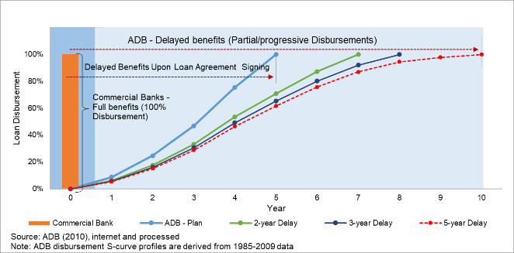
Figure-1: Loan Disbursements Comparison, Commercial Banks vs ADB

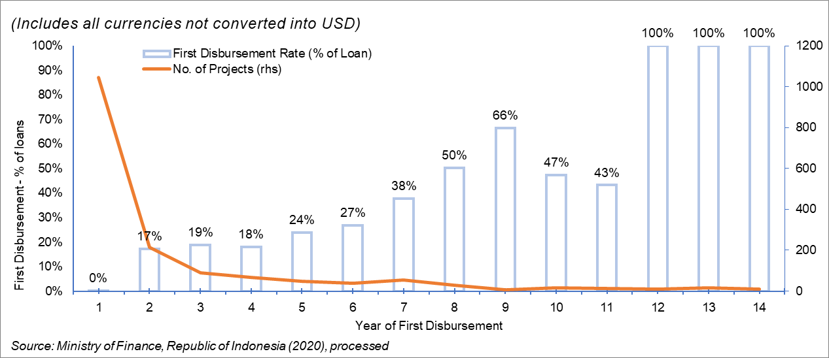
Figure-2: Indonesia-ADB Loans ‘First Disbursement’

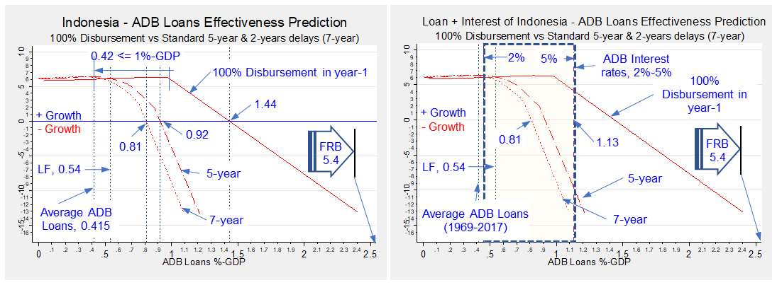
Note: LF = Loanable Fund and FRB = Fractional Reserve Banking. Source: Fauzi and Ingratubun (2020)
Figure-3: ADB Loans disbursement delay and interests impacts on Indonesia’s growth

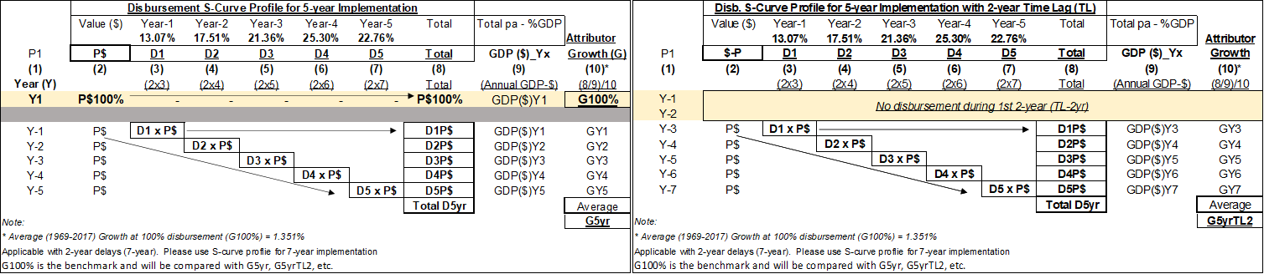
Figure-4: Basic Mechanics of the attribution methodology (DOA-BOGOR)

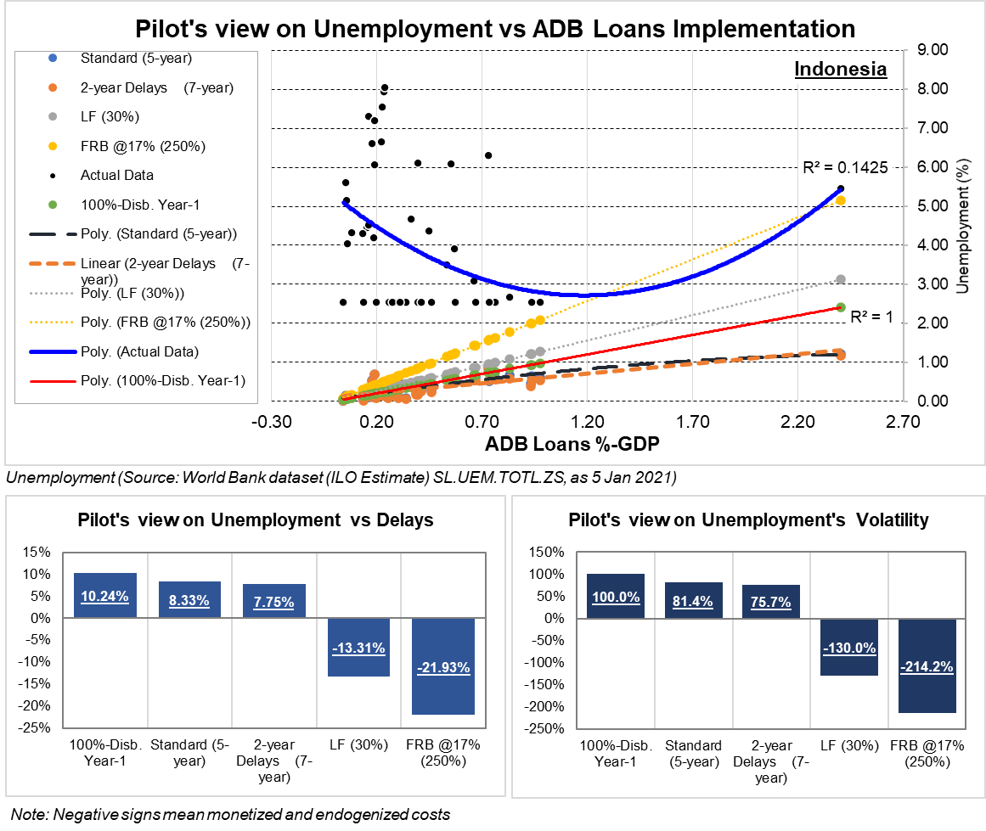
Figure-5: Indonesia Unemployment vs ADB Loans Relationship

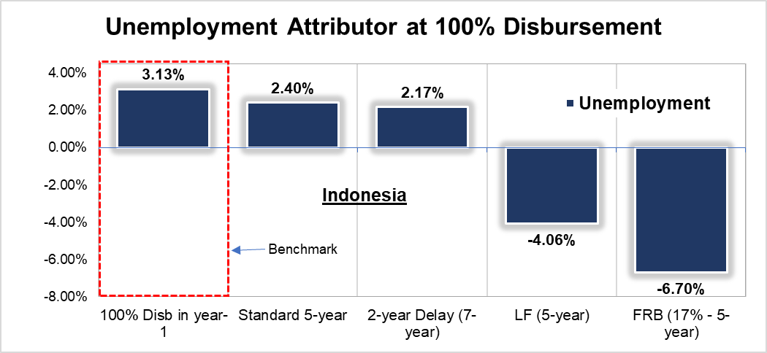
Source: Processed.
Figure-6: Unemployment attributor vs delays

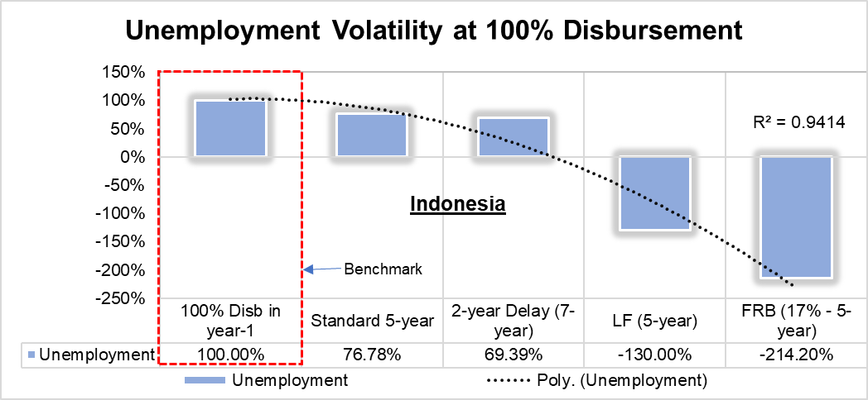
Source: Processed.
Figure-7: Unemployment attributor decays rate

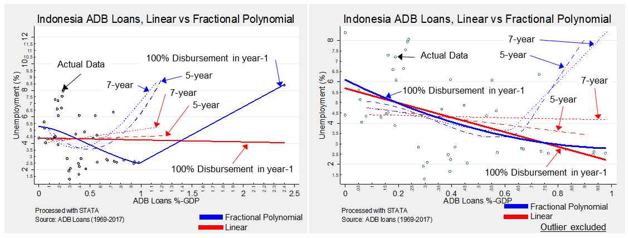
Source: World Bank dataset national estimate (SL.UEM.TOTL.NE.ZS, 2020). Processed with STATA.
Figure-8: Visual inspection of the best graphical representation of unemployment data, with and without outlier

Outlier excluded
Source: World Bank dataset national estimate (SL.UEM.TOTL.NE.ZS, 2020). Processed with STATA.
Figure-9: ADB’s loans effectiveness with a confidence interval, with and without outlier

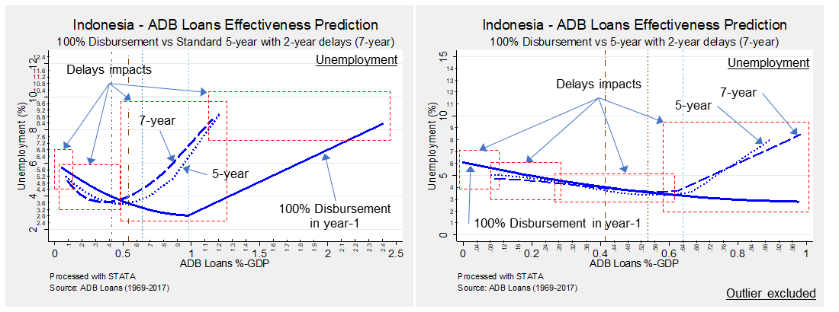
Source: World Bank dataset national estimate (SL.UEM.TOTL.NE.ZS, 2020). Processed with STATA
Figure-10: Impacts of delays on ADB loans effectiveness on Indonesia unemployment, with and without outlier

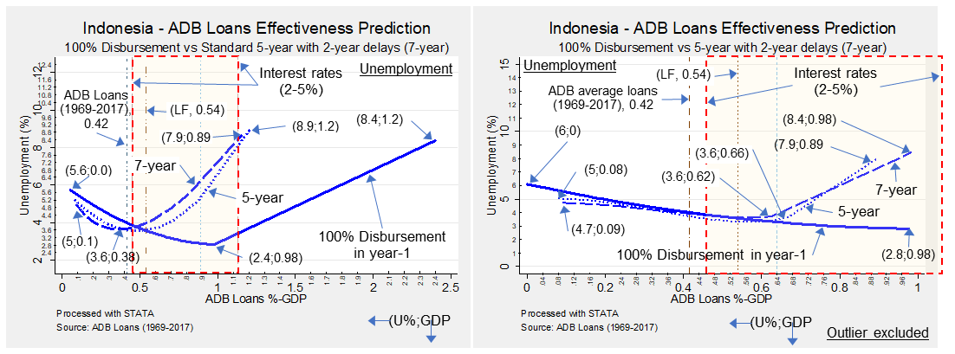
Source: World Bank dataset national estimate (SL.UEM.TOTL.NE.ZS, 2020). Processed
Figure-11: STATA’s predictions with Fractional Polynomial on ADB loans effectiveness on Indonesia unemployment, with and without outlier

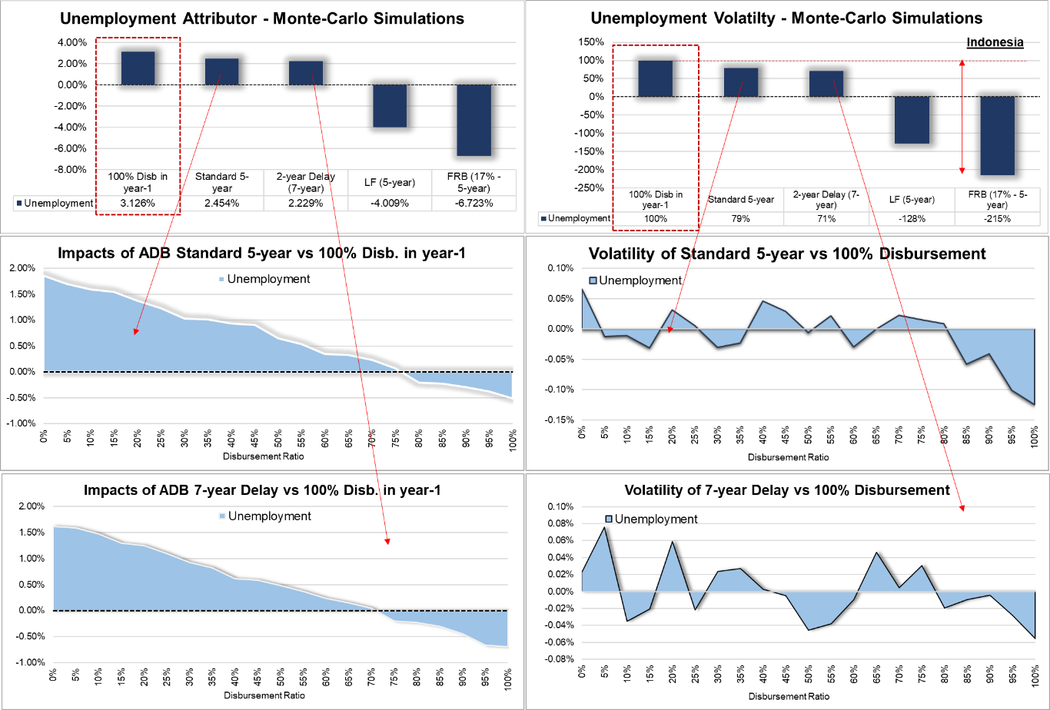
Note: Processed. Results may not be the same when rerun due to Monte-Carlo’s nature. Each bar was simulated with the same percentage of disbursement increment. World Bank dataset based on ILO estimate (SL.UEM.TOTL.ZS) is used.
Figure-12: Stochastic (Monte-Carlo) agent-based simulation (SABM) results showing the impacts of delays and their volatilities, measured against 100% disbursement.

Table-1: Normalized ADB Disbursement S-curve Profiles (2008-2017)

Table-2: Bayesian information criterion (BIC)
(Criteria: Best fit = smallest)
Model | Obs | ll(null) | ll(model) | df | AIC | BIC
Linear-All | 43 | - 90.38 | - 81.58 | 4.00 | 171.17 | 178.21
FP2-100% Diab. | 43 | - 21.49 | - 14.26 | 3.00 | 34.52 | 39.80
FP2-5-year | 43 | - 1.87 | - 0.92 | 3.00 | 7.85 | 13.13
FP2-7-year | 43 | 0.69 | 1.67 | 3.00 | 2.67 | 7.95
FP2-All | 43 | - 21.49 | 13.79 | 5.00 | - 17.58 | - 8.77
FP1-All | 43 | - 21.49 | 4.29 | 4.00 | - 0.59 | 6.45
Note: Processed with STATA. Data sources are from ADB (2020) and World Bank (2020)
FP = Fractional Polynomial; 1 and 2 are the maximum degree of FP being 2 is STATA’s default

Appendix-A: Indonesia ADB Loans Unemployment Attributors Estimated Annually

Appendix-B: Indonesia ADB Loans Unemployment Attributors Based on Total Average

Appendix-C: Indonesia ADB Loans Data (1969-2017)

Appendix-D: Summary Statistics

Appendix-E: Granger-causality Test

Appendix-F: Spearman Correlation Test

The Organization for Economic Co-operation and Development
Loans, grants, technical assistance (TAs), and in-kind assistance are categorized as aid (OECD, 2020). https://data.oecd.org/oda/net-oda.htm (25 Aug 2020)
ADB, 2018 Annual Portfolio Performance Report (APPR)
See McKee et all (2020) footnote 16 for more detailed elaborations on aid promotes or discourages growth at https://www.cgdev.org/sites/default/files/WP524-McKee-Mitchell-Aid-Effectiveness.pdf (14 Dec 2020)
Developing countries lose $2 for every $1 they earn. https://www.euractiv.com/section/development-policy/opinion/developing-countries-lose-2-for-every-1-they-earn/?fbclid=IwAR1-sYzJR0cWMFVtBiaBOuSe3Kp3RWqtlW70wG8f8mgJoGYvl7e4qxTItmU (23 Dec 2020)
Adopted based on Indonesia, Article 62.b, Law No.23 (1999) on Bank Indonesia.
Federal Reserve Bank, the central bank of the US.
ADB Information Statement 2020. https://www.adb.org/sites/default/files/institutional-document/417506/information-statement-2020.pdf (25 Aug 2020)
The British Broadcasting Corporation, https://www.bbc.com/
Savings calculator at https://www.thecalculatorsite.com/finance/calculators/savings-calculators.php (12 Dec 2020)
Keeping in mind that a signed LA is a promissory note and within the same day creates new money and generates gains thereupon.
Undang-Undang Republik Indonesia Nomor 23 Tahun 1999 Tentang Bank Indonesia
Current GDP in US$
Annual unemployment in %.
The London Inter-bank Offered Rate (LIBOR)
ADB Operations Manual OM Section D1/BP (Ordinary Capital Resources) https://www.adb.org/sites/default/files/institutional-document/31483/om-d1.pdf (Accessed 5 Jan 2021)
Ideally, subject to the availability of actual yearly disbursement data, they should be treated as the project progresses under S-curve profiles with compounded interest and fees on undisbursed sums added.
Source: https://data.adb.org/dataset/statement-adbs-sovereign-loans-1968-2017 (11 Dec 2020)
Source: World Bank Open Data https://data.worldbank.org or https://data.worldbank.org/topic/economy-and-growth (11 Dec 2020)
Source: https://fred.stlouisfed.org (11 Dec 2020)
See Bezemer & Hudson (2016) on 15% GDP transactions that contribute to growth.
STATA begins with 2 instead of 1
This is not yet incorporating money creation as a result of low time preference under LF and FRB.
This test only gives a one-dimensional view of data correlation. To have a 3-dimensional perspective, this needs to be triangulated with numerical, graphical, and stochastic approaches.
Under ADB’s 4% reserve ratio, yields $32 per $1 or 32 times of the loan value.
Amoral hazard is a situation in which decision-makers maximize their benefits while impairing others because of incomplete information on how things work, such as banking theories and practices and money creation.

