Copyrights Transfer Agreement

I, the undersigned below,

Name | : | Made Selphia Prahasasgita
Identity number | : | 5106024608010001
Type of  identification | : | √ Identity card ◻ driving license ◻ Passport Address
Institution | : | Program Studi Sarjana Psikologi, Fakultas Kedokteran, Universitas Udayana
Article title | : | Stimulus Untuk Meningkatkan Fungsi Kognitif Lansia: Literature Review

On behalf of all authors:

All authors name | : | Made Selphia Prahasasgita, Made Diah Lestari
All authors  email | : | selphia.gita@student.unud.ac.id , mdlestari@unud.ac.id

Hereby declare the following:

- I have the full power and authority to enter into and execute this Agreement and to convey the rights granted herein.
- The manuscript article is an original work which I have created independently. It has not been published before in its current or a substantially similar form.
- The manuscript article is not currently being considered for publication by any other journal or publication and will not be submitted for such review while under review by the Journal.
- Subject to the use of any third party rights where consents have been obtained in accordance with the paragraph below, I own all intellectual property rights vesting in the manuscript article.
- If third party material has been used in the manuscript article, I have obtained the necessary permission from the copyright holder/s to reproduce in the manuscript article, in all media in all countries, and transmit via all reputable third parties, any such materials including tables, figures and photographs not owned by me/us (Please upload any permissions documents.).
- The manuscript article does not contain any unlawful statements, does not infringe any existing copyright or violate any proprietary rights, rights of privacy or publicity, or any other rights of any third party. “Proof of consent” has been obtained for studies of named organisations and people (Please upload any evidence).
- All authors have received a final version of the manuscript article, take responsibility for the content, agree to its publication and the order of authors listed on the paper.
- Anyone who has made a significant contribution to the research and the manuscript article has been listed as an author. Minor contributors have been noted in the Acknowledgements section.
- I have declared any potential conflict of interest in the research. Any support from a third party has been noted in the Acknowledgements.
- I have read and adhered to the Journal author guidelines.

In consideration of Faculty of Psychology, Universitas Gadjah Mada agreeing to consider the above-named previously unpublished original manuscript for publication, I, by signing this form hereby assign Faculty of Psychology, Universitas Gadjah Mada the rights to publish my article. I understand that Faculty of Psychology, Universitas Gadjah Mada will act on my/our behalf to publish, reproduce, distribute and transmit the manuscript article and will authorise other reputable third parties (such as document delivery services) to do the same, ensuring access to and maximum dissemination of the manuscript. I am aware that by granting publishing rights to Faculty of Psychology, Universitas Gadjah Mada, granting third-party requests for reprinting and republishing is not permitted.

Furthermore, I am aware that author(s) retain the intellectual property rights and are free to share (copy and redistribute the material in any medium or format) and adapt (remix, transform, and build upon the material) for any purpose, subject to credit and attribution to the Journal as stated in the Journal’s Copyright Notice.

This agreement is made in a conscious state, without any coercion from any party, will not be withdrawn and can be used properly.

Denpasar, 16 December 2022
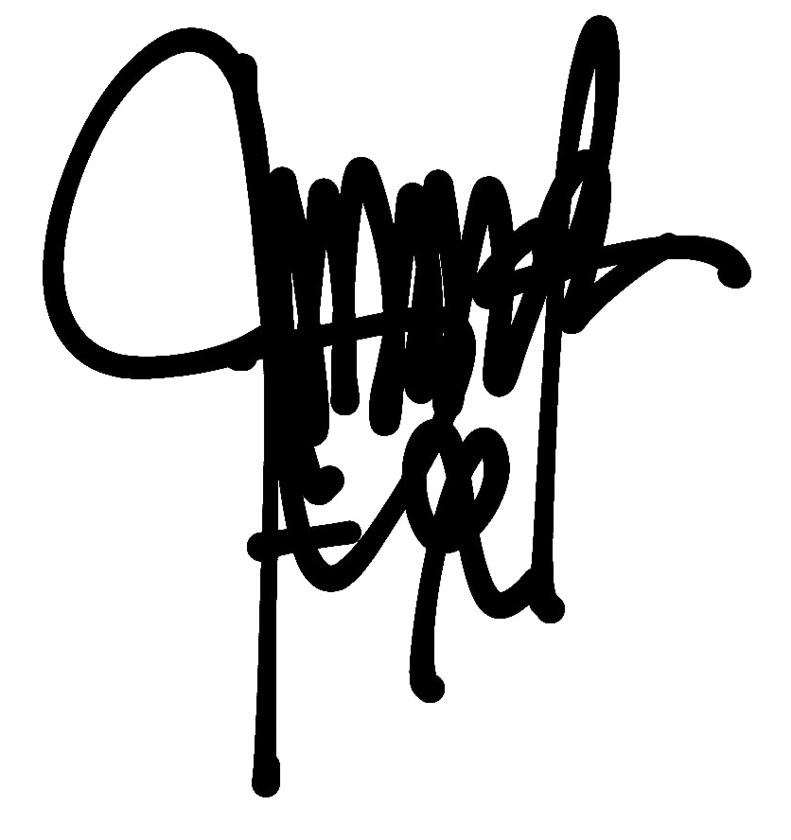

(Made Selphia Prahasasgita)

