Association Between Malaria Infections and Air Temperature at Kulon Progo District, Yogyakarta

Nilasari¹, Lutfan Lazuardi²
¹Departement of Environmental Health, Faculty of Medicine, Universitas Gadjah Mada, Yogyakarta, Indonesia, ²Departement of Health Policy and Management, Faculty of Medicine, Universitas Gadjah Mada, Yogyakarta, Indonesia.

Nilasari, Jalan Kaliurang KM 5.6, Pandega Siwi No.9, Sleman, Yogyakarta, 55281, 085727166340, nila.sari18@yahoo.co.id

ABSTRACT
Introduction. Malaria is still major public health issue in Indonesia. Kulon Progo, District remains high endemic area, with significant number of malaria cases for more than the last ten years. While previous study suggests that transmission of malaria is associated with climate conditions, it is not yet known whether this is also the case in Kulon Progo, District. Aim. The aim of the study was to analyze the association between malaria cases and climate data i.e. air temperature and to evaluate spatial-temporal distribution of malaria cases in Kulon Progo District, Yogyakarta. Method. This is an ecological study, which analyzes malaria cases in relation with climate data using spatial approach. A total of 1439 malaria cases were collected during the period of 2005-2015. Time-trend, bivariate analysis, and spatial analysis were performed. Results. The results show that air temperature lag 0 (p = 0.0000; r = 0.5225), air temperature lag 1 (p = 0.0009; r = 0.2850), air temperature lag 2 (p = 0.0329; r = 0.1858), are related to the incidence of malaria. Spatial analysis and time-trend analysis also shows direct relationship pattern between malaria and air temperature in Kulon Progo during the period of 2005-2015, with exception in the year 2006 and 2012. Conclusion. There is a relationship between malaria cases and air temperature. Spatial analysis approach is important for early alert system, to decrease morbidity and mortality due to malaria.
Keywords: malaria, air temperature, spatial analysis, yogyakarta.

- Introduction
Malaria is caused by Plasmodium parasites carried by Anopheles mosquitoes, malaria is the biggest killer disease called strike densely populated countries, especially in tropical and subtropical countries. Malaria transmission is highly sensitive to climatic conditions in the area, such as air temperature which climatic factors can reduce or increase the vector density.^{(1,2)} It is estimated that 3.2 billion people in 95 countries live in areas with high risk infection malaria, in 2015 there are 214 million new cases of malaria with 438.000 cases of malaria deaths, which is 88% occurred in Africa, 2% in East Mediterranean and 10% occurred in Asia including Indonesia.⁽³⁾
Malaria incidence is one of the indicators of the Millennium Development Goals (MDGs), which targeted to stop the spread and reduce the incidence of malaria by 2015 based on the indicator of decreased morbidity and mortality due to malaria. With the expiration of the MDGs by 2015, global commitments such continued through the Sustainable Development Goals (SDGs), which put an end to the AIDS epidemic, tuberculosis, malaria, tropical neglected disease in 2030.^{(3.4)}
In Indonesia malaria is a public health problem, which efforts to control malaria in Indonesia is monitored using indicators Annual Parasite Incidence (API) where every case of malaria must be proven by the results of blood examination and all positive cases should be treated with artemisinin-based combination drugs or ACT(Artemisinin-based Combination Therapies).^{(5.6)}
Yogyakarta province contributes in malaria burden of disease in Indonesia and the outbreak malaria cases occurred in Kulon Progo District. Kulon Progo District is one of the four districts in Yogyakarta Province, with capital city of Wates situated 30 km west of the city of Yogyakarta with area of 586.28 km². Kulon Progo area is mainly, flat surrounded by mountains that are mostly located in the northern region.⁽⁸⁾
Malaria is a disease that have not been successfully eliminated in Kulon Progo District, with persistent annual occurrence of the disease. The trend of malaria cases in Kulon Progo District from year 2005-2015 fluctuates with total number of cases reached 1439 cases in the last 11 years compared with the other endemic area in Indonesia.⁽⁸⁾
Climate change potentially increase the incidence of malaria where, climate change would caused temperature increase and will accelerate the growth of the gonotrophic cycle in mosquitoes, resulting in higher breeding rate and this rapidly increases, the mosquito population.^{(1,19)}Previous studies, show that air temperature is one explanatory factors in the increase in malaria cases but has not received adequate research focus.⁽⁹⁾
One method that can describe and monitor cases of malaria is the Geographic Information System (GIS), where spatial analysis can provide graphic information on the spread of malaria in relation with the air temperature in a region. The output of the mapping would assist in determining the spatial distribution, and in designing a control programs pertaining to reducing morbidity and mortality due to malaria through better prediction on future malaria patterns.^{(11.12)}
- Materials and methods

Materials

The place of this research is in Kulon Progo District, Yogyakarta. Population and sample in this study were all population with malaria of the District Health Office of Kulon Progo District in 2005-2015 from facility based reports, which during that period there were 1439 cases of malaria and air temperature weather data from Indonesian Agency for Meteorological, Climatological and Geophysics Province of Yogyakarta, Public Works Department of Housing and Energy of Mineral Resources Province of Yogyakarta and Great Hall of River Serayu Opak Province of Yogyakarta during the period 2005-2015 in Kulon Progo District. ⁽⁸⁾

  - Methods
Design of this research is study of ecology with the approach according to time, this study uses secondary data obtained documents/files regular reports from Indonesian Agency for Meteorological, Climatological and Geophysics Province of Yogyakarta, Public Works Department of Housing and Energy of Mineral Resources Province of Yogyakarta and Great Hall of River Serayu Opak Province of Yogyakarta for providing meteorological data, such as air temperature data per month and per year during the period 2005-2015 in Kulon Progo District and malaria case data from the District Health Office of Kulon Progo ⁽¹³⁾.

Data Analysis
Analysis graph/time-trend to show a pattern relationship based on graph between malaria cases with air temperature in Kulon Progo District ⁽¹³⁾. Bivariate analysis using correlation Spearman test, with variable air temperatures during the same month (lag0) to three months earlier (lag3), the purpose of using time-lag is to show which correlation values will be stronger in the air temperature at the same month until to the previous three months associated with malaria cases.⁽¹⁴⁾ Spatial analysis of air temperature analyzed using Mock method, with estimates through the nearest weather station as a reference, to determine the elevation of each of these stations can be assumed that every increase in elevation of 100 m the temperature will decrease by 0.6°C.⁽¹⁵ ⁾ In this study the station that became references is station Kokap with elevation is 400 mdpl because in the station Kokap data is available from 2005 to 2015 compared of other station. The value of air temperature data based other station point there are St. Galur (100 mdpl), St. Girimulyo (500 mdpl), St. Kalibawang (550 mdpl), St. Low (100 mdpl), St. Nanggulan (520 mdpl), St. Climbing (100 mdpl), St. Compassion (350 mdpl), St. Samigaluh (350 mdpl), St. Sentolo (100 mdpl), St. Temon (100 mdpl), and St. Wates (100 mdpl), and the value of air temperature in each District show by degradation line that is classified into 3 groups include: low temperature (20°C-23°C), moderate temperature (23°C-26°C) and high temperature (26°C-29°C) based on ouput Mock Method, output of malaria cases were classified into 4 criteria endemicity malaria cases is zero case, HCI (High Case Incidence) API>5 ‰, MCI ( Moderate Case Incidence) API 1-<5 ‰ and LCI (Low Case Incidence) API <1 ‰ show in different colors to the condition endemicity of malaria in a Sub-District, the pattern of the relationship between malaria cases and air temperature show by overlay.⁽⁶⁾

- Results
The average air temperature conditions in Kulon Progo District during 2005 and 2015 is 26.61°C with a standard deviation of 0.84°C. The minimum value of the air temperature is 25.2°C that was happened in February 2008, February 2009, June 2013, while the maximum value of air temperature was 28.6°C which was happened in September 2009.
The results of the bivariate analysis variable air temperature with malaria cases showed positive correlation when the air temperature increases, the distribution of malaria cases will increase as well. The value of the correlation will increase if the air temperature in the same month (lag0) associated with the distribution of malaria cases showed significant value of p-value is 0.0000<0.05 it means there is a relationship between air temperature (lag0) with a distribution of malaria cases, with r = 0.5225 statistically including moderate (Table1). In the graph/time-trend of the average air temperature and malaria cases by year during the last 11 years show a pattern of trends means that every increase in air temperature the distribution of malaria cases will increase as well (Figure 1). In the spatial analysis relationship between air temperature and malaria cases during the 11 years of the movement, malaria cases spread in all Districts, places where endemicity MCI and LCI has a value of temperatures from 23°C-29°C (Medium and high air temperature) (Figure 2).

- Discussion
Malaria cases from 2005 to 2015 have fluctuated. The average incidence of malaria in Kulon Progo District during 2005-2015 were 11, highest malaria cases occurred in January 2012 there are 74 malaria cases, while the highest malaria cases by year for the last 11 years occurred in 2005 was 248 malaria cases. The average air temperature by month during the last 11 years show in January is the month with the highest air temperature. Distribution of malaria cases dominant in Sub-Districts located in the Hills Menoreh with topography such as: height of ± 500-900 mdpl, most plants covered canopy, an average temperature of 28°C-30°C, compatible for breeding place of Anopheles Mosquitoes as a vector of malaria⁽⁸⁾.
Mosquitoes are a group of animals, in the class of insects, metabolism can influenced by the air temperature in the area, in this study based on graph/time-trend and analysis spatial within a few years show a pattern relationship, except in 2006 and 2012 because the air temperature is high the malaria cases is low, air temperature can be affected by several factors, as an air humidty, rainfall, etc.⁽²⁰⁾ Based on analysis statistic, air temperature associated with the distribution of malaria cases, this is in line with research Gunawan (2000), Raharjo (2003) and Huang (2011) which stated that there is a relationship between air temperature and malaria cases ^{(9,17,18)}.
The correlation of air temperature with malaria cases showed positive correlation when the air temperature increases, the distribution of malaria cases will increase as well. The value of the amount of correlation will increase if the air temperature in the same month lag 0 (p-value = 0.0000;r=0.5225) including moderate, January is the month with the case of malaria highest air temperature highest. Meanwhile, the results of the analysis spatial between air temperature with the case of malaria, showing places where endemicity MCI and LCI has a value of air temperature from 23°C-29°C.
Air temperature can affect physiological activities of living beings, because the body will adjust to maintain body heat in order to remain metabolic mechanisms. Mosquitoes are cold-blooded animals so that their metabolism and life cycle depends on the ambient air temperature, at a temperature less than 16°C and over 32°C it will disturb metabolism of the mosquito.
The air temperature optimum for mosquitoes in 23°C-27°C, tolerances on air temperature conditions for each species of mosquitoes are not the same, but almost all species of mosquitoes can not survive at air temperatures extreme environment that changes between 5°C-6°C because of difficult in the process of adaptation. Air temperature will affect in the sporogoni cycle or incubation extrinsic period, the higher air temperature, it can shorten the time sprogoni cycle, sporogoni cycle appropriate air temperature on daily average air temperature from 27 °C ^{(1.19)}. The water of air temperature can also affect the breeding of larvae of the Anopheles Mosquitoes, larvae is common live in warm places, one contributing factor why the Anopheles Mosquitoes are more in tropical areas, a hatching eggs of mosquitoes are also dependent on the air temperature, the higher the water air temperature it will the faster hatch ⁽¹⁹⁾.
Research by Rahman (2011) in Bangladesh, Hakim (2007) in Sukabumi give the result if the weather variables as an air temperature can be used to monitor increasing malaria cases and weather data used as an early warning system to be prevention outbreak malaria cases. Climate condition and disease events have a relationship, especially in infectious diseases. This result can be using to implementation policy to malaria control program, the increase of malaria cases beginning in October and more significant at the beginning of the year, the malaria contro program can be doing before the October.^{(21,22,23)}

- Conclusions
There was correlation between the air temperature and malaria cases in Kulonprogo District. The Implementation of malaria control program should pay attention to weather patterns and the approach with the spatial analysis Geographic Information Systems (GIS) is important to early warning systems to comprehensive malaria control program.

Acknowledgements
The authors express gratitude to LPDP (Institute for the Management of Education Funds), Ministry of Finance of the Republic of Indonesia for their financial support. The authors acknowledge District Health Office of Kulon Progo Municipality for providing malaria data; and Indonesian Agency for Meteorological, Climatological and Geophysics Province of Yogyakarta, Public Works Department of Housing and Energy of Mineral Resources Province of Yogyakarta and Great Hall of River Serayu Opak Province of Yogyakarta for providing meteorological data.

References
1. Sucipto CD. Manual Lengkap Malaria. Yogyakarta: Gosyen Publishing; 2015.
2. Harijanto P.N., Nugroho, A., Gunawan, C.A. Malaria dari Molekuler ke Klinis, Ed.2. Jakarta: Penerbit Buku Kedokteran EGC; 2009.
3. WHO. World Malaria Report 2015. Geneva, Switzerland: World Health Organization;2015.
4. Ditjen Pengendalian dan Penyehatan Lingkungan Kementerian Kesehatan RI. Buku Saku Menuju Eliminasi Malaria. Jakarta: Kementerian Kesehatan RI; 2011.
5. Ditjen Pengendalian dan Penyehatan Lingkungan Kementerian Kesehatan RI. Buku Saku Penatalaksanaan Kasus Malaria.Jakarta: Kementerian Kesehatan RI;2012.
6. Pusat Data dan Informasi Kesehatan Kesehatan RI. Situasi Malaria di Indonesia. Jakarta : Kemenkes RI; 2014.
7. Dinas Kesehatan,DIY. Profil Kesehatan D.I Yogyakarta Tahun 2015. Yogyakarta: Dinas Kesehatan,DIY; 2015.
8. Dinas Kesehatan Kabupaten Kulon Progo. Profil Dinas Kesehatan Kabupaten Kulon Progo Tahun 2016. Yogyakarta: Dinas Kesehatan Kabupaten Kulon Progo; 2016.
9. Gunawan NA. Analisa Spatial Penyakit Malaria di Kabupaten Banjarnegara Provinsi Jawa Tengah Tahun 1996 - 2000. Jakarta : Perpustakaan FK UI; 2000.
10. Gunawan D. Gas Rumah Kaca dan Perubahan Iklim di Indonesia. Cetakan I. Jakarta: Pusat Penelitian dan Pengembangan Badan Meteorologi Klimatologi dan Geofisika; 2013.
11. Riyanto D. Pengembangan Aplikasi Sistem Informasi Geografis. Yogyakarta: Gava Media; 2009.
12. Arsin AA. Pola Spasial Kasus Malaria dengan Aplikasi Sistem Informasi Geografis (SIG) di Kabupaten Halmahera Tengah 2008. Jakarta : Jurnal Masyarakat Epidemiologi Indonesia, Volume 1, Nomer 2; 2008.
13. Chandra B. Metode Penelitian Kesehatan. Jakarta: Penerbit Buku Kedokteran EGC; 2005.
14. Dahlan M s. Mendiagnosis dan Menata Laksana 13 Penyakit Statistik. Jakarta: Sagung seto; 2010.
15. Mock FJ. Land Capability Appraisal Indonesia Water Availability Appraisal : Food and Agriculture Organitation of United Nations; 1973.
16. Prahasta E. Sistem Informasi Geografis. Bandung: Informatika; 2014.
17. Raharjo M. Studi Klimograf Perubahan Cuaca dan Bangkitan Malaria di Kabupaten Banjarnegara.Jurnal Kesehatan Lingkungan, Volume 2; 2003.
18. Huang F, Zhou S, Zhang S, Wang H, Tang L. Temporal Correlation Analysis Between Malaria and Meteorological Factors in Motuo County , Tibet. 2011;1–8.
19. Santjaka A. Malaria Pendekatan Model Kausalitas. Yogyakarta: Nuha Medika; 2013.
20. Tjasyono.Klimatologi. Bandung: Institut Teknologi Bandung; 2004.
21. Achmadi,U.F.Manajemen Penyakit Berbasis Wilayah. Jakarta: UI Press; 2010.
22. Hakim, L.,Ipa, M.Sistem Kewaspadaan Dini KLB Malaria berdasarkan Curah Hujan, Kepadatan Vektor dan Kesakitan Malaria di Kabupaten Sukabumi.XVII,pp.34-40.2007.
23. Rahman, A., Kogan, F., Roytman, L., Goldberg, M. and Guo, W.,Modelling and Prediction of Malaria Vector Distribution in Bangladesh From Remote-Sensing Data.International Journal Remot Sensing.pp.37-41.2011.

Table(s)
Table1. Correlation Between Air Temperature (lag 0-lag3) with Malaria Cases
In Kulon Progo District Year 2005-2015

Air Temperature
 | lag 0 | lag 1 | lag 2 | lag 3
p-value | 0.0000 | 0.0009 | 0.0329 | 0.1360
r | 0.5225 | 0.2850 | 0.1858 | 0.1304

Figure legend(s)
Figure. 1. Graph/time-trend malaria cases and average air temperature in Kulon Progo District from January 2005 to December 2015.

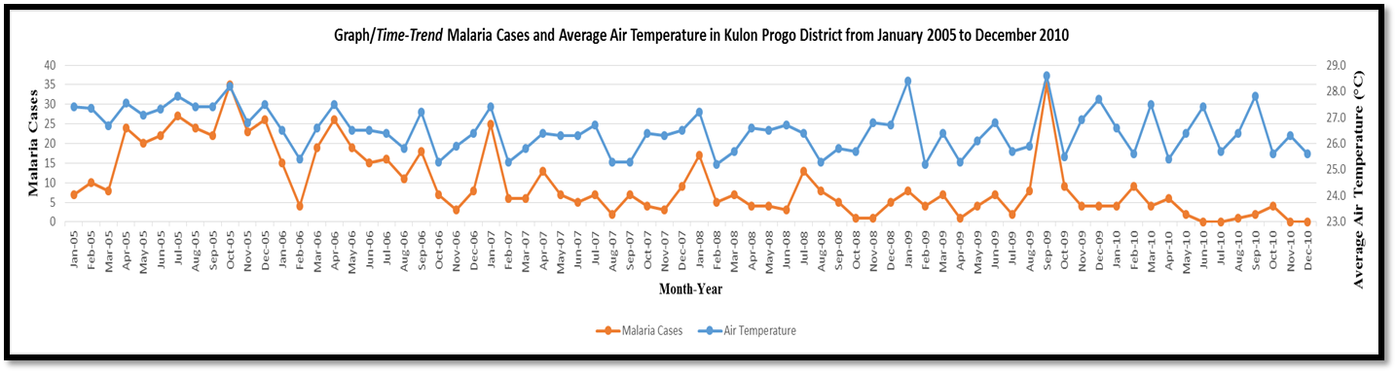
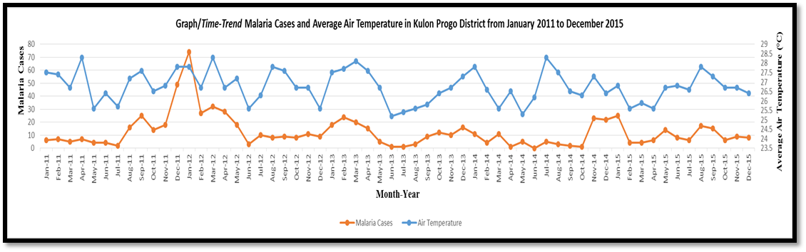
Figure. 1. Graph/Time-Trend Malaria Cases and Average Air Temperature in Kulon Progo District from January 2005 to December 2015.

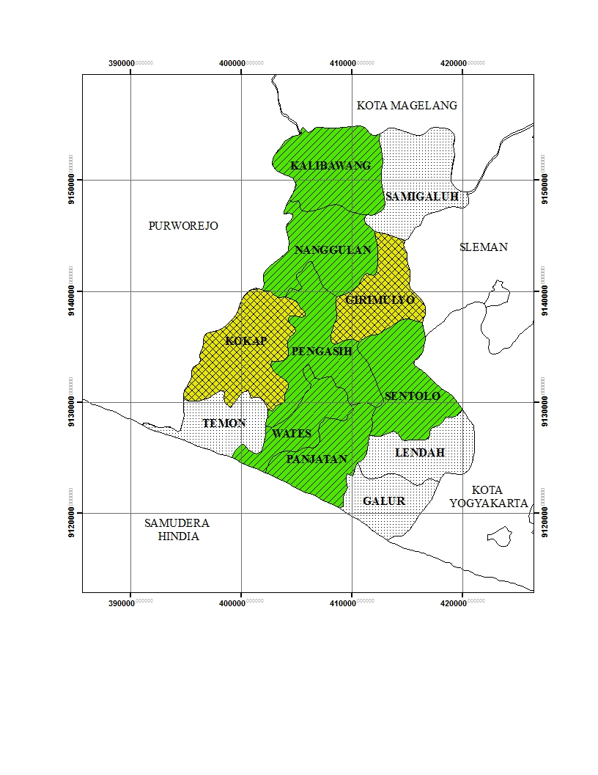  Figure. 2. Mapping of air temperature based on criteria endimicity in Kulon Progo District from 2005-2015. | 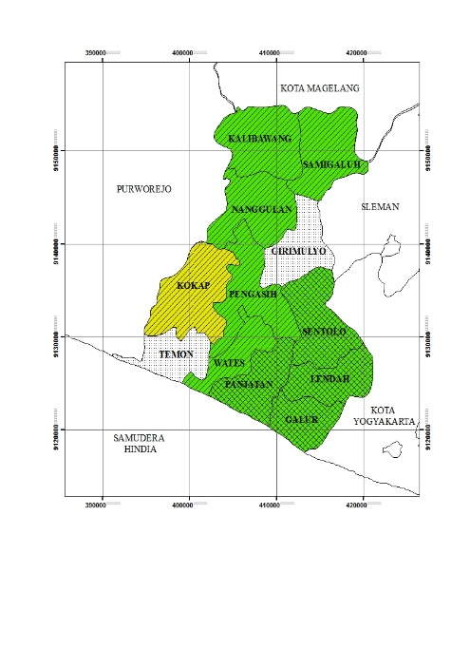 | 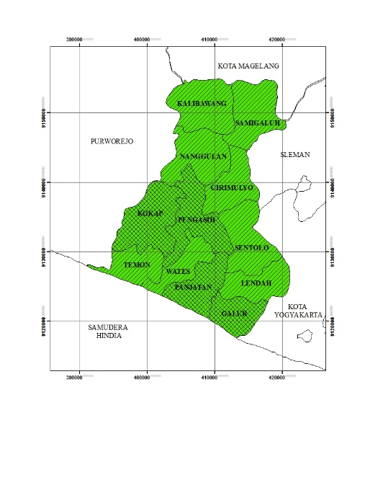
Year 2005 | Year 2006 | Year 2007
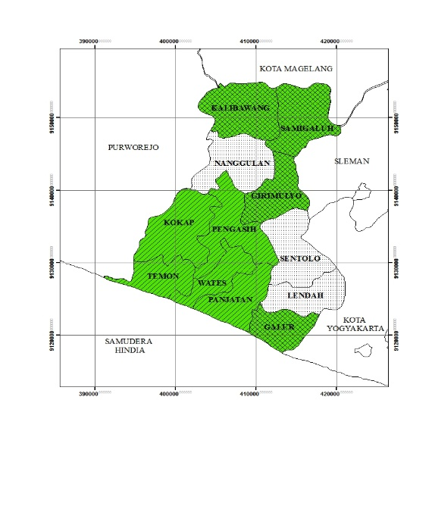 | 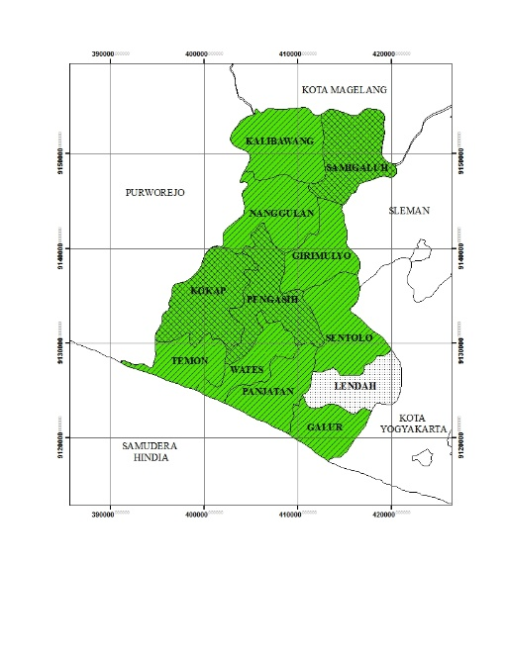 | 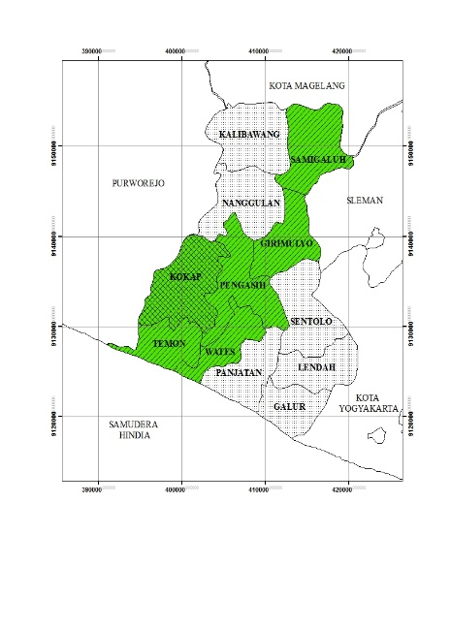
Year 2008 | Year 2009 | Year 2010

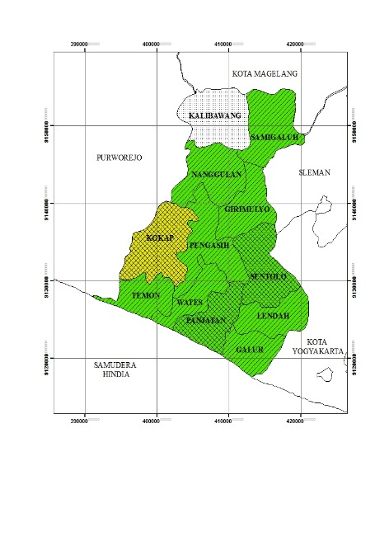 | 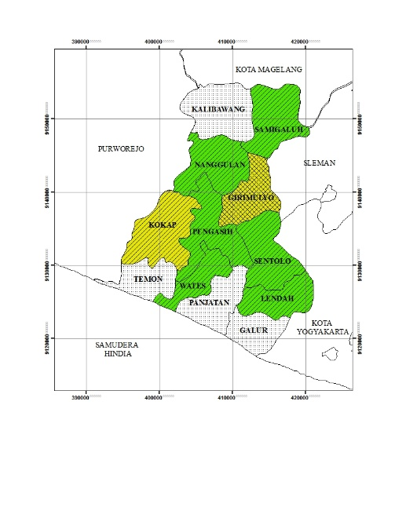 | 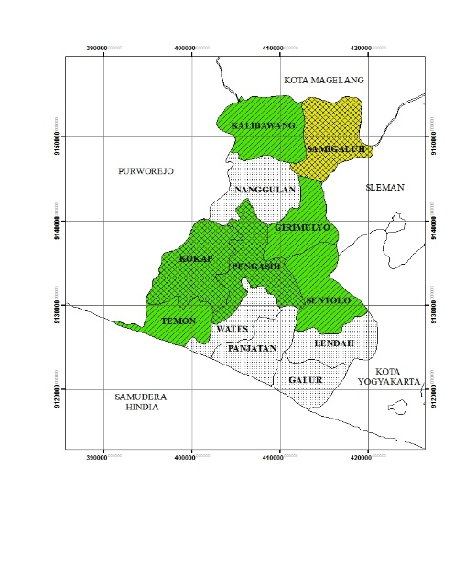
Year 2011 | Year 2012 | Year 2013
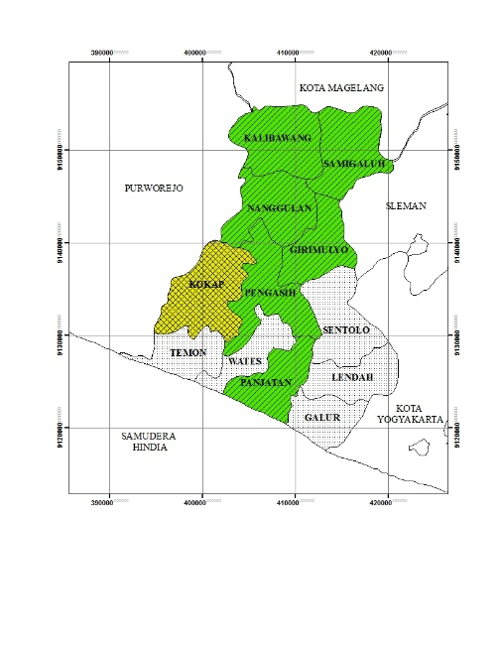 | 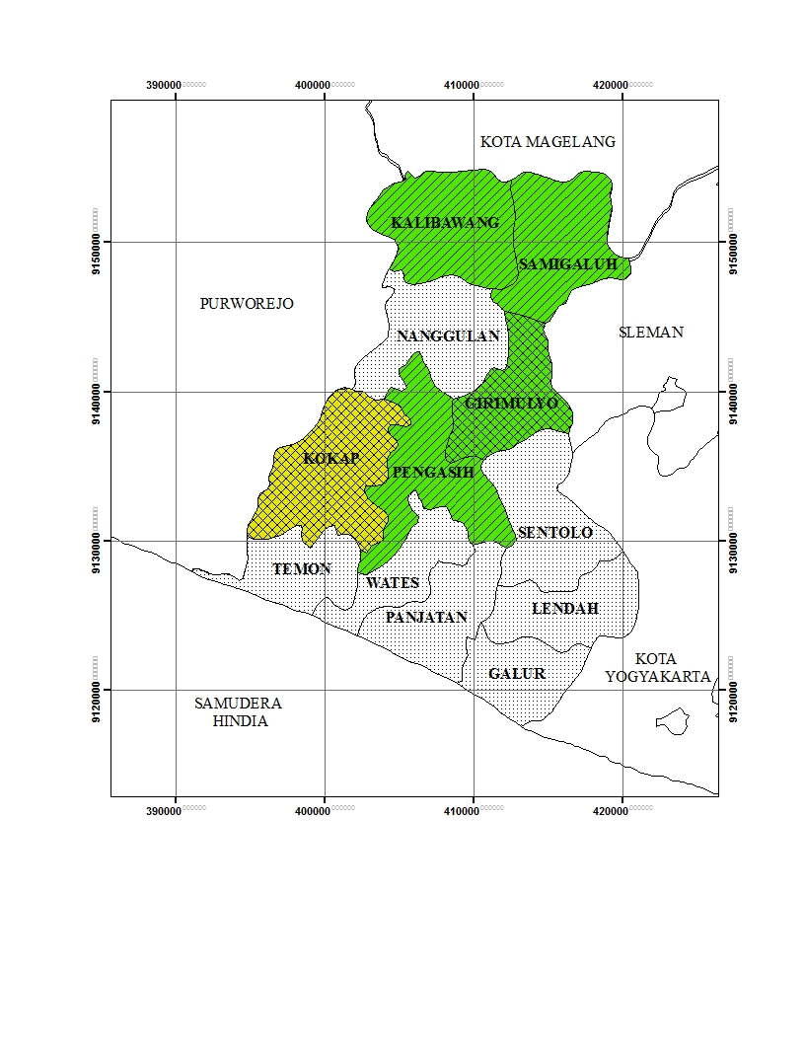 | 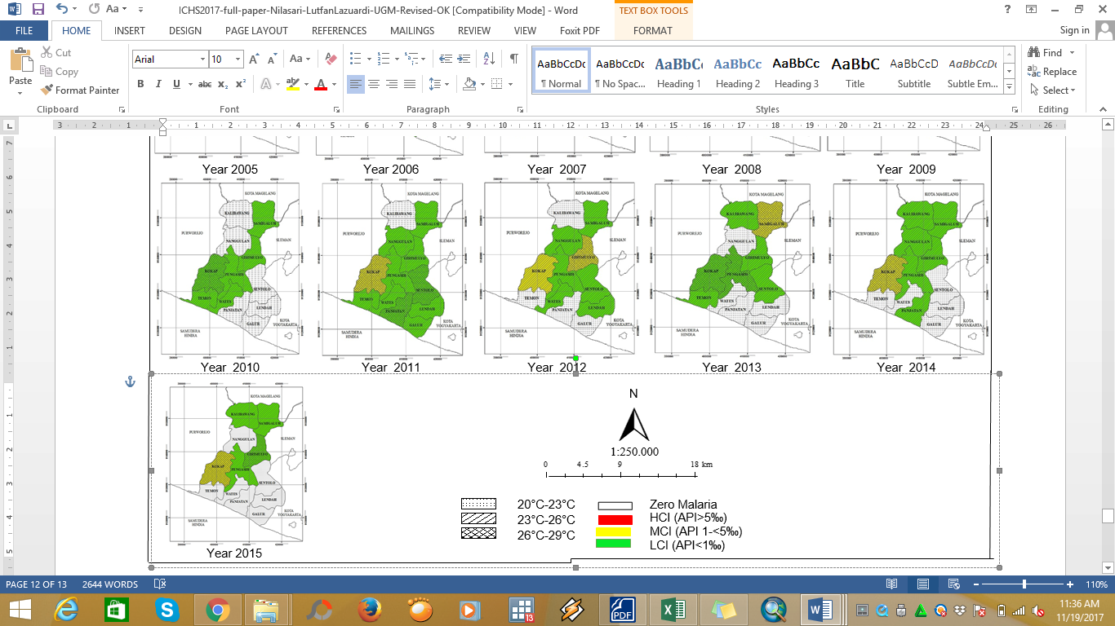  Information :
Year 2014 | Year 2015
Figure. 2. Mapping of air temperature based on criteria endimicity in Kulon Progo District from 2005-2015

