Molecular Mechanism of Synthesized Potential Anticancer Agent Chalcone
in Leukemia Cell Line K562
Arina Novillaª, Mustofa Mustofa^{b}, Indwiani Astuti^{c}, Jumina Jumina^{d}, Hery Suwito^{e}

ªDoctoral Program of Faculty of Medicine, Gadjah Mada University, Yogyakarta, Indonesia
^{b,c}Faculty of Medicine, Gadjah Mada University, Yogyakarta, Indonesia
^{d}Faculty of Chemistry, Gadjah Mada University, Yogyakarta, Indonesia
^{e}Doctoral Program of Faculty of Chemistry, Gadjah Mada University, Yogyakarta, Indonesia

Corresponding author: Arina Novilla, arin_novilla@yahoo.co.id

ABSTRACT
Chalcone, a precursor of flavonoids that are abundantly found in plants, has been investigated and found to possess anticancer activity. This study aimed to evaluate the effect of chalcone derivatives on the PI3K/AKT signaling pathway in the K562 cell line. A K562 cell line was treated with two chalcone derivatives: (E)-1-(4-aminophenyl)-3-(2,3dimethoxyphenyl)-prop-2-en-1-one (Compound 4), and (E)-1-(4-aminophenyl)-3-phenylprop-2-en-1-one) (Compound 7), and compared to the anticancer drugs imatinib and accutane. Measurement of AKT caspase-3, STAT3, and cyclin D1 were performed with ELISA, whilst cell cycle and apoptosis analysis were performed using flow cytometry. Both Compound 4 and Compound 7 at all concentrations showed the most significantly decreased AKT levels in K562. Compound 4 at 5 and 10 µg/mL, and Compound 7 at 10 µg/mL, significantly increased caspase-3 on K562, although this was lower than when using imatinib. Compound 4 and Compound 7 in all concentrations showed decreasing STAT3 on K562, which were comparable to imatinib. Compound 4 and Compound 7 showed the highest decrease of cyclin D1 among treatments, and also arrested G₀/G₁ and G₂/M phase in K562 cells, with the results being comparable to imatinib and Isotretinoin. Compound 4 and Compound 7 are promising anticancer agents that function via inhibition of the PI3K/AKT signaling pathway, induction of apoptosis through up-regulation of apoptotic markers, and blockade of cell cycle progression by regulating cell cycle-related factors.

ABSTRAK
Chalcone, prekursor flavonoid yang banyak ditemukan pada tanaman, telah diteliti dan diketahui memiliki aktivitas antikanker. Penelitian ini bertujuan untuk mengevaluasi efek senyawa turunan kalkon pada jalur sinyal PI3K / Akt pada sel lini K562. Sel lini leukemia K562 diperlakukan dengan dua senyawa turunan kalkon : (E) -1- (4-aminofenil) -3- (2,3dimethoxyphenyl) -prop-2-en-1-satu (Compound 4), dan (E) - 1- (4-aminofenil) -3-phenylprop-2-en-1-satu) (Compound 7), dan dibandingkan dengan obat antikanker imatinib dan isotretinoin. Pengukuran AKT caspase-3, STAT3, dan cyclin D1 dilakukan dengan ELISA, sementara siklus sel dan analisis apoptosis dilakukan dengan menggunakan flowcytometry. Kedua Senyawa 4 dan Compound 7 pada semua konsentrasi menunjukkan penurunan kadar AKT secara signifikan pada sel K562. Senyawa 4 pada 5 dan 10 µg/mL, dan senyawa 7 pada 10 µg/mL, secara signifikan meningkatkan caspase-3 pada sel K562, meskipun lebih rendah dibandingkan imatinib. Senyawa 4 dan senyawa 7 di semua konsentrasi menunjukkan penurunan kadar STAT3 pada sel K526, yang sebanding dengan imatinib. Senyawa 4 dan senyawa 7 menunjukkan penurunan kadar Siklin D1 tertinggi diantara perlakuan, dan juga terhentinya sel K562 pada fase G0/G1 dan G2 fase/M, dengan hasil yang sebanding dengan imatinib dan Isotretinoin. Senyawa 4 dan senyawa 7 merupakan agen antikanker yang menjanjikan melalui penghambatan jalur sinyal PI3K/AKT, induksi apoptosis melalui up-regulasi penanda apoptosis, dan menghambat progresi siklus sel oleh faktor-faktor yang berhubungan dengan pengaturan siklus sel.

Keyword : Anticancer, Chalcone, Leukemia, Cell Line K562

INTRODUCTION
Leukemia is a cancer of the white blood cells characterized by the widespread, rapid, and disorderly proliferation of leukocytes (Campana and Pui 2008; Modak et al. 2011). Leukemia is a rare disease; however, it exceeds the number of deaths caused by acute communicable diseases due to its fatal character (Modak et al. 2011). In 2012, leukemia was suffered by approximately 352,000 people around the world and caused 265,000 deaths (Stewart and Wild. 2014).
The PI3K/Akt signaling pathway plays an important role in both normal and malignant hematopoiesis (Martelli et al, 2010; Polak and Buitenhuis, 2012). The activity of AKT is regulated by P13K, which brings AKT into the cell membrane upon PIP3 binding, which is activated by PDK1 (Kandel and Hay, 1999). Activated AKT is an essential survival factor which inhibits apoptosis through phosphorylation of several targets, including Bad, FoxO transcription factors, Raf-1 and caspase-9 (Hanada et al, 2004). AKT also activates the transcription activator (STAT3), which is critical for leukemia cell survival and proliferation (Chiarini et al, 2012). Activation of STAT3 leads to tumor-promoting gene products, including cleavage caspase-3, cleavage poly ADP-ribose polymerase (PARP), cyclin D1, and survivin. Thus, these pathways are commonly targeted in cancer treatments.
Nowadays, chemotherapy is one of the most effective and potent strategies for the treatment of cancer (Ge et al. 2009). However, the use of anticancer treatments as chemotherapy is limited. All of the current anticancer drugs have severe side effects in normal cells due to their non-specificity. In addition, the resistance of cancer cells to anticancer drugs remains a significant challenge to successful chemotherapy (Liang et al. 2010). Therefore, the discovery and development of new anticancer treatments with specific targets and novel mechanisms are urgently required.

Compound 4 Compound 7
(E)-1-(4-aminofenil)-3-fenilprop-2-en-1-on (E)-1-(4-aminofenil)-3-(2,3-dimetoksifenil)prop-2-en-1-on

FIGURE 1. Chemical structure chalcone derivatives

Chalcones are precursors of flavonoids, which are abundantly found in plants, and are reported to possess anticancer activity (Figure 1). Several chalcones have been isolated or synthesized, and their cytotoxicity on cancer cell lines in vitro and their anticancer activity in cancer animal models have been reported (Saydam et al. 2003; Karthikeyan et al. 2015). Furthermore, the molecular mechanisms of the anticancer action of chalcones have also been investigated. The chalcones exhibited anticancer activity through multiple mechanisms including cell cycle disruption, angiogenesis inhibition, tubulin polymerization inhibition, apoptosis induction and blockade of the nuclear factor-kappa B (NF-κB) signaling pathway (Karthikeyan et al. 2015; Mandge et al. 2007).
We previously evaluated the cytotoxic activity of several chalcone derivatives on the K562 cell line, resulting in two chalcones showing the lowest IC₅₀ on K562: (E)-1-(4-aminophenyl)-3-(2,3 dimethoxyphenyl)-prop-2-en-1-one (Compound 4), and (E)-1-(4-aminophenyl)-3-phenylprop-2-en-1-one) (Compound 7). Thus, to evaluate the effects of Compound 4 and Compound 7 compared to leukemia drugs, imatinib, and Isotretinoin , on the level of AKT, Caspase-3, STAT3, Cyclin D1, and cell cycle in leukemia cell line, K562.

MATERIALS AND METHODS
Tested Compounds
The methoxy amino chalcone derivatives were synthesized by Dr. Hery Suwito in the Department of Chemistry, Faculty of Mathematics and Natural Science, Airlangga University, Surabaya, Indonesia.

Cell Culture
The K562 cell lines were obtained from Stem Cells and Cancer Institute (SCI) Jakarta, Indonesia. The cell lines were maintained in iscove's modified dulbeco's medium (Biowest L0190-500) supplemented by 10% fetal bovine serum (FBS) (Biowest S181H2), and 2% penicilin-streptomycin (Biowest L0022-100). The cell line was maintained at 37°C in a 5% CO₂ atmosphere with 95% humidity. After 24 hours of incubation, the number of viable cells was counted using a haemocytometer with tryphan blue staining.

Measurement of AKT on K562
The concentration of AKT was determined using an ELISA kit (ab176657). After pre-incubation of K562 treated with Imatinib (10 and 50 µg/mL), Isotretinoin (25 and 50 µg/mL), Compound 4 and Compound 7 (5 and 10 µg/mL), 50 μL of sample was added to wells, and then 50 μL of the antibody was added into each well, and incubated for 1 hour at room temperature. Each well was washed with 350 μL of wash buffer. 100 μL of TMB Substrate was added into each well, and incubated for 15 minutes in the dark. The reaction was stopped by adding 100 μL of stop solution to each well. Absorbance was recorded at 450 nm (MultiSkan Go Thermoscientific). Untreated K562 cells served as control.

Measurement of Caspase-3 on K562
An ELISA kit (ab181418) was used to determine Caspase-3 levels on K562 cells. After pre-incubation of K562 treated with Imatinib (10 and 50 µg/mL), Isotretinoin (25 and 50 µg/mL), Compound 4 and Compound 7 (5 and 10 µg/mL), 50 μL of sample was added into a 96-well plate, 50 μL of antibody solution was added, and the plates were then incubated for 1 hour at room temperature. Each well was washed with 350 μL Wash Buffer. One hundred μL of TMB Substrate was then added into each well, and incubated for 10 minutes in the dark. One hundred μL of Stop Solution was then added to each well. Absorbance was measured at 450 nm (MultiSkan Go Thermoscientific). K562 cells without treatment served as control.

Measurement of STAT3 on K562
The concentration of STAT 3 was determined using an ELISA kit (ab176666). After pre-incubation of K562 treated with Imatinib (10 and 50 µg/mL), Isotretinoin (25 and 50 µg/mL), Compound 4 and Compound 7 (5 and 10 µg/mL), 50 μL of all samples were added into wells, and then 50 μL of the antibody solution was added into each well, and incubated for 1 hour at room temperature. Each well was washed with 3 x 350 μL 1X Wash Buffer PT. One hundred μL of TMB Substrate was then added to each well and incubated for 15 minutes in the dark. One hundred μL of Stop Solution was then added to each well. Absorbance was recorded at 450 nm (MultiSkan Go Thermoscientific). Untreated K562 cells served as control.

Measurement of Cyclin D1 on K562
After pre-incubation of K562 treated with Imatinib (10 and 50 µg/mL), Isotretinoin (25 and 50 µg/mL), Compound 4 and Compound 7 (5 and 10 µg/mL), one hundred µL of sample was added into wells, incubated for 90 min at 37⁰C, and then 100 µl of Biotinylated detection Ab was added into each well, and incubated for 1 h at 37⁰C. The solution was then discarded and washed with 300 µL of wash buffer. One hundred µl HRP conjugate was added into each well and incubated for 30 min at 37⁰C. Ninety µL of the substrate was then added, and incubated for 15 min at 37⁰C in the dark. Stop Solution was then added, and absorbance was measured at 450 nm (MultiSkan Go Thermoscientific).

Cell cycle analysis
Cells (2 x 10⁶ cells/well) were cultured in 24-well plates, and then treated with vehicle (0.1% DMSO), and 100µl compound at an appropriate final concentration (imatinib 10 and 20 µg/ml, Isotretinoin 25 and 50 µg/ml, Compound4 5 and 10 µg/ml, Compound7 5 and 10 µg/mL), before being incubated for 24 hr. Cells were harvested, washed using PBS, fixed in 70% ethanol overnight and stained with 50 μg/mL PI and 20 µg/mL RNAse. Data acquisition and analysis were performed on a MACSQuant Analyzer 10 flowcytometer (Miltenyil Biotec), and data from 500,000 cells were collected for each data file. Cell cycle analysis was performed with MACSQuantify™ Software (Miltenyil Biotec).

Statistical Analysis
SPSS (Version 16, SPSS Inc., Chicago, IL, USA) was used to perform one-way ANOVA in order to verify the results of different treatments, and Duncan post hoc was used to validate significant differences for all treatments. The results are displayed as means±standard deviation with a 95% confidence level.

RESULTS
Measurement of AKT on K562
The PI3K/AKT signaling pathway plays an important role in both normal and malignant hematopoiesis (Martelli et al. 2010; Polak and Buitenhuis, 2012). Activated AKT acts an essential survival factor by inhibiting apoptosis (Hanada et al. 2004). AKT level on K562 treated with chalcone derivatives can be seen in Figure 2.
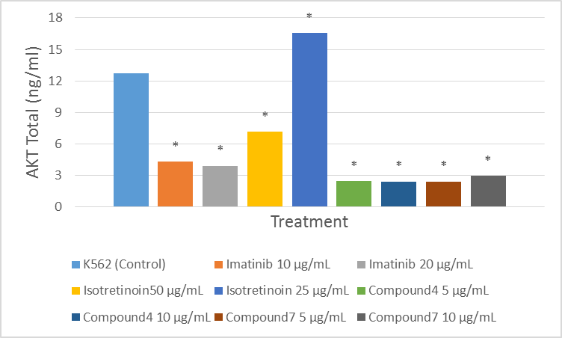
FIGURE 2. AKT level on K562 cell line treated with imatinib (10 and 50 µg/mL), Isotretinoin (25 and 50 µg/mL), Compound 4 and Compound 7 (5 and 10 µg/mL).
The measurement was performed with ELISA. Data are presented as mean±standard deviation from treatments which were performed in triplicate. The asterisk (*) indicates a significant difference between treatments compared to control (untreated K562), analyzed by ANOVA and Duncan post hoc (p<0.05).

Based on Figure 2, almost all treatments significantly decreased AKT levels on K562, except Isotretinoin at 25 µg/mL, which increased the AKT level. Both Compound 4 and Compound 7 showed the most significant decrease among treatments. Compared to control (2.5409 ng/mL), at concentration of 5 and 10 µg/mL, Compound 4 decreased AKT level (0.5176 and 0.5097 ng/mL, respectively), as well as Compound 7 (0.5096 and 0.6190 ng/mL, respectively). Compound 4 and Compound 7 resulted in lower AKT levels than when using imatinib at 10 and 20 µg/mL (4.30 and 3.91 ng/mL, respectively).

Measurement of Apoptosis on K562
Anticancer agents are expected to induce apoptosis in cancer cells. Apoptosis is by far the best-characterized type of cell death and defined by morphologic modifications that promote executioner caspase activation (Green, 1998). Effects of chalcone derivatives on apoptosis in K562 cell lines are indicated in the caspase-3 level and apoptotic index, which are shown in Figure 3-4.
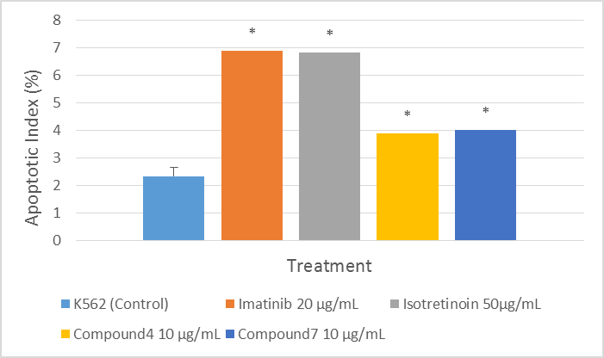
FIGURE 3. Apoptotic index on K562 cell line treated with Imatinib (20 µg/mL), Isotretinoin (50 µg/mL), Compound 4 and Compound 7 (10 µg/mL).
The measurement was performed with flowcytometry. Data are presented as mean±standard deviation from treatments which was performed in triplicate. The asterisk (*) indicates a significant difference between treatments compared to control (untreated K562), analyzed by ANOVA and Duncan pos hoc (p<0.05).

As shown in Figure 3, all treatments of chalcone derivatives showed higher apoptosis compared to control. The highest apoptotic indices were found in treatments with imatinib 20 (6,89%) and Isotretinoin 50 (6,84%).
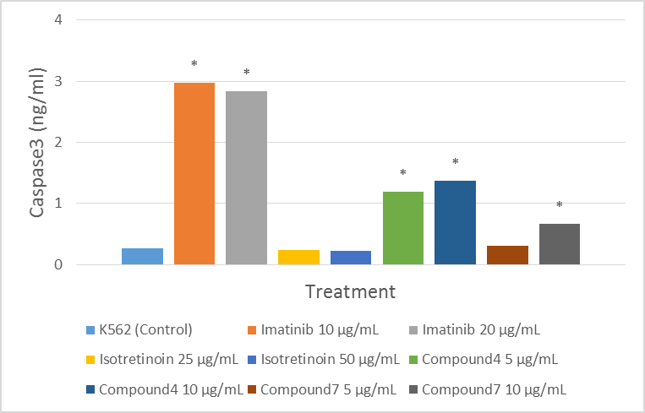

FIGURE 4. Caspase-3 level on K562 cell line treated with Imatinib (10 and 50 µg/mL), Isotretinoin (25 and 50 µg/mL), Compound 4 and Compound 7 (5 and 10 µg/mL).
The measurement was performed with ELISA. Data are presented as mean±standard deviation from treatments which was performed in triplicate. The asterisk (*) indicates a significant difference between treatments compared to control (untreated K562), analyzed by ANOVA and Duncan pos hoc (p<0.05).

As shown in Figure 4, imatinib, Compound 4, and Compound 7 significantly increased caspase-3 on K526. Compound 4 increased caspase-3 level at concentrations of 5 and 10 µg/mL (1.19 and 1.37 ng/mL, respectively), which was significant compared to control (0.26 ng/mL). Compound 7 also significantly increased caspase-3 level at concentrations of 10 µg/mL, which was 0.66 ng/mL. Imatinib showed the highest increase among treatments, both at 10 and 20 µg/mL (2.97 and 2.83 ng/mL, respectively).

Measurement of STAT3 on K562
Signal transducer and activator of transcription-3 (STAT3), an oncogenic transcription factor, is often constitutively active in human cancer cells (Bromberg et al, 1999). STAT3 levels in K562 cells treated with chalcone derivatives are presented in Figure 5.

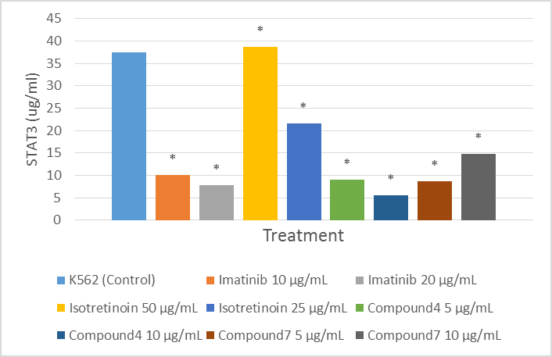

FIGURE 5. STAT3 level on K562 cell line treated with Imatinib (10 and 50 µg/ml), Isotretinoin (25 and 50 µg/mL), Compound 4 and Compound 7 (5 and 10 µg/mL).
The measurement was performed with ELISA. Data are presented as mean±standard deviation from treatments which was performed in triplicate. The asterisk (*) indicates a significant difference between treatments compared to control (untreated K562), analyzed by ANOVA and Duncan pos hoc (p<0.05).

Figure 5 shows almost all treatments showed decreasing STAT3 on K562, except Isotretinoin of 50 µg/mL. At the concentration of 5 and 10 µg/mL, Compound 4 decreased STAT3 level (9.00 and 5.48 ng/mL respectively), as well as Compound 7 (8.62 and 14.77 ng/mL), which were significant compared to control (37.56 ng/mL). These results were comparable with imatinib of 10 and 20 µg/mL (10.11 and 7.83 ng/mL respectively).

Measurement of Cell Cycle
Eukaryotic cells have developed control mechanisms that restrain cell-cycle transitions in response to stress. These regulatory pathways are termed cell-cycle checkpoints (Paulovich et al, 1997). Cells can arrest transiently at cell-cycle checkpoints to allow for the repair of cellular damage. The cyclin D1/CDK4 complex is responsible for cell cycle progression in early G₁ phase and is frequently overexpressed in various human carcinomas (Kusume et al, 1999; Wolter et al, 2001; Bali et al, 2004). Cyclin D1 levels on K562 cells treated with chalcones derivatives can be seen in Figure 6, and the cell cycle is presented in Figure 7.
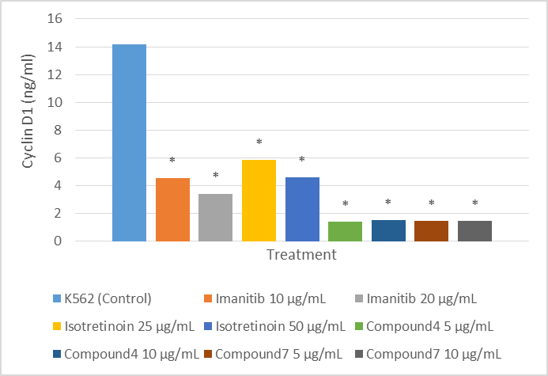

FIGURE 6. Cyclin D1 level on K562 cell line treated with Imatinib (10 and 50 µg/mL), Isotretinoin (25 and 50 µg/mL), Compound 4 and Compound 7 (5 and 10 µg/mL).
The measurement was performed with ELISA. Data are presented as mean±standard deviation from treatments which was performed in triplicate. The asterisk (*) indicates a significant difference between treatments compared to control (untreated K562), analyzed by ANOVA and Duncan pos hoc (p<0.05).

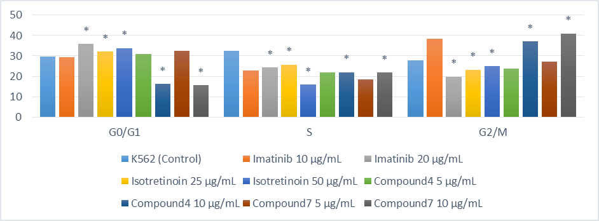

FIGURE 7. Cell cycle on K562 cell line treated with Imatinib (10 and 50 µg/mL), Isotretinoin (25 and 50 µg/mL), Compound 4 and Compound 7 (5 and 10 µg/mL).

Based on Figure 6, all treatments significantly decreased cyclin D1 levels on K526 cells. Compound 4 and Compound 7 showed the highest decrease among treatments. At concentrations of 5 and 10 µg/mL, Compound 4 decreased cyclin D1 level (1.41 and 1.51 ng/mL, respectively), as well as Compound 7 (1.45 and 1.47 ng/mL, respectively), which were significant compared to control (14.19 ng/mL). Both Compound 4 and Compound 7 showed higher results than imatinib at 10 and 20 µg/mL (4.53 and 3.43 ng/mL, respectively), as well as accutane at 25 and 50 µg/mL (5.85 and 4.62 ng/mL, respectively).

As shown in Figure 7, Compound 7 at 5 µg/mL was the only chalcone level that significantly arrested G₀/G₁ phase (32.42%), and it was comparable to imatinib of 20 µg/mL (35.99%) and Isotretinoin of 25 and 50 µg/mL (32.15 and 33.87%, respectively). Both Compound 4 and Compound 7 decreased S phase. Compound 4 of 5 and 10 µg/mL decreased S phase (21.73 and 22.01%, respectively), as well as Compound 7 (18.50 and 21.94%, respectively), which were significant compared to control (32.52%). Compound 4 and Compound 7 of 10 µg/mL arrested G₂/M phase (37.21 and 41.07%), which were comparable to imatinib at 10 µg/mL (38.45%).

DISCUSSION
Chemotherapy is one of the most potent and effective strategies to treat cancer (Ge et al. 2009). However, all of the anticancer therapies that are currently available have severe side effects on normal cells due to their non-specificity, leading to the development of new anticancer therapies with specific targets. Molecular mechanisms of cancer have been studied in drug discovery. The PI3K/AKT signaling pathway plays an important role in both normal and malignant hematopoiesis (Martelli et al. 2010; Polak and Buitenhuis 2012). Activated AKT is critical for leukemia cell survival and proliferation (Chiarini et al. 2012), and is known to function as an essential survival factor by inhibiting apoptosis (Hanada et al. 2004). These pathways are commonly targeted in cancer treatments.
Almost all treatments in the present study significantly decreased AKT levels on K562 cells, except Isotretinoin at 25 µg/mL, which increased the AKT level. Both Compound 4 and Compound 7 showed the most significant decrease among treatments. These findings are in accordance with previous studies that reported on chalcone derivatives as anticancer agents. Xu et al (2015) showed chalcone derivative, L2H17, inactivated NF-κB and AKT signaling pathways in colon cancer. The role of AKT in cancer involves the following: survival of cells by blocking the function of proapoptotic proteins and processes; phosphorylation of Bad (Datta et al, 1997; delPeso et al, 1997), that promotes release of Bad from heterodimeric of Bcl-2 and Bcl-XL; phosphorylation of MDM2 (Ogawara et al, 2002; Feng et al, 2004), stabilizing it and promoting its translocation to the nucleus, where it triggers p53 degradation; and phosphorylation of XIAP, an inhibitor of caspase cascade, and thus inhibiting its degradation (Dan et al, 2004).
In this study, Compound 4, and Compound 7 also significantly increased caspase-3 on K562, as confirmed by the higher apoptotic index compared to the control. Chalcones have also been reported to induce apoptosis in cancer cells. Referring to a previous study, chalcones (1,3-diphenyl-2-propenone) in a human diet rich in fruits and vegetables inhibit the proliferation of T24 and HT-1376 cells by inducing apoptosis. Chalcone increased the expression of Bax and Bak, but decreased the levels of Bcl-2 and Bcl-X(L) and subsequently triggered the mitochondrial apoptotic pathway (release of cytochrome c and activation of caspase-9 and caspase-3) (Shen et al. 2007). Apoptosis is by far the best-characterized type of cell death and is defined by morphologic modifications (chromatin condensation, loss of mitochondrial membrane potential, plasma membrane asymmetry, overall cell shrinkage, blebbing of the plasma membrane, and detachment from the cellular matrix), all occurring before the loss of plasma membrane integrity. Those modifications occur due to executioner caspase activation (Green, 1998).
The results of the present study showed that all treatments decreased STAT3 on K562. These findings are validated by a previous study which showed that a chalcone derivative, 4,3′,4′,5′-tetramethoxychalcone (TMOC), inhibits the phosphorylation of STAT3 and its upstream protein tyrosine kinase c-Src (Qi et al. 2014). STAT3, an oncogenic transcription factor, is often constitutively active in human cancer cells (Bromberg et al. 1999). Activated STAT3 may up-regulate the expression of genes such as apoptosis inhibitors (Bcl-xl, Bcl-2), cell cycle regulators (cyclin D1) and oncogenic transcription factors (c-myc) in tumorigenesis (Chan et al. 2004; Yu et al. 2007).
In this study, all treatments significantly decreased cyclin D1 levels on K562 cells. Compound 4 and Compound 7 showed the highest decrease among treatments. The cyclin D1/CDK4 complex is responsible for cell cycle progression in early G₁ phase, and is frequently overexpressed in various human carcinomas (Kusume et al, 1999; Wolter et al, 2001; Bali et al, 2004). Compound 4 and Compound 7 also arrested G₀/G₁ and G₂/M phase in K562 cells, with the results being comparable to imatinib and accutane. These findings are in agreement with a previous study that shows chalcone inhibits the proliferation of T24 and HT-1376 cells by blocking cell cycle progression in the G₂/M phase (Shen et al, 2007). Another study investigated the effect of a synthetic chalcone derivative, 4,3′,4′,5′- tetramethoxychalcone (TMOC), that resulted in G₀/G₁ cell cycle arrest through the down-regulation of cyclin D1 and CDK4, and the up-regulation of p16, p21 and p27 proteins in A2780 cells (Qi et al, 2014). The p16 protein is a specific inhibitor of CDK-cyclin D complex, preventing the phosphorylation of Rb and cell cycle reentry at G₀/G₁ phase (Kusume et al, 1999). Eukaryotic cell cycle progression involves sequential activation of cyclin-dependent kinases (CDK), whose activation is dependent on their association with cyclins (Sancar et al, 2004). A complex formed by the association of Cdc2 (also known as Cdk1 or p34Cdc2) and cyclin D1 plays a major role at entry into mitosis (Sancar et al, 2004). The phosphorylation of Tyr15 of Cdc2 suppresses the activity of Cdk1/cyclin B1 kinase complex. Dephosphorylation of Tyr15 of Cdc2 is catalysed by Cdc25 phosphatases, and this reaction is believed to be the ratelimiting step for entry into mitosis (De Souza et al, 2000). Cell cycle progression is also regulated by the relative balance between the cellular concentration of CDK inhibitors, such as members of the CDK-interacting protein/CDK-inhibitory protein (CIP/ KIP) and inhibitor of CDK families, and that of cyclin-CDK complexes. The CIP/KIP family, including CIP/p21, and KIP/p27, bind to cyclin-CDK complexes and prevent kinase activation and subsequently blocking the progression of the cell cycle at the G₀/G₁ or G₂/M phases (Sancar et all, 2004; Di Genmaro et al, 2003).

CONCLUSION
It can be concluded that chalcone derivatives Compound 4 and Compound 7 may be potential compounds for treating leukemia. The molecular mechanisms of chalcone derivatives in the leukemia cell line K562 involved: (i) inhibition of the PI3K/AKT signaling pathway, (ii) induction of apoptosis through the up-regulation of apoptotic markers, and (iii) the blockade of cell cycle progression by regulating cell cycle-related factors.

ACKNOWLEDGMENT
This research was supported by Biomolecular and Biomedical Research Center, Aretha Medika Utama, Bandung, Indonesia for laboratory facilities, and research methodology. We are thankful to staff of Biomolecular and Biomedical Research Center, Aretha Medika Utama, Bandung for their valuable assistance. We also would like to Stem Cell and Cancer Institute, Kalbe Farma, Jakarta who provided K562 cell line.

REFERENCES
- Bali A, O′Brien PM, Edwards LS, Sutherland RL, Hacker NF, et al. (2004) Cyclin D1, p53, and p21Waf1/Cip1 expression is predictive of poor clinical outcome in serous epithelial ovarian cancer. Clinical cancer research 10: 5168–5177.
- Bromberg JF, Wrzeszczynska MH, Devgan G, Zhao Y, Pestell RG, et al. (1999) Stat3 as an oncogene. Cell 98: 295–303.
- C Chiarini F, Lonetti A, Teti G, Orsini E, Bressanin D, Cappellini A, Ricci F, Tazzari PL, Ognibene A, Falconi M, Pagliaro P, Iacobucci I, Martinelli G, Amadori S, McCubrey JA, Martelli AM. A combination of temsirolimus, an allosteric mTOR inhibitor, with clofarabine as a new therapeutic option for patients with acute myeloid leukemia. Oncotarget. 2012;3:1615–28.
- Chan KS, Sano S, Kiguchi K, Anders J, Komazawa N, et al. (2004) Disruption of Stat3 reveals a critical role in both the initiation and the promotion stages of epithelial carcinogenesis. Journal of Clinical Investigation 114: 720–728.
- De Souza CP, Ellem KA, Gabrielli BG. Centrosomal and cytoplasmic Cdc2/cyclin B1 activation precedes nuclear mitotic events. Exp Cell Res 2000;257:11–21.
- Di Gennaro E, Barbarino M, Bruzzese F et al. Critical role of both p27KIP1 and p21CIP1/WAF1 in the antiproliferative effect of ZD1839 (‘Iressa’), an epidermal growth factor receptor tyrosine kinase inhibitor, in head and neck squamous carcinoma cells. J Cell Physiol 2003;195:139–50.
- Green DR. Apoptotic pathways: the roads to ruin. Cell 1998; 94: 695–8.
- H.C. Dan, M. Sun, S. Kaneko, R.I. Feldman, S.V. Nicosia, H.G. Wang, B.K. Tsang, J.Q. Cheng, Akt phosphorylation and stabilization of Xlinked inhibitor of apoptosis protein (XIAP), J. Biol. Chem. 279 (2004) 5405–5412.
- Hanada M, Feng J, Hemmings BA. Structure, regulation and function of PKB/AKT—a major therapeutic target. Biochim Biophys Acta 2004; 1697: 3–16.
- J.H. Feng, R. Tamaskovic, Z.Z. Yang, D.P. Brazil, A. Merlo, D. Hess, B.A. Hemmings, Stabilization of Mdm2 via decreased ubiquitination is mediated by protein kinase B/Akt-dependent phosphorylation, J. Biol. Chem. 279 (2004) 35510–35517.
- Kusume T, Tsuda H, Kawabata M, Inoue T, Umesaki N, et al. (1999) The p16-cyclin D1/CDK4-pRb pathway and clinical outcome in epithelial ovarian cancer. Clinical cancer research 5: 4152–4157.
- L. del Peso, M. Gonzalez-Garcia, C. Page, R. Herrera, G. Nunez, Interleukin-3-induced phosphorylation of BAD through the protein kinase Akt, Science 278 (1997) 687–689.
- Martelli AM, Evangelisti C, Chiarini F, McCubrey JA. The phosphatidylinositol 3-kinase/Akt/mTOR signaling network as a therapeutic target in acute myelogenous leukemia patients. Oncotarget. 2010;1:89–103.
- Paulovich, A.G. et al. (1997) When checkpoints fail. Cell 88, 315–321
- Polak R, Buitenhuis M. The PI3K/PKB signaling module as key regulator of hematopoiesis: implications for therapeutic strategies in leukemia. Blood. 2012;119:911–923.
- Qi, Z., Liu, M., Liu, Y., Zhang, M. and Yang, G., 2014. Tetramethoxychalcone, a chalcone derivative, suppresses proliferation, blocks cell cycle progression, and induces apoptosis of human ovarian cancer cells. PloS one, 9(9), p.e106206.
- S.R. Datta, H. Dudek, X. Tao, S. Masters, H.A. Fu, Y. Gotoh, M.E. Greenberg, Akt phosphorylation of BAD couples survival signals to the cell-intrinsic death machinery, Cell 91 (1997) 231–241.
- Sancar A, Lindsey-Boltz LA, Unsal-Kacmaz K, Linn S. Molecular mechanisms of mammalian DNA repair and the DNA damage checkpoints. Annu Rev Biochem 2004;73:39–85.
- Shen, K.H., Chang, J.K., Hsu, Y.L. and Kuo, P.L., 2007. Chalcone arrests cell cycle progression and induces apoptosis through induction of mitochondrial pathway and inhibition of nuclear factor kappa B signalling in human bladder cancer cells. Basic & clinical pharmacology & toxicology,101(4), pp.254-261.
- Wolter F, Akoglu B, Clausnitzer A, Stein J (2001) Downregulation of the cyclin D1/Cdk4 complex occurs during resveratrol-induced cell cycle arrest in colon cancer cell lines. Journal of nutrition 131: 2197–2203.
- Xu, S., Chen, M., Chen, W., Hui, J., Ji, J., Hu, S., Zhou, J., Wang, Y. and Liang, G., 2015. Chemopreventive effect of chalcone derivative, L2H17, in colon cancer development. BMC cancer, 15(1), p.870.
- Y. Ogawara, S. Kishishita, T. Obata, Y. Isazawa, T. Suzuki, K. Tanaka, N. Masuyama, Y. Gotoh, Akt enhances Mdm2-mediated ubiquitination and degradation of p53, J. Biol. Chem. 277 (2002) 21843–21850.
- Yu C, Krystal G, Varticovksi L, et al. Pharmacologic mitogen-activated protein/extracellular signal-regulated kinase kinase/mitogen-activated protein kinase inhibitors interact synergistically with STI571 to induce apoptosis in Bcr/Abl-expressing human leukemia cells. Cancer Res 2002; 62: 188–99.
- Yu H, Kortylewski M, Pardoll D (2007). Crosstalk between cancer and immune cells: role of STAT3 in the tumour microenvironment. Nature Reviews Immunology 7: 41–51. doi: 10.1038/nri195

