Stability of Ethanol Extract Sunscreen Gel Spray Formula

Kalakai leaves **(Stenochlaena palustris (Burm F.) Bedd)**

**Weni Puspita1)*, Heny Puspasari1), Dian Kartikasari1)**

1)Akademi Farmasi Yarsi Pontianak, East Pontianak, West Kalimantan, Indonesia

Corresponding author : *weni.puspita.apt@gmail.com

**Abstract**

The ethanol extract of kalakai leaves (*Stenochlaena palustris* (Burm F.) Bedd) is known to have activity as a sunscreen in the ultra protection category. This research aims to determine the stability of the kalakai leaves ethanol extract sunscreen spray gel formula. The ethanol extract of kalakai leaves was obtained by maceration using 70% ethanol solvent, then concentrated using a rotary evaporator until a thick extract was obtained. EEDK was then formulated into a spray gel preparation with EEDK concentration (FI: 5%, FII: 7.5%, FIII: 10%). The EEDK spray gel formula was tested for physical stability using the cycling test method using a climatic chamber at temperatures of 40°C ± 2°C and 4 °C ± 2°C for 6 cycles. Tests include organoleptics, homogeneity, viscosity, pH, adhesive spreadability, and spray pattern. The sunscreen test was carried out using the UV-Vis spectrophotometer method at 290-320nm wavelength. Quantitative data of physical stability and sunscreen were analyzed by t-dependent test. The results of the physical stability test on the three EEDK spray gel formulas (FI: 5%, FII: 7.5%, FIII: 10%) showed good physical stability because there were no significant differences during six storage cycles (p>0.05). The results of the stability test of the EEDK spray gel sunscreen activity in the three formulas showed that there was no significant change (P>0.05) in the sunscreen activity during six storage cycles with the highest average SPF value before and after the cycling test, namely in Formula III, which was 35.82 ± 0.50 with ultra protection category.

**Keywords:** Spray gel, ethanol extract of *Stenochlaena palustris* (Burm F.) Bedd leaves, Physical stability, Sunscreen

**INTRODUCTION**

The secondary metabolite content contained in kalakai leaves (*Stenochlaena* *palustris* (Burm F.) Bedd) is alkaloid, steroid, and flavonoid compounds, where flavonoids are known to have properties as free radical scavengers or antioxidants, inhibitors of hydrolysis and oxidative enzymes and work as anti-inflammatories (Anggraeni & Erwin, 2015). The ethanol extract of kalakai leaves can reduce free radicals, as indicated by the IC50 value of 143.1431 ppm (Rantia, V., 2018). Based on research by Syamsul et al. (2019), it is stated that the ethanol extract of Kalakai leaves has a total flavonoid content of 2.2159 ± 0.083%. Apart from that, according to research by Puspita et al. (2023), kalakai leaf ethanol extract has activity as a sunscreen with an SPF value of 21.22, where this value is included in the category of ultra-protective sunscreen ability level.

Sunscreen is a preparation used to protect the skin from the harmful effects of solar radiation. In contrast, sunscreen for facial skin care would be better formulated in topical form than oral because the active substance will interact longer with facial skin (Draelos & Thaman, 2006). One of them is the spray gel formulation, which has advantages including being safer because the level of microorganism contamination is lower, the drug contact time is relatively longer compared to other preparations, is more practical in use, and can be formulated into elegant cosmetic products (Shabrina et al., 2019).

Product stability is an essential factor that must be considered in the quality of cosmetic preparations. Stability guarantees that pharmaceutical preparations' quality, purity, and strength are within the specifications applied until the time of use and storage (Kuncari et al., 2014).

Temperature cycling test is a method developed to evaluate the stability of cosmetic preparations with variations in storage temperature within certain time intervals (CTFA, 2004). This method simulates temperature changes during product storage to test product stability (Suryani et al., 2017). A spray gel preparation that is stable if the period of use and storage is within acceptable limits. This research aims to obtain the stable product formula of spray gel sunscreen from ethanol extract of kalakai leaves (*Stenochlaena palustris* (Burm F.) Bedd).

**METHODOLOGY**

**Tools and materials**

The tools in the research were mortar and stamper, analytical balance, stir bar, hot plate (Maspion), aluminum foil, beaker glass (Pyrex), watch glass, pH meter (Handylab pH 11/SET), viscometer (Rion VT-06), refrigerator (Sharp), rotary evaporator (Heidolph), UV-Vis spectrophotometer (Shimadzu), pH meter, measuring flask (Pyrex), measuring cup (Pyrex), micropipette, dropper pipette, stopwatch, and spray bottle. The ingredients in this research were kalakai leaves, 96% ethanol, carbopol 940, triethanolamine, propylene glycol, methyl paraben, propyl paraben, and distilled water.

**Table 1. Formula of Kalakai Leaf Ethanol Extract Gel Spray**

|  |  |  |  |
| --- | --- | --- | --- |
| **Bahan** | **Concentration (%)** | | |
| **FI** | **FII** | **FIII** |
| Kalakai leaf ethanol extract | 5 | 7,5 | 10 |
| Propylene glycol | 10 | 10 | 10 |
| Carbopol 940 | 0,5 | 0,5 | 0,5 |
| Triethanolamine | 0,5 | 0,5 | 0,5 |
| Methyl paraben | 0,18 | 0,18 | 0,18 |
| Propyl paraben | 0,02 | 0,02 | 0,02 |
| Aquadest ad | 100 g | 100 g | 100 g |

**Method**

**Making Kalakai Leaf Ethanol Extract Spray Gel Preparation**

The first step is that Carbopol 940 is dispersed with hot water until Carbopol 940 is completely dispersed, then Triethanolamine (TEA) is added to form a transparent gel mass. Then, dissolve Methyl paraben and Propyl paraben in Propylene glycol. Then, mixed until homogeneous in a large mortar, the ethanol extract of kalakai leaves and the remaining distilled water were added. Then, the preparation is stirred until homogeneous, and the preparation is put into a spray bottle.

**Evaluation of Physical Stability of Kalakai Leaf Ethanol Extract Gel Spray**

The stability test was carried out using the cycling test method. The cycling test was carried out in 6 cycles. The preparation is kept at a cold temperature of ± 4°C for 24 hours, then removed and placed at a temperature of ± 40°C for 24 hours. This process is calculated as one cycle. The treatment was repeated for six cycles, and observations were made regarding organoleptic parameters, homogeneity, pH, viscosity, adhesive spreadability, and spraying pattern.

**Testing of sunscreen activity of ethanol extract kalakai leaves spray gel formula**

Determination of sunscreen activity is carried out by determining the SPF value in vitro using UV-Vis spectrophotometry. Spray gel of kalakai leaf ethanol extract FI (5%), FII (7.5%), and FIII (10%) were weighed as much as 0.1 gram, 5 mL of 96% ethanol was added and mixed until homogeneous in a 5 mL measuring flask. The UV-Vis spectrophotometer was calibrated first using 96% ethanol. Put 96% ethanol into the cuvette and put it into the UV-Vis spectrophotometer for calibration. A test absorption curve was made in a cuvette, with a wavelength between 290-320 nm, using 96% ethanol as a blank. The absorbance results of each concentration were recorded, and then the SPF value was calculated (Damogalad et al., 2013). The spray gel preparation was tested before and after being stored in a cycling test for six cycles.

**RESULTS AND DISCUSSION**

**Kalakai Leaf Extraction**

The extraction of kalakai leaves uses 70% ethanol solvent because it is polar, so it is hoped that all flavonoids will be extracted. Extraction is a chemical separation process using an appropriate solvent to obtain the appropriate chemical content. Extraction aims to separate as much chemical content as possible so that it is easier to use and can be stored longer. The extraction method used in this research is the maceration method. Maceration was chosen because it can extract compounds well and prevent heat decomposition of unstable compounds.

The spray gel of kalakai leaves ethanol extract preparation was made by varying the kalakai leaf ethanol extract into three concentration variants, namely FI (5%); FII (7.5%), and FIII (10%). The spray gel formulation was made with carbopol 940 as a gelling agent, triethanolamine as a base agent, propylene glycol as a humectant, methylparaben and propylparaben as a preservative, and distilled water as a solvent. Next, the spray gel was evaluated for physical and chemical stability, including organoleptic, homogeneity, pH, adhesive spreadability, viscosity, spray pattern, as well as sunscreen activity tests on the sunscreen spray gel preparation of kalakai leaf ethanol extract (*Stenochlaena palustris* (Burm F.) Bedd).

The extraction of kalakai leaves uses 70% ethanol solvent because it is polar, so it is hoped that all flavonoids will be extracted. Extraction is a chemical separation process using an appropriate solvent to obtain the appropriate chemical content. Extraction aims to separate as much chemical content as possible so that it is easier to use and can be stored longer. The extraction method used in this research is the maceration method. Maceration was chosen because it can extract compounds well and prevent heat decomposition of unstable compounds.

The ethanol extract of kalakai leaf spray gel preparation was made by varying the ethanol extract of kalakai leaves into three concentration variants, namely FI (5%), FII (7.5%), and FIII (10%). The spray gel formulation was made with carbopol 940 as a gel former, triethanolamine as a base, propylene glycol as a humectant, methyl paraben and propyl paraben as a preservative, and distilled water as a solvent. Next, the spray gel was evaluated for physical and chemical stability, including organoleptic, homogeneity, pH, adhesive spreadability, viscosity, spray pattern, as well as sunscreen activity tests on the sunscreen spray gel preparation of kalakai leaf ethanol extract (*Stenochlaena palustris* (Burm F.) Bedd).

**Physical Stability Test of Kalakai Leaf Ethanol Extract Gel Spray**

The physical stability test of Kalakai leaves ethanol extract gel spray included observing organoleptic parameters, homogeneity, pH, viscosity, sticky spreadability, and spraying pattern.

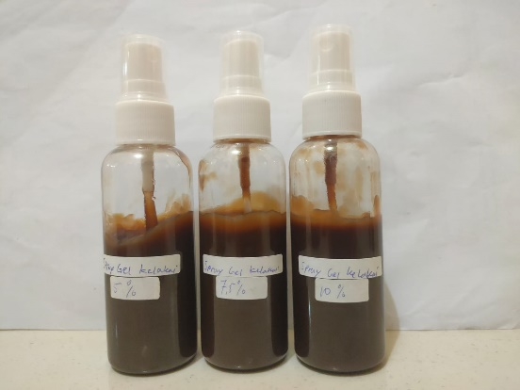

1. ** (b)**

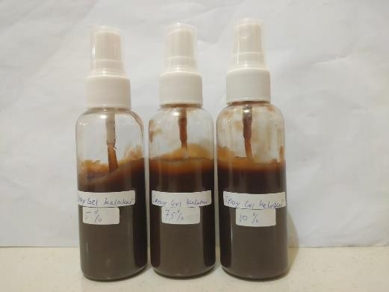

**Figure 1. Visualization of spray gel (a) before temperature cycling test and (b) after temperature cycling test of several formulas. FI formula spray gel EEDK 5%, FII formula spray gel EEDK 7.5% and FIII formula spray gel EEDK 10%**

**Table 2. Organoleptic Examination Results of EEDK Gel Spray**

|  |  |  |  |  |
| --- | --- | --- | --- | --- |
| **Before cycling test** | **Organoleptic** | **FI (5%)** | **FII (7,5%)** | **FIII (10%)** |
| Color | Dark Brown | Dark Brown | Dark Brown |
| Typical kalakai smell | Yes | Yes | Yes |
| Tekstur | Thick | Thick | Thick |
| **After cycling test** | **Organoleptik** | **FI** | **FII** | **FIII** |
| Color | Dark Brown | Dark Brown | Dark Brown |
| Typical kalakai smell | Yes | Yes | Yes |
| Tekxture | Thick | Thick | Thick |

The organoleptic test is a physical parameter test for the shape/texture, color, and smell. The organoleptic test is carried out by looking at the color, smelling the smell, and the shape/texture of the spray gel being made (Ansel, 1989). The results of organoleptic observations in Figure 1 and Table 2 show that adding kalakai leaf ethanol extract to the three formulas produces a spray gel preparation that is dark brown, has a distinctive kalakai odor and has a thick texture. These three spray gel formulations produce organoleptically stable preparations before and after the temperature cycling test conditions.

**Table 3. Homogeneity Test**

|  |  |  |  |
| --- | --- | --- | --- |
| **Temperature cycling test** | **Homogeneity** | | |
| **FI (5%)** | **FII (7,5%)** | **FIII (10%)** |
| **Before** | Homogeneous | Homogeneous | Homogeneous |
| **After** | Homogeneous | Homogeneous | Homogeneous |

The requirement for a homogeneous preparation is that it must not contain coarse materials that can be touched. Homogeneity examination aims to see the particle distribution of the preparation (Armadany et al., 2016). Based on Table 3, examining the homogeneity of spray gel preparations using glass preparations from the three formulas shows that each preparation is homogeneous and has particles evenly distributed before and after the temperature cycling test. The results are shown like that because there are no coarse grains in all preparation formulas, and they show a homogeneous composition or no lumps in the preparation.

**Table 4. Results of pH measurements**

|  |  |  |  |
| --- | --- | --- | --- |
| **Temperature cycling test** | **pH value** | | |
| **FI (5%)** | **FII (7,5%)** | **FIII (10%)** |
| **Before** | 5,54 ± 0,08 | 5,61 ± 0,01 | 5,54 ± 0,05 |
| **After** | 5,56 ± 0,12 | 5,70 ± 0,02 | 5,57 ± 0,11 |

The pH test results of the spray gel preparation showed no significant change in pH with temperature changes that occurred during six cycles in the temperature cycling test (p>0.05). Based on the results in Table 4, the pH value of the spray gel before and after the temperature cycling test is a stable spray gel preparation that meets the skin pH requirements, namely 4.5-6.5 (Tranggono & Latifah, 2007). If the pH of the preparation is outside the skin's pH interval, it is feared that it will cause scaly skin or even irritation. In contrast, if it is above the skin's pH, it can cause the skin to feel slippery and dry quickly and affect skin elasticity (Dureja et al., 2010).

**Table 5. Viscosity Measurement Results**

|  |  |  |  |
| --- | --- | --- | --- |
| **Measurement** | **Viscosity (dPas)** | | |
| **FI (5%)** | **FII (7,5%)** | **FIII (10%)** |
| **Before temperature cycling test** | 17,33 ± 0,57 | 14,33 ± 0,57 | 09,00 ± 0,01 |
| **After temperature cycling test** | 16,85 ± 0,27 | 14,20 ± 0,57 | 08,55 ± 0,57 |

The viscosity test aims to determine the resistance of a liquid to flow. The resulting spray gel preparation has a low viscosity value with the aim of making it easier to apply by spraying (Sihombing & Lestari, 2015). Viscosity measurements of the three spray gel preparation formulas were carried out using a Rion VT-06 viscometer with viscometer stirrer number 2, where based on the results in Table 5, the viscosity of the spray gel before and after the temperature cycling test did not change (p>0.05) so that the spray. The resulting gel is in the stable preparation category. The three spray gel formulas' viscosity still meets the 500-5000 cPs range or 5-50 dPas. If the viscosity is less than 500 cP, it will cause dripping too quickly when sprayed from the applicator. If the viscosity is more than 500 cP, it will cause the particle size of the sprayed preparation to become irregular and large so that it is less spread over the surface of the skin or mucous membrane (Shafira & Lestari, 2015).

**Table 6. Results of EEDK spray gel spray pattern inspection**

|  |  |  |  |
| --- | --- | --- | --- |
| **Measurement** | **Average weight/spray (grams)** | | |
| **FI (5%)** | **FII (7,5%)** | **FIII (10%)** |
| **Before temperature cycling test** | 0,098 ± 0,57 | 0,112 ± 0,67 | 0,142 ± 0,60 |
| **After temperature cycling test** | 0,121 ± 0,27 | 0,135 ± 0,57 | 0,174 ± 0,27 |

Evaluation of the spray applicator looks at the spray pattern. Factors that influence spraying patterns include formula characteristics. The spraying distance and the viscosity of the preparation also influence variations in spraying patterns. The spraying distance is proportional to the diameter of the spraying pattern of the preparation. The greater the distance, the greater the resulting spray pattern. The three formulas produce a spray pattern with an elongated and spreading pattern. Based on the results in Table 6, the three spray gel formulas in terms of the delivery weight of the spray gel preparation, each spray is stable both before and after the temperature cycling test (p>0.05), so from the stability test process the three spray gel formulas have the delivery weight of the preparation every spray is stable. The test result shows that the applicator used in the EEDK spray gel preparation effectively delivers reproducible amounts with each spray (Sayudi, 2014).

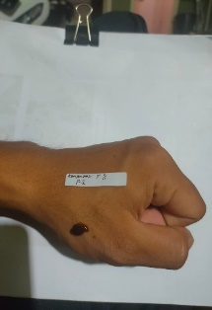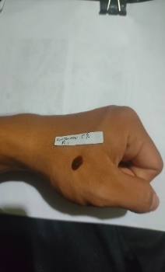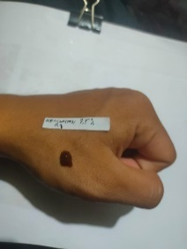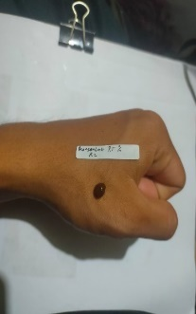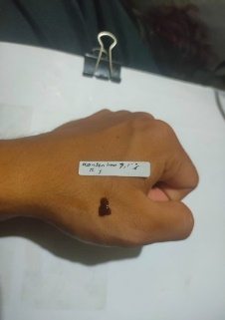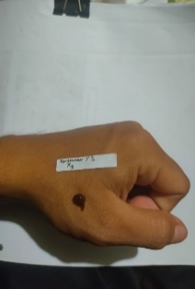

FIII

FII

FI

FIII

FII

FI

1. **(b)**

**Figure 2. Visualization of the adhesive spread of spray gel (a) before the temperature cycling test and (b) after the temperature cycling test for several formulas. FI formula spray gel EEDK 5%, FII formula spray gel EEDK 7.5% and FIII formula spray gel EEDK 10%**

The adhesive spreadability test results of the three formulas in Figure 2, both before and after the temperature cycling test, show that the EEDK spray gel preparation can stick when sprayed on the skin on the upper arm for 10 seconds. It can form a layer that sticks to the skin and does not flow. Based on the research results, the EEDK spray gel preparation meets the requirements for spray gel preparations, produces good physical properties, and can be applied to the skin.

**Table 7. SPF Value of Kalakai Leaf Ethanol Extract Gel Spray**

|  |  |  |  |
| --- | --- | --- | --- |
| **Measurement** | **SPF Value** | | |
| **FI (5%)** | **FII (7,5%)** | **FIII (10%)** |
| **Before temperature cycling test** | 22,01 ± 0,20  (Ultra Protection) | 23,34 ± 0,25  (Ultra Protection) | 35,82 ± 0,50  ((Ultra Protection)) |
| **After temperature cycling test** | 21,30 ± 0,27  (Ultra Protection) | 22,75 ± 0,57  (Ultra Protection) | 34,52 ± 0,27  (Ultra Protection) |

Based on the SPF value test results in Table 7, the spray gel has an SPF value ranging from 21.30 ± 0.27 (Ultra Protection) – 35.82 ± 0.50 (Ultra Protection). The SPF value of each formula, both before and after the cycling test conditions, increases as the concentration of the extract contained in the spray gel formula increases. The research (Damogalad et al., 2013) states that the higher the extract concentration, the greater the SPF value produced. The SPF value test showed a decrease in the spray gel SPF value but was not significantly different before and after the cycling test (p>0.05). The highest average SPF value before and after the cycling test, namely in Formula III, was 35.82 ± 0.50 in the ultra-protection category.

In this study, concentration is a factor that influences the determination of sunscreen activity as indicated by the SPF value. This factor can increase or decrease the UV absorption of each sunscreen, where each extract concentration can absorb different UV rays, as indicated by an increase in absorbance as the extract concentration increases. The sunscreen activity of the ethanol extract of kalakai leaves (*Stenochlaena palustris* (Burm F.) Bedd) is due to the reasonably high flavonoid content in kalakai leaves, namely 2.2159 ± 0.083% (Syamsul et al., 2019). Flavonoids have potential as a sunscreen because of the chromophore group, which can absorb UV rays, both UV A and UV B, thereby reducing their intensity on the skin (Shovyana, 2013).

**CONCLUSION**

Based on the results of the research carried out, it can be concluded that the results of the physical stability test spray gel of three formulas of the kalakai leaves (FI: 5%, FII: 7.5%, FIII: 10%) show good physical stability because they did not experience significant differences over time. Six storage cycles (P>0.05) with the resulting preparation have a characteristic kalakai odor, dark brown, thick, homogeneous texture, meeting the pH, viscosity, spray pattern, and adhesive spreadability requirements. The results of the stability test of the sunscreen activity of spray gel ethanol extract of kalakai leaves in the three formulas showed that there was no significant change (P>0.05) in the sunscreen activity during six storage cycles with the highest average SPF value before and after the cycling test, namely in Formula III. 35.82 ± 0.50 in the ultra protection category.

**ACKNOWLEDGEMENT**

The author would like to thank the Yarsi Pontianak Pharmacy Academy for their support while the author was conducting research.

**References**

Anggraeni, D.S., dan Erwin. (2015). “Uji Fitokimia dan Uji Toksisitas (*Brine Shrimp Lethality Test*) Ekstrak Daun Kalakai (*Stenochlaena palustris*)”. *Prosiding Seminar* *Tugas Akhir*. FMIPA Universitas Mulawarman. Hal: 71-75.

Ansel, C, Howard, 1989, Pengantar Bentuk Sediaan Farmasi, Edisi Keempat, Jakarta Universitas Indonesia Pres, 162-163; 390-391; 605-608

Armadany FI, Hasnawati MS. 2017. Formulasi sediaan masker gel peel off antioksidan dari ekstrak sari tomat (*Solanum lycopersicum* L. var. cucurbita) Majalah Farmasi, Sains, dan Kesehatan. 1(2):29-32.

CTFA, 2004. Guidelines on Stability Testing of Cosmetic Products, (pp. 5), Europe: The European Cosmetic Toiletry and Perfumery Association.

Damogalad, Viony., Edy, H. J., dan Supriati, H. S., 2013., Formulasi Krim Tabir Surya Ekstrak Kulit Nanas (*Ananas Cosmosus* L *Merr*) dan Uji *In Vitro* Nilai *Sun Protecting Factro* (SPF), *Jurnal Ilmiah* Farmasi, Universitas Sam Ratulangi, Manado, 2.

Draelos, Z.D., dan Thaman, L.A. 2006. Cosmetic Formulation of Skin Care Product. New York: Taylor and Francis Group

Dureja, H., Kaushik, D., Gupta, M., Kumar, V., dan Lather, V., 2010, Cosmeceuticals:An Emerging Concept, *Indian J Pharmacol*.

Kuncari, E. S., Iskandarsyah dan Praptiwi. (2014). Evaluasi, Uji Stabilitas Fisik Dan Sineresis Sediaan Gel yang Mengandung Minoksidil, Apigenin dan Perasan Herba Seledri (*Apium Graveolens* L.). Bulletin Penelitian Kesehatan. 42 (4): 213-222.

Puspita, W., Puspasari, H., Masykuroh A., dan Fitria, R., 2023. Penentuan Nilai SPF (*Sun Protecting Factor*) Ekstrak Etanol Daun Kalakai Muda (*Stenochlaena palustris* (Burm F.) Bedd). Jurnal Komunitas Farmasi Nasional, 3 (1): 509-517.

Rantia, Verani. 2018. Uji Aktivitas Antiosidan Ekstrak Etanol Daun Kalakai muda  
(*Stenochlaena palustris* (Burm.F.) Bedd.) Menggunakan Metode DPPH  
(1,1-difenil-2-pikrilhirazil). *Karya Tulis Ilmiah*. Akademi Farmasi  
Samarinda.

Sayudi, S.D., 2014. Formulasi Gel Semprot Menggunakan Kombinasi Karbopol 940 dan  
Hidroksi Propil Metil Selulosa (HPMC) Sebagai Pembentuk Gel. Skripsi, UIN Syarif  
Hidayatullah. Jakarta.

Shabrina, A., Herlinda, R., Setyawan, B., 2019. Uji Stabilitas dan Penentuan SPF secara in  
vitro Gel Semprot Ekstrak Spirulina platensis. Prosiding, Seminar Nasional Perhipba,  
Universitas Pancasila.

Shafira, U., Gadri, A., dan Lestari, F., 2015. Formulasi Sediaan Spray Gel Serbuk Getah  
Tanaman Jarak Cina (*Jatropha multifida* Linn.) dengan Variasi Jenis Polimer Pembentuk  
Film dan Jenis Plasticizer. Prosiding Penelitian SPeSIA, Unisba, Jakarta)

Shovyana, H.H., A Karim Zulkamain. (2013). Physical Stability and Acivity of Cream w/o Etanolic Fruit Extract of Mahkota Dewa (*Phaleria macrocarpha* (sccheff.) Boerl,) as A a Sunscreen. Traditional Medicine Journal18(2). Yogyakarta: Fakultas Farmasi UGM, 2013.

Sihombing, L.N.B., dan Lestari P.C., 2015. Formulasi dan Evaluasi Sediaan Spray Gel Lidah  
Buaya (*Aloe Vera* L.) dengan Variasi Konsentrasi Carbomer dan HPMC. Jurnal Farmasi,  
Jurusan Farmasi Politeknik Kesehatan Kementrian Kesehatan, Bandung.

Suryani., Putri, A.E.P, Agustyiani, P. 2017. Formulasi dan Uji Stabilitas Sediaan Gel Ekstrak Terpurifikasi Daun Paliasa (*Kleinhovia Hospita* L.) yang Berefek Antioksidan. Pharmacon 6 (3): 157-169.

Syamsul, E. S., Hakim, Y. Y., & Nurhasnawati, H. (2019). Penetapan Kadar Flavonoid Ekstrak Daun Kalakai (*Stenochlaena Palustris* (Burm. F.) Bedd.) Dengan Metode Spektrofotometri UV-Vis. Jurnal Riset Kefarmasian Indonesia, 1(1), 11-20

Tranggono, Retno Iswari, Latifah, Fatmah. 2007. Buku pegangan ilmu pengetahuan kosmetik. Jakarta (ID): PT. Gramedia Pustaka.