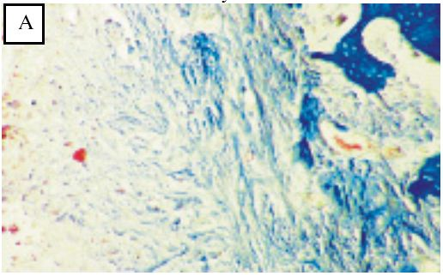
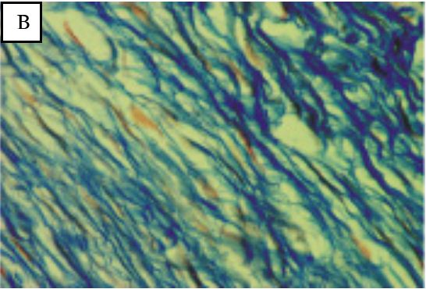
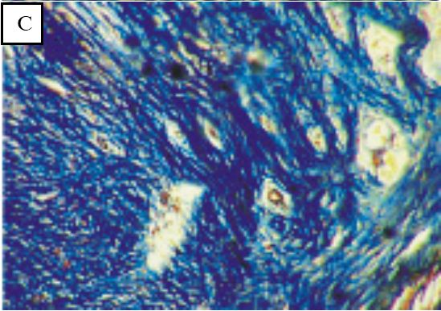
Figure 1. Criteria for valuation collagen density A=score 1, B=score 2, C=score 3 (Tandelilin et al., 2006)

Figure 2. Collagen density between treatment and placebo group significantly different

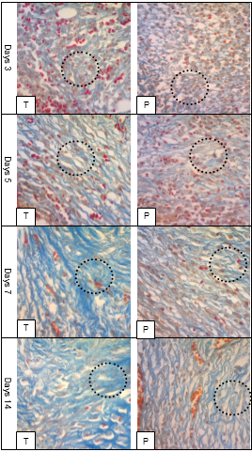
Figure 3. Histological microphotograph of collagen density in alveolar bone on treatment groups (T) and placebo groups, 400(X) magnification

