Title: Antioxidants and Antityrosinase Activity of Ethanolic Basil Leaves Extract (Ocimum americanum L.) and Eugenol______________________________________________________
Running title: Antioxidants and Antityrosinase Activity of Ethanolic Basil Leaves Extract (Ocimum americanum L.) and Eugenol ______________________________________________

Authors& Affiliation: Dio Damara Handoyo, Universitas Prima Indonesia _________________

Corresponding Author: Ermi Girsang, Ali Napiah Nasution, I Nyoman Ehrich Lister________

Author’s declaration
With the submission of this manuscript, I would like to undertake that the above mentioned manuscript is original and has not been published nor accepted for publication elsewhere, and herewith be willing to hand in the right of first publication of the manuscript to Majalah Obat Tradisional (Trad. Med. J).

Authors’ contributions
Authors | Contribution
Dio Damara Handoyo | Conception and design, Acquisition of data, Analysis and Interpretation of data, Drafting or Revising the article, Making Final Manuscript.
Ermi Girsang | Conception and design, Drafting or Revising the article
Ali Napiah Nasution | Drafting or Revising the article
I Nyoman Ehrich Lister | Conception and design, Acquisition of data

Conflict of interest:

The authors declare that they have no conflict of interest.
Authors | Signature
Dio Damara Handoyo | 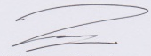
Ermi Girsang | 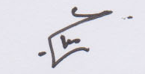
Ali Napiah Nasution | 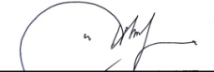
I Nyoman Ehrich Lister | 