Figure and Table
Table 1. Comparison of IC₅₀ values ​​of meniran, buas-buas, secang wood, roselle, and maceration extraction combinations with comparison
No | Plant | Graph Equation | IC₅₀ Value (μg/ml)
1 | Herbs Meniran (HM) | Y = 1720x + 0.3557  R2 = 0.9973 | 28.9
2 | Buas Buas leaves (DBB) | Y = 1634.1x + 13.852  R2 = 0.9898 | 22.1
3 | Sappan Wood (KS) | Y = 7315.6x + 5.891  R2 = 0.99 | 6.0
4 | Roselle Flower (BR) | Y = 224.74x + 16.012  R2 = 0.9918 | 151.3
5 | HM : DBB : KS : BR (1 : 1 : ½ : ½) | Y = 1710.8x + 31.279  R2 = 0.9961 | 11.0
6 | HM : DBB : KS : BR (2 : 1 : ½ : ½) | Y = 1485x + 30.291  R2 = 0.9942 | 13.3
7 | HM : DBB : KS : BR (1 : 2 : ½ : ½ ) | Y = 1992.1x + 11.381  R2 = 0.9923 | 19.4
8 | Quercetin | Y= 11.406x + 31.264  R2 = 0.9999 | 1.644

Table 2. Relationship of total gallol equivalent phenol equivalents, total quercetin equivalent flavonoids, and maceration extraction antioxidant activity
No. | Plant | Total Phenol (%w/w EAG) | Total Flavonoids (%w/w EQ) | IC₅₀ (µg/mL)
1 | Herbs Meniran (HM) | 30.60 | 14.78 | 28.9
2 | Buas Buas leaves (DBB) | 9.82 | 54.17 | 22.1
3 | Sappan Wood (KS) | 11.10 | 139.76 | 6.0
4 | Roselle Flower (BR) | 26.15 | 4.96 | 151.3
5 | HM : DBB : KS : BR (1 : 1 : ½ : ½) | 28.99 | 44.73 | 11.0
6 | HM : DBB : KS : BR (2 : 1 : ½ : ½) | 33.57 | 74.00 | 13.3
7 | HM : DBB : KS : BR (1 : 2 : ½ : ½ ) | 7.58 | 55.09 | 19.4

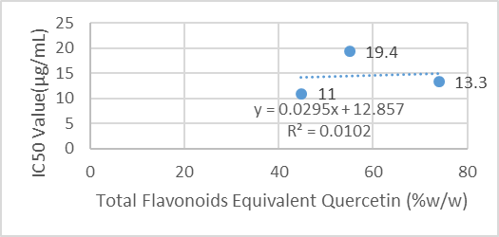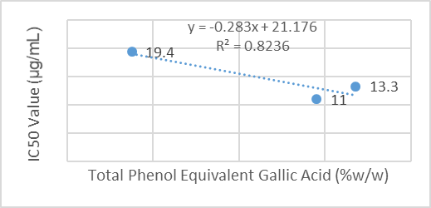
Figure 1. Linear regression curve between total phenols (Graph 1), total flavonoids (Graph 2) and percent antioxidant activity from maceration extraction

