**(a) research instruments**

UV lamp (Cagma), *biosafety cabinet* (NUAIRE), *inverted microscope* (BOECO Germany)

**(b) data sets, which comply with the terms of the study's research ethics review**

1. Data Hasil Uji Sitotoksik Ekstrak Etanolik Daun Ungu Terhadap Sel WiDr





1. Data Hasil Uji Sitotoksik Fraksi Heksan Ekstrak Etanolik Daun Ungu Terhadap Sel WiDr





1. Data Hasil Uji Sitotoksik Fraksi Kloroform Ekstrak Etanolik Daun Ungu Terhadap Sel WiDr





1. Data Hasil Uji Sitotoksik Fraksi Etil Asetat Ekstrak Etanolik Daun Ungu Terhadap Sel WiDr





1. Data Hasil Uji Sitotoksik Fraksi Etanol-air Ekstrak Etanolik Daun Ungu Terhadap Sel WiDr





(c) sources that otherwise would be unavailable to readers

(d) figures and tables that cannot be integrated into the text itself, or other materials that add to the contribution of the work.

Figure 1. TLC profile of extract and fractions below UV 366. (A) TLC profile of extract with the stationary phase of silica gel F254 and mobile phase of ethyl acetate-glacial acetic acid (100:11:20 v/v) after sprayed with cytoborate reagent. (B) TLC profile of fractions with n-hexane-ethyl acetate mobile phase (4:1 v/v) visible light, (C) UV254, (D) UV366 and (E) after sprayed with anisaldehyd-sulfuric acid. Description: E: ethanolic extract, FH: n-hexane fraction, FK: chloroform fraction, FEA: ethyl acetate fraction and FA: ethanol-waterfraction.

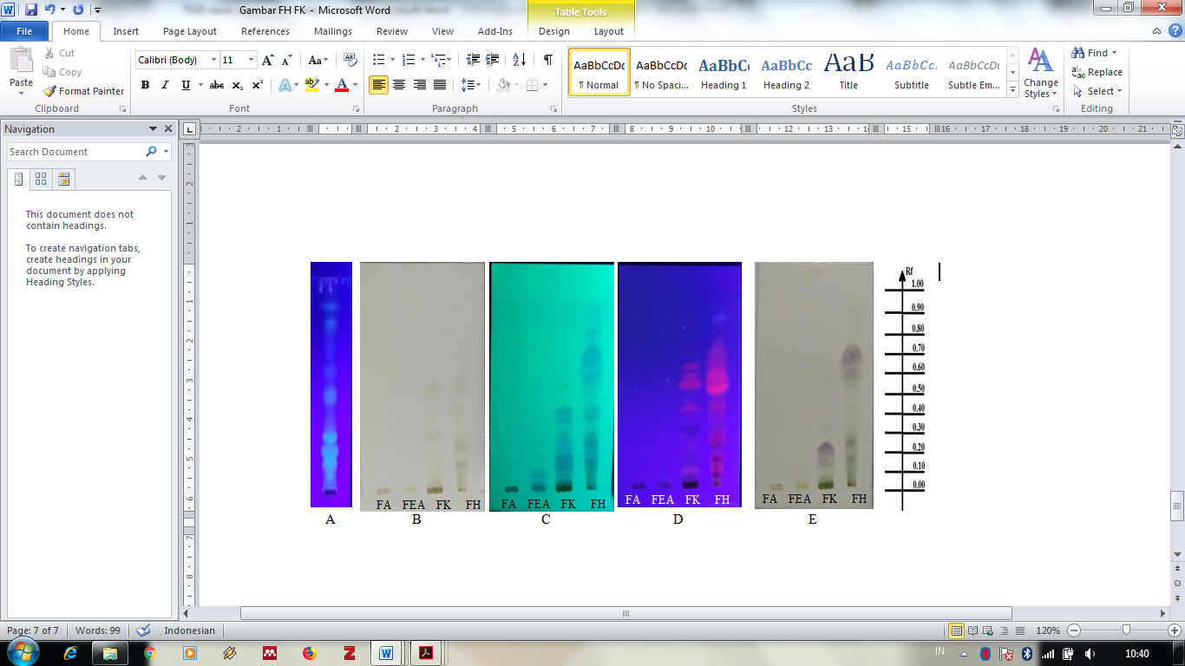

Figure 2. The effect of *G.pictum* ethanolic extract administration and n-hexane, chloroform, ethyl acetate, ethanol-water fraction on the viability of WiDr cells for 24 hours.

|  |  |
| --- | --- |
|  |  |
|  |  |
|  |  |

Figure 3. Morphology of cell after treatments. Observations were made with an inverted microscope magnification 20x. Black arrows indicate that living cells and red arrows indicate cells that have morphological changes.

|  |  |  |  |
| --- | --- | --- | --- |
| Description: Description: D:\thesis\Graptophyllum pictum\gambar\azizah\widr daun ungu\percobaan ke 2\Ekstrak\KS1.jpg | D:\thesis\Graptophyllum pictum\gambar\azizah\widr daun ungu\percobaan ke 2\Ekstrak\6.jpg | D:\thesis\Graptophyllum pictum\gambar\azizah\widr daun ungu\percobaan ke 2\Fraksi Heksan\5.jpg |  |
| Control | extract 2000 µg/mL | n-hexane fraction 125 µg/mL |  |
| Description: Description: D:\thesis\Graptophyllum pictum\gambar\azizah\widr daun ungu\160519 widr fk6 b.jpg | Description: Description: D:\thesis\Graptophyllum pictum\gambar\azizah\widr daun ungu\percobaan ke 2\Fraksi Etil Asetat\7.jpg | Description: Description: D:\thesis\Graptophyllum pictum\gambar\azizah\widr daun ungu\percobaan ke 2\Fraksi Air\6.jpg |  |
| Chloroform fraction  500 µg/mL | Ethyl acetate fraction  4000 µg/mL | Ethanol-water fraction  4000 µg/mL |  |

Figure 4. The results of TLC identification of n-hexane and chloroform fractions using various types of spray reagents. Elution was carried out on silica gel F254, and the mobile phase was n-hexane-ethyl acetate (4: 1 v/v). (a) Observation of spots on visible light, (b) observation of spots under UV254, (c) observation of spots under UV 366, (d) observation after spraying FeCl3, (e) observation after spraying H2SO4, (f) observations after spraying LB, (g) observations after anisaldehyde sprayed on visible light, (h) observations after being sprayed with anisaldehyde under UV 366 and (i) observing after spraying with vanillin sulfuric acid. Description: FH: n-hexane fraction, FK: chloroform fraction

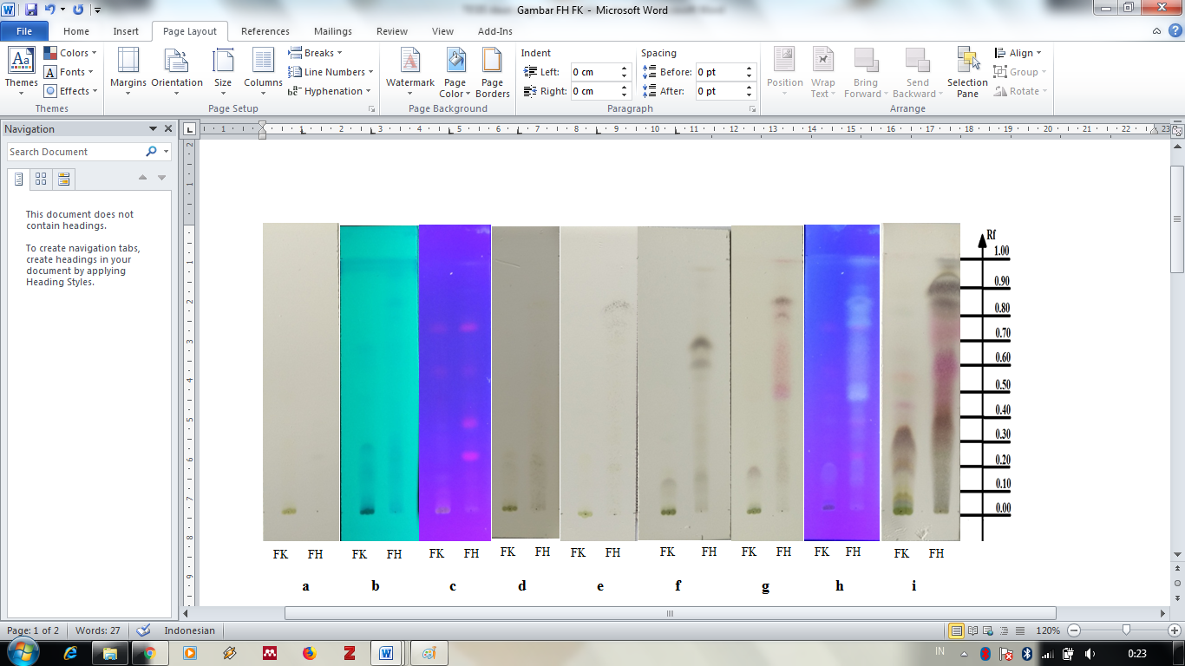

Table 1. IC50 values of *G.pictum* on WiDr cell.

|  |  |
| --- | --- |
| Sampel | IC50 value (µg/mL) |
| Ekstrak (EGP) | 2431,47 |
| Fraksi heksan (FHGP) | 195,61 |
| Fraksi kloroform (FKGP) | 507,20 |
| Fraksi etil asetat (FEAGP) | 3538,67 |
| Fraksi etanol-air (FAGP) | 3186,60 |