Title: Ethanol Extracts of Detam 1 Soybean Seed (Glycine max L. Merr) for Chronic Kidney Disease Therapy by In Vitro Study

Running title: Glycine max for Chronic Kidney Disease Therapy

Authors & Affiliation: Sijani Prahastuti¹, Meilinah Hidayat¹, Stella Tinia Hasiana¹, Wahyu Widowati^{1*}, Annisa Amalia², Rismawati Laila Qodariah², Rizal Rizal², Satrio Haryo Benowo², Hanna Sari Widya Kusuma²
¹Faculty of Medicine, Maranatha Christian University, Jl. Prof. Drg. Surya Sumantri 65, Bandung 40163, West Java, Indonesia
² Aretha Medika Utama, Biomolecular Research Center, Jalan Babakan Jeruk II No. 9, Bandung 40163, West Java, Indonesia

Corresponding Author: Wahyu Widowati (wahyu_w60@yahoo.com)

Author’s declaration
With the submission of this manuscript, I would like to undertake that the above mentioned manuscript is original and has not been published nor accepted for publication elsewhere, and herewith be willing to hand in the right of first publication of the manuscript to Majalah Obat Tradisional (Trad. Med. J).

Authors’ contributions
Authors | Contribution
Sijani Prahastuti | Participated in the design of study, read and approved the final manuscript
Meilinah Hidayat | Participated in the design of study, read and approved the final manuscript
Stella Tinia Hasiana | Participated in the design of study, read and approved the final manuscript
Wahyu Widowati | Conceived of the study and participated in its design
Annisa Amalia | Conceived of the study and participated in its design
Rismawati Laila Qodariah | Participated in drafted the manuscript and performed the statistical analysis, read and approved the final manuscript
Rizal Rizal | Participated in drafted the manuscript, read and approved the final manuscript
Satrio Haryo Benowo | Participated in drafted the manuscript, read and approved the final manuscript
Hanna Sari Widya Kusuma | Participated in drafted the manuscript and performed the statistical analysis, read and approved the final manuscript

Conflict of interest:

The authors declare that they have no conflict of interest.
Authors | Signature
Sijani Prahastuti | 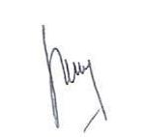
Meilinah Hidayat | 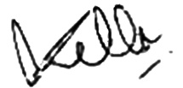
Stella Tinia Hasiana | 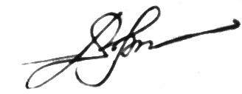
Wahyu Widowati | 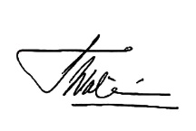
Annisa Amalia | 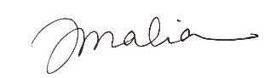
Rismawati Laila Qodariah | 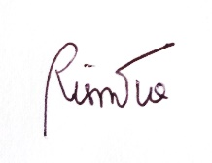
Rizal Rizal | 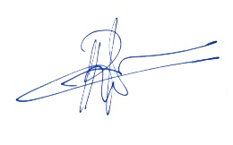
Satrio Haryo Benowo | 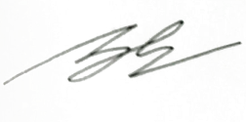
Hanna Sari Widya Kusuma | 