Supplementary Data A: Rutin Identification and Quantification
The procedure of HPLC analysis for rutin identification and quantification that was described earlier was employed to determine the presence of rutin in plant extracts. During the HPLC analysis of pure rutin (Figure A1), the peak appeared at the retention time of 11.125 min. This is highly consistent with the peak that appeared at the retention time of 11.121 min when papaya plant extract obtained through MAE was injected and went through the same analysis (Figure A2). For quantification of rutin, rutin hydrate were weighed and dissolved in absolute ethanol to create rutin solution with the concentration of 1.0 mg/ml. It was then further diluted into different lower concentrations of rutin solution to form a standard calibration curve with the correlation coefficient (r²) = 0.99. This calibration curve was later used to compare with the HPLC results of leaf extracts to determine the respective rutin content.

- Pure rutin
- Papaya leaves extract
Figure A.1: HPLC analysis of pure rutin (a) and papaya leaves extract (b).

Supplementary Data B: HPLC Analysis
Plant extracts were filtered into a HPLC vial using 0.22 µm syringe filter for the identification and quantification of rutin. Agilent 1200 series HPLC system were utilized to determine the content of rutin in each plant extracts. The mobile phases used in this study are HPLC grade methanol and ultrapure water produced by Milli-Q ultrafiltration system. Prior to the analysis, pure methanol was allowed to run through the HPLC system with purge valve opened for 15 min to get rid of remaining solvent from previous user from the HPLC system before entering the analysis column. Subsequently, pure methanol ran through the analysis column for another 15 min to dissolve remaining compound within column and allowed to remove accordingly. Next, the column was subjected to 5 % methanol water for 15 min to condition the column prior to the start of rutin analysis. Solvent gradient of rutin analysis in this present paper was as follow: 5 % methanol water (0 – 3 min), 5 - 100 % methanol water (4 – 6 min), 100 % methanol (7 – 13 min), 100 - 5 % methanol water (14 – 16 min), 5 % methanol water (17 – 20 min) at the flow rate of 1.0ml/min. The injection volume of sample was fixed at 10 µL and the separation were detected by Ultraviolet-Diode Array Detection (UV-DAD) at the wavelength of 360 nm. Results obtained were compared against standard calibration curve to determine the rutin concentration of leaf extract. The analysis column used in this study was Agilent ZORBAX Eclipse Plus C18, 5 µm, 4.6 x 150 mm and the operating temperature set at 25 ºC.

Supplementary Data C: Rutin yield from male papaya leaf using individual MAE and UAE method

Table C.1: The four-factors three-levels BBD involved in this paper.
No. | Factors |  | Level
 |  |  | -1 | 0 | 1
1 | Extraction time (min) | MAE | 2 | 5 | 8
 |  | UAE | 20 | 70 | 120
2 | Solid-Liquid Ratio (wt/wt) | MAE | 1:10 | 1:50 | 1:90
 |  | UAE | 1:10 | 1:90 | 1:170
3 | Particle Size (µm) |  | 355 | 500 | 710
4 | Ethanol Mixture Concentration (%) |  | 20 | 50 | 80

Supplementary Data D: Rutin yield from male papaya leaf using individual MAE and UAE method

Table D.1: The BBD with experimental data of MAE and UAE using male papaya leaves.
MAE |  |  |  |  |  | UAE
Parameters |  |  |  | Yield (mg/g) |  | Parameters |  |  |  | Yield (mg/g)
T_{M} (min) | R (wt/wt) | S (µm) | C (%) | Observed | Calculated | T_{U} (min) | R (wt/wt) | S (µm) | C (%) | Observed | Calculated
5 | 1:90 | 500 | 20 | 1.90 | 1.90 | 70 | 1:170 | 500 | 20 | 1.31 | 1.55
5 | 1:50 | 500 | 50 | 4.11 | 2.96 | 70 | 1:90 | 500 | 50 | 3.88 | 3.87
5 | 1:10 | 500 | 20 | 2.39 | 1.96 | 70 | 1:10 | 500 | 20 | 2.55 | 2.46
5 | 1:50 | 500 | 50 | 4.12 | 2.96 | 70 | 1:90 | 500 | 50 | 4.19 | 3.87
8 | 1:10 | 500 | 50 | 3.15 | 3.20 | 120 | 1:10 | 500 | 50 | 3.17 | 2.30
2 | 1:10 | 500 | 50 | 2.58 | 2.53 | 20 | 1:10 | 500 | 50 | 3.32 | 3.52
2 | 1:50 | 710 | 50 | 2.83 | 1.80 | 20 | 1:90 | 710 | 50 | 2.03 | 2.18
5 | 1:90 | 710 | 50 | 2.87 | 2.25 | 70 | 1:170 | 710 | 50 | 1.13 | 1.44
5 | 1:10 | 710 | 50 | 2.18 | 2.34 | 70 | 1:10 | 710 | 50 | 2.73 | 3.22
2 | 1:50 | 500 | 20 | 1.88 | 1.50 | 20 | 1:90 | 500 | 20 | 3.26 | 2.61
5 | 1:10 | 355 | 50 | 2.88 | 3.02 | 70 | 1:10 | 355 | 50 | 3.37 | 3.15
5 | 1:10 | 500 | 80 | 1.74 | 1.32 | 70 | 1:10 | 500 | 80 | 1.82 | 1.78
2 | 1:90 | 500 | 50 | 3.26 | 2.42 | 20 | 1:170 | 500 | 50 | 1.66 | 1.72
2 | 1:50 | 500 | 80 | 1.71 | 0.57 | 20 | 1:90 | 500 | 80 | 2.43 | 1.86
5 | 1:50 | 355 | 80 | 2.17 | 0.97 | 70 | 1:90 | 355 | 80 | 3.12 | 3.13
5 | 1:50 | 500 | 50 | 3.42 | 2.96 | 70 | 1:90 | 500 | 50 | 3.81 | 3.87
5 | 1:50 | 500 | 50 | 3.51 | 2.96 | 70 | 1:90 | 500 | 50 | 4.02 | 3.87
5 | 1:90 | 355 | 50 | 4.05 | 2.92 | 70 | 1:170 | 355 | 50 | 4.28 | 3.82
5 | 1:50 | 710 | 20 | 0.83 | 0.92 | 70 | 1:90 | 710 | 20 | 3.01 | 2.12
8 | 1:90 | 500 | 50 | 3.21 | 3.12 | 120 | 1:170 | 500 | 50 | 4.46 | 3.44
5 | 1:50 | 500 | 50 | 3.29 | 2.96 | 70 | 1:90 | 500 | 50 | 3.89 | 3.87
8 | 1:50 | 500 | 80 | 2.52 | 1.48 | 120 | 1:90 | 500 | 80 | 2.02 | 2.77
2 | 1:50 | 355 | 50 | 3.73 | 2.36 | 20 | 1:90 | 355 | 50 | 3.84 | 4.06
8 | 1:50 | 355 | 50 | 3.85 | 3.13 | 120 | 1:90 | 355 | 50 | 3.76 | 3.72
5 | 1:50 | 355 | 20 | 2.07 | 2.08 | 70 | 1:90 | 355 | 20 | 2.86 | 3.07
5 | 1:90 | 500 | 80 | 2.74 | 1.19 | 70 | 1:170 | 500 | 80 | 1.71 | 2.02
8 | 1:50 | 710 | 50 | 2.84 | 2.36 | 120 | 1:90 | 710 | 50 | 3.31 | 3.30
5 | 1:50 | 710 | 80 | 1.83 | 0.80 | 70 | 1:90 | 710 | 80 | 2.81 | 1.78
8 | 1:50 | 500 | 20 | 2.24 | 1.96 | 120 | 1:90 | 500 | 20 | 1.54 | 2.21
*Note: Highlighted data are the centre points of this study.

Supplementary Data E: ANOVA Table

Table E.1: ANOVA analysis of MAE and UAE with male papaya leaves.
Terms | MAE |  |  | UAE
 | F-Value | p-Value | Significance | F-Value | p-Value | Significance
Model | 10.31 | 0.00 | Significant | 3.22 | 0.02 | Significant
Linear | 4.96 | 0.01 | Significant | 2.18 | 0.13 | Insignificant
C (%) | 19.59 | 0.00 | Significant | 5.33 | 0.04 | Significant
T_{M} (min) | 1.37 | 0.26 | Insignificant | N/A
T_{U} (min) | N/A |  |  | 0.84 | 0.37 | Insignificant
S (µm) | 1.53 | 0.24 | Insignificant | 0.03 | 0.86 | Insignificant
R (mg/ml) | 1.30 | 0.27 | Insignificant | 1.76 | 0.21 | Insignificant
Square | 26.37 | 0.00 | Significant | 6.27 | 0.00 | Significant
C² | 104.89 | 0.00 | Significant | 19.57 | 0.00 | Significant
T_{M}² | 1.75 | 0.21 | Insignificant | N/A
T_{U}² | N/A |  |  | 1.90 | 0.19 | Insignificant
S² | 4.92 | 0.04 | Significant | 0.10 | 0.76 | Insignificant
R² | 4.38 | 0.06 | Insignificant | 8.73 | 0.01 | Significant
2-Way Interaction | 1.37 | 0.29 | Insignificant | 1.90 | 0.15 | Insignificant
C*T_{M} | 0.42 | 0.53 | Insignificant | N/A
C*T_{U} | N/A |  |  | 0.99 | 0.34 | Insignificant
C*S | 2.07 | 0.17 | Insignificant | 0.09 | 0.77 | Insignificant
C*R | 4.61 | 0.05 | Significant | 0.74 | 0.41 | Insignificant
T_{M}*S | 0.09 | 0.77 | Insignificant | N/A
T_{U}*S | N/A |  |  | 1.21 | 0.29 | Insignificant
T_{M}*R | 0.79 | 0.39 | Insignificant | N/A
T_{U}*R | N/A |  |  | 4.94 | 0.04 | Significant
S*R | 0.21 | 0.65 | Insignificant | 3.44 | 0.09 | Insignificant
Lack-of-Fit | 0.67 | 0.72 | Insignificant | 27.15 | 0.00 | Significant
R² | 91.2 % |  |  | 76.3 %
Adj-R² | 82.3 % |  |  | 52.6 %

Supplementary Data F: Model fitting

r²=0.91
Figure F.1: Regression model of rutin extraction from male papaya leaves using MAE (a) and UAE (b).

Supplementary Data G: Surface and contour plot for rutin extraction from male papaya leaf using individual MAE

- CT_{M} |  | - SC
- RC |  | - ST_{M}
- RT_{M} |  | - RS
Figure G.1: The surface and contour plots for rutin yield with MAE using male papaya leaves under the influence of irradiation time and ethanol mixture concentration (a), size of plant matrix and ethanol mixture concentration (b), solid-liquid ratio and ethanol mixture concentration (c), particle size and irradiation time (d), solid-liquid ratio and irradiation time (e), and solid-liquid ratio and size of plant matrix (f).

Supplementary Data H: Surface and contour plot for rutin extraction from male papaya leaf using individual UAE

- T_{U}S |  | - SC
- RC |  | - ST_{U}
- RT_{U} |  | - RS
Figure H.1: The surface and contour plots for rutin yield with UAE using male papaya leaves under the influence of sonication time and ethanol mixture concentration (a), size of plant matrix and ethanol mixture concentration (b), solid-liquid ratio and ethanol mixture concentration (c), particle size and sonication time (d), solid-liquid ratio and sonication time (e), and solid-liquid ratio and size of plant matrix (f).

Supplementary Data I: SEM Images
- Before Extraction | - After MAE Treatment | - After UAE Treatment
30 µm and 2000 x
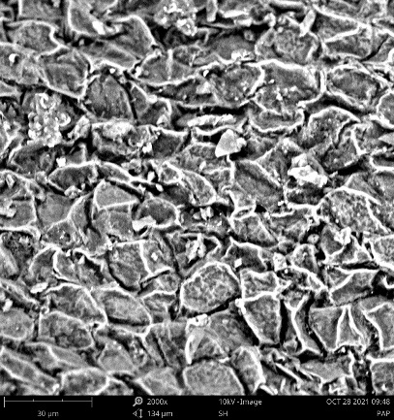 | 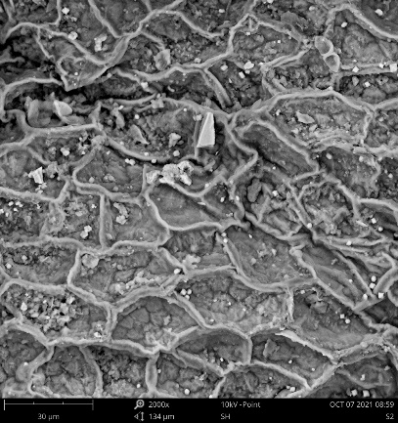 | 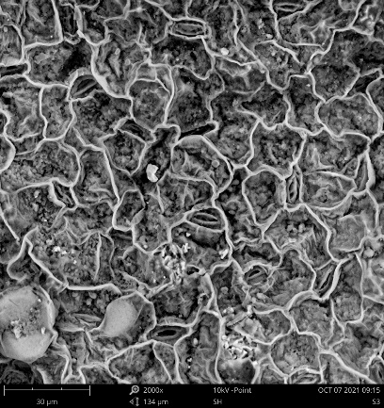
Figure I.1: SEM scan of male papaya leaves before extraction process (a), after MAE process (b), and after UAE process (c) under the scale of 30 µm and the magnification level of 2000 x.

Supplementary Data J: Extraction Efficiency

Figure J.1: Extraction efficiency, energy consumption and the energy required to produce 1 gram of rutin using MAE and UAE.

