**Supplementary Information**

**A Pilot Plant Study of Coal Dryer: Simulation and Experiment**

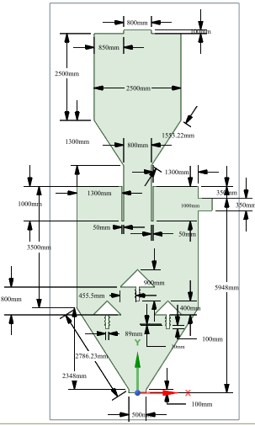

**Figure S1** The specific geometry of simulated coal dryer



**Figure S2** The moisture content of several ER in Line A, B, C, and D

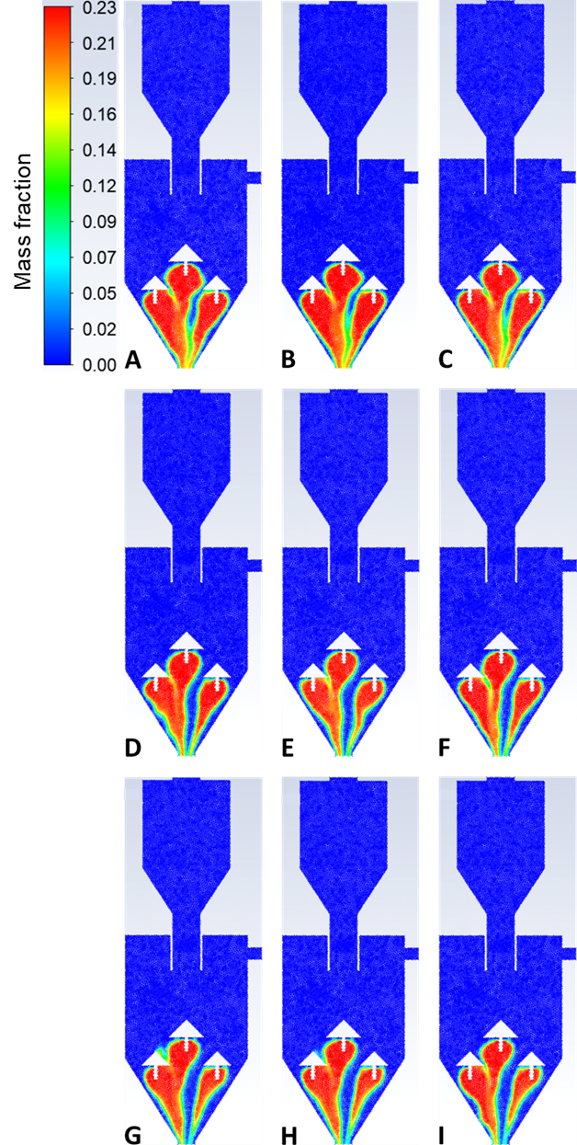

**Figure S3.** Oxygen distribution for Variable A (ER 0.63), B (ER 0.68), C (ER 0.74), D (ER 0.91), E (ER 1), F (ER 1.08), G (ER 1.1), H (ER 1.2), I (ER1.31) in the steady state

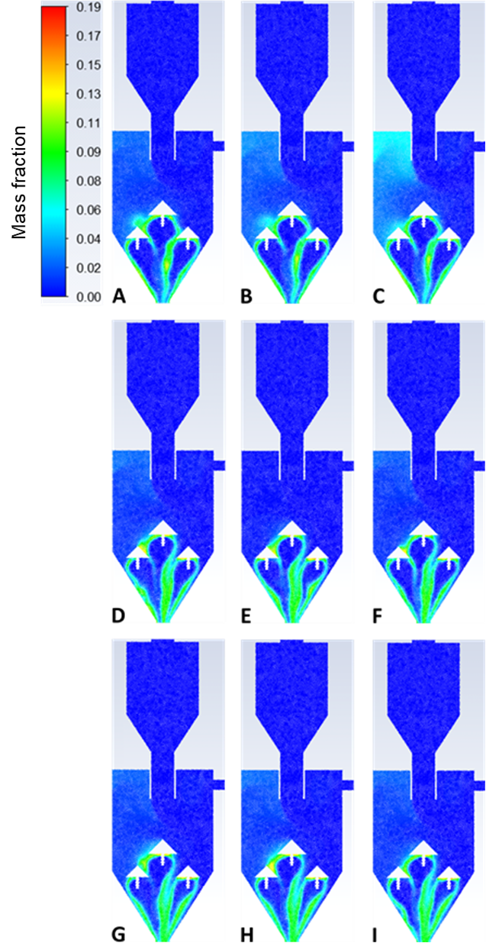

**Figure S4.** Distribution of CO2 gas in Variable A (ER 0.63), B (ER 0.68), C (ER 0.74), D (ER 0.91), E (ER 1), F (ER 1.08), G (ER 1.1), H (ER 1.2), I (ER1.31) in the steady state condition

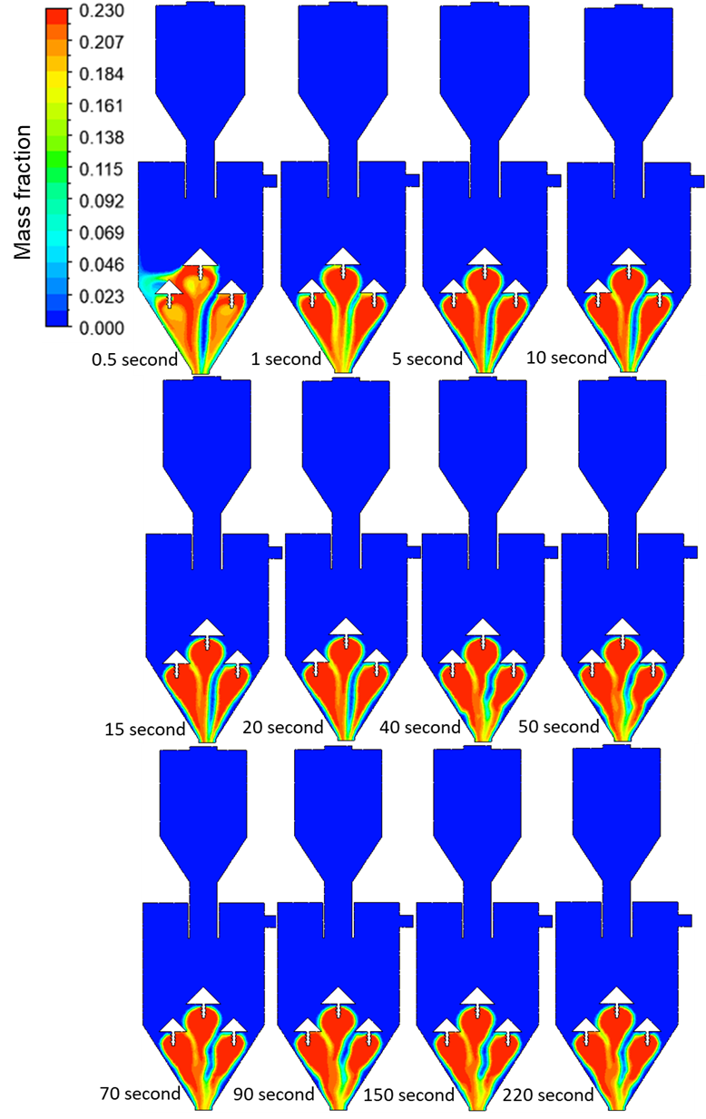

**Figure S5.** Distribution of Oxygen Variable B in unsteady state conditions

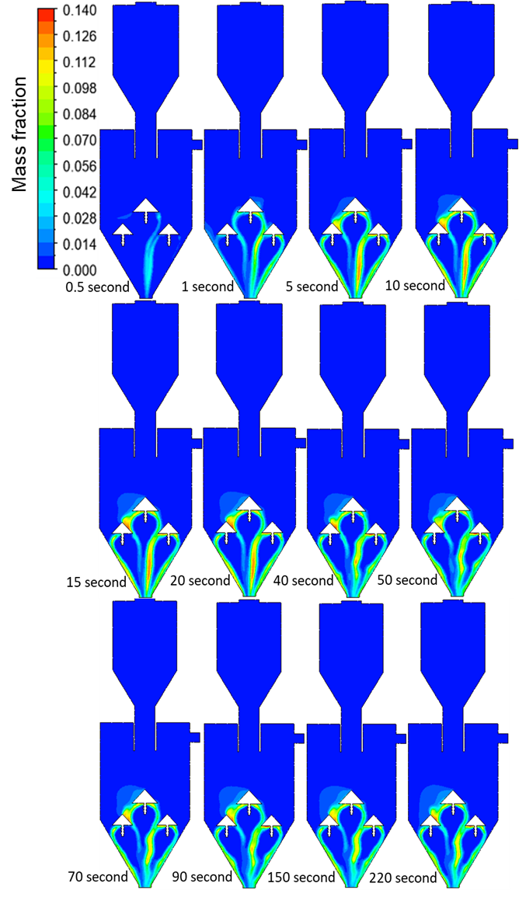

**Figure S6.** Distribution of CO2 Variable B in unsteady-state conditions